Systems integration in question – a comparison of Airbus and Boeing
Mustafa Erdem SAKINÇ¹
¹ GREThA UMR - CNRS 5113 Université de Bordeaux. mustafa.sakinc@u-bordeaux.fr

Abstract.
Commercial aircraft industry went under a substantial transformation in the last 20 years oriented by technological, organizational and financial drivers. For Airbus and Boeing, top companies of the commercial aircraft food chain, the transformation corresponds to the adoption of systems integration business model with their new products introduced in the last five to ten years. In a comparative-historical perspective, the paper examines the three pillars of this new business model which have been raised by strategic, organizational and financial inclinations of two companies. While major differences in their organizational dynamics still persist, strategies around new product development and underlying financial motives have marked similarities. The long-term durability of the model is inherently uncertain as long as it is not based on governance compromises which are set between different stakeholders.
Keywords: Commercial aircraft manufacturing, Airbus, Boeing, business/productive models, outsourcing, financialization, employment relations.

INTRODUCTION
Crystallized in their latest aircraft programs A350 and B787, Airbus and Boeing have been adopting new strategies of product development and production organization since the late 1990s. Having redefined their supplier organizations and introduced new mechanisms of procurement and coordination, their common aim is to cut development costs, to focus on final integration of aircraft systems and to reduce production lead times. Today, both companies claim that they adopted a systems integration perspective in which, together with their design and development, manufacturing of major aircraft sections and systems is mainly performed by suppliers. And the two companies claim to focus on their ‘core competencies’ primarily restricted to final assembly and supply chain management. Accordantly, they have been pursuing several cost-cutting programs in order to keep product development and manufacturing costs under control and to boost earnings which had important employment and financial implications. Meanwhile both companies have been receiving substantial amounts of governmental subsidies particularly for their new product development efforts in multiple forms. Since the early 2000s, formed around the issue of government support, a quarrel on commercial aircraft trade has been intensified along with a decade long WTO dispute.
The emergence of systems integration as a new business model for Airbus and Boeing, in effect, coincides with the systemic transformation of capitalist economies all over the globe. Globalization of production, profound technological developments and emergence of new industries, changing dynamics of industrial relations and work organization, and the rise of financial capital accumulation along with increasing financial transactions have been instrumental in this transformation. To understand the dynamics of this transformation, scholarly research necessitates an economic and social analysis concentrated on the main economic unit of contemporary capitalism, the business enterprise. It is the business enterprise that is in the heart of the transformation as the primary actor of economic development and the reproduction of productive resources as the essence of the development.

METHODOLOGY AND ANALYTICAL FRAMEWORK
In this study, a comparative-historical analysis is outlined to investigate the repercussions of these transformations in a specific industry; the commercial aircraft manufacturing with a focus on its two main actors Airbus and Boeing.
Claiming that neoclassical economic theory is badly limited to offer sound explanations of firm, industry and economy wide differences, many scholars highlighted the importance of comparative analysis in explaining sources of superior economic performance and underlying differences at governance, organizational and institutional levels (Nelson, 1991; Chandler, 1993; Whitley, 1999; Lazonick, 2007; Sako, 2008). As a research method, comparative analysis gradually became indispensable in understanding the variety of organizational and institutional forms mobilized for similar economics activities in a competitive way and bringing similarities and contrasts into focus which help to understand the evolution of the conditions of innovation and the ways in which economic activities coordinated and controlled in different times and places.
Besides comparative perspective, any analysis of productive activity requires a rigorous study of historical reality. At this point, historical experience of Schumpeter (1954) is an essential research competence. It enables not only to understand the context, or to put it in a dynamic way, the flux in which the actors of economic activity make their decisions over productive resources in order to pursue their productive activities including innovation, but also to document the evolution of motives and organizational forms of economic actors across time. The experience also conceives the depth of change which heralds the passage of one form of activity to another in a specific firm, industry or nation.
As a result, the study includes both meso (industry) and micro (firm) level analysis in a comparative-historical way with a consideration of the integral role of macro level dynamics imposed on firms and industries by social conditions specific to a country or a region and national institutional environment. Institutions play a key role for a comparative analysis as long as they provide nation specific rules and norms applicable to economic activity. They are also important for historiography as they are not immune to change and their slower but persistent transformation over time which is also structured by economic actors has substantial consequences over the productive activity of a specific nation or region.
Out here, productive models approach of regulation theorists (Boyer and Freyssenet, 2002) provides strong analytical tools and a conceptual framework for this study. The second framework which is applied in parallel especially at the micro level is Lazonick’s (2013) theory of business enterprise. Even though they follow different terminologies and their flows of analysis differ due to varying emphasis on different aspects of productive activity of firms, two perspectives are rather complementary with shared perspectives over the sources of nation and firm level competitive advantage.
Mainly following these two frameworks, the analysis is embedded in a model of the relations among industrial sectors, business enterprises, and economic institutions which support innovative productive activity. Whether the focus of analysis is the business enterprise represented by Airbus and Boeing, the analysis continuously refers to the matter of industries and institutions in explaining the organizational dynamics of Airbus and Boeing for their respective productive activities.
Accordingly, the comparative-historical analysis presented in this study permits to identify converging and contrasting practices of the commercial manufacturing activity in the last two decades in order to understand the changing organizational dynamics of its primary actors. Such an analysis practically helps to investigate the interrelated dynamics of these firms’ changing growth strategies, productive organizations, employment relationships, and their use and reuse of financial resources along new product development or innovation. For the sake of specificity, the analysis is focused on the motives behind and the implications upon these practices at Airbus and Boeing with a focus on last two decades while the companies have heavily invested in their latest aircraft development programs. To repeat, the study is an exploratory effort to reveal the interrelations between the emerging business orientation of systems integration in commercial aircraft manufacturing and the rise of intensive outsourcing/offshoring/partnering, major transformations in employment relations and work organization, and the intensified use of financial tools and mechanisms together with the growing dominance of finance over corporate strategies.
In the second part of the study, the concept of systems integration is discussed in three sections. First the preliminary conceptualization of systems integration is presented in its historical context, as a task to accomplish multi-actor, novel and high tech product development in the period after the WWII. Second the recent literature which presents systems integration as a capability for firms to coordinate progressively complex and multi-actor production process especially in high-tech sectors is discussed. Third, the orientation of Airbus and Boeing towards systems integration is presented as a productive/business model transformation. In order to do so, a brief discussion on business models is presented and an approach blending Regulationists’ productive models and Lazonick’s innovative enterprise is outlined. In the third part of the study this new model is discussed around a strategy-organization-finance scheme. Each component of the model and its practice by Airbus and Boeing is elaborated through a comparative analysis with reference to a set of descriptive data and information. Concluding remarks are provided in the final part.

SYSTEMS INTEGRATION

C.1. CONCEPTUALIZATION OF SYSTEMS INTEGRATION
The concept of systems integration is originally derived from systems engineering; the work of organizing and bringing together different processes of the development and production of complex new products i.e. systems (Johnson, 1997). An engineering element of production process, it was conceptualized from 1940s to 1960s as a means to coordinate and control the development of complex aerospace and computing systems particularly utilized by the US government. Principally, systems engineering was the latest stage of systems/product development, the final integration of the components built by different organizations involved in a project. It also included testing and verification of the final product after all the components are integrated (Johnson, 2003).
In the wake of systems engineering, systems integration emerged as the task to bring together different components of a weapon system which were previously performed within the walls of government owned and managed arsenals but progressively assigned to business firms, to let them develop weaponry and aircraft systems (Sapolsky, 2003). As a result, the reliance of armed services to business contractors increased after the WWII. Rather different than the war time when the race was on weapon mass production, military technology race of Cold War was on new weaponry development in which technological performance mattered more than numbers (Jones, 1990; cited in Sapolsky, 2003). However, the rapid change of technologies and processes of systems made their development, integration and utilization a big challenge each time. In order to reap the benefits of rapid progress in technologies, coordination had to be well established and continuous learning and the development of new skills became central to the work of system integrators.
In the aerospace industry, systems integration emerged as a standalone assignment to bring together different systems like electronics or weaponry that had to be designed with the aircraft from the very beginning (Johnson, 2003). The prime contractor, main integrator of the final product as a complex system, had to develop the systems knowledge necessary to understand and coordinate diverse talents and technologies required to develop final systems by attracting and mobilizing skilled scientists and engineers (Sapolsky, 2003). This knowledge has always been the main tool that has to be heavily invested by firms in order to cope with technological uncertainties which pervade the design and development of a new airframe or a new engine (Mowery and Rosenberg, 1989).
Thus the main function of systems integration is the ability to maintain necessary communication and coordination of a predominantly multi-actor project from the preliminary design till customer services confronted with a tremendous level of uncertainty due to the magnitude, novelty and complexity. It is primarily a social process which necessitates social and cognitive solutions only provided by appropriate organizations which aim to improve and manage the communication and control of technical development.

C.2. CAPABILITY-BASED DISCUSSION
The implementation and the management of systems integration by business enterprise rather than the government and its transformation from a communications method to a source of competitive advantage eventually entail a discussion on business strategy and what social scientists and business scholars say on systems integration as a business action. In the last two decades, a limited but focused research has been performed by a group of scholars embracing evolutionary and resource-based views on the coordination of technological capabilities and knowledge within and across the boundaries of firm (Brusoni et al., 2001; Brusoni and Prencipe, 2001; Prencipe, 2001; Prencipe et al., 2003; Hobday et al., 2005; Acha et al., 2007; EMR Special Issue, 2009). The research is limited due to the nature of systems integration as a tool specific to multi-actor and multi-tech sectors. However, the rising importance of such sectors like telecommunications, electronics and aerospace and increasing relevance of the concept to the knowledge management and innovation strategy of corporations active in these sectors have made existing and further research valuable.
The literature discusses systems integration mainly as an issue of capability management along changing firm boundaries. This change can either be through backwards disintegration as a result of increasing outsourcing including design and development of components or final products (Pavitt, 2003; Sturgeon, 2002) or forward integration into services and business solutions for existing or novel products by moving downstream into the provision of services to distribute, operate, maintain and finance a product through its life cycle (Wise and Baumgartner, 1999; Davies, 2003). In both cases, system integrator companies develop and utilize different problem-solving capabilities to deal with necessary integration of distinct systems while they function in harmony when they are integrated. Adopting systems integration capabilities is understood as a competitive process of coordinating tasks for different sections of systems, integrating them and maintaining the continuity of the final product by supporting and offering necessary services and solutions. One basic question is how firms organize themselves to manage technological evolutions around complex products. Rising complexity, rapid technological change and the extension of knowledge paths to develop new systems force firms to adapt new forms of design, development and manufacturing in order to preserve their competitive advantage. Thus systems integration is embedded in the business strategy of a firm to manage value creation both internally and externally.
In that regard, scholars of industrial organization and innovation have addressed the role of systems integration as a new stage in the life of the Chandlerian enterprise (Prencipe, et al., 2003; Hobday et al., 2005). Basically driven by better understanding of technologies, and accumulated and codified knowledge, firms are enabled to hive off some of their in-house activities or to skip the option to develop new resources and capabilities necessary to design and develop parts of a technologically complex new product while keeping the coordination and final integration under control which may or may not include vertical integration through different phases of the new product life cycle (Brusoni and Prencipe, 2001; Hobday et al., 2005). At the end, armed with systems integration capabilities, firms are able to choose whether or not to outsource specific elements of design and production (Hobday et al., 2005) and they basically ‘know more than they do’ thanks to these capabilities needed to actively manage technological and organizational interfaces (Brusoni and Prencipe, 2001). The feature that accompanies the technological aspect of systems integration is the organizational dimension which expresses the involvement of different organizational profiles like prime contractors and subcontractors as well as technical advisors and government bodies in a systems integration task (Gholz, 2003). These profiles bring their specific technical and management skills for the execution of integration. In this context, outsourcing is an integral feature of systems integration that the firms outsourcing parts of production have to possess necessary organizational capabilities to integrate components produced or knowledge generated by suppliers (Pavitt, 2003).
Thus, systems integrators are the key actors of innovation by maintaining a diverse set of competences across a wide range of technologies and scientific disciplines (Acha et al., 2007). Several studies have already documented the competence development as an increased technology diversification provided through the increase in the diversity of patents filed by firms in high-tech industries in the last three decades (Granstrand et al., 1997; Brusoni et al., 2001; Brusoni and Prencipe, 2001; Acha and Brusoni, 2008; Dibiaggio and Nasiriyar, 2009). These perspectives provided a variety of explanations for organizational solutions of firms faced with intense competition and rising demand for more complex and better quality designs. At the end, as an outcome of increasing specialization in knowledge production (Pavitt, 2003), systems integration is principally a capability either limited to coordinate the diverse and complex learning trajectories of suppliers and to orchestrate their network (Brusoni and Prencipe, 2001; Dosi, et al., 2003) or expanded to redesign of an existing system in order to take full advantage of a technical innovation which may involve not only product design but also the plant layout, production system, and business organization (Best, 2003).
However, the development of capabilities and their utilization is the essence of a broader business strategy of acquiring competitive advantage. If these scholars correctly define systems integration as a capability, and highlight its importance for innovative performance, they fail to connect this capability development process to broader strategic, organizational and financial challenges that these corporations have to meet in order to sustain their innovativeness and transform it into prosperity for their stakeholders as the basic aim of business enterprises. In order to identify underlying reasons for shifting boundaries of firms or the passage from vertical to systems integration, a reformulation is needed which provide a broader framework unrestricted to the imperatives of technological transformations and resulting organizational changes.

C.3 BUSINESS/PRODUCTIVE MODELS
Systems engineering and systems integration are not new concepts in aerospace. In different ways they are expressed in terms of technical and organizational capabilities of corporations inclined to organize and run the design, development and operation of technologically complex, innovative, learning stage (in the sense that knowledge accumulated to develop and operate the final product and its components is new) and high cost programs performed by multiple actors. If systems integration is the organizing of innovation and production process, how can productive reorganization along new product development be a new business/productive model for commercial aircraft manufacturing and before all, what is the use of such models?
Business enterprises execute their innovation strategies through organizational and financial structures that are built for the purpose of creating and distributing value. These structures are utilized through certain modes of action that are expected to enable coherence between strategic, organizational and financial inclinations.
Economic and business literatures approach business strategy through a big variety of analytical frameworks containing rather distinct features shaped by different motives and interests. Similarly, the growing literature on business models contains a very large number of propositions structured by the emphasis on distinct parts of productive activity. Boyer and Freyssenet (2002) provide a list of the ways in which a model is articulated. A model can be an ideal to be attained; a set of attributes to firm performance; a methodological construct to estimate the coherency of theoretical arguments over firm performance; and an ex post articulation of change along with its roots and outcomes. Similarly, a business model can be approached from several different aspects identified by the analytical point of departure. The coherence between the purpose of models described and their conceptualized functioning defines boundaries of models proposed.
To begin with growing business models literature, despite Porter’s (2001) early warning of the blurring character of the term spread through the internet bubble of late 1990s, the business model idea was quickly embraced by the literature with an aim to highlight the role of emerging technologies in value creation and capture process (Chesbrough and Rosenbloom, 2002; Mahadevan, 2000; discussed in detail in Zott and Amit, 2011).
Following the slowdown of e-business fervor of internet boom which helped the misuse of the term to vanish (Magretta, 2002), the literature on business models has expanded in an unfolding and deepening way. It started to include a big variety of old and new perspectives, tools and concepts of business and strategy literature while the definitions and points of interest remained divergent. It can be a set of choices on how to mobilize internal and external resources and capabilities in order to generate revenues (Lecocq et al., 2006), a system of interdependent activities in a networked form that transcends the firm itself (Zott and Amit, 2011), an apparatus to conceptualize and run the logic to create and deliver value to customers in exchange of profits (Teece, 2010), and a mechanism to generate financial surplus through a network of information always channeled to the focal corporation (Haslam et al., 2012). Whether the literature is rich in propositions and concepts, it remains theoretically underdeveloped and hardly distinguishable at a conceptual level from other business organizational forms continuously being used by business and economic literature (Teece, 2010; Zott and Amit, 2011).
On the contrary, the productive models approach of Boyer and Freyssenet provides a much more rigorous explanation of value creation or in a loose way ‘business enterprise at work’ with a solid theoretical background. In their own words a productive model is defined ‘by the conjunction of a profit strategy and a company governance compromise in order to make coherent product policy, productive organization and employment relationships, along with the relevance with respect the macroeconomic growth mode’ (Boyer and Freyssenet, 2002). The authors articulated the concept with their deep understanding of the functioning of capitalist economies developed through the Regulation school’s long efforts to shed light on underlying forces of capitalist development and change. The links between productive models and the macroeconomic environment including fundamental dynamics of aggregate demand provide a solidly built macro base which does not exist in the business models literature where the point of interest is always the specific demand for the specific commodity to be produced by the specific firm or network in question. Thus, in productive models, the role of institutions in shaping productive models by creating constraints or enablers is critical (Lung, 2008). In addition, the emphasis on the employment relationship and the compromise between different stakeholders as decisive components of profit strategy of firms and their productive organization is fundamental.
However, the role of finance in redefining productive strategies and organization, a critical factor in shaping productive models, was missing in early conceptualization of Boyer and Freyssenet. They were truly aware of the fact that financial sphere would have important consequences on governance compromises. However, the role of finance becomes important only when firms lose control over their funding mechanisms and their independence as if a firm, on its own, is a homogenous entity with shared objectives by different stakeholders. Here, Haslam et al., (2012) provide important insights to the business model discussion which can be thought in line with productive model approach as a financial sphere. For them, the purpose of following a business model is to generate financial surplus through leveraging stakeholders (Haslam et al., 2012).
Thus an integrated methodological perspective discussing specific forms of business/productive models of the 21st century including the ones in commercial aircraft manufacturing is still needed. The divergence of scholarly concerns and analytical perspectives within this ‘models’ literature hinder the potential to offer a methodological set to be applicable to different industries and firms. The empirical investigation of productive models’ was only on 20th century auto industry and the atomized approaches to business models do not help to constitute a solid template to analyze a specific case within a business/productive model framework. As it is highlighted, a theoretical background is critically needed to put forward the fundamental elements of proposed models and to exert analytical rigor on an empirical study.
Lazonick (2013) provides a comprehensive view of business enterprise which is involved in three generic activities to transform productive resources into commodities to be sold. These activities are
Strategy allocates resources to investments in developing human and physical capabilities that, it is hoped, will enable the firm to compete for chosen product markets. Organization transforms technologies and accesses markets, and thereby develops and utilizes the value-creating capabilities of these resources to generate products that buyers want at prices that they are willing to pay. Finance sustains the process of developing technologies and accessing markets from the time at which investments in productive resources are made to the time at which financial returns are generated through the sale of products.
The study assumes that an enterprise’s execution of each of these activities or modes of action identify the guidelines of their business or productive model. Within a specific industry for a certain period of time, there may be a dominant model adopted by prominent firms of the industry. However, certain aspects of the model may or may not exist in a firm or another depending on their different strategic orientations. Equally important, institutional environment may or may not allow firms to put forward certain aspects of the dominant model or compel them to modify it. Despite growing interest within the business literature, there is still a requisite to explain productive/business models within the domain of economic theory with an emphasis on technological change, industrial relations, financial orientations, and regulatory frameworks. Each of these concepts is a major determinant of the particularities and boundaries of a model at a specific point in time, within defined geographies and industries (Montalban and Sakinc, 2013).
Thus, for the purpose of this study, systems integration is proposed as a new business/productive model for commercial aircraft manufacturing that implies a Chandlerian type organizational learning strategy in a Regulationist macro environment highlighted with the orientation towards financialization in the last several decades. Within the framework of a model, business enterprises follow their basic aim of generating a surplus and reinvest or distribute it to certain stakeholders while coping with different types of uncertainties and adapting to changes along new product development (new shop floor practices, new technologies, new communication forms and channels, new product market environment, etc.).
Similar to the relation of organizational capabilities for the managerial capitalism of the 20th century depicted by Chandler (1992), the new face of systems integration as a core capability of the modern corporation (Hobday et al., 2005) can only be understood if we establish the relation between the development of such new capabilities and the remaking of business enterprise. It is the centrality of the relation between productive organization and business strategy in systems integration (or in any other business orientation) that provides a research framework to analyze the meaning of systems integration for the commercial aircraft manufacturing primarily represented by Airbus and Boeing. Furthermore, in order to develop necessary productive and organizational resources and fund new product development, business enterprises together with their stakeholders are also required to provide financial commitment. As a third element, finance and its impact on strategic decision making and organizational integration should also be analyzed. This aspect, which has been restricted either to the research on financial performance or to policy discussions, has been largely ignored by organization and technology scholars for a long time. However, the commitment and the control over financial resources and the pursuit of financial objectives are vitally decisive over the integration of strategy and organization.
Therefore, a study on the implications of systems integration approach in modern business organization in general and its reflections in the commercial aircraft industry in particular should first deconstruct the discourse of systems integration especially embraced by Boeing (in the case of Airbus the new orientation has been defined more technically as New Systems Policy). Such an analysis should include the research underlying motives and potential outcomes of their actions while they reorganize their productive organizations. At the end, systems integration can be understood as a business model for firms developing products that necessitate reformulated structures progressively embedded in their business strategy, productive organization and corporate finance.
In the following parts, the period of advancement of systems integration at Airbus and Boeing is analyzed through their new product development efforts in the last ten to fifteen years within a comparative perspective by looking at their specific activities with factual and quantitative evidence. The primary attribute of the model is the reorganization of the product development and its supply chain. However, as it is highlighted, throughout the introduction of a new business model one has to consider financial and employment motives as integral elements of industrial restructuring. Systems integration already has fundamental organizational and financial implications. The similarities and differences of two firms in each dimension should be highlighted in order to reveal dynamics of competitive performance as well as to question the sustainability of their distinctive practices at organizational and financial levels.

SYSTEMS INTEGRATION AT WORK

D.1 STRATEGY
Following Chandler, strategy can be defined as the planning and carrying out of the growth of organizations. This definition is still relevant for contemporary industry studies as long as the main cause of modern business enterprise is to transform productive resources into goods and services that can be sold in a competitive way. For a business enterprise planning and carrying out are about the set of decisions on resource allocation and their implications for productive returns. These implications are conditioned by different types of uncertainties depending on the form of activity, by the environment in which the enterprise act and equally important by the motives of corporate decision-making.
A major element of strategic decision concerns the scope of the business portfolio of products and the markets being served (Sako, 2006) as it is also stated in productive models approach. The peculiarities of the commodity that the business enterprises produce are crucial to the discussion of the business models of a specific industry. This is especially relevant for an industry like aerospace where the corporate strategy is strictly bounded to new product launch. Today a new commercial aircraft costs more than $15 billion with a development period of five to seven years. The product life is 25.6 years on average (Forsberg, 2012). Aerospace companies usually put at risk their own entity during a new product development. Any plans to initiate a new aircraft program bring along important strategic decisions on resource allocation, productive reorganization and financing.
Both Airbus and Boeing follow the industry old logic of having commercial aircraft families with aircrafts having different capacities to carry from 100 to 500+ passengers. The aim is not to be restricted with a single model that prevents any economics of scale opportunity in terms of investments, production and marketing as airlines generally prefer to have same kind of aircraft families in their fleet. Today both companies have several aircraft models serving in every segment of the industry and continue to offer new or upgraded models as well as derivatives of existing ones. Faced with a very strong pre-market uncertainty, companies have to do a detailed market research and cost/benefit calculations that may extend several years, sometimes without success. Response of customers to pre-launch propositions provides important feedbacks for product launch decisions. Another decision factor is the availability of new technologies to be integrated and their access (Szodruch et al., 2011). When original equipment manufacturers (OEMs) plan to launch a new aircraft program, they face with a set of options have to be considered which include but not limited to the segment choice depending on the current market needs (narrow body - wide body, short haul – long haul), degree of novelty (a highly innovative new product vs. an upgrade of an existing one), diversity of models/versions (different configurations with different numbers of seats, passenger and cargo versions), targeted geographies (world market, home market, Asia, China, etc.), pre-launch negotiations and collaborations with potential partners, and market research with sales objectives (a certain number of aircraft sales as a threshold for financial returns). The history of commercial aircraft manufacturing is basically an account of winners and losers with few successful and profitable aircraft programs and many failed attempts.
Beyond the simplification of cost and availability constrained make-or-buy decisions, during a new product launch (or part of reorganization efforts within ongoing production lines), OEMs may resort to restructuring their internal and external production organization in response to the magnitude of capital investment and resource reallocation. Technological requirements of a new design, the extent of accumulated in-house capabilities and existing opportunities in the form of R&D efforts of current or prospective partners are main aspects of reorganization and the most elaborated ones by innovation studies.
In the commercial aircraft industry, new product development has been strictly related to mobilize internal capabilities of firms including the efforts of thousands of designers and engineers to design and develop an innovative aircraft addressing new and sophisticated needs. It also includes the setting up an organization capable to manage the development of the aircraft and its production line to be commercially successful. Very large initial fixed capital investment, high unit costs, complexity of products, heavy-engineering, high expectations for safety, reliability and performance, and requirements of extensive coordination and communication are main characteristics of the industry which entail very strong internal capabilities for OEMs (Sorscher, 2011). Basic success of Airbus and Boeing resides on their capabilities to address specific customer demands with sustained production runs that help them to convert their high fixed costs into low unit costs.
Therefore outsourcing is strictly connected to the integration of production activities within or outside the boundaries of a firm which is responsible to organize entire production process from the conception to the delivery of its product to customers. The integration also includes a joint capability development process for the actors involved. The sustainable growth of suppliers with the help of OEMs is the main outcome of collaboration and strategic decisions. Commercial aircraft production is a very appropriate example to explain this industry-level integration.
Aircraft manufacturing’s mass outsourcing which also includes design and development or the orientation towards systems integration, in many instances, are the result of joint efforts of OEMs and suppliers to transfer existing capabilities to suppliers or to help them develop their own ones rather than a search for advanced capabilities outside the boundaries of the OEM. Thus, in the commercial aircraft industry, outsourcing is rather a historical process of collective learning led by OEMs and facilitated by suppliers’ own efforts whether basic reasoning of cost-cutting is also relevant in some other situations. Product development in aircraft manufacturing has primarily become an industrial level undertaking to be decided on a global level. Compared to 30 years ago, many companies from developing economies have become important actors in aircraft supply chains with different capabilities in specific or broader areas within aerospace.
The decisions on collaboration and outsourcing are based on a complex set of factors. Beside historical course of collaboration between existing partners over specific areas, dynamics of capability development in response to technological change and resulting reallocation of resources; geographical expansion of production and consumption together with demand-related elements like offsetting; IPR-related issues; industrial relations; government involvement into decision-making in different forms; and existing sources of finance for the new aircraft development are all influential one way or another on strategic decisions over new product development and its division of labor.
Thus, in the case of commercial aircraft industry, corporate decisions on which capabilities are developed in-house and which ones are procured during a new product development program are historically shaped and institutionally characterized. The industry is dominated by a limited number of OEMs and specialized component makers from a limited number of economies predominantly from the industrialized world while the share of developing world is slowly increasing. China and Brazil are the two countries from the old Third World with OEM capabilities. Each of these aerospace giants, either an OEM or a major component/systems provider manages its own global supplier network. Traditionally, manufacturers of original equipment have defined main requirements of a specific component/part of an aircraft, designed it and then assigned a supplier to develop and manufacture in collaboration. Considering the increasingly complex and integrated architecture of commercial aircrafts, procurement has been performed through partnerships and collaborations which usually continued in following programs. New designs containing advanced technologies like those in electronics or materials require new capabilities that can also be developed and utilized outside of the walls of OEMs. In the case of the US aerospace, development of the US industrial base as well as the military industrial complex throughout the twentieth century accumulated a tremendous skill base utilized by firms which experienced a steady growth through rising commercial aviation and increasing defense budgets. Dual applications of aerospace technologies on civilian and military products provided these firms with desired flexibility to advance their R&D activities and related skills development efforts including suppliers. The cooperation among US firms helped them to develop their capabilities in specific areas and also provided them to procure for foreign OEMs like Airbus and other global actors producing airplanes of different sizes. Like Brazilian, Chinese or Russian OEMs today, Airbus was also helped by US suppliers of critical components for its early programs (McGuire, 2007). Later, the collaboration between OEMs and suppliers has progressively extended beyond national borders. Strictly connected to national efforts to build and maintain a domestic aerospace industry generally organized around a single company or a few of them, countries which do not have an OEM, established strong aerospace foothold thanks to their participation to collaborative civilian and military projects.
As a result, the stronger than ever emphasis on globalized supply chain organization (and service and communications-related capabilities) in the systems integration business model has been progressively created by OEMs/systems integrators throughout their product development efforts. One major criticism of contemporary resource-based views is that these views underestimate the deliberate action of business firms to organize capability development of their own and their partners in a systematic way that regards not only technological requirements and future resource needs but also the shape of commercial, organizational, financial and even political conditions that cannot be usually measured quantitatively or technically.
Whether the current orientation towards systems integration looks similar for both firms, there are also differences between two firms depending either on existing competences or the willingness to develop new ones. For example when Airbus decided to launch A350, it was highly probable that it would develop and produce the composite wings in-house (in its UK plants) as the company already accumulated necessary capabilities to design and develop all-composite wings throughout its previous work on A400M military transport aircraft. On the contrary, Boeing outsourced the development and production of B787 composite wings to its Japanese partners as a further stage of the collaboration. Neither Boeing, nor its Japanese partners had a fully developed capability package for an all-composite wing in advance but the full support provided by Japanese government for the development of wings and other necessary infrastructural measures gave them necessary impetus to bid for Boeing contracts (MacPherson and Pritchard, 2007). Only in 2014, Boeing turned to develop composite wing manufacturing capabilities in-house with a controversial decision to upgrade its 777 model due to a labor relations dispute it contained. The details of the dispute are provided in the Organization section.
Thus the essence of systems integration lies upon the commitment of OEMs to share work with others together with the willingness of those partners to develop required capabilities. As a result, in the last two decades, we observe a convergence of two firms considering extensive outsourcing of design, development and manufacturing which give its essence to systems integration strategy they emphasize whether the extent of it may vary. Risk-sharing partnerships in the very early stages of product development for ever larger components and systems became a norm for both firms. Earlier involvement of partners to design and develop integrated components has also allowed suppliers to consolidate their own supply chains. The best illustrative cases are their latest programs of Boeing 787 and Airbus A350.
The Figure 1 below shows the geographical distribution of 787 workshare in comparison with A350. In comparison to limited outsourcing of A350 out of Europe and North America (traditional centers of aerospace), Boeing created a much more extended network of suppliers leveraging its previous civil and military collaborations as well as new partnerships. Beside these contractors, a number of joint ventures of both companies in China and Russia (and Malaysia for Boeing) are also involved in 787 and A350 networks.
Figure 1: Geographical distribution of Airbus A350 and Boeing 787 contracts with suppliers
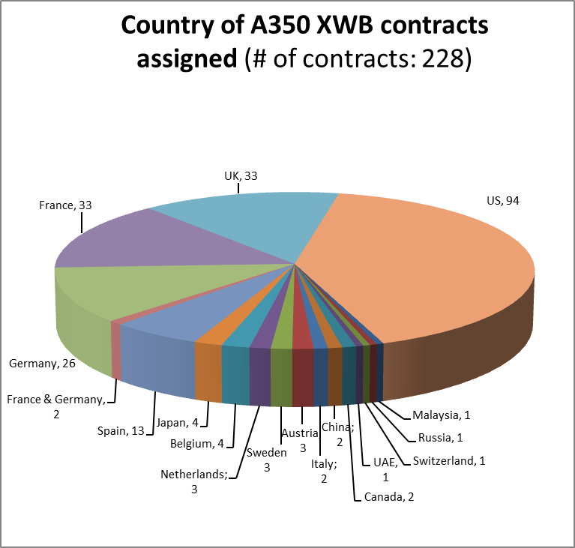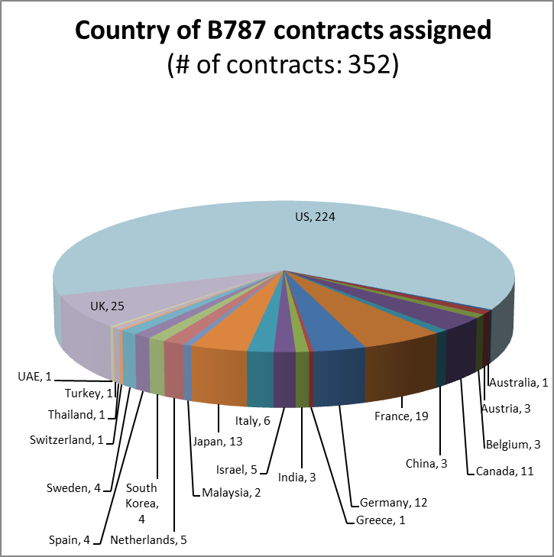
Source: Airframer + author’s collection through company news releases and company web sites
Systems integration orientation and heavy outsourcing of both firms eventually address the degree of the strength of commitment to develop necessary technological and organizational capabilities configured around their business strategies. Cognitive or physical, human skills are the major and indispensable requisites to develop and deploy those capabilities for specific purposes like setting up a product development organization.
B787 and A350 examples show that, in order to sustain their competitive advantage OEMs have to maintain a delicate balance between their in-house and external capabilities. In-house capacity is required to meet technical performance of advanced aerospace products. External capabilities developed by partners are also crucial as they can be superior or unreachable for systems integrators and they have to rely on numerous other technologies developed outside their walls. Moreover they have to possess necessary organizational capabilities to establish a steady flow of information running in and out of the firm to guarantee product development. In some cases, any issue with the flow of information within the boundaries of the firm may also cause problems as the A380 example has shown. These capabilities help them to maintain a full control over innovation through accumulated knowledge, skills, experience and the diffusion of control and authority to minimize related risks. In the systems integration business model as it is expressed in the latest programs of Airbus and Boeing, there is a focused capability development effort in the commercial aircraft production which is extensive in knowledge but selected in application. In effect both firms have been harnessing knowledge dispersed in different domains of technology and patenting them in an accelerated speed in the last three decades. Author’s analysis on patent applications shows that Airbus has been following an energetic strategy to publish more patents than Boeing in the latest years especially in fields important for new aircraft designs.
As it is mentioned above, part of their new product development strategies of Airbus and Boeing includes divestments in specific areas which are not core or low value according to their systems integration business strategy. Both firms divested a significant amount of their assets and related capabilities in 2000s. In the meantime they have been very active in mergers and acquisitions for several reasons including competence development in specific fields. The dual role of divestments and acquisitions is necessary to understand the growth strategies of two firms. While Airbus has been two times more active in acquisitions and divestments in the period between 2000 and 2015, Boeing’s divestments were either through divesture of complete business segments like commercial helicopters or rocket engines or several large commercial aircraft manufacturing units within the US in line with its systems integration objective. The only comparable divestment of Airbus in terms of size and capability loss was its liquidation of UK Filton wing component manufacturing and assemblies unit in 2009.

D.2 ORGANIZATION
In the previous section, strategy was presented as the process of continuous resource allocation within and across the boundaries of the enterprise that are constantly redefined by corporate decision-makers through capital investments, generation of intellectual property, acquisitions, divestments, relocations, restructurings and reorganizations of value chain. However, defining boundaries cannot only be explained with an analysis of corporate resource allocation and knowledge management. In order to execute these efforts, a business enterprise has to reconfigure constantly its organizational structure in terms of its resources inseparably attached to its employees and managers. More precisely, resource allocation and boundary changes cannot be explained independently from organizational dynamics.
A primary action of strategy remaking and boundary redefinition is the effort of a business enterprise to invest in its own organizational capabilities. A firm’s competitiveness depends above all on its innovative capacity and the ability to utilize this capacity within a broader corporate environment. Any effort to extend innovative capacity and to follow different strategies in doing so depends on the success of the people to enable and run the mechanisms of value creation in the form of innovative ideas and resulting products.
Thus, in order to comprehend the functioning of corporate strategy and the sources of organizational and technological change and its social determinants, it is indispensable to understand how firms mobilize their resources and their production workers to transform invested resources into products (Lazonick, 1990). In designing resource allocation the enterprise has to set up a working organization that utilizes the value-creating capabilities of resources to innovate and to generate products (Lazonick, 2012). A shop-floor focus is indispensable for the research on innovation and industrial dynamics.
Organization is the second dimension of the systems integration model presented in this study. The study understands it as the functioning of the productive setting that develops and utilizes the value-creating capabilities of productive resources. However, the integration of capabilities into the production process is not automatic. Within a business enterprise, there is always a division of labor having different functional specialties and hierarchical responsibilities. As a kind of dynamic setting, this division frames the forms of integration and transformation of capabilities and in doing so, it defines the skill base of the firm to be mobilized (Lazonick, 2005). Skill formation and the access to different types of skills are central to the long-term success of a business organization. As important as skill formation and its utilization, is the retention of these skills within a secure organizational structure backed up with unrestrictive career opportunities. The integration of career schemes and current and future incentives are strictly connected to skill development and training opportunities.
Moreover, the engagement of workforce in the development and utilization of productive resources requires the setting to be promoting and interactive in order to create incentives to apply workforce’s skills and efforts. Thus skill development, incentives, remuneration and participation are keys elements of the setting which are also highlighted by productive models approach (Boyer and Freyysenet, 2002).
The setting is also conditioned by employee-employer relations as well as contestations between them in specific situations. In a modern business enterprise, the duties of the workforce to create value and the incentives provided to do so are continuously negotiated by means of different mechanisms depending on organizational and institutional architectures. This aspect is particularly important in manufacturing industries where the workforce engagement and its regulation through negotiations/contestations are still predominantly realized through worker representation (unions) and labor’s participation to decision-making (unions, work councils). In this context, Sako (2006) provides an important perspective on the importance of labor organizations’ role on corporate strategy and structure and vice versa. Focused on organizational boundaries, she shows that such boundaries of corporations and unions emerge as a result of political contestation between management and labor. In effect, the conflicting strategies and structures of labor and management lead to a power play between the two sides which results in a negotiated boundary or a boundary one party imposes on the other (Sako, 2006, p. 24). The formation of workforce representation has important implications over organizational integration and skills development. The forms of representation and its strengths and weaknesses do not only have an impact on the functional and hierarchical division of labor. Depending on the level of influence they impose, such forms are also critical for the long term orientation of the organization and its innovative success as long as they influence over decisions on resource allocation.
Thus, within a business organization, value creation by deploying productive resources is socially constructed and historically shaped. The organization of work of a firm is structured through career schemes and skills development, modes of remuneration, seniority, benefits, and collective representation and participation into decision-making. As a result, in order to comprehend the relation between the development of productive capabilities of Airbus and Boeing and their innovation and technological development efforts, an analysis of the dynamics of work organization is crucial.
Compared to a large number of failed cases of aircraft manufacturing on both sides of the Atlantic including technologically advanced initiatives (Lockheed Martin, Concorde, Fokker and BAC among others), superior performances of Airbus and Boeing resides on their managerial and organizational capabilities that transform their knowledge and skill base into commercial success. Hickie (2006) emphasizes the source of success as the organizational integration of different stakeholders:
Boeing’s capability to enter the jet age with such rapidity and to such competitive effect, was significantly due to the way its research, design and manufacturing activities were managed, and on its focus on relations hip marketing with key customers. Nor was such management simply a matter of formal structures and processes. It was also firmly rooted in tacit knowledge (e.g. when designers appreciate the needs of production engineers) and cultural understandings (e.g. what are reasonably demands to make of a supplier). Similarly the teams involved in Airbus design and manufacture can draw on 35 years of direct collaboration, which have developed relationships of mutual trust and understanding. The strength of the relationships has critically underpinned the Airbus partners’ willingness to move towards a more united decision-making structure.
To develop and build technically advanced aircrafts, a long learning and training period which include on-the-job training, is required for the acquisition of the specific skills and necessary knowledge. Training is strictly connected to the job performed where people with different levels of experience interact. Thus, design, development and manufacturing environment operates largely as a community and designers, engineers and machinists deploy their skills within an integral technical community where competence and expertise are acquired and shared with a steady flow of information (Sorscher, 2002). Moreover, on the shop floor, each airframe assembly requires unique processes and tooling, and workers need a fair amount of time to familiarize themselves with these new techniques (Kronemer and Henneberger, 1993). Learning curves are practical measure of value created by an integrated community. They measure productivity improvements resulting from accumulated knowledge and networks of relationships (Sorscher, 2002).
In terms of organizational integration, learning and skills development are expressed in terms of career paths, seniority, incentives and collective representation. All professions in aerospace and particularly engineering require a long period of development. For an aerospace engineer, it takes up to 20 years to lead an engineering team depending on her permanent access to training at every stage of her career. And employees of a company try to make decisions about their career development with a long term perspective. Knowledge workers need to have unambiguous avenues of professional advancement as a major motivator (Imberman, 2001).
Besides career opportunities, aerospace employees seek for appropriate incentive mechanisms in the form of promotion, remuneration and other benefits. Accordingly compensation structure and policies must be clear and in accord with the professional criteria of their technical community (Imberman, 2001). Aerospace workforce is highly organized all over the world as the industry is well established. These incentive mechanisms have long been the main subjects of contract negotiations and employee participation. Industrial relations within aerospace, and especially within the US aerospace, are a history of contestations and compromises that are integral to broader managerial strategies and corporate decision-making. Employees strongly link these processes to their long term career goals and increasingly to job security. One of the most remarkable similarities between Airbus and Boeing is the emphasis of their workforce on job security. The concerns over it appear in every type of aerospace profession and every region they operate. With the rise of outsourcing as a corporate strategy (especially with more design and development outsourcing), job security has become the main topic of contract negotiations and other communication. However, the differences between the mechanisms of collective representation and employee participation on two sides of the Atlantic result in different forms of resolutions in employee-employer relationships.
Maintaining a sufficient number of qualified employees in technical positions is one of the industry’s chief challenges. Recurring layoffs are not desired due to skill loss as well as the considerable investment on training (Kronemer and Henneberger, 1993). Voluntary quit rates are also low compared to other industries (Kleiner et al., 2002). Average length of service in aerospace industry is substantially higher than other manufacturing industries (BLS, 2000). While the average length of service of Airbus employees is 13.5 years in 2013, the figure for Boeing Puget Sound employees is 16.
In recent years, one of the most important concerns of the industry is the aging workforce in aerospace and defense sectors (AIA, 2011; Sorscher, 2011; Yudken, 2010). The average age of Boeing workers is 48, compared with 43 at Airbus. About 28% of Boeing’s current employees are 55 or older, and hence eligible to retire, and that proportion is rising rapidly (Burreson, 2013). In the presence of globalization of production, ongoing technological change and the longer term possibility of a large-plane entrant from Asia, a key question is the extent to which Boeing and Airbus are investing in the long-term career of their younger employees that will be required for global leadership over the next generation.
Thus, aircraft manufacturing is a long-term proposition. Through long-term investments in education and training with major emphasis on math and science, the aerospace industry has to have constant access to a scientifically and technologically trained workforce (US Aerospace Comm., 2002). The wealth primarily comes from skills retention, employment and career opportunities (Pierson, 1991). Manufacturers’ reaction to short-term cycles through layoffs and divestments as well as postponing and cancelling new projects hamper innovative capabilities of firms in the long run (Kronemer and Henneberger, 1993).
Boeing’s work organization
Boeing has been historically known as a paternalistic firm with structured internal promotion. Most of the company’s management was composed of Boeing’s professional engineers who ‘regard themselves more as members of a learned society than as mere employees of a corporation’ (Imberman, 2001). In the periods before and after the WWII, seniority issues were important elements of employment relationships that are marked with a strong presence of union membership to protect rights and benefits of the workforce and negotiate over them at each contract. Unionization at Boeing dates back to mid-1930s when the Wagner Act guaranteed the US workforce the right to organize in unions and to engage in collective bargaining. Right after the war, engineers and other professionals also formed their unions with similar aims to machinists and other assembly workers.
Engineering mindset was also decisive on most top management decision-making at Boeing. ‘Scientific’ decisions based on factual analysis were imposed on factory floor that all employees should logically follow orders based on the ‘truths’ formulated by senior management (Imberman, 2001). Such strict command thinking was also a result of its close relationship with the DoD (Newhouse, 2007).
At Boeing contract talks with unions have always been very important to set main topics of discussion between management and labor and negotiate various issues around these topics. These negotiations are especially critical considering the prevalent problems of communication between management and employees (Imberman, 2001) and they go beyond the traditional topics of wages and benefits and involve in corporate strategies including outsourcing and productivity measures. They provide the consent of the workforce for new work and management practices to increase productivity as well as the decisions on externalization imposed by the company management.
Related to the tense relationship between management and labor, however, contract talks are always prone to disagreements during negotiations which often result in strikes. The history of workforce unionizing at Boeing is also decorated with a series of strikes and other major conflicts with management. These conflicts, in effect, give important insights to understand the tense relation between corporate strategies and organizational integration as well as the changing dynamics of company and nation level power relations. Workforce conflicts at Boeing have a long history with multiple reasons expressed themselves during the periods of new contract negotiations.
Prior to 1980s, major topics in contract negotiations as well as the sources of conflict were remuneration of employees and seniority (Fridie, 1961). In the following period, the company progressively offered more flexible pay schemes consisting bonuses and profit sharing that may change according to manufacturing up and downturns. The management believed that such schemes would also minimize layoffs. In addition, bonuses cost less than increases in base wages, because they do not count toward sick pay, overtime, vacation pay and pension benefits. Such payments were especially popular among young employees who are more interested in immediate cash than pensions or sick pay. Later in the late 1980s, however, unions wanted Boeing to abandon bonus system as the company tied it to productivity improvements and more importantly to profitability.
On the contrary, Boeing extended its non-fixed payment schemes including share-based compensation plans to a broader group of employees in the 1990s with an aim “to link their interests and efforts to the long-term interests of the Company's shareholders” (Boeing 10-K, 1993). In 1996, the company also established a 12-year trust called ShareValue Trust that was ‘designed to allow substantially all employees to share in the results of increasing shareholder value over the long term’ (Boeing 10-K, 1996). The aim was to distribute every four years a certain amount of stock depending on the level of average annual stock return. Interestingly, workers’ representatives expressed their content that they also became eligible to receive stocks as a form of compensation like executives. Compared to less complex compensation schemes at Airbus introduced after its IPO in 2000, in the period after 1990, Boeing introduced multiple forms of compensation for employees and executives with specific conditions of eligibility.
Pensions for Boeing workers have also become in time a hot topic of discussion between the management and labor. Thanks to perpetual layoffs of younger employees Boeing had and still has a rapidly aging workforce and employees became more and more concerned about their post-employment earnings which remained pretty much the same in terms of real value since late 1980s. Progressively employee-funded pensions and health care benefits have become major sources of conflict in the last two decades and resulted in several strikes after the failure of contract talks in 2000s. However the most striking conflicts between the management and labor around pension schemes erupted in 2013. First in early 2013, after a long contract negotiation period, Boeing engineers and technical workers finally accepted Boeing’s offer which eliminated defined-benefit pension plans for new hires, leaving them only with a 401(k) plan. In effect, Boeing wanted to join already entrenched trend away from defined plans towards 401(k) plans over the last decades. The claim was to reduce its already underfunded pension liability and increase corporate performance in terms of earnings-per-share. The second and the biggest dispute occurred at the end of the same year when Boeing’s commercial aircraft production workers who are also members of the International Association of Machinists voted down a new contract proposal that would have guaranteed the 777X be built in the Seattle region but would freeze the pension program, raise the cost of health care and create an adjusted wage scale for new hires. In the first days of 2014, however, after Boeing’s initiative to search for a new place to produce the new aircraft outside Washington, the members of the union approved the contract with a 51% in favor of the agreement which freeze pension contributions in 2016 and shift to a 401(k) plan with defined employer contributions instead of their previous program of fixed benefit payments.
Since the early 1990s, Boeing tried to imply lean manufacturing practices and continuous work flow in order to boost productivity, to reduce inventories, to reduce delivery times (order to delivery) as an aim to free cash flow. Workforce cooperated with management as long as improved productivity brought them more secure jobs and better remuneration. However, the cyclical nature of the commercial aircraft business, continuous and rapid layoffs of employees during downturns and rising outsourcing (another issue emerged as a hot topic of discussion in the 1990s and 2000s) made it hard to estimate the long-term real impact of productivity increases and sharing of its benefits. Communication between the management and workforce remained limited contrary to terms specified in contracts.
Having lack of established means to maintain steady flow of information and two-way communication channels that the company management can listen and respond to the needs and suggestions of the workforce (Imberman, 2001), the company has been faced with numerous workplace conflicts accelerated especially during its systems integration period. Their impact on productive and financial performance led Boeing to introduce new methods to solve them like relocation of work (relocation of 787 assemble line in South Carolina, a non-union state) or bidding employment benefits to decisions on plant location (keeping 777X final assembly in Washington, in exchange of change in pension plans). Such actions show that employment relations continue to remain a hot topic for Boeing. During the period Boeing’s relations with its Canadian and Australian workers has also been tense.
Lastly, together with massive layoffs intensified during the period after 1990, job security became a very important concern for Boeing’s workforce. Organized labor started to seek explicit job-protection measures without success. Since the early 1980s, Boeing laid off thousands of workers each year without rehiring incentive in general. Based on author’s calculations through the collection of executed – not announced – layoffs excluding reduction in workforce due to divestments of Boeing since 1981, the company laid off a total of more than 116000 employees, a number close to three quarters of its 2015 workforce. As a comparison, Airbus’ forced layoffs since its establishment as a standalone public company in 1999, is zero. In effect, in the case of Boeing the federal and state governments helped Boeing to ease its layoffs in the early 1990s (Mueller et al., 1998) as well as during other massive layoffs in 2000s through different mechanisms always funded with taxpayer’s money.
Airbus’ work organization
Compared to Boeing, Airbus’ workforce represents a nonhomogeneous and less unified structure mainly due to differences in the historical development of industrial relations in countries where Airbus operates. In each country, labor force is represented by several distinct unions and issues of collective bargaining may vary considerably depending on national conditions and institutional factors. For Airbus, it is a big challenge to harmonize internal employment policies and related procedures due to differing frameworks between countries.
National diversification is not only a difficulty for employment relations. Selection of executives including CEO has always been a hot topic. In elections, national governments as major shareholders were also involved with strict perspectives regarding choices. Many issues related to employment relations have been politically characterized.
Different to Boeing, collective agreement talks with employees are more formal and less prone to escalated conflicts and still represent national differences. A vibrant topic of latest collective agreements in each country is working time arrangements. Since its establishment as a standalone corporation in 1999, Airbus utilized flexible employment practices regardless of the country of operation. Beside changing working hours of full-time workers depending on rising and falling workload, the company also promoted part-time and temporary work schemes and extensive utilization of contract work at company sites as part of productivity measures. Such measures also helped the company to avoid redundancies during downturns in the last fifteen years. Airbus has been a direct beneficiary of rising flexible but increasingly precarious work schemes in Europe and specifically in Germany (Laffitte, 2008).
One important mechanism to maintain communications is European Work Council that was established in 2000 after the incorporation of Airbus. Comprised of representatives of employees and management, the committee operates under a signed agreement to inform and consult representatives on the prospects of the company and general business conditions. However, the success of the Council in maintaining a dialogue in a proactive and coordinated manner is questionable. Despite early efforts of the Council to convey the message on the details of Power 8 restructuring program, between 2007 and 2008 Airbus workers set various strikes and work stoppages in France and Germany to protest the program and the plans for job cuts and plant closures. Concerns over job security are also growing among Airbus workers. For example, IG Metall from Germany, the strongest labor union of Airbus, continuously tries to include clauses over job security and flexible practices during negotiations over collective agreement. Job insecurity is one strikingly similar issue for Airbus and Boeing employees in comparison to major differences in other areas of industrial relations.

D.3 FINANCE
The third element is the extent of financial commitment in the systems integration model. For the sake of the integrity of the model, a comparison can only be completed if we identify the similarities and differences in the degree of financial commitment required for innovation and capability development, and the pursuit of financial objectives that may support or undermine them. Several studies have so far tried to approach the relationship between corporate finance, business strategy and workplace organization/work system through one or two dimensional perspectives exploring the impact of one aspect on another. A complete business model analysis should include all three dimensions as multiple interdependent variables. The aim of the study is to make an elementary contribution to this debate through an empirical exploration of these issues in commercial aircraft manufacturing. From a market perspective, in this case, business strategies should be understood as firm location in product markets, firm location in capital markets (Froud et al., 2006) and firm location in labor markets. Due to the firm connections among these three dimensions and their dynamic nature, they are interdependent rather than one is dependent on other or only one among them is independent.
To sustain the development of necessary technologies for superior products and the subsequent production process require high-cost investments of each type. Any business undertaking necessitates finance to keep itself afloat during the investment period until the time at which financial returns are generated through the sale of products (Lazonick, 2012). Managers of a company who control over the allocation of corporate resources have to guarantee the steady inflow of financial resources. These resources may either be generated through internal cash accumulated through the returns of previous investments or bond and stock issues with favorable terms which also reflect previous achievements considering productivity and innovation. In addition, companies can also share some part of their product development and subsequent costs with their existing or potential partners; they may receive progress payments from their customers; or they may resort to governments for any form of subsidy to fund their productive efforts. Financial commitment of corporate decision-makers and other stakeholders including governments is rather a condition than a proposition. It is the set of relations that ensures the allocation of funds to sustain innovation (Lazonick, 2013) and its level of significance is directly proportional to the magnitude of the investments in innovation bearing high uncertainty. The degree of commitment to different sources of finance may eventually condition the depth and the length of innovative efforts.
Thus, for a large corporation of global capitalism like Airbus or Boeing, the decisions on new product development and accompanying efforts over innovation process and productive reorganization do not just depend on the magnitude of internal and external funds and the control over them but also on the choices of decision-makers to retain and distribute corporate resources created. The reconfiguration of these choices has had direct implications for the production processes and related business strategies of manufacturing industries all over the world. Corporate decisions on cost-cutting and organizational restructuring have become integral to maximizing shareholder value as the ultimate aim of late 20th, early 21st century capitalism. Therefore, in order to understand strategic orientation towards systems integration of Airbus and Boeing from the perspective of the association of financial commitment and strategic control, it is necessary to interpret the repercussions of shareholder value ideology on commercial aircraft industry and the impact of financialization as a bundle of structural changes in the functioning of finance for the economies and their actors.
In the commercial aircraft manufacturing, financial commitment is primarily about providing substantial amount of funds necessary to develop a new aircraft model which starts with preliminary conceptual design stage and may last until the point where unit costs of each aircraft become low enough for the profitability of the program. For companies large enough to be profitable in a sustained way like Airbus and Boeing, the primary source of finance is the retained earnings which are being generated through existing profitable programs. However, none of the companies have so far financed a new program only through their internal sources. Since the early ages of aviation, government support has been the most important source of funding R&D and other expenses of new aircraft development. For every new or derivative program both companies continue to receive substantial amounts of direct or indirect funding in multiple forms. The funding can range from several millions to several billions of US dollars (Sakinc, 2014). Another major source of funding is the investment of suppliers to the development through worksharing programs. For example, Japanese and Italian aerospace firms have invested substantial amounts in Boeing 787 as they were responsible for the detailed design and development of the sections they currently produce for Boeing. Similarly the increasing workshare of suppliers in A350 also included early development and required investments.
Two main variables showing the degree of financial commitment for new product development of Airbus and Boeing are their capital expenditures and R&D expenses.
In the commercial aircraft sector, R&D expenditures and capital investments rapidly increase with a new program and then gradually decrease close to its completion. The extent of the program in terms of its technological sophistication, infrastructural requirements and the participation of program partners to development costs specify the size of expenditures for the parent firm. Figure 2 shows commercial segment and total R&D expenditures of Boeing and Airbus and their proportions to commercial and total sales in the last two decades. The monetary amount of resources allocated by OEMs and their partners substantially increased in line with the increase in technological complexity and tightening regulations required to produce safer and higher quality aircrafts. After a swift decline at the end of the development of 777, R&D expenditures of Boeing have risen once again along the B787 R&D program which cost Boeing a minimum of $12 billion despite early plans to spend as less as $5.8 billion to develop the airplane mostly due to missteps of the company (Gates, 2011). After a steep increase during the development of 787, total and commercial segment R&D expenditures of Boeing decreased quickly after 2011. On the contrary, R&D expenditures of Airbus were mostly stable or only slightly increased but usually higher than Boeing’s during the years the company developed its wide-body airplanes, A380 and A350.
Figure 2a: Research and Development Expenditures of Boeing (1994-2014) and Airbus (1999-2014) in the commercial aircraft segment as a proportion to commercial aircraft sales
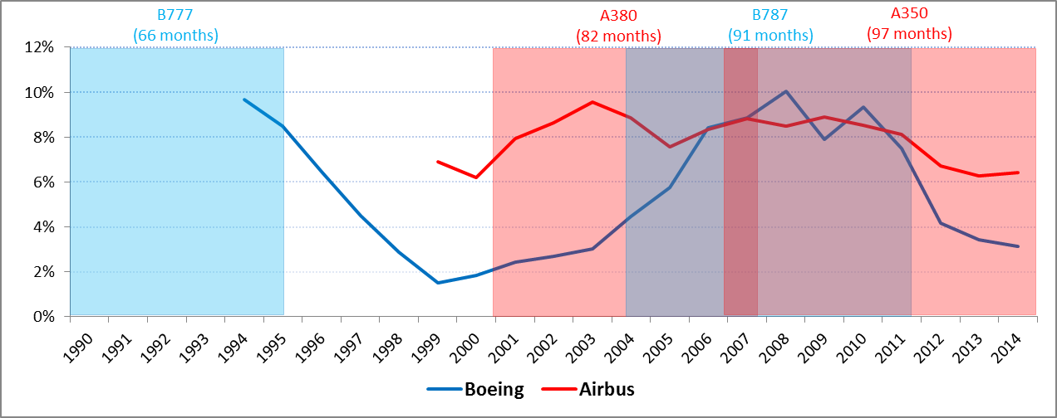

Figure 2b: Total Research and Development Expenditures of Boeing (1980-2014) and Airbus (1999-2014) as a proportion to total sales
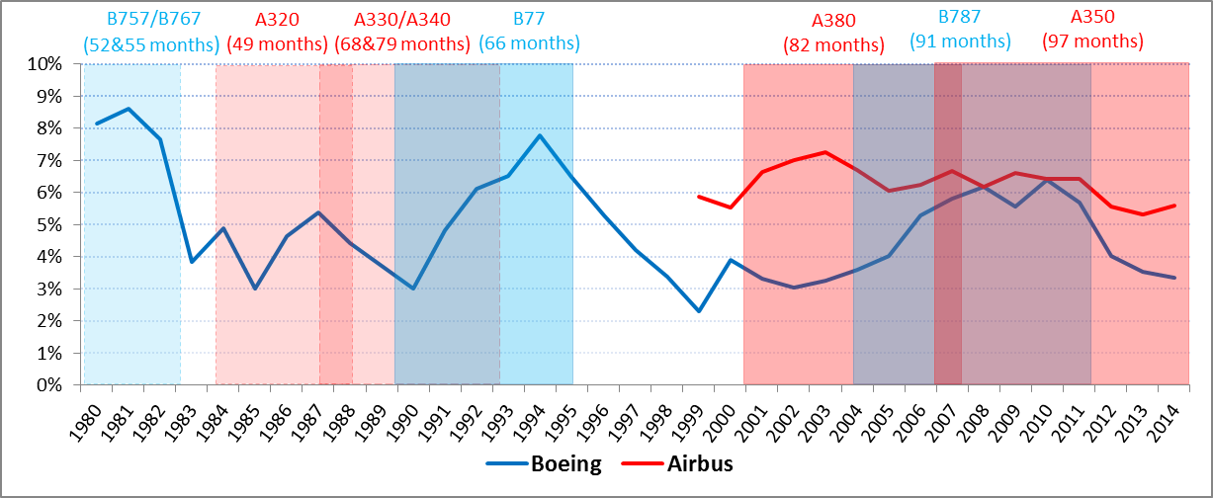
Source: Company annual reports, Months in parenthesis indicate the length of the development period represented with red and blue columns starting with the launch of the program until the delivery of the first aircraft.
Aerospace companies have to mobilize substantial amounts of financial resources also for their spending on new machinery, tooling and new assembly lines or manufacturing plants. Details on the expenditures on new production sites, engineering centers, assembly lines and advanced machinery provide valuable information on growth strategies regarding the projected market share and value-added amounts, and the extent of desired capabilities in specific fields of aircraft manufacturing. The degree of financial commitment is tightly connected to the allocation of funds for material utilization through the links between investment strategies and long-term commitment to innovation. Through new sites, centers and production lines, an OEM demonstrates its commitment to both product and process innovation and learning capacity of its workforce which, after required training, will utilize its productive capabilities with advanced machinery, tools and techniques.
In detail, we observe a setback in in Boeing’s capital expenditures and a decline in real terms since late 1990s. Compared to Boeing, Airbus’ investment on new machinery and equipment is remarkable. Between 2000 and 2014, Airbus increased its investment on new technical equipment and machinery fivefold in current terms compared to around 25% increase of Boeing during the same period. The spending of Boeing on land and new buildings also remained very low compared to Airbus. Boeing’s floor space data shows that since 2000, the company shrank close to 30% in terms of physical space through divestments and closure of production sites. The access of Boeing to NASA and Department of Defense facilities and equipment through its research and development contracts may also explain the reason of low level investment. Another explanation offered was lower level of investments of Boeing into new generation of tools and equipment which Airbus was heavily investing in the late 1990s and early 2000s for its new programs (MacPherson and Pritchard, 2003). In addition, in its latest program Airbus’ investment in new technologies exceeded Boeing’s similar investments as the extent of outsourcing parts utilizing composite technology, new materials and electronics is much higher in the case of Boeing compared to Airbus.
If we go deeper in detail, we see a widening gap between the investments done by Airbus and Boeing since late 1990s. Airbus’ investments are much greater in monetary values and represent broad-scale facilities as first time investments including new final assembly lines (Figure 3). Moreover Airbus’ investments are geographically more diverse both for commercial aircraft and other segments. Out of 33 major capital investments since 2000, the biggest number of investments was on commercial aircraft divisions (18) while Eurocopter (today Airbus Helicopters) had seven major investments and more than half of them were out of Airbus home countries. During the period, the company opened eight technology centers with six out of Europe. All of these investments are active as of 2015. During the same period capital investments of Boeing remained limited especially in the first half of 2000s and the company divested several of its new investments in the same period. Only beginning with 2010s, the company made several important investments including those for 787. It opened several research and technology centers within or outside the US in line with the restructuring of its research organization, with important employment implications. Another difference with Airbus, Boeing mainly resort to expansions of existing sites while Airbus opens up completely new sites thanks to its superior geographical and segmental expansion.
Figure 3: Capital Expenditures of Boeing and Airbus in the commercial aircraft segment as proportion to commercial aircraft sales
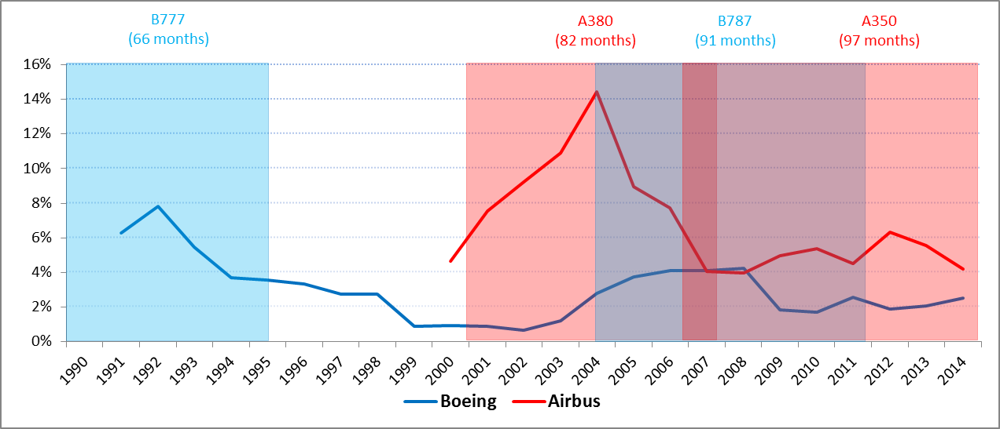
Source: Company annual reports. Unallocated capital expenditures, which are substantially higher in the case of Boeing, are distributed to each segment according to their relative weight as a proportion to total allocated capital expenditures
If the ultimate aim of a firm and its business model is to create value with all those investments and if value creation became subordinated to shareholder value creation in the financialized economy, the value created has to be extracted from stakeholders to direct it to shareholders. As stated above, two main forms of distribution are dividends and share repurchases. Especially in the United States, share repurchases became ‘systemic and massive’ in the last 20 years and together with dividends they reached around 80% of net income on average among large US corporations (Lazonick, 2013). They were also intensified in Europe after regulatory changes in late 1990s and early 2000s among large European corporations (Sakinc, 2012). However the extent of stock buybacks in Europe is still limited compared to the US. Main form of shareholder value distribution in Europe is common and preferred dividend payments. European companies distribute equal amounts with US counterparts on average when share repurchases and dividends are added together (Figure 4).
Figure 4a: Mean Share Repurchases of US S&P500 (399) and European S&P350 (302) companies
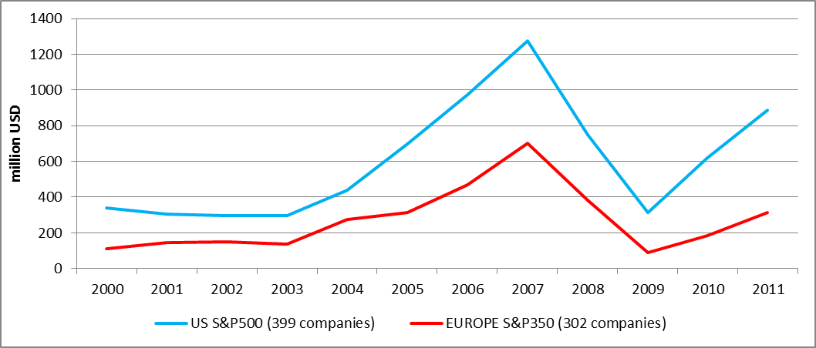

Figure 4b: Mean Dividends of US S&P500 (399) and European S&P350 (302) companies
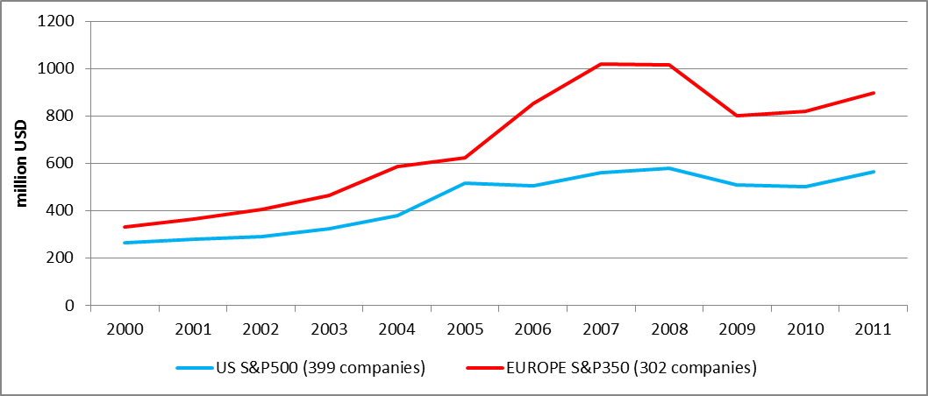

Figure 4c: Mean Dividends + Share Repurchases of US S&P500 (399) and European S&P350 (302) companies
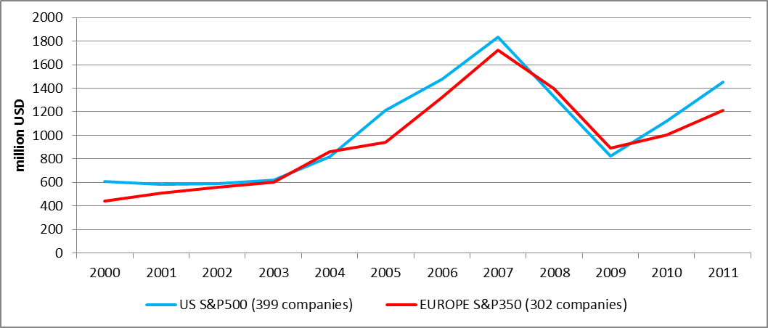
Source: Compustat and CapitalIQ databases and company annual reports
As a representative of financialized US corporations, in the last 15 years Boeing has also distributed large sums of cash through in the form of share repurchases and dividends while Airbus’ distribution remained modest at least until 2013. As a proportion of cumulative earnings in the period between 2000 and 2014 Boeing distributed 95 percent of its earnings while this ratio is 66 percent for Airbus mostly due to its not-so-unusual negative income figures in some years during the same period. In the case of Boeing, we observe three periods of mass repurchases interrupted with two periods of industry level and economy-wide economic crises while dividend payments and dividends per share amounts were gradually increased since the late 1980s (Figure 5).
On the contrary Airbus’ shareholder value distribution does not follow any specific trend except the gradual increase in its dividend payments in the last five years. Since its IPO in 2000, the company distributed limited amounts of cash in the form of dividends and share repurchases. In the case of share repurchases, up to year 2013, the total amount spent on stock buybacks remained under the amount obtained through capital increases and option and warrant exercises. Only in 2013, next to the shakeout in share ownership through the exit of strategic shareholders Daimler AG and Lagardère SCA and a small reduction in state ownership, the company administered a large share repurchase program and spent more than $2.6 billion. Same year an Airbus executive, for the first time in the history of the company, defined the creation of shareholder value as the center of company’s strategy. However, despite its existing program to repurchase up to 10% of shares, Airbus has not performed any share repurchase in the rest of 2013 and 2014. However, it has plans to execute a share repurchase program in 2015.
Figure 5a: Total Payout of Boeing and Airbus (dividends + share repurchases), current prices
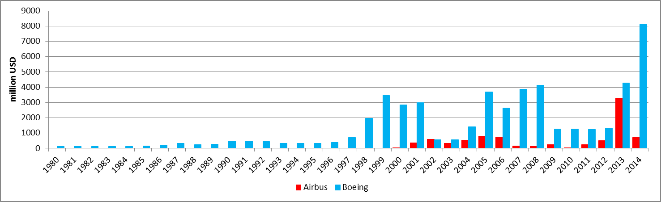
Figure 5b: Dividend payments of Airbus and Boeing, current prices
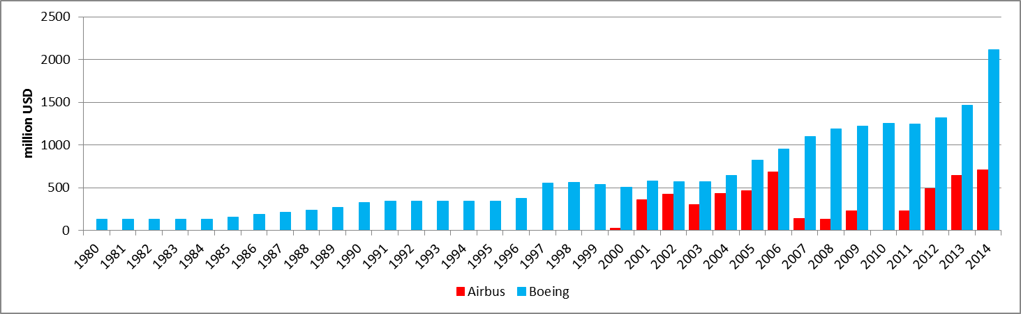
Figure 5c: Share repurchases of Airbus and Boeing, current prices
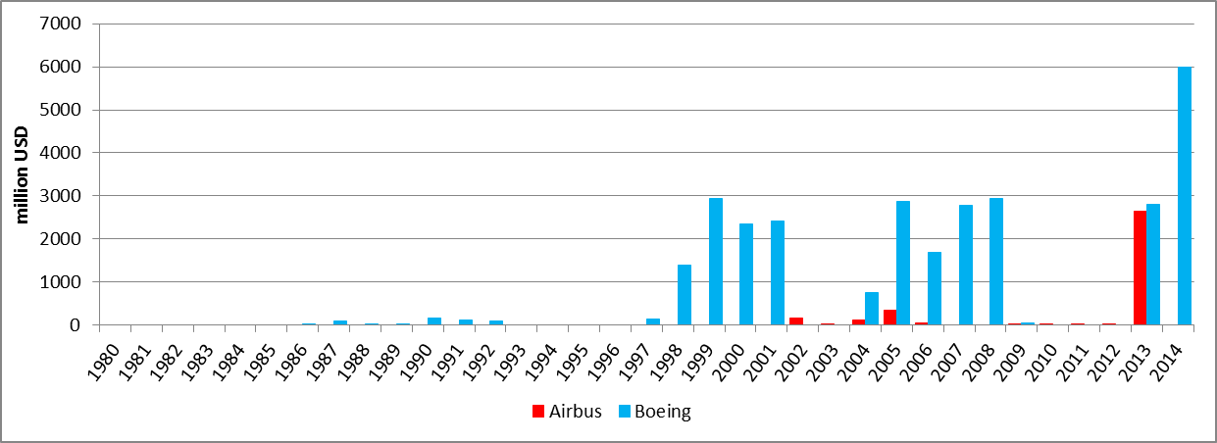
Source: Company annual reports
One major argument proposed by corporations to perform stock buybacks is to offset the dilution from exercising stock options which are disproportionately granted to top executives as a form of compensation and conditioned to financial performance of the firm. Because so much of executive compensation comes from stock options, top executives have a strong incentive to take steps to increase their company’s stock price, and stock buybacks provide an easy tool to do so (Batt and Appelbaum, 2013). High stock prices inflated mostly through unrealistic expectations created by company managers and circulated by financial advisors motivate executives to exercise options and sell their stock at these higher prices while they also administer big stock buyback programs. Thus there is an inherent relation between stock options and stock buybacks. Consequently expenditures on research and development and long-term investments were negatively affected by stock options share repurchases due to the lower funds available (Bhargava, 2013). The relation between stock options and stock buybacks is also reflected in the difference between American and European corporations. According to an estimate comparing executive compensation in major corporations of the two sides of the Atlantic in the first half of 2000s, a top European executive holds options worth €1.3 million while the amount of options a US executive holds worth €18 million. Income of a top European executive rises around €85,000 as a result of a one percent increase in company stock price versus €2.2 million for a US executive (Muslu, 2010).
In the case of commercial aircraft manufacturing, for Boeing the total number of stocks options and other stock awards granted to executives and other high-ranking employees equals to around 1.1 percent of total number of outstanding shares on average since 2000 (Figure 6). For the same period Airbus distributed such awards equal to around 0.64 percent on average of its total outstanding shares. The ratio between Airbus and Boeing for the awards granted to CEOs is also similar to the ratio between total granting (0.036 percent to 0.020 percent). However, exercise of stock options by Boeing executives is quite regular while Airbus executives have exercised their options only during the period of 2005 and 2006, and the rest of the years since 2000 (except an exercise of 13500 stock options by Airbus CEO in 2010) none of the top executives utilized their stock awards as a form of remuneration. Only in 2006, ex-CEO of EADS, Noël Forgeard exercised close to 300,000 options together with several other executives and sold the shares before news of Airbus A380 delays was released. They were accused of insider trading but the case is still open as it turned into a constitutional debate because of the juridical disagreements in France.
Figure 6: Proportion of stock options/awards granted to CEOs (A) and all high-ranking employees (B) to total shares outstanding of Boeing and Airbus
A B
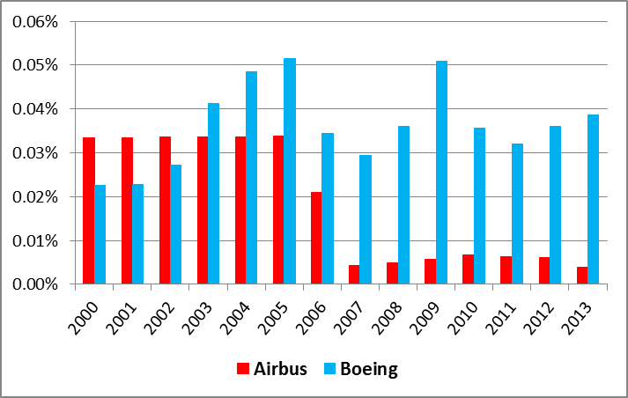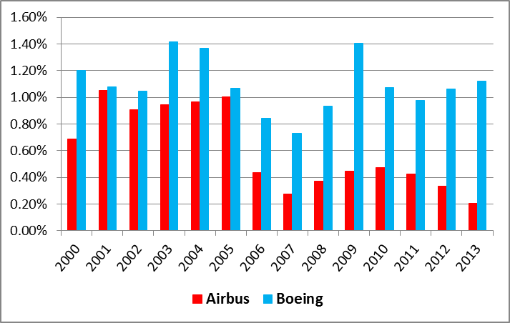
Source: Company annual reports and proxy statements

CONCLUSION
Proposed as a key element of the reorganization of value stream, systems integration deserves to be analyzed in the context of manufacturing and commercial activity in transformation. However, a narrow articulation which limits the analysis of systems integration to its investigation as a new capacity/capability may hinder us to see the broader picture of business strategy reorientation in technology intensive industries and its relation to the other two aspects of a production organization; capital (finance) and labor (organization). Without any role attributed to new orientations in finance and work organization/industrial relations in executing these so-called systems integration strategies, the identification of distinct constructive and destructive processes of any integration/disintegration strategy remains impossible.
The results of this research show that there is a strong correlation between extensive outsourcing, financialization of business strategies and conflicting employment relations. Outsourced more than 70% of its latest innovation program B787 and aimed to keep capital expenditures and R&D costs under control, Boeing has been exerting pressure on its employees through recurring layoffs, relocation and cuts in employment and post-employment benefits. Job security has become the most important concern of the workforce and the reorganization of new product development extends tensions between the management and workforce. While the company aims to reduce spending through outsourcing and tightening labor practices, it has also extended its shareholder value orientation through dividends and stock buybacks and stock options granted to executives and other high-ranking employees as means of value extraction. Financialization has deep roots in the company. Compared to Boeing, Airbus has followed a balanced strategy, mitigating conflicting interests up until the present day. Despite it outsourced 50% of its latest aircraft program A350 and divested several business units as part of cost-cutting programs, the tension with the workforce and massive distribution of shareholder value so far remained under control. However, its most recent discourse and practices provides some evidence that a more financialized business strategy is on the way. The concerns of the workforce over job security are also on the rise.
Evidence detailed throughout the study suggests that systems integration business model à la Boeing and à la Airbus is no use to their long term competitive capabilities and none of the companies is immune to the perils of financialization and deteriorating employment practices. The long-term durability of the model is inherently uncertain as long as it is not based on governance compromises which are set between different stakeholders. This is especially marked in the case of Boeing. However, as long as the imperatives of shareholder value ideology continues to spread over Europe, there are signs for extending convergence especially in the case of financial inclinations and resulting consequences over their productive capabilities which also make the future of manufacturing of the Western economies gloomier than ever.

- REFERENCES CITED
Acha V., Brusoni S., Prencipe A. [2007] “Exploring the miracle: strategy and management knowledge of the knowledge base in the aeronautics industry”, International Journal of Innovation and Technology Management, vol.4, n°1, pp.15-39.
Acha V., Brusoni, S. [2008] “The changing governance of knowledge in avionics”, Economics of Innovation and New Technology, vol.17, n°1-2, pp.43-57.
AIA [2011] “Human Capital Management”, Aerospace Industries Association, December.
Batt R.L., Appelbaum E. [2013] “The Impact of Financialization on Management and Employment Outcomes”, Upjohn Institute Working Papers, 13-191.
Bhargava A. [2013] “Executive compensation, share repurchases and investment expenditures: econometric evidence from US firms”, Review of Quantitative Finance and Accounting, vol.40, n°3, pp.403-422.
Best M. H. [2003] “The Geography of Systems Integration” in Prencipe A., Davies A. and Hobday M. eds, The Business of Systems Integration, Oxford: Oxford University Press, pp.201-228.
Boyer R., Freyssenet, M. [2002] “Globalization but Still a Large Diversity of Productive Models and Corporate Governance Styles” Seoul Journal of Economics, vol.15, n°2, pp.149-191.
Brusoni S., Prencipe A., Pavitt K. [2001] “Knowledge specialization and the boundaries of the firm: why do firms know more than they make?”, Administrative Science Quarterly, vol.46, n°4, pp.597-621.
Brusoni S., Prencipe A. [2001] “Unpacking the Black Box of Modularity: Technologies, Products and Organisations”, Industrial and Corporate Change, vol.10, n°1, pp.179-205.
Burreson M. [2013] “Boeing Workforce Development and Training”, Boeing Commercial Airplanes, July.
Chandler A. [1992] “Organizational Capabilities and the Economic History of the Industrial Enterprise”, The Journal of Economic Perspectives, vol.6, n°3, pp.79-100.
Chandler A.J. [1993] “Organizational Capabilities and Industrial Restructuring: A Historical Analysis”, Journal of Comparative Economics, vol.17, pp.309-337.
Chesbrough H. W., Rosenbloom R. S. [2002] “The role of the business model in capturing value from innovation: Evidence from Xerox Corporation’s technology spinoff companies”, Industrial and Corporate Change, vol.11, n°3, pp.529-555.
Davies A. [2003] “Integrated Solutions: The Changing Business of Systems Integration” in Prencipe A., Davies A. and Hobday M. eds, The Business of Systems Integration, Oxford: Oxford University Press, pp.333-368.
Dibiaggio L., Nasiriyar M. [2009] “Knowledge integration and vertical specialisation in the semiconductor industry”. European Management Review, vol.6, n°4, pp.265-276.
Dosi G., Hobday M., Marengo L., Prencipe A. [2003] “The Economics of Systems Integration: Towards an Evolutionary Interpretation” in Prencipe A., Davies A. and Hobday M. eds, The Business of Systems Integration, Oxford: Oxford University Press, pp.95-113.
EMR [2009] “EMR Special Issue on Strategic Dynamics in Industry Architectures: The challenges of Knowledge Integration”, European Management Review, vol.6, n°4, pp.209-277.
Forsberg D. [2012] “Aircraft Retirement Trends & Outlook”, Avolon.
Fridie W. [1961] “Wage chronology No. 40: The Boeing Co. Washington plants, 1936-61”, Monthly Labor Review, vol.84, n°4, pp.754-764.
Froud J., Johal S., Leaver A., Williams K. [2006] Financialization and Strategy Narrative and Numbers, London: Routledge.
Gholz E. [2003] “Systems Integration in the US Defence Industry: Who Does It and Why Is It Important?” in Prencipe A., Davies A. and Hobday M. eds, The Business of Systems Integration, Oxford: Oxford University Press, pp.279-306.
Granstrand O., Patel P., Pavitt, K. [1997] “Multitechnology corporations: Why they have ‘distributed’ rather than ‘distinctive core’ capabilities”, California Management Review, vol.39, n°4, pp.8-25.
Haslam C., Andersson T., Tsitsianis N., Yin Y.P. [2012] “Business Models Redefined: Strategy in a Financialized World”, paper submitted to the British Academy of Management Conference.
Hickie D. [2006] “Knowledge and Competitiveness in the Aerospace Industry: The Cases of Toulouse, Seattle and North-west England”, European Planning Studies, vol.14, n°5, pp.697-716.
Hobday M., Davies A., Prencipe A. [2005] “Systems integration: a core capability of the modern corporation”, Industrial and Corporate Change, vol.14, n°6, pp.1109-1143.
Imberman, W. [2001] “Why Engineers Strike- The Boeing Story”, Business Horizons, November-December, pp.35-44.
Johnson S. B. [1997] “Three Approaches to Big Technology: Operations Research, Systems Engineering, and Project Management” Technology and Culture, vol.38, n°4, pp.891-919.
Johnson S. B. [2003] “Systems Integration and the Social Solution of Technical Problems in Complex Systems” in Prencipe A., Davies A. and Hobday M. eds, The Business of Systems Integration, Oxford: Oxford University Press, pp.35-55.
Jones W. D. Jr. [1990] Arming the Eagle: A History of US Weapons Acquisition Since 1775. Fort Belvoir, VA: Defense Systems Management College Press.
Kleiner M.M., Leonard J.S., Pilarski A.M. [2002] “How Industrial Relations Affects Plant Performance: The Case of Commercial Aircraft Manufacturing”, Industrial and Labor Relations Review, vol.55, n°2, pp.195-218.
Kronemer A., Henneberger J.E. [1993] “Productivity in aircraft manufacturing”, Monthly Labor Review, June, pp.24-33.
Laffitte [2008] “Airbus: Français Et Allemands Prêts à S’étriper”, Bakchich, July 5.
Lazonick W. [1990] Competitive Advantage on the Shop Floor, Boston: Harvard University Press.
Lazonick W. [2005] “The Innovative Firm”, in Fagerberg J., Mowery D., Nelson, R. eds., The Oxford Handbook of Innovation, Oxford: Oxford University Press, pp.29-55.
Lazonick W. [2007] “Varieties of Capitalism and Innovative Enterprise”, Comparative Social Research, vol.24, pp.21-69.
Lazonick W. [2012] “The Innovative Enterprise and the Developmental State: Toward an Economics of “Organizational Success”” paper prepared for the annual conference of the Institute for New Economic Thinking, Breton Woods, NH, April 8- 11, 2011, and revised for the conference on Finance, Business Models, and Sustainable Prosperity, Ford Foundation, New York, NY, December 6-7, 2012.
Lazonick W. [2013] “The Theory of Innovative Enterprise: A Foundation of Economic Analysis” AIR Working Paper Series #13-02/01.
Lecocq X., Demil B., Warnier V. [2006] “Le business model, un outil d’analyse stratégique”, L’Expansion Management Review, n°123, pp.96-109.
Lung Y. [2008] “Modèles de firme et formes du capitalisme: Penser la diversité comme agenda de recherche pour la TR” Revue de la regulation, n°43: pp.1-23.
MacPherson A., Pritchard D. [2003] “The international decentralisation of US commercial aircraft production: implications for US employment and trade”, Futures, vol.35, pp.221-238.
MacPherson A., Pritchard D. [2007] “Boeing’s Diffusion of Commercial Aircraft Technology to Japan: Surrendering the U.S. Industry for Foreign Financial Support”, Journal of Labor Research, vol.28, pp.552-566.
Magretta J. [2002] “Why Business Models Matter”, Harvard Business Review, May, 86-92.
Mahadevan B. [2000] “Business models for Internet-based e-commerce: An anatomy”, California Management Review, vol.42, n°4, pp.55-69.
McGuire S. [2007] “The United States, Japan and the aerospace industry: from capture to competitor?”, The Pacific Review, vol.20, n°3, pp.329-350.
Montalban M., Sakinc M. E. [2013] “Financialization and productive models in the pharmaceutical industry” Industrial and Corporate Change, vol.22, n°4, pp.981-1030.
Mowery D., Rosenberg N. [1989] Technology and the Pursuit of Economic Growth, Cambridge: Cambridge University Press.
Mueller C.B., Van Deusen C., Hornsby J.S. [1998] “Successful Downsizing: The Case of the Boeing Reemployment Program”, Journal of Leadership & Organizational Studies, vol.5, n°3, pp.152-161.
Muslu V. [2010] “Executive Directors, Pay Disclosures, and Incentive Compensation in Large European Companies” Journal of Accounting, Auditing & Finance, vol.25, n°4, pp.569-605.
Nelson R.R. [1991] “Why do firms differ, and how does it matter?”, Strategic Management Journal, vol.12, Special Issue, pp.61-74.
Newhouse J. [2007] Boeing versus Airbus: The Inside Story of the Greatest International Competition in Business, New York: Vintage Books.
Pavitt K. [2003] “Specialization and Systems Integration: Where Manufacture and Services Still Meet” in Prencipe A., Davies A. and Hobday M. eds, The Business of Systems Integration, Oxford: Oxford University Press, pp.78-91.
Porter M. E. [2001] “Strategy and the Internet”, Harvard Business Review, March, 63-78.
Prencipe A. [2001] “Exploiting and Nurturing In-House Technological Capabilities: Lessons from the Aerospace Industry” International Journal of Innovation Management, vol.5, n°3, pp.299-321.
Prencipe A., Davies A., Hobday M. [2003] The Business of Systems Integration, Oxford: Oxford University Press.
Pritchard D. [2002] Global Decentralization of Commercial Aircraft Production, Unpublished Dissertation, State University of New York at Buffalo.
Sakinç, M.E. [2012] Share Repurchases in Europe, Unpublished research note.
Sako M. [2006] Shifting Boundaries of the Firm: Japanese Company–Japanese Labour, Oxford: Oxford University Press.
Sako M. [2008] “Do industries matter?”, Labour Economics, vol.15, pp.674-687.
Sapolsky H. M. [2003] “Inventing Systems Integration” in Prencipe A., Davies A. and Hobday M. eds, The Business of Systems Integration, Oxford: Oxford University Press, pp.15-34.
Schumpeter J. A. [1954] History of Economic Analysis, Oxford: Oxford University Press.
Sorscher S. [2002] “Challenge in Aerospace Leadership”, SPEEA Business Critique.
Sorscher S. [2011] “Problem-solving culture in Boeing Commercial Airplanes” Unpublished research note.
Sturgeon T. [2002] “Modular production networks: A new American model of industrial organization”, Industrial and Corporate Change, vol.11, n°3, pp.451-496.
Szodruch J., Grimme W., Blumrich F., Schmid R. [2011] “Next generation single-aisle aircraft - Requirements and technological solutions”, Journal of Air Transport Management, vol.17, pp.33-39.
Teece D. [2010] “Business models, business strategy and innovation”, Long Range Planning, n°43: pp.172-194.
US Aerospace Commission [2002] “The Final Report of the Commission on the Future of the United States Aerospace Industry”, November.
Whitley R. [1999] Divergent Capitalisms: the Social Structuring and Change of Business Systems. Oxford: Oxford University Press.
Wise R., Baumgartner P. [1999] “Go Downstream: The New Profit Imperative in Manufacturing” Harvard Business Review, September-October, pp.133-141.
Yudken J.S. [2010] “Manufacturing Insecurity: America’s Manufacturing Crisis and the Erosion of The U.S. Defense Industrial Base” Report prepared for the Industrial Union Council AFL-CIO, September.
Zott C., Amit R., Massa L. [2011] “The Business Model: Recent Developments and Future Research”, Journal of Management, vol.37, n°4, pp.1019-1042.

In the study, the word innovation is used interchangeably with ‘new product development’ when product innovations are mentioned
In that sense, systems integration capability can be also considered as a part of Chandler’s organizational capabilities that are created during the knowledge-acquiring processes including solving problems of scaling up the processes of production; acquiring knowledge of customers’ needs and altering product and process to service needs; coming to know the availabilities of supplies and the reliability of suppliers; and becoming knowledgeable in the ways of recruiting and training workers and managers.
Commercial aircrafts or commercial jets are composed of airliners with more than 100 seats. As of early 2015, only Airbus and Boeing are producing commercial jets of this type. In 2015, Bombardier will start to deliver its first commercial aircraft in smallest segments to become the third company of the industry after 18 years of duopoly between Airbus and Boeing since the acquisition of McDonnell Douglas in 1997 by Boeing.
For example, after three years of negotiations with its Japanese partners, Boeing cancelled its promising 7J7 program due to lack of interest in the changing economic climate in 1987. It also cancelled its Sonic Cruiser project in the early 2000s and opted for 787. Airbus, on the other hand, evaluated different options for around 10 years after it finally decided to develop its super jumbo A380 in 2000. As another example from Airbus, after receiving dissatisfied returns from customers on its first A350 proposition as an upgraded version of its A330 aircraft, the company had to come with a brand new design in late 2006.
Limited success of some programs like Sud Aviation’s Caravelle, Hawker Siddeley’s Trident or British Aircraft’s BAC-111 helped these European manufacturers to keep and to upgrade jet aircraft manufacturing capabilities which enabled them or their successive companies to initiate and run Airbus program.
“Crucial Boeing talent nearing retirement” Michelle Dunlop, Daily Herald, May 23, 2010
“Above All, Boeing Wants to Slow Wage Increases” Louis Uchitelle, The New York Times October 6, 1989
“Boeing sets up $1 billion stock fund for employees”, Martin Wolk Reuters News July 11, 1996
“Why Boeing’s fighting to retire pensions”, Steve Wilhelm, Puget Sound Business Journal, January 11, 2013
“Why Boeing is Going to War With Its Employees”, Bill Saporito, Time, November 19, 2013
“Boeing Union Accepts Concessions to Keep 777X in Seattle”, Julie Johnsson, Brendan Case and Peter Robison, Bloomberg Business, January 4, 2014
Boeing started to publish commercial R&D figures only in 1994 and Airbus data is available starting with 1999. The difference between commercial aircraft segment and total reflects higher R&D spending of Boeing on military products. Between 2000 and 2014 for a total of 15 years, Boeing devoted 63% of its total R&D on commercial aircraft programs while this ratio reaches up to 80% for Airbus.
Pritchard (2002) provides a discussion of aircraft assembly technologies utilized by Airbus and Boeing and conclude that the passage of Airbus to newer assembly technologies was prompt and extended especially due to incessant introduction of new models in the 1990s and 2000s.
“Hedge Fund Urges EADS to Sell Dassault Stake”, The New York Times, August 5, 2013
“French court suspends Airbus insider trading trial”, Tim Hepher and Chine Labbé, Reuters, October 3, 2014

