SGCI Conference Registration Information

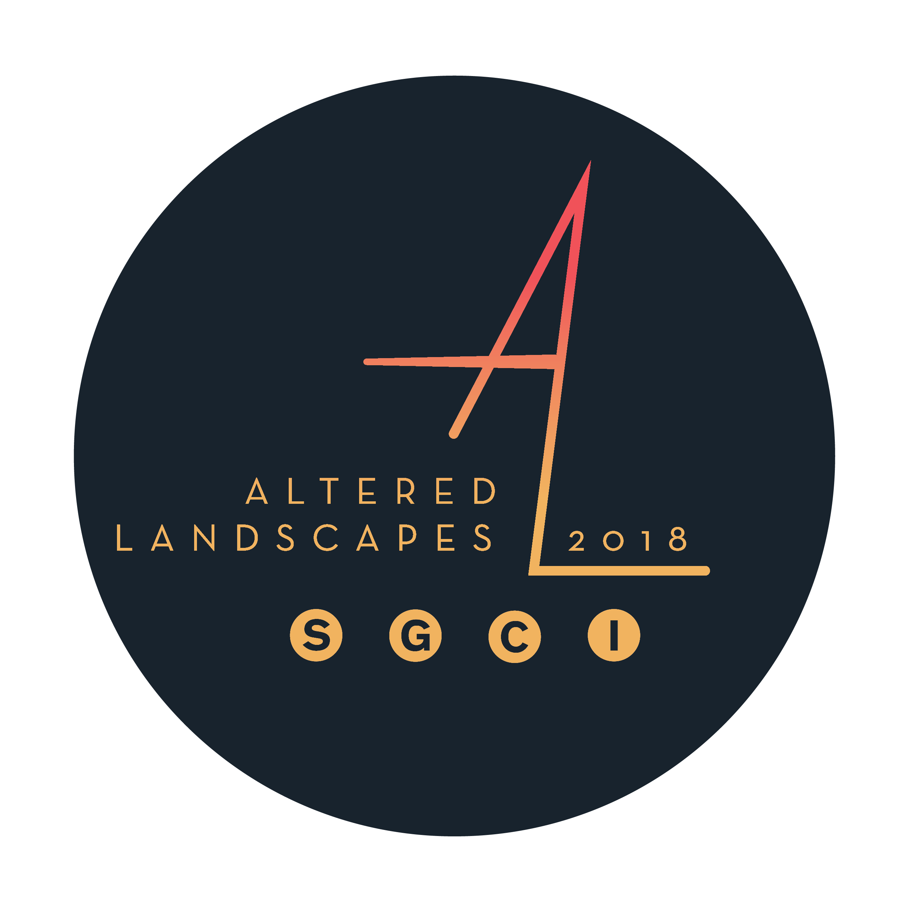

REGISTRATION RATES for SGCI 2018 Conference: Altered Landscapes

SGCI Memberships
- Student $35*
- Professional $75*
- Sustaining $100*
- Patron $250*
- Lifetime $500**

* annual renewal
** one-time fee

For more information on SGCI Membership, please visit: https://sgcinternational.org/membership/

Full Registration Rates: Early Bird | Regular | On-site
- Student Members $175 $250 $300
- Non-student Members $275 $350 $400

Daily Registration Rates (for all members):
- Wednesday, March 15 $75
- Thursday, March 16 $150
- Friday, March 17 $150
- Saturday, March 18 $150

Vendor/Publisher/Program Fair Rates:
- Level 1: (1 Table + 1 Full Registration) $350
- Level 2: (2 Tables + 2 Full Registrations) $500
- Level 3: (3 Tables + 2 Full Registrations) $550

Conference Participation Options:
- Member Exchange Portfolio $20
- Open Portfolio Session* $10
- Mentorship Session* FREE

* Limited sessions/quantities. Sign up is first come, first served.

Catalog Advertisement:
- Full Page Ad $400
- Half Page Ad $250
- Quarter Page Ad $150

SGCI 2017 Conference Frequently Asked Questions (FAQ)

REGISTRATION & MEMBERSHIP

When is online registration?
- Online registration will open Friday, October 21, 2016
- EARLY BIRD registration rates will end at midnight on Sunday, January 15, 2017
- Registering as a VENDOR, PUBLISHER or PROGRAM for the FAIR will end at midnight on Sunday, January 15, 2017
- REGULAR registration will end at midnight on Sunday, February 26, 2017

What is the difference between SGCI Membership and SGCI Registration Fees?
- An SGCI Membership is an annual membership that supports SGC International. In addition to discounted rates through online registration to the annual SGCI conferences, members have the opportunity to submit articles, reviews, and artwork to be published in the newsletter, participate in SGCI member exhibitions, and receive news about opportunities within the print community and the art world at large. You MUST be an SGCI Member to register for the conference online, but you do not need to be a member to register on-site or attend the Vendor/Publisher/Program Fair or evening activities that are free and open to the public during the conference.
- The SGCI Registration fee covers the costs of conference programming, including Incubators, Themed Portfolios and the Saturday Printmakers Ball at the Bally’s Hotel; subsidization for presenters at the conference for all the Demos, Panels, and Special Exhibitions throughout the conference; Conference Catalog and Bag; and so many more amazing opportunities the conference affords SGCI Members and participants!

What is the difference between Early Bird, Regular and On-site Registration?
- SGCI Members have the benefit of registering for the conference online, and thus receiving discounted rates. The most economical rate is the Early Bird rate ($175 for student members, $275 for non-student members), and it ends at midnight on Friday, January 12, 2018. The Regular online registration rate (also a discounted rate at $250 for student members & $350 for non-student members) starts at 12:01 am on Saturday, January 13, 2018 and runs through the end of online registration at midnight on Friday, March 2, 2018. You MUST be an active SGCI Member to register for the conference online, and thus receive the discounted rates. Anyone may register for the conference on-site at full value ($300 for students, $400 for non-students). There is no Early Bird or Regular discounted rates for the Daily Registrations.

What is the difference between Professional Membership, Sustaining Membership, Patron Membership, and Lifetime Membership?
- The Professional Membership is the most economical annual option for anyone who is not currently a student, who wishes to support the organization and/or access online registration for the conference to take advantage of the discounted rates (Early Bird or Regular). The cost of the annual Professional Membership is $75.
- The Sustaining Membership and Patron Membership are annual options for individuals who are not currently students, and who wish to give even more support to SGCI and/or access online registration for the conference to take advantage of the discounted rates (Early Bird or Regular). The cost of the annual Sustaining Membership is $100, and Patron Membership is $250. The SGCI Board is also looking for ways to celebrate these Members who do give more each year in this way - so stay tuned for more information about that!
- The Lifetime Membership is a ONE TIME FEE of $500. When you become a Lifetime Member, you will never again have to pay for an annual membership to access online registration for conferences, etc.

Can an institution purchase an SGCI Membership, or only individuals?
- Only individuals can sign up for SGCI Memberships. No company, organization or institution may do so at this time.

What if I purchased my SGCI Membership in-between the conferences?
- All current members whose accounts will be in good standing during the conference have been contacted with a registration code. If you have not been contacted, then your previous membership will not be active during the 2017 Conference.
- If you have not been contacted but you believe your membership will be in good standing for the 2018 Conference, please verify this information by contacting the SGCI Administrative Coordinator, Kate McQuillen (admin@sgcinternational.org).

Do I have to purchase an SGCI Membership if I register for the conference On-site?
- No, an SGCI Membership is not required to register for the conference On-site.
- However, certain conference options such as Open Portfolios, the Member Exchange Portfolio, and Mentorship meetings will only be available for members who pre-register for the conference online.

Do I have to register for the conference to attend the Vendor/Publisher/Programs Fair?
- No! The Vendor/Publisher/Programs Fair is free and open to the public. The Fair will be open for the 2018 Conference on Thursday, April 5 and Friday, April 6 from 9 am - 5 pm. It will be open on Saturday, April 7 from 9 am – 3 pm.

CONFERENCE PROGRAMS

What is a Panel?
- A panel is a topic of conversation pitched to the local steering committee pertaining to anything of interest to printmakers and print enthusiasts. The selected panels are Chaired by the person who submitted their application in the Tier 1 Call for Participation (typically close to a year prior to the conference).
- Individuals interested in speaking on one of the selected panels contacted the Panel Chair directly during the Tier 2 Call for Participation. The steering committee requested that the Panel Chair choose two individuals to be on their panel from the Tier 2 Call, and one individual that they personally request.
- Panels typically consist of four people:
  - the Panel Chair (who originally conceived of the Panel Topic and was selected in Tier 1), who will introduce each speaker, contextualize their presentations, and lead any Q&A sessions at the end of the panel discussion
  - Panelists, who share their own expertise and experience on the topic
- The set up for a Panel discussion is theater-style; the panelists are seated at a table in the front of a room or onstage with microphones, and usually a projector or A/V screen set up next to/behind them. Conference-goers are sat facing the panelists.
- Panels are scheduled for a two hour increment, but typically last about an hour and a half.
- The number of panels change at each conference, depending on the amount of spaces available and/or number of proposals. There are always three SGCI Designated Panels, chaired by members of the SGCI Board:
  - Education Panel
  - International Panel
  - Student Panel

What is a Demo?
- A Demo is a demonstration of a printmaking technique, material, tool or process by an SGCI Member, utilizing the presses, equipment, spaces, and/or materials available at the local conference venues.
- Individuals submit an application during the first or second Tier of Calls of the demonstration they’d like to perform. Oftentimes, they may need to bring their own specialty supplies or tools. Based on the space, equipment and press availability for the conference venues, the local steering committee makes selections that showcase as much novelty, breadth, beauty and innovation as possible!
- Demos can be challenging to access after they begin due to their popularity; therefore it is highly recommended to get to a Demo early for a good spot and commit to the entire demonstration. Hand-outs and PDF forms may be made available to conference-goers during or after the conference.

What is a Themed Portfolio?
- There are a number of different Themed Portfolios that are displayed during the conference. These portfolios are curated by SGCI Members, and are based on the conference’s theme of that year.
- In the Tier 1 Calls for Participation, individuals who are interested in curating and collating a themed exchange portfolio (based on the conference theme) are invited to submit an application. The local steering committee selects Themed Portfolios based on space availability, applicability and interest. Artists who are interested in having their work considered for a particular Themed Portfolio contact the organizer and submit an application during the Tier 2 Call for Participation.
- Selected participants in the Themed Portfolios create an edition of prints; one complete set of prints are exhibited during the Conference, and the participants receive a portfolio with a full set of prints.
- All Themed Portfolios are added to the SGCI Archives at the Zuckerman Museum of Art.

What is an INKubator?
- INKubators arose out of the desire for more informal, group discussions about pertinent topics for printmakers and print enthusiasts that the Panels weren’t set up to accommodate. INKubators are set up as round table discussions, moderated by the INKubator organizer.
- Calls for INKubator topics were requested during the Tier 1 Call for Participation for the 2017 Conference.
- INKubators are scheduled for a two hour increment, but typically last about an hour and a half.
- Unless otherwise indicated for a specific session, there are no pre-registration required to attend an INKubator. Drop-ins are welcome!

What is the Member Print Exchange?
- This is a print exchange open to ALL active SGCI Members. SGCI Members create an edition that is turned in during the first half of the conference, and receive an exchange portfolio of 10 prints at the end of the conference to take home! Your work from this Member Exchange will be collected by the SGCI Archives at the Zuckerman Museum of Art, as well as local conference area institutions. There is no restriction as to the number of participants in this exchange!

- THEME: The theme of the 2018 Member Print Exchange is “Altered Landscapes.”

Meadows appeared in the desert through spring-fed grasses, providing Las Vegas its name in 1821. The city glitters like an oasis, casting a barrage of light in the shadows of the Spring Mountains. But like a mirage, the promises of Las Vegas can be fickle.

The city’s landscape has shifted from canyon petroglyphs to the Old Spanish Trail to a home for hydroelectric workers eager to lose themselves in the pleasures of an illicit speakeasy or underground casino while building the Hoover Dam. Las Vegas is known for its glitz and glamorous facades, yet the underpinnings of the city rest on rusted bones in the middle of the desert. Printmaking can be viewed in a similar light - the intimate result of labor and process; malleable visual expressions that can both mimic and innovate.

SGCI 2018 Altered Landscapes will bring printmakers together to explore the tension between reality & representation; alteration & reincarnation; ventures & adventures; construction & decay. Altered Landscapes will capture the spirit of Las Vegas’s perpetual reinvention and the fallacy of its promises. Through dialogue and demonstrations, Altered Landscapes will explore transformations in artist attitudes towards the natural environment, and printmaking’s evolving roles in creative and social practice.

- PAPER: The paper size is 11” x 14.” (All paper must be archival.) Prints can be full bleed, horizontal or vertical.
- INTERLEAVING: All editions must be interleaved with glassine or equivalent archival protective sheets, also 11” x 14”.) Please do not use newsprint, bags, tracing paper, wax paper, or mylar as interleaving.
- EDITION SIZE: The edition size is 13 prints, numbered 1/13, 2/13, etc.
- PAPERWORK: All members must pre-register to participate in this exchange. The Zuckerman Museum of Art will provide a form to be filled out and turned in with the edition at the conference for archiving purposes. Please type up and print this form out before you arrive at the conference to avoid any issues.
- EXHIBITION: The Member Prints will be exhibited at the Bally’s Hotel on Saturday, April 7 from 9 am - 3 pm. The exhibition will be on display in the Palace Rooms 1-5.
- AWARDS: Four cash awards will be presented for the best prints in the following categories: Best in Show ($500), Best Print by a Student Artist ($250), Best Print by an Emerging Artist ($250), and Best Print by a Professional Artist ($250). Award recipients will be recognized during the SGCI Awards Ceremony, held from 8 - 9 pm on Saturday, April 7 in the Platinum Ballroom at the Bally’s Hotel.
- COST: It is a $20 fee to participate in the Member Exchange Print Portfolio. If you are not able complete your edition before the conference, you may exchange your place for another artist at your discretion. No refunds will be offered.
- DROP OFF TIMES: Complete editions at the Loews Hotel near the registration table during the following times:
      - Wednesday, April 4, 12 pm - 5 pm
      - Thursday, April 5, 8 am - 6 pm
      - Friday, April 6, 8 am - 2 pm
  - At the time of drop off, portfolio participants will be checked against a register of preregistration. All editions will be checked for compliance with the portfolio guidelines for media, size and interleaving, and dryness. All editions must include a completed Information Form provided prior to the conference by the Zuckerman Museum of Art. Participants will be issued a receipt that must be presented at the time of portfolio pick-up on Saturday April 7. The portfolio organizers reserve the right to refuse entry of any submission that fails to conform to the portfolio guidelines. No refund will be offered if the edition does not meet the requirements for inclusion.
- PICK UP TIME: Portfolios must be picked up at the same desk where the editions were originally dropped off during the following times:
      - Saturday, April 7, 8 am - 12 pm
  - All Member Print Exchange Portfolios will consist of 10, randomly collated prints from the collection. You must present your Member Print Exchange ticket/receipt to collect your portfolio - it is your responsibility to hold on to this ticket! No exchange of portfolios will be offered.

FAQ:
Can I print my paperwork at the hotel?
- We cannot guarantee that a printer will be available for you at the hotel. Therefore, it’s advised to print your paperwork out BEFORE you arrive to the conference.

Can I get a refund if I don’t end up bringing an edition?
- Unfortunately, we do not offer refunds. You can, however, exchange your ticket with a friend or fellow artist who did not pre-register for the Member Print Exchange, and work out payment on an independent level.

Can I sign up to participate in the Member Print Exchange AT the conference if I didn’t pre-register?
- Unfortunately not. (Exchange Portfolios are being produced based on the number of pre-registered participants in the Exchange.) However, you can likely find a friend or fellow artist who pre-registered and ended up not bringing their edition, and turn your edition in in their place.

Will you provide Glassine or other Archival Interleaving?
- NO! We do not have those materials on hand. Please prepare your edition and interleaving before you arrive at the conference hotel to turn them in. Editions without interleaving will not be accepted into the collection.
- If you have any additional questions about the Member Print Exchange, please contact Daryl DePry at Daryl.DePry@csn.edu with the subject line, “Question about Member Print Exchange.”

What is Open Portfolio?
- Open Portfolio provides an opportunity for conference delegates to present their work on a 6 foot table alongside one another in 1-hour sessions. These displays are free and open to the public. There are a limited number of spots, so sign up with be limited to first-come, first-served until sessions are full.

- DESIGNATION: When you sign up for an Open Portfolio session, you will select a descriptor that best describes you: Student, Emerging, Professional, Professor. Each Portfolio Session will include a mixture of all designations of artists.
- DATE & LOCATION: The event will be held on Saturday April 7, in the Bronze, Silver and Gold Rooms at the Bally’s Hotel.
- SESSION TIMES: The portfolio sessions will take place according to the following schedule:
    - Portfolio Session 1: 10:30 am – 11:30 am
    - Portfolio Session 2: 11:45 am – 12:45 pm
    - Portfolio Session 3: 1:00 pm – 2:00 pm
  - Sessions will be assigned at random to participants. Unfortunately, no session time requests can be guaranteed. Please be prepared to pack up your prints and make room for the artist at your table in the session after you when you hear the 5-minute warning that your session time is ending!
- COST: The cost is $10 to participate. Individuals must pre-register to participate in Open Portfolio online. (Participation sign up is first-come, first-served.) IF any sessions are still available at the conference, they may be purchased at the Registration Desk in the Loews Hotel as supplies last. No refunds will be offered.

FAQ:
Can I display items on the wall or in bins on the side of my table?
- No. The tables abut one another in order to have as much room as possible for people to traverse the space and see all of the art. It’s a fire hazard to place bins or other display apparatus in the aisles where people will be walking. We are not able to hang or adhere art onto the walls of the hotel. However, your space ON the table is entirely yours to do with as you will - you can put bins, posters, panels, etc on top of your table, and/or bring tape to display your work on the front of your table.

Can I sell my work?
- Yes! You are welcome to sell and/or exchange your artwork during Open Portfolios. If you take cloud-based payments, you may need to provide your own wifi (personal hotspot on your phone, etc); we cannot guarantee free wifi at the hotel.

Can I participate in more than one Open Portfolio Session?
- You can only pre-register for one session, as there are a limited number of spots and we want to ensure everyone has an equal chance of participating. However, if there are still spots available at the start of the conference, we will be selling additional session tickets at the Registration Desk on a first-come, first-served basis while supplies last.

Can I choose my session time or location in the room?
- Session times and spots are assigned at random, and we cannot guarantee that requests can be honored. If you’d like a specific session time, you can switch with another participant at your discretion. If you have any questions about this, please contact Jennie Suddick at prewashedjennie@gmail.com with the subject line, “Question about Open Portfolios.”

What is a Career Mentor Session?
- SGC International is an educational non-profit organization committed to informing our membership about issues and processes concerning original prints, drawings, book arts, and handmade paper. SGCI is pleased to continue the Career Mentoring Services at the 2017 Conference. Services are provided at no cost to SGCI members attending the conference. Mentoring services are available for individuals at all stages of their careers – whether you are an undergraduate student thinking about an MFA, a graduate student seeking career advice, an independent artist looking to start a press, or someone in a tenure-track position looking for advice about navigating academia. There are a limited number of spots, so sign up will be first-come, first-served until sessions are full.

- Mentor Sessions will be held in Skyview 1 at the Bally’s Hotel.

- TOPICS: Mentoring Topics include (but are not limited to):
  - Artist Portfolio Reviews
  - Career Advice for Emerging and Mid-Career Artists
  - Tenure and Academic Advancement
  - Independent Presses, Non-Profits, and Community-Based Art

- SESSION TIMES: Mentor sessions are 20 minutes in duration. Wifi is not guaranteed, so if you plan to show any artwork, documents, etc on your computer or tablet, it is recommended that you download PDF documents or other files that do not require wireless internet to see before you arrive for your session.
  - Thursday, April 5, 11 am – 4 pm
  - Friday, April 6, 11 am – 4 pm

- COST: Free! There is no cost for any SGCI Member to register for a Career Mentor Session.

- MENTORS: Mentors are SGCI Members who are experienced professionals, and want to serve our membership and foster interest in our field. This is a volunteer service that they provide.

- For any questions on becoming a mentor or signing up for mentorship, please contact SGCI Vice President of Outreach, Nicole Hand, at outreach@sgcinternational.org

