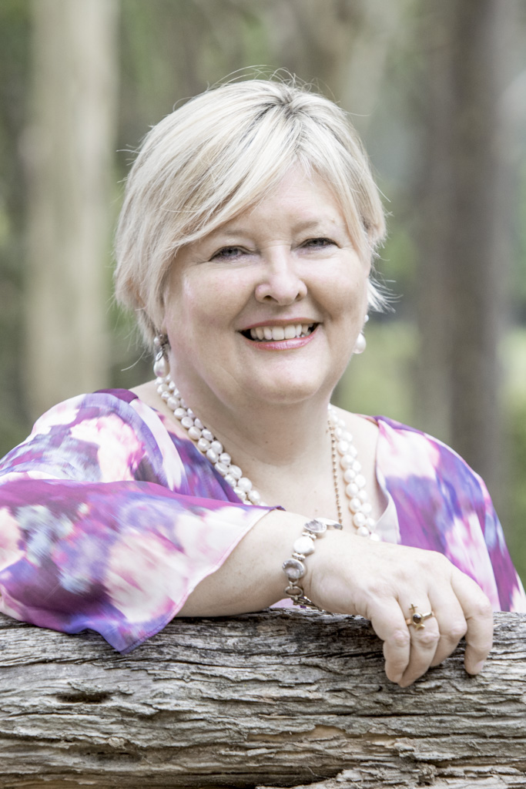
Shakti Durga is an enigma. She is highly educated, having degrees in law and economics and, prior to commencing her vocation in spirituality, practiced law for 17 years. She also has a huge grasp of Vedic, Tantric and Western mysteries and is the founder of international spiritual school Shanti Mission. She is a mixture of east and west.

She has written 5 books, developed a comprehensive joy-filled spiritual training program, has countless spiritual music, mantra and meditation CDS, and 3 inspirational card decks.

Shakti Durga is a compelling and magnetic teacher. She is hilarious and yet can go deep as the ocean to support people into their full blazing light. Propelled down her spiritual path through a personal crisis, she has lived her challenges and road-tested the teachings through her own experiences.

Recognised as a Swami in India, a Spiritual Master, healer and teacher, she is an extraordinary woman who takes people on a massive spiritual journey. She is able to bring souls along to an exquisite degree of self-awareness and mastery. Her particular loves, apart from her children and partner of many years, are music, singing, the sound of the Divine and relationships as pathways to self-realization.

Shakti Durga is one of 8 Spiritual Masters invited to China by the largest provider of spiritual content in that country. She is also one of the 108 Living Masters featured on the world’s largest spiritual website, Times of India’s Speaking Tree. She and her team of empowered teachers have taught thousands of people in Australia, USA, Canada, UK, China, India, Brazil, New Zealand and Germany.

She has two grown children and lives with her life partner in Cooranbong, north of Sydney in NSW Australia.

