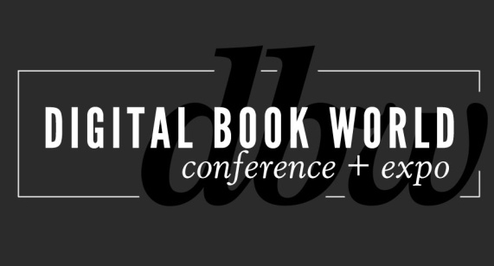
Contact: Stacie Berger F+W Media, Inc.
513.531.2690 x 11457
stacie.berger@fwmedia.com

BISG Details Making Information Pay Program at Digital Book World 2014

NEW YORK – November 6, 2013 – In collaboration with the Digital Book World Conference & EXPO 2014, the Book Industry Study Group (BISG) will host their popular annual conference Making Information Pay for Higher Education on January 13 in New York City. Registration for the event is now available at http://conference.digitalbookworld.com and special rates are available for BISG members. Register by November 8 to secure the lowest conference rate.

BISG will present a comprehensive look at consumer attitudes, trends and changes caused by digital disruption and offers industry leaders' perspectives on key issues in Higher Education publishing today. A summary of the 4th Annual Student Attitudes toward Content in Higher Education survey findings will also be released at the event.
“Now in its fourth year, MIP for Higher Ed is an established way for the entire higher education publishing ecosystem to hear thought leaders offer perspectives about trends and innovative approaches to a rapidly changing industry. Our expanded, full-day program coupled with Digital Book World’s conference expertise should ensure our best conference yet,” says BISG Executive Director, Len Vlahos.

Program highlights include:
- Hacking Higher Education: What Higher Ed Content and Platform Providers Can Learn from Improvised and Self-published Solutions. How custom course packs, hybrid uses of educational platforms, and other remixes of resources can address today’s needs.
- SPOCs and the Future of Online Education: Anant Agarwal, president of EdX, and pioneer of SPOC s (Small Private Online Classes) discusses the new possibilities and the promise of online networked education.
- The Big Picture: American Policy on Higher Education: A discussion of current educational policy and priorities for the future from a government perspective.
- Student Attitudes toward Higher Education: Portraits & Perspectives - In this panel, four university students with different backgrounds, from different schools, at different stages in their educational careers will share their experiences of higher education, offering a more personal perspective on the trends observed in BISG's Student Attitudes toward Higher Education, Volume 4.
- Master Class: Industry Leaders On the State of Higher Education: Moderated by BISG Executive Director Len Vlahos, industry leaders will participate in a wide-ranging discussion of the state of higher education in America.
# # #
About F+W Media, Inc.
F+W Media, Inc. is a community-focused, content creator and marketer of products and services for enthusiasts offering a diversified portfolio of ecommerce, books, ebooks, magazines, events, competitions, education services, instructional video, and more. The Company is considered the authoritative, trusted voice guiding enthusiasts with relevant, helpful information and connecting them to the products and services they need to achieve success, profit from their passion, or find inspiration. www.fwmedia.com.

About the Book Industry Study Group, Inc.
The Book Industry Study Group, Inc. (BISG) is the book industry’s leading trade association for policy, standards, and research. The mission of BISG is to create a more informed, empowered, and efficient book industry. Membership consists of publishers, manufacturers, suppliers, wholesalers, retailers, librarians, and others engaged in the business of print and electronic media. For over 35 years, BISG has provided a forum for all industry professionals to come together and efficiently address issues and concerns to advance the book community. Learn more about BISG at www.bisg.org.

Press Inquiries:
F+W Media, Inc. / Digital Book World
Stacie Berger, Vice President, Communications
stacie.berger@fwmedia.com
Book Industry Study Group
Jeanette Zwart
646-336-7141
jeanette@bisg.org

