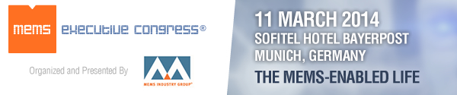

11 March, 2014
Sofitel Hotel Bayerpost, Munich, Germany

An executive forum promoting the commercialization of MEMS

European Business Leaders Explore MEMS in Automotive, Consumer, Health/Wellness, Industrial
MEMS is critical to European companies and research organizations driving innovation in automotive, consumer products, health/wellness, and industrial. Through panel discussions and a featured presentation, MEMS Industry Group (MIG)’s third annual MEMS Executive Congress® Europe, 11 March, 2014 in Munich, Germany, offers an inside look at recent advancements and commercial opportunities in these varied markets.

MEMS in Automotive
Historically the growths of the MEMS industry and the automotive industry have been tightly aligned. But the landscape is growing more complex, with demand from BRIC (Brazil Russia India China) countries rising while automobile ownership in developed countries declines. How are European automotive leaders dealing with these changes? Will the promise of a connected car to a connected road in a connected city (all part of the Internet of Things) be the answer?
Our speakers include:
- Marc Osajda (moderator), director, Freescale Pressure Sensor Business Unit, Freescale Semiconductor – Germany
- Richard Dixon (panelist), principal analyst, MEMS & Sensors, IHS iSuppli
- Frank Schäfer (panelist), senior manager product management, Automotive MEMS, Robert Bosch GmbH
- Christoph Wagner (panelist), European automotive marketing manager, Analog Devices

MEMS in Consumer Products
Today, MEMS and sensors are ubiquitous in consumer products -- from smartwatches and smartphones to video games and smart home devices. With MEMS helping to dramatically improve the user experience at decreasing price points, what unique expertise and advantage do European companies bring to the global market?
Our speakers include:
- Dr. Roland Helm (moderator), director & segment head, Microphone & Reliability, Infineon Technologies AG
- Jean-Christophe Eloy (panelist), president & CEO, Yole Développement
- Dr. Yannick Levy (panelist), vice president of corporate business development, Parrot SA
- Teemu Rämö (panelist), senior manager, Audio HW, Nokia Lumia Technology

MEMS in Health and Wellness
From wearables that diagnose sleep apnea to an iPhone app that can determine if a child is having an asthmatic episode, we are seeing the enabling power of MEMS and sensors in today’s health/wellness products. How is MEMS helping consumers to take charge of their healthcare? In what ways is MEMS improving quality of life with regard to prevention, monitoring, management, replacement and rehab? And how will users (and providers) manage the “big data” generated by these devices?
Our speakers include:
- Dr. Eero Punkka (moderator), head of health research, VTT
- Georg Bauer (panelist), vice president of BioSciences, SONY DADC Austria AG
- Dr. Harald Mathis (panelist), head of Biomolecular Optical Systems, Fraunhofer FIT
- Peter Peumans (panelist), program director, Life Sciences Technologies, imec
- Dr. Andreas Schüle (panelist), MedLab business manager, FESTO AG & Co. KG

MEMS in Industrial
Driven by current advances in microsystems technology, a transformation is taking place in today’s industrial applications. As we move toward more autonomous systems that act within self-organizing networks, how do we manage integration of increasingly complex functionality?
Dr. Jörk Habenstreit, managing director, Research & Development Technology Software, Testo AG, will give a featured presentation on future business opportunities of microsystem technology from the perspective of Testo, a worldwide manufacturer and distributor of a wide range of metrological measurement instruments.
Please join us 11 March, 2014 at MEMS Executive Congress Europe 2014
10:00-11:00 MEMS in Automotive Panel
11:30-12:00 Featured Speaker: Microsystem Technology: Future Business Opportunities in Industrial Applications
13:30-14:30 MEMS in Consumer Products Panel
14:30-15:30 MEMS in Health and Wellness Panel
Should you wish to join us as a member of the press, we encourage you to review our press credentials. Please direct all inquiries for press registration to Ingrid Daschner, European public relations on behalf of MIG, tel: +49 (0)89 89 40 85-11, email: ingridd[at]johnsonking.de.

Host Organization
MEMS Industry Group
Connect with MEMS Industry Group!

Sponsors
Premier sponsors of MEMS Executive Congress Europe 2014 include: Platinum Sponsor – EV Group; Gold Sponsor - SPTS Technologies; Silver Sponsors – Analog Devices and Freescale Semiconductor; and Bronze Sponsors - ACUTRONIC, Applied Materials and X-FAB MEMS Foundry.
Supporting sponsors and partners include: acam, Akustica, Bosch Automotive Electronics, Bosch Sensortec, Fries Research & Technology (FRT), imec, IVAM, MicroTEC Südwest, Plan Optik, SEMI, Smart Systems Integration, Solid State Technology, Tronics, Yole Développement and the ZVEI.
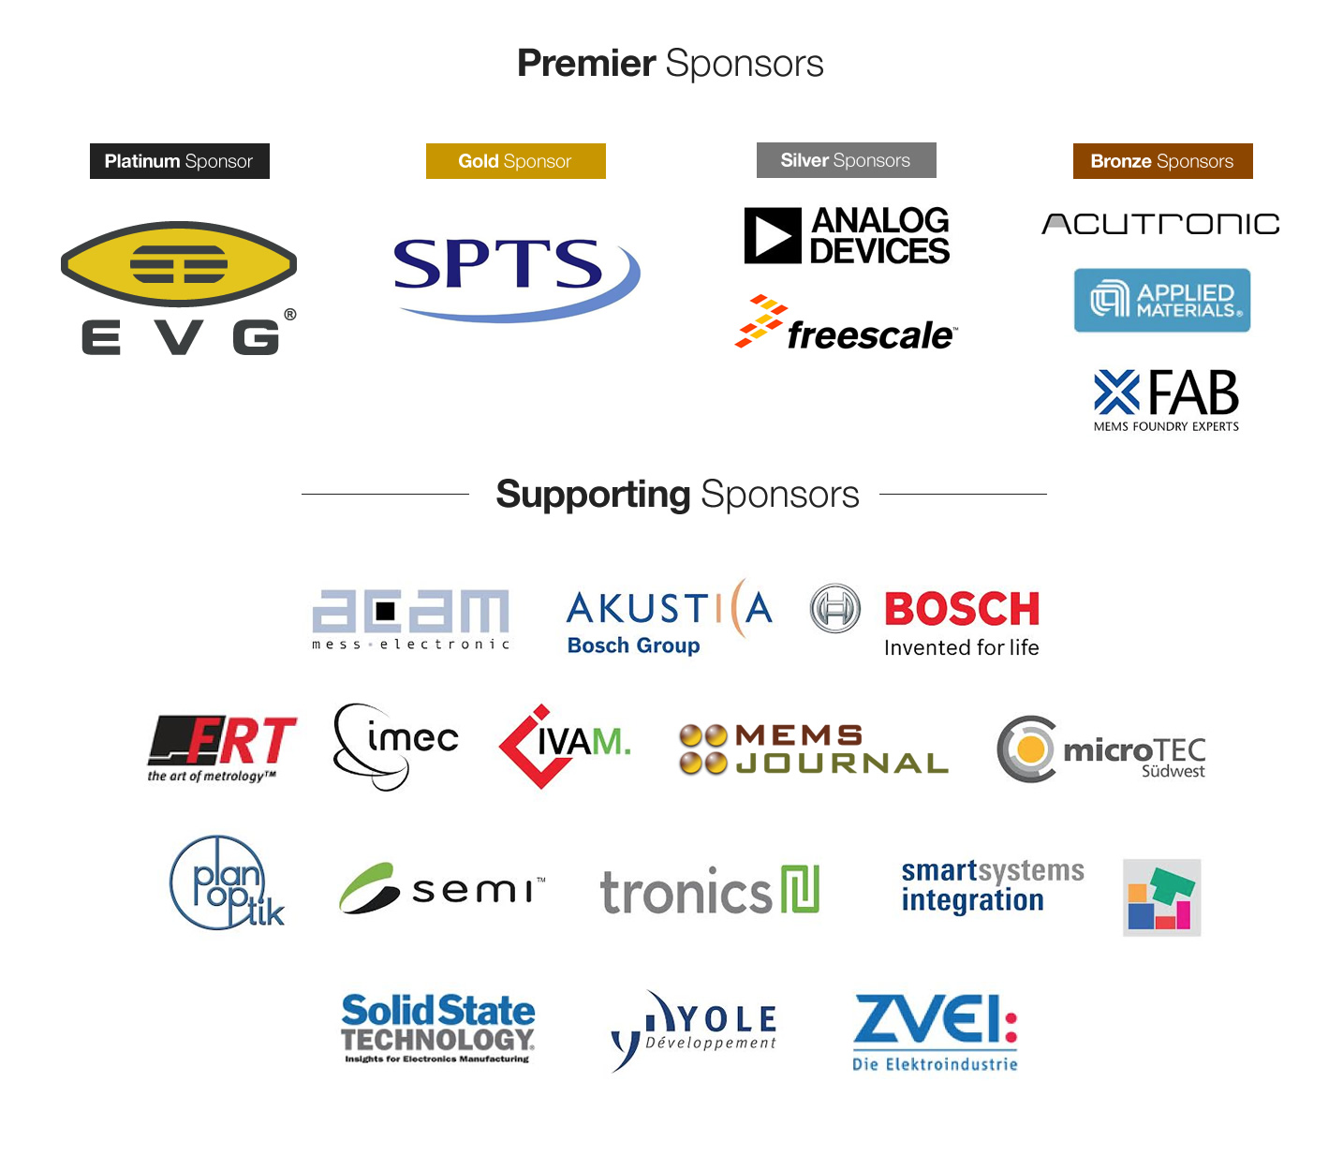

MEMS Industry Group®, MEMS Executive Congress® and the MEMS Industry Group® logo are registered trademarks of MEMS Industry Group®. All product and company names are trademarks or registered trademarks of their respective holders.
MEMS Industry Group®- 1620 Murray Avenue, Pittsburgh, PA 15217. Phone: 1.412.390.1644

