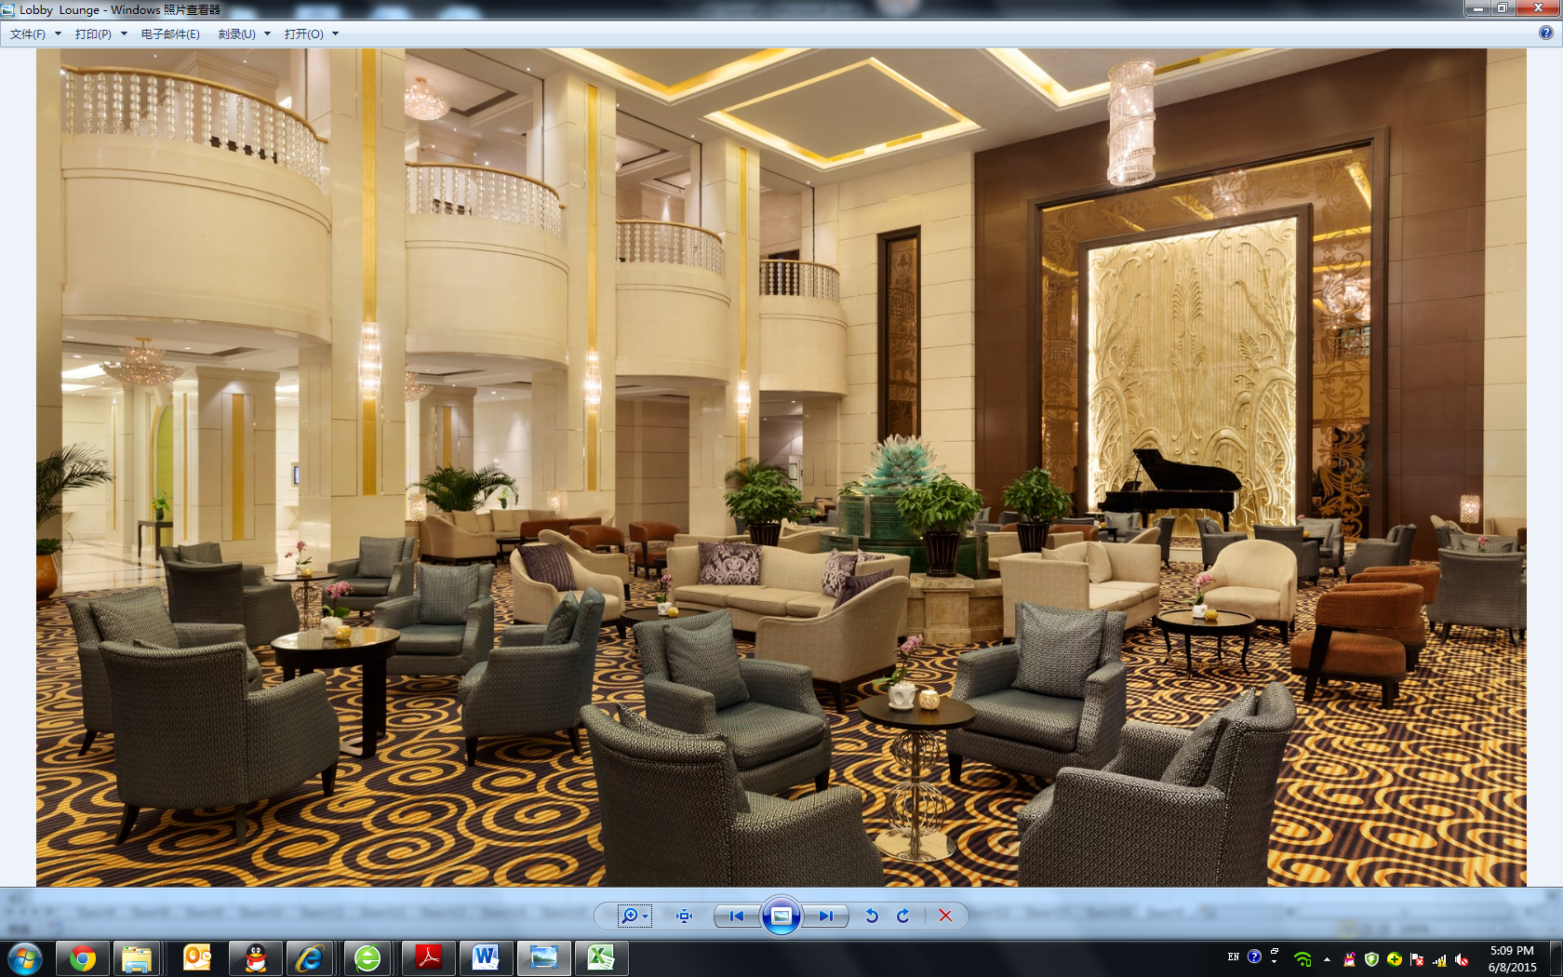
Hotel Reservation 
Please fill up the below fields and send to Ms Dong Juan via email (dongjuan@cawa.org.cn)

Guest Registration顾客信息
Title*  尊称 |  | Mr / Mrs / Ms  先生/夫人/女士 |  | Nationality*  国籍
Family / Last Name* |  |  |  | Given / First Name*  姓
HP No.*  手机 |  |  |  | Email Address*  邮箱
Companion’s name (if any)
陪同人员姓名（如果有）
Arrival Date*  抵达日期 |  |  |  | Departure Date*  离店日期
*If you are arriving between midnight and the official check-in time, please make the reservation one day prior to the date of arrival.
如果您在午夜或者官方入住时间之前抵达，请将预定时间延长至前一天。
Room Type & Preferential Price 酒店房型及优惠价格
Please select room type  请选择房型 |  |  |  | Room Rates  (Single / Double Occupancy)  房间价格（单人/标准间）
1 | Deluxe King Room  (One King-sized Bed)  豪华单间 |  | RMB 600 per room per night  600元/间/晚
2 | Executive Panorama Deluxe  (Twin Beds)  豪华标间 |  | RMB 600 per room per night  600元/间/晚
3 | Executive Suite  行政套房 |  | RMB 1500 per room per night  1500元/间/晚

Terms and Conditions
- The “Group rate” is valid for stay period from Oct 28-Nov 2, 2019 only. All reservations are subject to rooms’ availability at the time of the reservation.
- The room fees will be charged at check-in counter of Kempinski hotel.
- We respectfully remind you that our usual check-in time is 14:00, check-out time is 12:00 noon. Early check-in or late check-out are available upon request and will be charged.
- Only the registered guests/visitors shall enjoy the preferential prices during the congress. Please make sure your registration fee to the WUWM congress has been transferred successfully.
- If you need more reservation to Kempinski Hotel, please visit www.kempinski.com/guiyang.

