1. Sweetgreen
Salads
4075 Wilson Blvd., Arlington, VA
Phone: 703-522-2016
http://order.sweetgreen.com/ballston/menu
2. Kapnos Taverna
Greek
4000 Wilson Blvd., Suite A, Arlington, VA
Phone: 703-243-4400
https://kapnostaverna.patronpath.com/
3. Taylor Gourmet Sandwiches
Sandwiches, Salads & Soups
4000 Wilson Blvd., Arlington, VA
Phone: 703-940-3690
http://order.taylorgourmet.com/
4. Chipotle Mexican Grill
Mexican
4300 Wilson Blvd, Arlington, VA
Phone: 703-243-9488
https://order.chipotle.com//Meal/Index/323?showloc=1&_ga=1.4991603.1701008143.1463417415
5. Subway
Sandwiches
801 N Quincy St #1A, Arlington, VA
703-243-9226
https://order.subway.com/Cart/Menu2.aspx
6. Sichuan Wok
Chinese
901 N Quincy St, Arlington, VA
Phone: 703-527-0660
http://www.sichuanwokarlington.com/orderonline.aspx
7. Jimmy John’s
Cold Sandwiches & Chips
550 N. Quincy Street, Unit B, Arlington VA
Phone: 703-276-3036
https://online.jimmyjohns.com/#/selectlocation/%231511
8. Zoes Kitchen
Mediterranean
4245 North Fairfax Drive Suite 150, Arlington VA
Phone: 703-807-0410
https://zoeskitchen.alohaorderonline.com/Time.aspx
9. Cosi
Sandwiches, Salads, Soup, & Flatbreads
4250 Fairfax Drive, Arlington VA
Phone: 703-527-9717
https://orders.getcosi.com/index.cfm?fuseaction=order&action=preorder&isToGo=1&store_code=046
10. Potbelly Sandwich Shop
4250 Fairfax Dr, Arlington, VA
Phone: 703-807-4100
http://www.potbelly.com/Food/OurMenu.aspx?subPage=Sandwiches

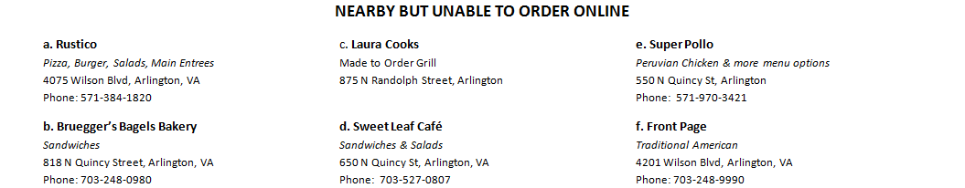

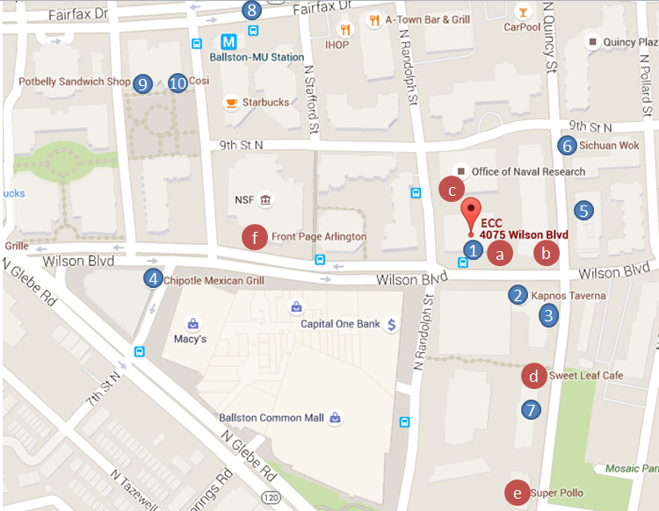
Nearby but unable to order online

a. Rustico
Pizza, Burger, Salads, Main Entrees
4075 Wilson Blvd, Arlington, VA
Phone: 571-384-1820
b. Bruegger’s Bagels Bakery
Sandwiches
818 N Quincy Street, Arlington, VA
Phone: 703-248-0980
c. Laura Cooks
Made to Order Grill
875 N Randolph Street, Arlington
d. Sweet Leaf Café
Sandwiches & Salads
650 N Quincy St, Arlington, VA
Phone: 703-527-0807
e. Super Pollo
Peruvian Chicken & more menu options
550 N Quincy St, Arlington
Phone: 571-970-3421
f. Front Page
Traditional American
4201 Wilson Blvd, Arlington, VA
Phone: 703-248-9990

