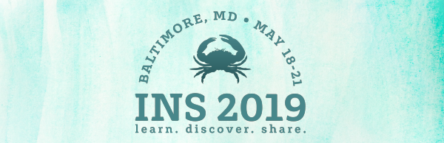
[Today's Date]
[Your Supervisor's Name]
[Your Supervisor's Title]
[Your Employer's Name]
[Your Employer's Address]
Dear [Your Supervisor's Name]:
I would like to attend the Infusion Nurses Society’s 2019 Annual Meeting & Exhibition, which will be held May 18-21, 2019, in Baltimore.
INS 2019 is one of the largest international gatherings of infusion therapy nurses and experts. By attending, I will be provided with evidence-based practice guidelines and tools to reduce risks and optimize outcomes for patients receiving infusion therapy.
INS is anticipating hundreds of professionals from across the world to attend, providing an invaluable forum for nurses to learn, discover, and share the most current research and innovations related to the clinical practice of infusion therapy.
Here are some of the benefits I will receive from attending INS 2019:
- The ability to earn as many as 20 continuing nursing education credits
- 40 CRNI® recertification units
- More than 35 educational sessions to choose from
- The opportunity to network with more than 1,000 professional colleagues
- Special networking events
- Access to more than 80 exhibitors showcasing the latest innovations in infusion therapy

The sessions I plan to attend:

Exhibitors I plan to visit:

The registration fee is $____ . INS has reserved hotel rooms at a special rate of $229 a night, plus tax. I have found airfare for $_____. The total cost to attend will be $________.
By attending INS 2019, I will be empowered to share evidenced-based best practices with my colleagues, which will lead to improved infusion therapy outcomes and greater satisfaction among our patients.
Thank you for taking the time to consider my request for financial assistance to attend this valuable conference. More information, including a list of the educational sessions planned, is available at www.ins1.org.
Sincerely,
[Your Name]

