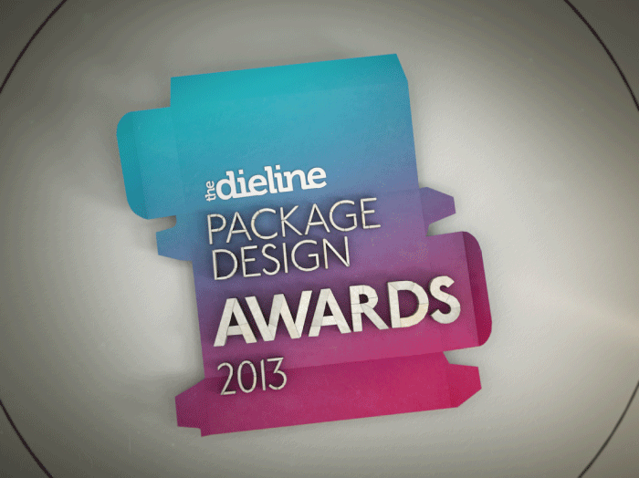

**For Immediate Release:**

Contact: Andrew Gibbs

[andrew@thedieline.com](mailto:andrew@thedieline.com)

**THE DIELINE PACKAGE DESIGN AWARDS 2013 WINNERS ANNOUNCED**

*Winners Announced at The Dieline Package Design Conference at HOW Design Live:*

*Innovative Student Project takes Best of Show*

San Francisco, California—June 23, 2013 - The Dieline has announced the winners of The Dieline Package Design Awards 2013 presented by Inwork at The Dieline Package Design Conference, held in conjunction with HOW Design Live at the Moscone Center in San Francisco.

The Dieline Package Design Awards are a worldwide competition devoted exclusively to the art of brand packaging. The 2013 competition received over 1100 entries from 61 countries around the world.

Forty-two winners across 13 different categories were awarded a 1st, 2nd, or 3rd place Award, and the highest scoring project received a one-of-a-kind "Best of Show" award, and presented a case study at The Dieline Package Design Conference 2013. An "Editor's Choice" award was handpicked by Andrew Gibbs, founder of The Dieline.  A new Sustainable Packaging Award was created to highlight innovative contributions to the field of sustainable package design.

The Dieline Package Design Awards entrants were judged by a highly esteemed panel of 12 industry experts, based on quality of creativity, marketability and innovation. Debbie Millman, President of Design at Sterling Brands, served as the chairwoman of the judges.

**ABOUT THE BEST OF SHOW, EDITOR'S CHOICE, & SUSTAINABLE PACKAGING AWARD WINNERS**

**BEST OF SHOW**

BANDiful by Jiawei Feng & Yu Ping Chuang

For the first time in The Dieline Package Design Awards history, an innovative student project was the highest rated project among the judges, and was named Best of Show. [Vivi Feng](http://vivifeng.com/) & [Yu-Ping Chuang](http://yuping.prosite.com/) created an innovative solution to a common problem: the challenge of using a single hand to apply a bandage.

Applying a bandage using a single hand can be challenging, especially when both of your hands are injured. BANDiful solves this problem by applying a special structure to avoid extra steps in unwrapping bandages.

-more-

Not only does BANDiful offer a functional benefit, but also enables a new personal experience of using a bandage. Incorporated with a hanger on the top of the package, the consumer can hang BANDiful on the wall near his/her desk. With bright patterns, bandages are no longer invisible but beautiful. Normally people use bandages only for small wounds, but by offering a convenient user experience, a consumer could also feel emotionally comforted as well.

**EDITOR’S CHOICE:**

Method Ocean Plastic dish + hand soup by  Method Products

[Method](http://methodhome.com/) created the world’s first bottle made with ocean plastic - It’s estimated that several million tons of plastic makes its way into our oceans every year, polluting the environment and hurting our marine populations. Method is tackling this issue with a unique product packaged in bottles made from a blend of ocean plastic + recycled plastic (PCR).

**SUSTAINABLE PACKAGING AWARD:**

Sustainable expanding bowl by Tomorrow Machine / Innventia

Swedish research company [Innventia](http://www.innventia.com/) teamed up with designers Anna Glansén and Hanna Billqvist from design agency Tomorrow Machine to develop a sustainable package customized for freeze-dried food. The instant food package combines different aspects of sustainability. It saves space in transportation by being compressed and it is made out of a 100% biodegradable material from renewable sources, invented by Innventia.

 To see the full list of winners, please visit <http://thediel.in/DLAwards13>

# # #



Established in 2007 by Andrew Gibbs, The Dieline is dedicated to the progress of the package design industry and its practitioners, students and enthusiasts. Its purpose is to define and promote the world's best packaging design, and provide a place where the package design community can review, critique and stay informed of the latest industry trends and projects being created in the field. The Dieline has become the most visited website on package design in the world, with readership spanning millions across hundreds of countries.

The Dieline also produces The Dieline Package Design Awards – a worldwide package design awards competition devoted exclusively to the art of brand packaging. The Dieline and F+W Media have formed a partnership to deliver world-class conferences on package design – The Dieline Package Design Conference, and The Dieline Forum.[www.thedieline.com](http://www.thedieline.com)