New tools for the patient and medical researcher
Imec and its health care partners share a vision on how people will follow up on their health in the future.
Thanks to breakthroughs in electronics, everyone will be able to do precise diagnostic tests. Test for which today we still need to go to the hospital. These tools will e.g. be lab-on-chip systems or body sensors.
In addition, physicians will have reliable, miniaturized, and cheap diagnostic kits to do clinical tests wherever needed. A revolution for physicians that work in rural areas far from cities and hospitals.
The medical revolution in electronics will be equally important for medical researchers. It will give them tools to look into DNA, proteins, and even cells at very high speeds and throughputs, with an unparalleled precision.
These are a number of projects that we are working on:
Smart petri dishes
These petri dishes have a bottom with thousands of integrated micro-electrodes on which cells and tissues can be grown. This allows monitoring individual cells over a long period. A possible application is real-time and label-free measuring of the toxicity of medicines on tissues. Such tests closely resemble in-vivo tests.
Micro-PCR
Imec develops disposable chips that detect genetic markers in a fast way and with great sensitivity. These systems have the size of half a credit card. They include microfluidics to prepare the sample, to amplify the DNA, and to detect markers in DNA and RNA.
Lens-free microscopy
With lasers and advanced processing, it is possible to make high-resolution images of cells without using lenses. This allows to add a microscope that fits into e.g. a bioreactor or lab-on-chip (read also our page on Image sensors and vision systems).
Cell sorter
Imec’s researchers develop a lab-on-chip cell sorter. In this system, cells are pushed through microfluidic channels past a lens-free microscope that identifies them. After identification, the cells are sorted: depending on the outcome of the identification, ultrasmall steam bubbles push individual cells into separate channels.
Thanks to parallelization, this technology has the potential to sort up to 20 million cells per second, enough e.g. to look for circulating tumor cells in the blood stream. An added advantage is that cells remain intact in the process, so that they may still be analyzed on the molecular level.
Smart and small implants
We also develop advanced brain probes that are more compact and intelligent than existing systems. Such probes allow measuring the electrical activity of individual brain cells. They are developed and used for brain research, but may one day also contribute to therapies.

All lab-on-chip components in silicon!
A lab-on-chip (LOC) is a miniaturized system with all the functionality of a medical lab. It may filter samples, detect and quantify disease markers, process data and compute results. It consists of microfluidic channels, micropumps and –valves, biosensors, readout electronics, and a user interface. Imec fabricates and integrates all these components in silicon, which enables a most compact design and cost-effective mass fabrication.
For this R&D, we collaborate with a number of industrial partners including equipment and material suppliers. An example is SPTS technologies, which develops etching tools that are essential to manufacture microfluidic channels. And a longstanding partner of ours, JSR, developed a new material (PA - photo-patternable adhesive) that allows wafer-level patterning of such channels.
Next to technology, we also develop specific applications with companies such as JSR, Pacific Biosciences, TEL, and Panasonic.
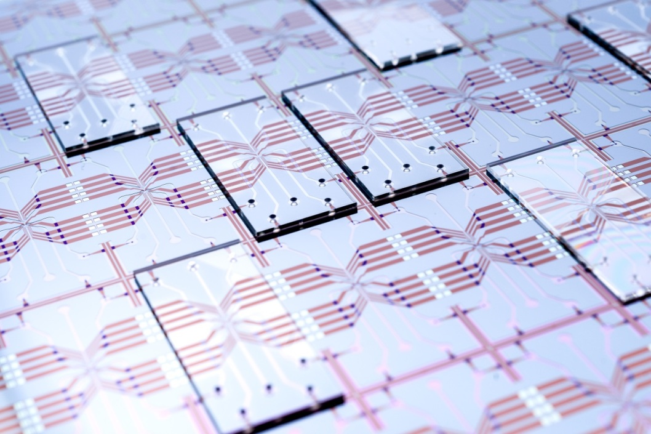

Johns Hopkins University and imec join expertise to build breakthrough medical tools
At imec, we envision that future consumers will go to their local pharmacy to buy disposable medical chips (link to movie).
With these labs-on-chip (LOC), we’ll be able to test blood, urine, or saliva for specific characteristics. We’ll assess the level of iron or vitamin D in our blood, or look if we have had a viral infection. Our smartphone may then send the results of these tests directly to our physician.
Such LOCs will also revolutionize the doctors’ practice. The technology will e.g. enable them to follow the effect of a treatment directly. As a result, they’ll see which of the possible drugs is the best fit for a specific patient.
In 2013, imec announced a collaboration with a top medical institute: Johns Hopkins University (USA). Imec will develop LOC disposable technology and the researchers at Johns Hopkins will develop the diagnostic tests to put on the chips. Around this platform, both parties want to assemble an ecosystem of companies to develop and distribute actual diagnostic products.
http://www.youtube.com/watch?v=Z3P5pwdbjBY&feature=c4-overview&list=UUcYtfWpZLpBqrWVXNBbL59Q
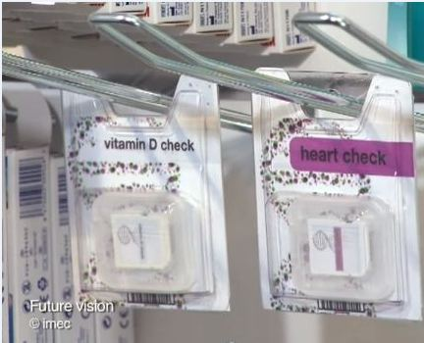

Supercomputers unlock the human body
Supercomputers are fast becoming essential tools for researchers in life sciences. As essential as lab experiments. Their computing power is key e.g. to speed up genome sequencing and to model biological processes in cells and tissues.
To develop dedicated supercomputing software for the life sciences, experts from the domains of computer sciences and life sciences will now collaborate and share their experience in the ExaScience Life Lab.
The ExaScience Life Lab is housed at imec. It is a collaboration between imec, Intel, Janssen Pharmaceutica and five Flemish universities.
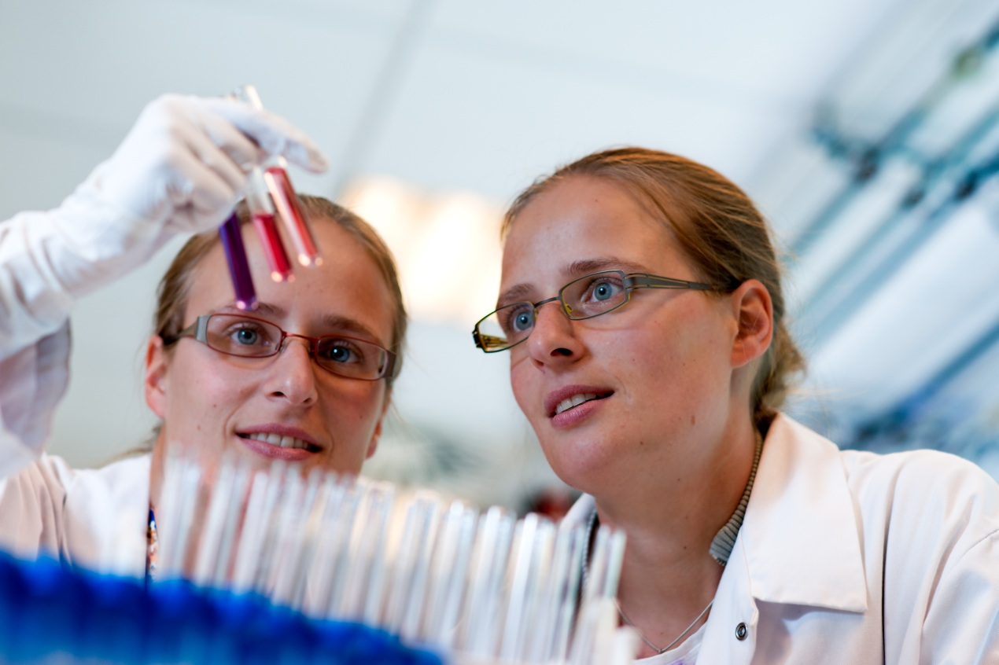

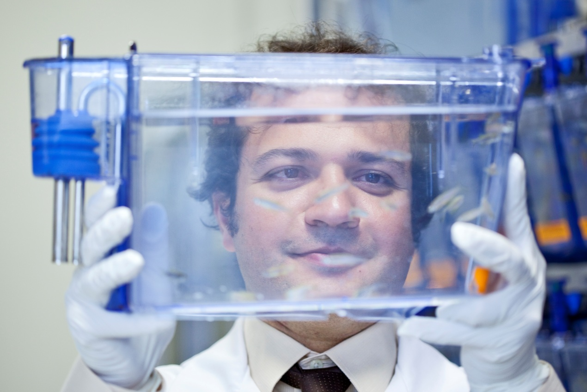
Better neuroprobes for brain research
At the 2013 ISSCC conference in San Francisco, imec showed a neuroprobe with 455 active electrodes and 52 channels integrated in the probe. The low-power device (1.45mW) was made in standard 0.18µm CMOS technology.
Neuroprobes such as this one are essential for brain research, notably for measuring the electrical activity in the brains of living animals.
Most commercially available probes have no more than 16 recording sites, and must be connected by a long wire to external electronic receivers.
Through using state-of-the-art silicon design and processing capabilities, researchers think it possible to create an innovative instrument that will provide an order of magnitude better performance than today's technology at 1/100 of the cost.
That is the goal of a new collaboration between imec and Howard Hughes Medical Institute (HHMI), the Allen Institute for Brain Science, the Gatsby Charitable Foundation, the Wellcome Trust, en UCL (University College London). The partners of this 4.2 million euro effort expect to complete the project and transition to the production of probes for the research community within four years.
