0 | As people enter the room they will be directed to select from a number of pictures of various “tools.” They will select the picture that “speaks” to them and their role as a project participant.  I will then ask the participants to find others with the same picture and discuss why they chose that particular picture.  After about 5 minutes for discussion I will ask participants to share the key points of the discussion in their groups.  (I will call back to some of these comments during my presentation.) | 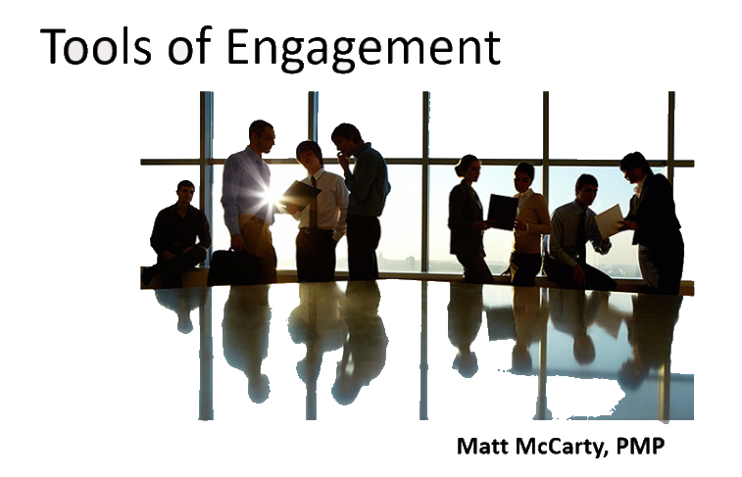 | 12 | It seems engaging, but I would give an introductory speech before everything gets started.
1 | Research has shown that sixty percent of all projects fail to meet project goals in either scope, budget or quality.  Another study found that 75% of IT project managers believe their software project will fail before it even starts!  Study after study indicates that, with all the growth of project management methods and ideas, we're still not getting the results we would like.  Why is that? What are we missing?  Different studies point to different key causes: lack of sponsor involvement, lack of team member accountability, lack of other resources...  I am going to suggest that many of the key causes of project dysfunction can be boiled down to one concept: | None | 2 | Good point
 | Engagement  As a project leaders, if you can increase the engagement team member and sponsor engagement, you will greatly improve our projects' chances of success. | 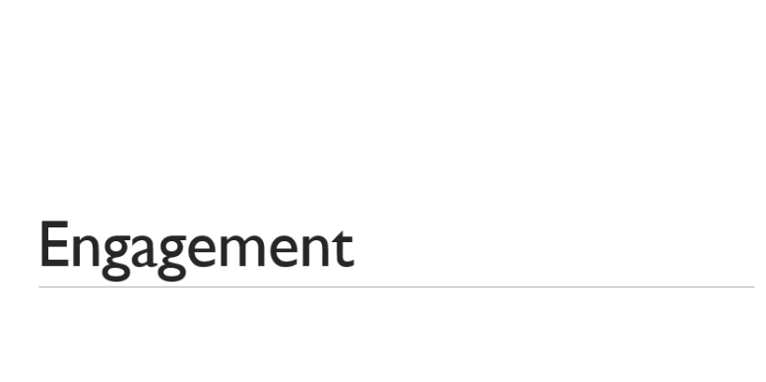
2 | So, what is engagement?  There are many different definitions of engagement.  I’m going to suggest that there are two aspects of engagement that everyone can agree on:  - Engaged team members are involved in, committed to and enthusiastic about their work  - They are willing to spend discretionary effort towards achieving the project goals. | 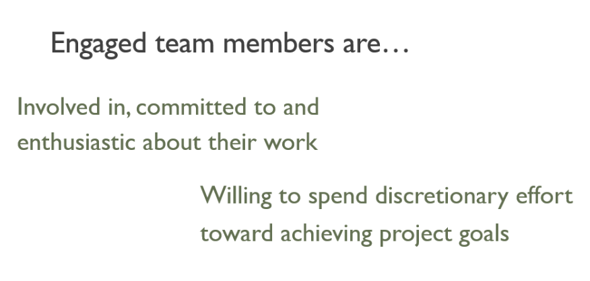 | 1 | Clear and concise
3 | We know through studies that engaged employees are better performers. They provide higher levels of service, they are more productive and they are better collaborators. | 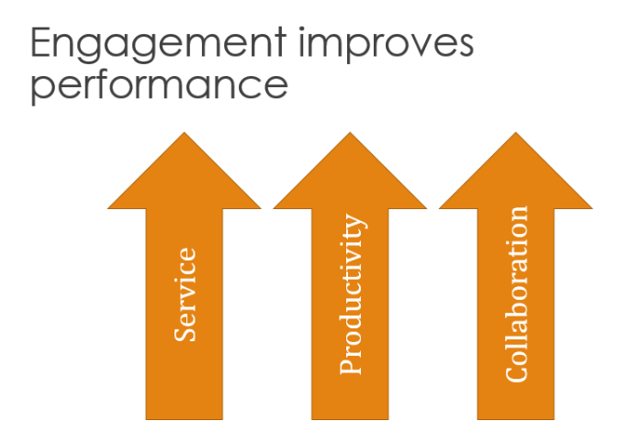 | 1
4 | However, the Gallup engagement study has shown that only 30% of employees in the US are engaged.  And that same study shows that 17% of employees are actively disengaged. That means they are trying be counter-productive! (These numbers have remained static for the last three years.)  And if this is true of organizations in general, think of what that means to us as project managers, because it’s probably truer of projects. | 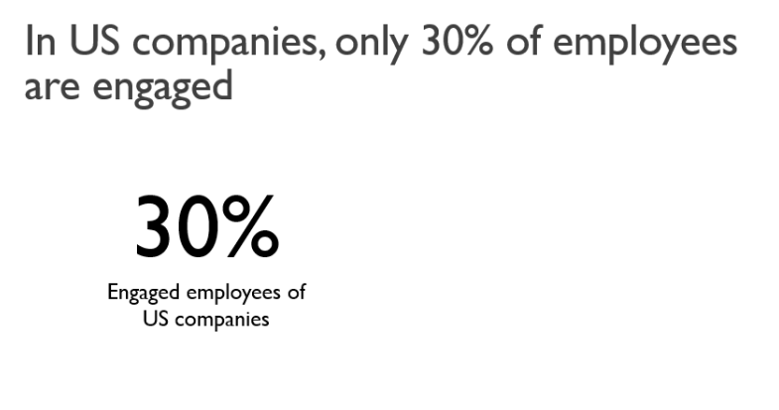  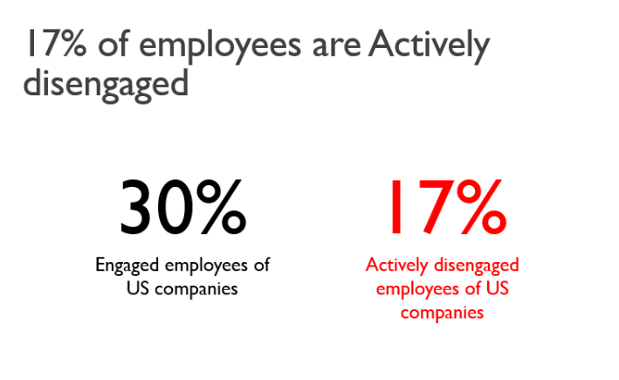 | 1 | Ok
5 | So what can we do; and why haven’t we been more successful?  I’m going to suggest that, as project managers and for organizations in general, when we’re trying to deal with problems of engagement we’re using the wrong toolbox.  We’re using managers’ tools. We set the plans and deadlines and communicate them to the team members, and if we don’t get the results we need we escalate to functional managers or sponsors who step in and try to make them compliant.  “You need to comply with the plan!”  Deep down we all know that you can’t force people to be compliant.  Products are compliant.  Processes are compliant.  Even service outcomes can be compliant.  People are engaged.  And the management tools are all about compliance, not engagement.  Processes and things are managed. People are led.  So I’m going to suggest that we need to use tools from the leadership toolbox. Specifically the “Serving Leadership” toolbox.  Today you are going to pick up six specific tools from the serving leadership toolbox that you can use as project leaders to help foster an environment of engagement. | None | 3 | Very clear
6 | Those tools are:  - Understand and articulate purpose  - Focus on outcomes and strengths  - Use engaging language  - Listen to learn  - Coach for growth  - Evaluate to engage  There are two things I want you to understand about these tools as we talk about them.  First of all, they build upon each other to form a system for building engagement.  Second, each one has two facets: mindset and practice. The mindset is where you come to grips with how you are going to employ this tool. How this tool will impact the way you think and operate. The practice are those things that you can do to manifest these tools in your project teams. | 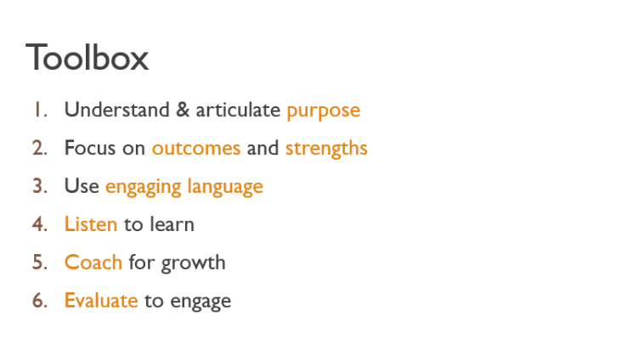  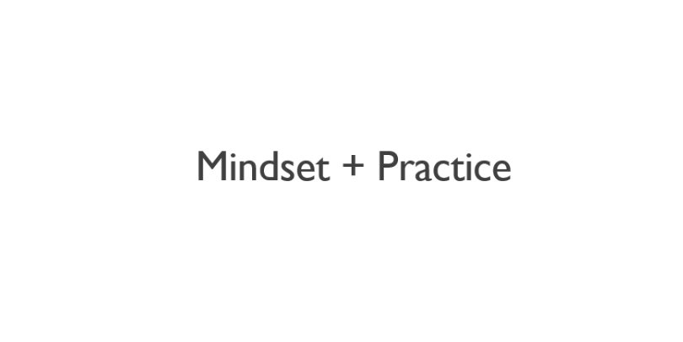 | 3 | Ok
7 | Let’s jump right in to the first tool: Understand and Articulate Purpose.  We can define purpose as “a stable and generalized intention to accomplish something both meaningful to the self and of consequence to the world beyond the self.”  We can boil that down to one word: | 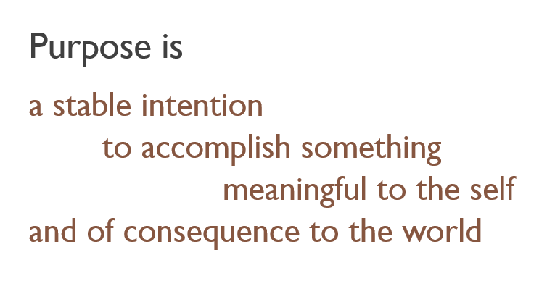 | 0.5 | Ok
8 | “Why?”  Why are we doing the things we are doing? We have to be able to articulate our “why” in a way that makes sense to each of our team members. You need to understand that the “why” for each team member may be different and as a leader your job is to make sure that all those individual whys can align with the overarching why. You have to make sure everyone understands the big Why.  In his book, “Start With Why,” Simon Sinek illustrates this with what he calls the Golden Circle  [explain and illustrate Sinek’s Golden Circle with flipchart]  [examples of how organizations focus on the why, Kelly, Apple]  As project managers we need to understand our why. And not only understand it, but articulate it. | 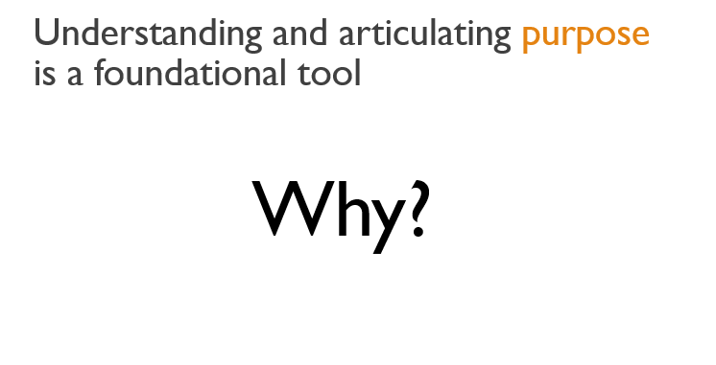  [use flipchart to illustrate Sinek’s Golden Circle] | 5 | Sinek is a great choice for keeping the audience engaged
9 | If we can understand and articulate our why that supports intrinsic motivation  [example of intrinsic motivation from Daniel Pink’s “Drive”]  Intrinsic motivation in turn supports Empathetic collaboration. If we are all working towards the same why we can collaborate better. What empathetic collaboration means is that if I, as an IT project manager, know and understand what life is like for my colleagues in the finance department. I know what life is like for my colleagues in accounting at year end. And that makes me more willing to collaborate and, again, to use my discretionary time to help them out.  And the top of the pyramid is Creative Autonomy. That’s where we want our people to be. Creative autonomy means that I can independently solve problems as they arise and in a manner that is consistent with the goals and objectives of the project or organization. | 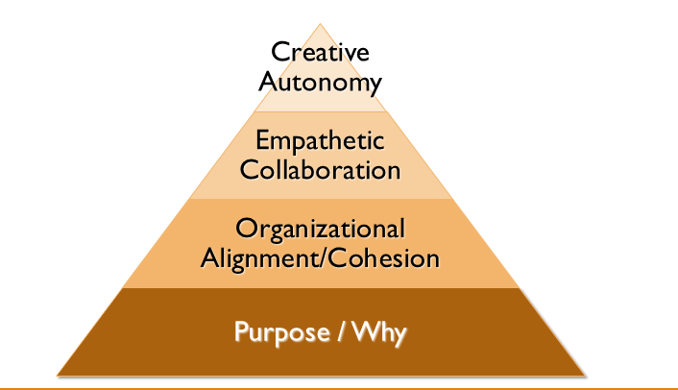 | 3 | Ok
10 | To illustrate how important purpose is I would like to share the story of Samuel Pierpont Langley.  [Share the story of Samuel P. Langley and the Wright Brothers.] | 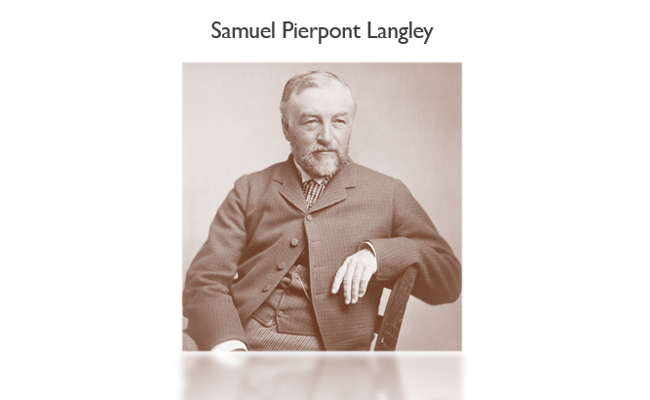 | 3 | Are three minutes going to be enough?
11 | The second tool in our Engagement toolkit is the ability to focus on outcomes and build on strengths. | 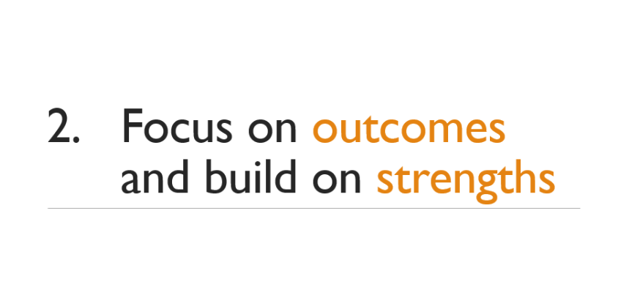 | 0.25 | Ok
12 | When we focus on problems we pay attention to what we DON’T want.  When we focus on outcomes we pay attention to what we DO want.  A problem focus fuels anxiety and disengagement. We want to run away from our problems.  An outcome focus fuels empowerment and engagement we come together to achieve our outcomes.  Focusing on problems leads to reactive behaviors. We get stuck in fight, flight or freeze mode.  Focusing on outcomes leads to creative behaviors and fosters innovative solutions to roadblocks and challenges.  Focusing on problems is limiting, we tend to slow down or even retreat. Any progress is made cautiously [driving example]  Focusing on (and celebrating) outcomes is accelerating. We are encouraged and tend to achieve our goals faster.  [Story about S.P. Langley and Wright bros. and how they approached the problem of steering the craft.] | 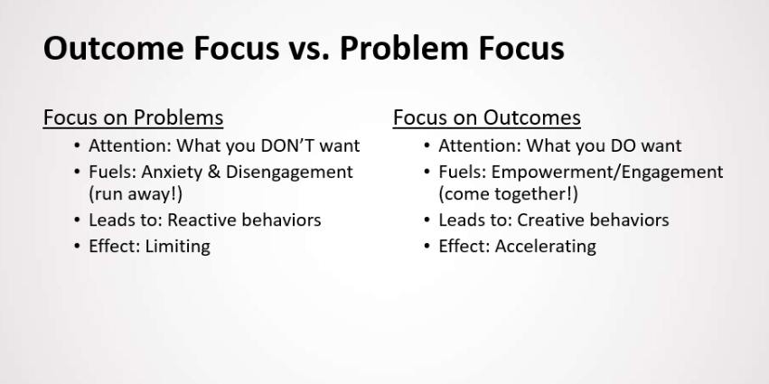  [I use a series of slides to differentiate between outcome and problem focus] | 4 | Really great point
13 | When dealing with individual team members many project managers tend to focus on their deficits. Where do they struggle? What are their weaknesses and how do we mitigate them?  An engaging leader will focus instead on a team members strengths. What are the possibilities? Where are the opportunities to make connections?  I’m not suggesting that you should ignore the challenges, I’m suggesting you use a different model. A different mix, if you will. Focus 80% on a team members strengths, their assets, possibilities and connections; and only 20% on their deficits, challenges and barriers. | 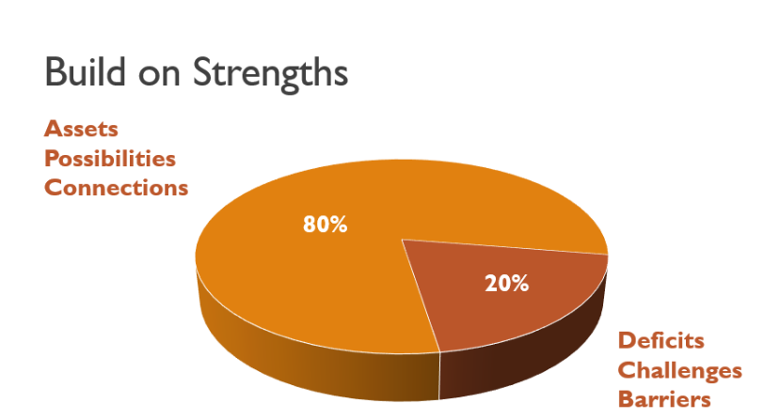 | 2 | Ok
14 | As we drill down a little further we come to the next tool that will help us foster engagement and that is the use of engaging language.  This is a very practical tool. It may seem simple but it has a very big impact. And it’s not easy because it is so tied to habit. I will admit that I struggle with this sometimes—but I’m working on it. | 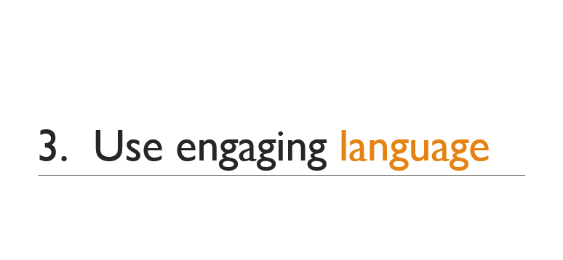 | 0.25 | Ok
15 | It is so important to be aware of how you approach conversations.  It’s a practical tool but it begins with a mindset. It’s helpful to think about how you are going to approach a conversation before you even begin that conversation.  There are four things you can do to make sure your conversations are engaging.  First is to Identify your assumptions and biases. What do you think and feel about the particular team members on your team?  Are they smart or are they stupid?  Are they resourceful or are they lazy?  Are they individuals who have something worthwhile to contribute or are they simply hands and feet to get done what you need to get done?  If you find yourself in that latter camp then you may need to do some introspection on “where am I coming from?” “What’s my outlook?” And, “How can I bring myself to where I can see these people as contributors rather than just resources?” And that gets back to focusing on strengths. | 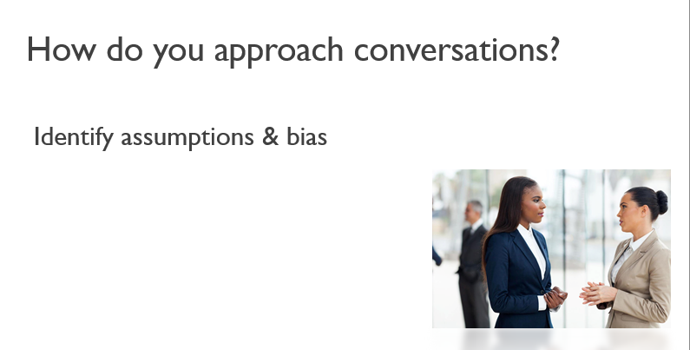 | 1.5 | One and half minute seems to be a very short amount of time, especially in this part where I think is a great occasion to get the audience engaged.
16 | Second, choose to have adult to adult conversations.  What do I mean by that?  Raise your hand if you are familiar with Transactional Analysis.  [give a brief background of TA]  In most management situations we are communicating in a Parent/Child relationship. “I’m going to tell you what I need you to do, you’re going to do it and then you’re going to tell me when it’s done.”  Nobody likes being told what to do. Think about when you were a young adult and your parents said, “look, this is how it’s going to be.” You didn’t like it, right? We rebelled for a reason.  The same is true for your team members. If you treat them like children, they’re going to become defensive and even rebellious.  They will disengage.  Choose instead to have Adult/Adult conversations.  A simple way to think of this is that you honor the choice of the individual.  In other words, I can describe the behavior that I want to see, or the outcome that I want to achieve, and I honor the choice of that individual to agree. I honor the choice of the individual whether or not to engage with me. | Ay | 2.5 | Might require detailed clarification, since the adult/adult part is not pristine
17 | So honoring the choice that your individual team members have allows you to have adult to adult conversations. It also allows you to have dialogues instead of monologues.  We want to make sure that the conversation is two-way.  I’m going to talk in a minute about some specific tools we can use to make sure we are getting that two-way flow.  We want to make sure the team member has input and that’s how we build engagement. | 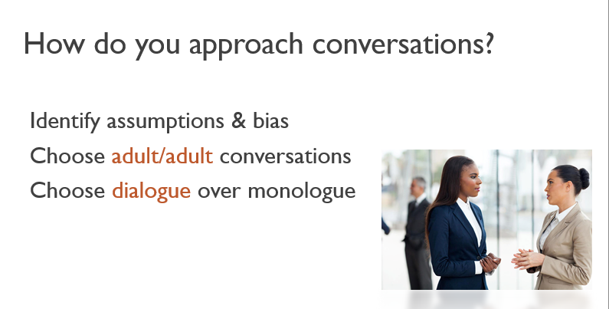 | 0.5 | Ok
18 | And we want to choose engaging words.  This is where I tend to struggle  [Hi, my name is Matt and I’m a disengaging word user]  The words we use are important. Experts will tell us that only 7% of our communication is through the words we use, yet many words carry meaning beyond the meaning. They have emotional weight and they can work for or against engagement.  Most of us aren’t even aware of our word choice—it’s habit.  To fully take advantage of this engagement tool we need to become mindful of our word choice. | 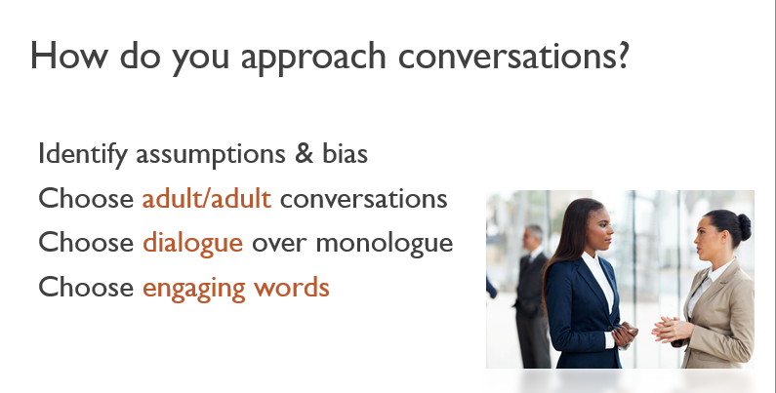 | 0.5 | Ok
19 | Take a look at this list of disengaging words and engaging words. You have this list in your handouts on page ___. What I would like you to do is circle three disengaging words that you know you have used. Think about how you have used them. Now select three engaging words that you could use instead and draw a box around them. Now take a few minutes to discuss your choices with the person next to you.  OK. Two more things about this list.  I want to call special attention to the word “but.” Raise your hand if you circled that word.  [discussion of the word choice “but/and”]  [examples of how to phrase requests using engaging words as opposed to disengaging words.]  Lastly, there’s one word that appears in both lists, raise your hand if you noticed that. Why do you think that word is on both lists?  [discussion of the word “want”] | 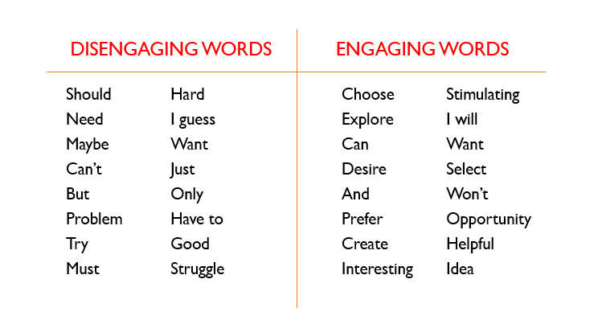 | 5 | Good
20 | Our fourth tool from the engaging leader’s toolkit is listening to learn.  I believe we have to practice listening. It’s not a skill we’re taught in school and most people are not that good at it. | 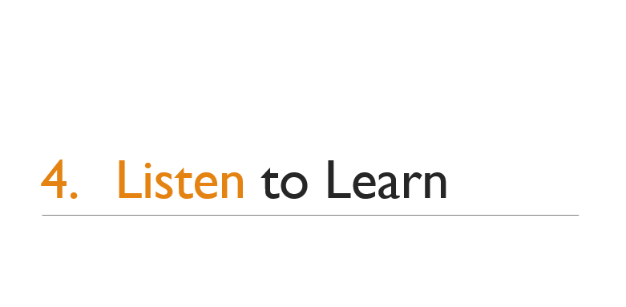 | 0.25 | Ok
21 | [Clark Terry story] | 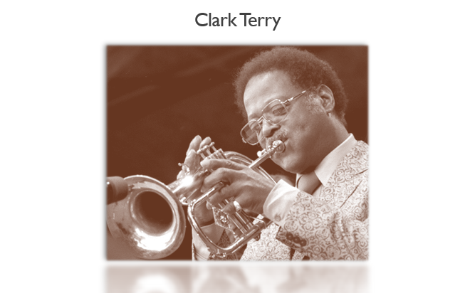 | 2 | Ok
22 | Ordinarily, people listen to [respond]  The effective serving leader listens to learn. As a leader you’re always on the lookout for new information. You know you don’t have all the answers. And you know that your team members are resourceful and creative contributors that are a gold mine of information!  I want to give you a framework that can help you listen to learn. I call it the PAIR listening framework (because it takes a pair to communicate.)  [explain the PAIR framework] | 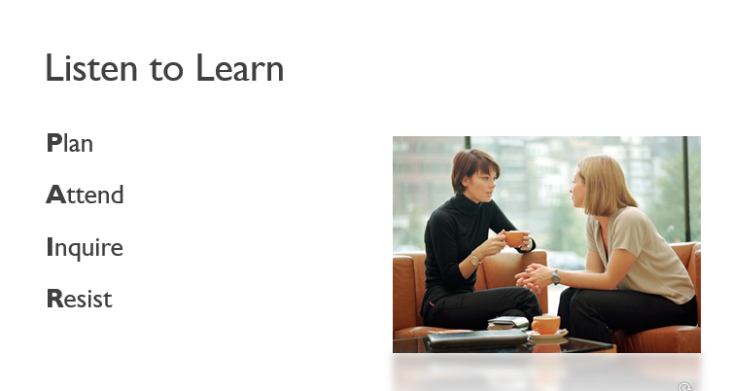 | 6 | Sounds engaging
23 | The fifth tool builds on the first four and it’s one of the most important, yet more challenging tools to master.  Coaching is a mindset that really embodies the spirit of the serving leader. As a serving leader you know that your job is to make sure the team members you lead are experiencing personal growth. That’s why they engage.  Too often, leaders think they have to know it all. They play the role of the hero. They have to have all the answers. They have to take everything on themselves. They become expert tellers. | 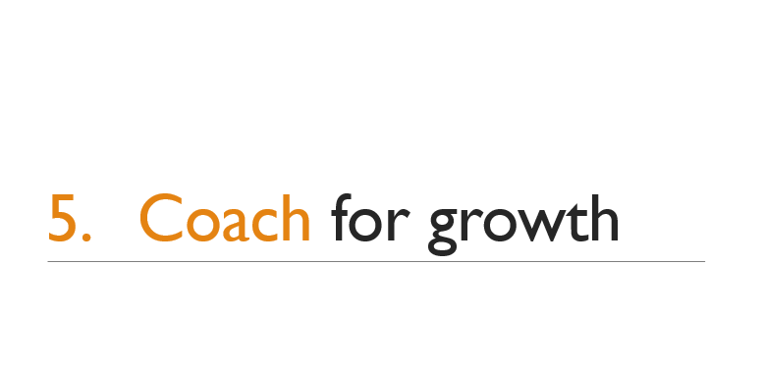 | 1 | Ok
24 | They dispense their knowledge like a PEZ dispenser gives candy.  Their team soon learns that they don’t have to take responsibility.  Engaging leaders choose to be thinking partners with their team.  Instead of giving them the answers, they help their team members think through the issues and develop their own, creative answers. Often better answers than the leader would have come up with. | 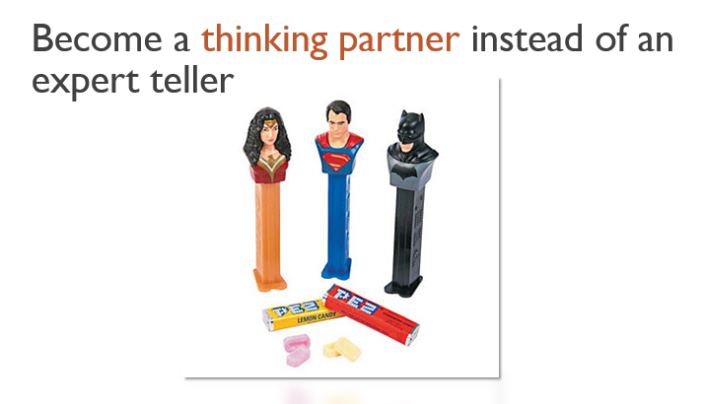 | 1 | Ok
25 | To be an effective coach, it’s helpful to have a framework.  I have developed a coaching framework I call the PRIDE framework. Here’s how it works:  [Explain the PRIDE coaching framework] | 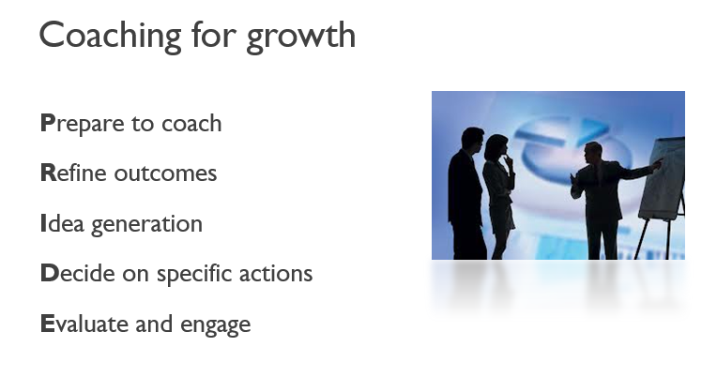 | 4 | Ok
26 | The sixth tool, evaluate to engage, brings all the other tools together.  Raise your hand if, when you think of evaluations, you think of once-a-year performance reviews.  Evaluations should be used to reinforce as well as to correct. | 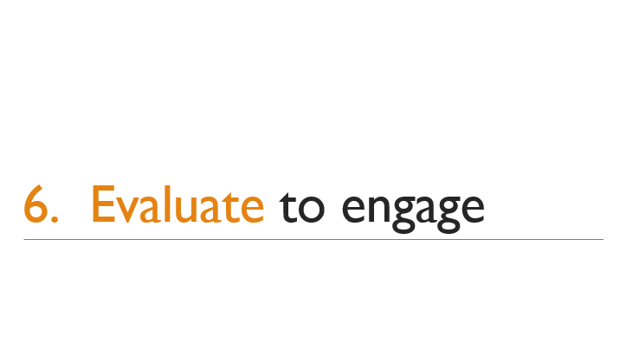 | 1 | True
27 | Like all of the other the other tools, engagement works best if you plan ahead.  Using a tool can be very helpful, especially when making corrections. It helps you stay focused on the desired outcome and keep emotions at bay.  [Share the Providing Candid Feedback Tool]  It is important to remember to use the other tools during your evaluation session: Listen to learn and coach for growth. | 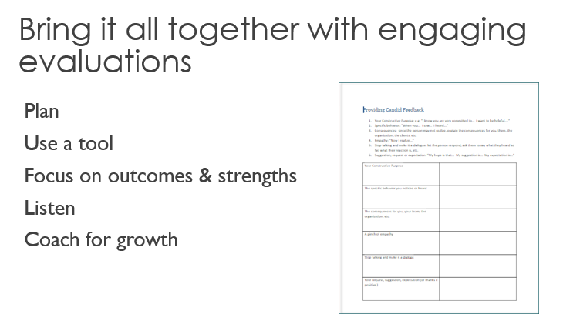 | 4 | Ok
28 | Before I wrap up, I would like to know what questions you have. | [none] | 3 | I would us these confrontation moments more often during the presentation, since the whole thing is about “engagement”
29 | Leading people can be a challenge.  Sometimes we think we are being efficient by attempting to force compliance on team members. It feels like the expedient thing to do.  Personal compliance is the enemy of engagement. Remember that compliance is for processes; people need to be engaged.  If you do the work to make sure your process are compliant and your people are engaged, success is virtually guaranteed.  Learning to use these Tools of Engagement isn't easy, but it's worth the effort. | 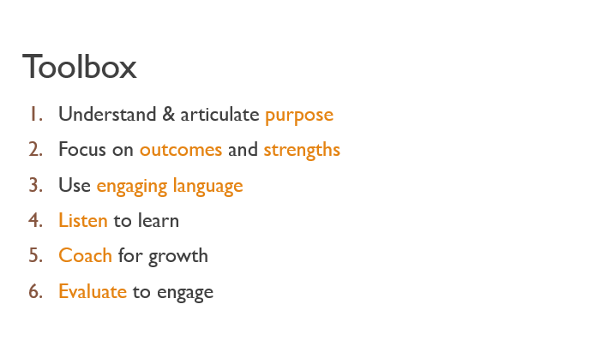 | 1 | Really interesting presentation

Learning Objective Alignment

Once you have completed the above exercise, please indicate which of the above slides align to your learning objectives:

- Learning Objective 1
Slides | 5-13; 23-27

- Learning Objective 2
Slides | 14-27

