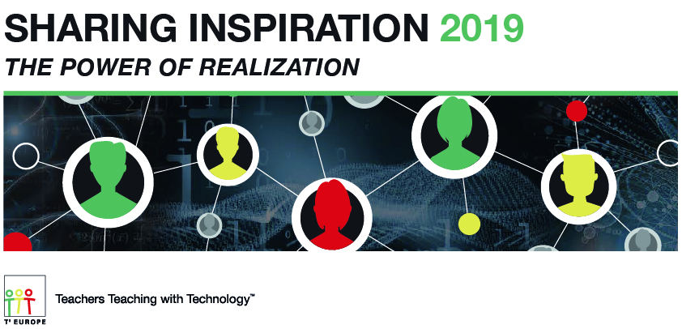

Sharing Inspiration 2019: The Power of Realization

*…for Policy Makers*

Conference Program

Committee of the Regions, Jacques Delors Building, Rue Belliard 99-101, B-1040 Brussels

2019, March 28

[t3europe.eu/sharing-inspiration](http://t3europe.eu/sharing-inspiration)

Conference partners in alphabetical order

|  |  |  |  |  |
| --- | --- | --- | --- | --- |
| Bildergebnis für digital europe | C:\Users\garkovl\AppData\Local\Microsoft\Windows\INetCache\Content.Word\logo_ce-en-rvb-hr.jpg | English |  | Logo Deutscher Verein zur Förderung des mathematischen und naturwissenschaftlichen Unterrichts e.V. - MNU |
| Bildergebnis für scientix | Semi logo | **C:\Users\a0197020\Documents\My Documents\Business Development\2016\happy faces\T3 Europe logo.png** |  |  |

**Sharing Inspiration – The Power of Realization**

***Sharing Inspiration – The Power of Realization*** is the 2019 edition in tradition of a biennial conference format of an educator network named **T³ Europe** [T-cubed]. The conference focusses on sharing best practices across Europe regarding curriculum aligned STEM education.

The 2019 conference theme is “The Power of Realization”. The conference theme has a double meaning: “to realize” in the sense of “**to understand**” and also in the sense of “**to make something concretely happen**”. This tackles the pedagogical efforts in the classroom as much as the efforts of policy makers and alike to set the right conditions.

Day 1 of the conference is specifically designed for **policy makers, industry stakeholders, key decision makers and leading educators** from across Europe. We expect 100+ participants exchanging about **classroom implementation** and structural questions **setting the context** regarding further improved **STE(A)M education**.

Venue: Committee of the Regions, Jacques Delors Building, Rue Belliard 99-101, B-1040 Brussels

|  |  |
| --- | --- |
| 09.00-09.30 | Registration |

|  |  |
| --- | --- |
| 09.30-09.55  *Auditorium* | **Welcome**  **N.N.** (CoR) |
|  | **Inspiration Space – A journey to the Stars**  **Dr. Insa Thiele-Eich** (Initiative „Die Astronautin“) |
| 09.55-10.30 | **Round 1: Classroom Implementation** – Warm-up |
| *Auditorium* | **Setting the Scene & Moderation**  Moderator: **Dr. Helmut Heugl** (Head of ACDCA (Austrian Center for Didactics of Computer Algebra, T³ Austria)  ***Curriculum*: New generation of STEM integrated curricula**  **N.N.** (MoE France)  ***Content*: Common Framework: Which natural science and mathematics competences need to be found in our society?**  **Jürgen Langlet** (former chairman of MNU and school principal)  ***Classroom Practice*: Innovating STEM classroom practices**  **Dr Agueda Gras-Velazquez**, Science Programme Manager, European Schoolnet |

|  |  |
| --- | --- |
| 10.30-10.50 | Coffee break |

|  |  |
| --- | --- |
| 10.50-12.10 | **Round 1: Classroom Implementation** – Deep Dive |
| *Workshop rooms* | ***Curriculum*: New generation of STEM integrated curricula**  Moderator and Impulses**: N.N.** [tbc] (MoE France)  ***Content*: Common Framework: Which natural science and mathematics competences need to be found in our society?**  Moderator: Jürgen Langlet (former chairman of MNU and school principal)  Impulses:   * *GeRRN - Common Framework of Reference for the Natural Sciences*  Jürgen Langlet * *Basic competencies in mathematics education*  Dr. Hubert Langlotz (vice-principal, MNU, T³ Germany)   ***Classroom Practice*: Innovating STEM classroom practices**  Moderator and Impulses: Dr Agueda Gras-Velazquez, Science Programme Manager, European Schoolnet |

|  |  |
| --- | --- |
| 13.10-13.45 | Lunch |

|  |  |
| --- | --- |
| 13.10-13.45 | **Round 2: Connecting to the Wider Context** – Warm-up |
| *Auditorium* | **Setting the Scene & Moderation**  Moderator: **Marc Durando** (Managing Director, European Schoolnet)  ***Policy*: Promoting STEM and digital competences in the EU**  **Dr. Vladimir Garkov** (European Commission - DG EAC)  ***Outreach*: The Role of the European Regions in Strengthening STE(A)M Education**  **Csabo Borboly** (CoR Commission for Social Policy, Education, Employment, Research and Culture (SEDEC) – Rapporteur Education, President of Harghita County Council)  ***Industry Role*: Technology Supplier and Employer – Industry between all chairs in STE(A)M?**  **Laith Altimime** [tbc] (President, SEMI Europe) |

|  |  |
| --- | --- |
| 13.45-14.10 | Break |

|  |  |
| --- | --- |
| 14.10-15.30 | **Round 2: Connecting to the wider Context** – Deep Dive |
| *Workshop rooms* | ***Policy*: Promoting STEM and digital competences in the EU**  Moderator and Impulses: **Dr. Vladimir Garkov** and **Annika Östergren Pofantis** (both European Commission)  ***Outreach*: The Role of the European Regions in Strengthening STE(A)M Education**  Moderator: **Csabo Borboly** (CoR- SEDEC)  Impulses:   * *N.N.* **Ms Grögör** [tbc], Representation of Saxony   ***Industry Role*: Technology Supplier and Employer – Industry between all chairs in STE(A)M?**  Moderator: **Laith Altimime** [tbc] (President, SEMI Europe)  Impulses:   * *Digital Skills and Job Coalition* **N.N.** [tbc] (Digital Europe) * *Professionals go back to School*  **Jeanette Axisa** (Transport Malta, member of STEM Alliance) |

|  |  |
| --- | --- |
| 15.30-15.50 | Break |

|  |  |
| --- | --- |
| 15.50-16.50 | **Reports & Discussion** |
| *Auditorium* | **Reports from deep dive sessions & discussion**  **Alexandre Titin-snaider** (Director Education Technology Europe, Texas Instruments)  **Khalil Rouhana** [tbc] (Deputy Director General DG Connect) |
| 16.50-17.00  *Auditorium* | **Summary & End**  **Ian Galloway** (Chairman T³ Europe) |

|  |  |
| --- | --- |
| 17.00-19.00 | Networking |

+++++++++++++++++++++++++++++++++++++++++++++++++++++++++++++

Sharing Inspiration 2019: The Power of Realization

*…for Educators*

Day 2-4 of the conference ***Sharing Inspiration – The Power of Realization*** target educators and teacher trainers. From Friday March 29 to Sunday March 31, around 180 T³ instructors from Europe, Australia and US and guests from other educational organizations will meet for 3 days and exchange ideas in various presentation and workshop formats on math, science and STEM education.

From the program:

* Basics of autonomous driving
* The development of concepts by using prefabricated applets
* Forensic science
* Linear programming; Python; et sim.
* STEM Camps & Projects
* M and S side by side
* Who Is Drowning in Our Trash? – STEM and Environmental Solutions
* How can physics and maths help each other
* Promoting Productive Struggle to Enhance Student Learning
* Engineering Practices in STEM Education
* Creating instructional videos
* The STEM debate from the Science perspective
* Pioneering the Future of Work in Teaching and Learning
* Next Generation Science Standards - 3-Dimensional Learning

More information: [t3europe.eu/sharing-inspiration](http://t3europe.eu/sharing-inspiration)