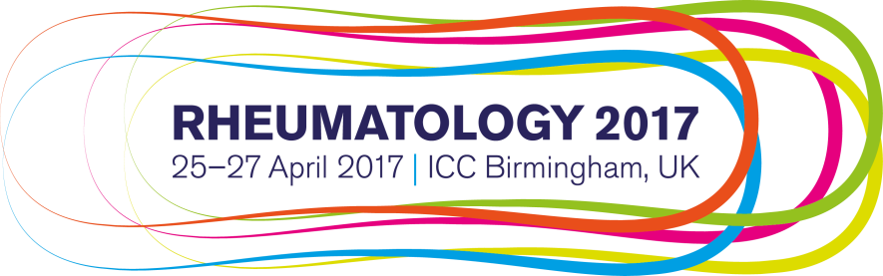

Dear <Line manager name> fai

I would like to ask for your approval to attend Rheumatology 2017, the UK’s leading conference for physicians and healthcare professionals in rheumatology. The meeting is organised by BSR, BHPR and BSPAR and will take place in Birmingham on 25 April – 27 April 2017.

The conference is focused on the exchange of best practice in rheumatology. It is essential that rheumatology professionals keep abreast of the latest developments in order to provide optimal patient care. This event will feature sessions presented by UK and international experts, consultant rheumatologists, trainees, AHPs, nurses, and other experts in rheumatology.

Going to this conference is a great investment of time and money. Whilst there I can update my knowledge, improve my practice and network with colleagues. In addition, the conference will provide me with CPD credits that I can use towards maintaining my <certification/registration>.

The conference will provide me with the opportunity to:

- better equip me for my job responsibilities and help ensure patients receive the latest evidence based care
- expand contacts with other rheumatology professionals
- learn about emerging trends and new research
- gain knowledge in specific areas of <areas of interest>

I have put together my itinerary for my time at the conference to show what a valuable learning opportunity this is.

Summary of Conference Costs

Conference registration fees £
Estimated travel costs £
Estimated hotel costs £
Estimated subsistence £ (Note that lunch is included in your conference fee)

Total £

At your request I can submit a post-conference report including a summary, major takeaway concepts, techniques or tips and action items for each of the sessions that I attended during the conference.

For more information about the conference, go to www.rheumatology2017.org.uk.

I would like to register by 10 February 2017 in order to take advantage of the discounted early bird registration rate.

Thank you for considering my request to attend Rheumatology 2017.

Yours sincerely,
<Your name>

