

**The *“Summit”* in Coeur d’Alene**

(An EMS and Emergency Services Conference) ***May 7th- 9th, 2015***

***www.emsassociates.com***

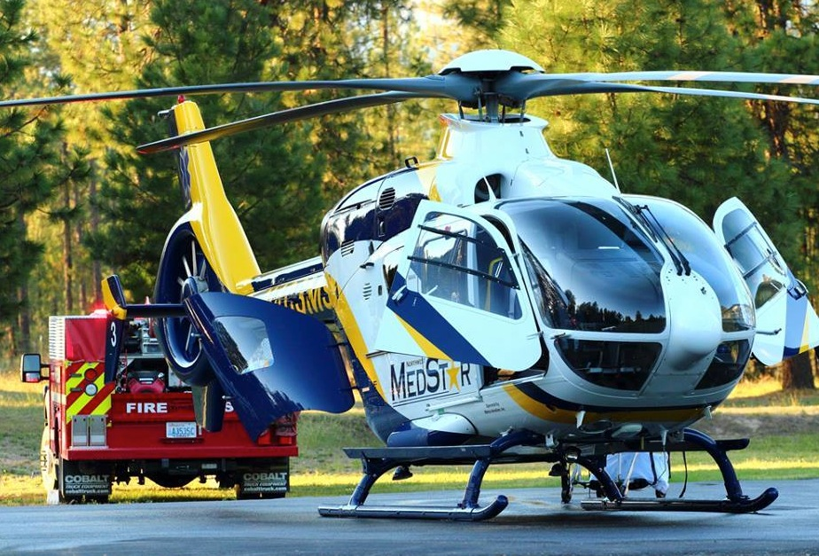

***3rd Annual*** 

|  |  |
| --- | --- |
| ***BUNDLE PACKAGES and PreCon Sessions*** | |
| ***ALL PreCon Sessions are held on Thursday, May 7th, 2015*** | |
| **The *“Procedural Cadaver”* Package***(choose ONE session)*  ***INCLUDES: Complete Conference*** (2) Full days + **One** (3hr.) PreCon  **(Pick ***ONE 3hr. session* [AM or PM] *ONLY***)  ***\*\*Procedural Cadaver Lab*...** **Hands-on Skills Lab**  ***(AM or PM) Sessions***  Available Times: ***(choose ONE session only)***  **- 7:00 am - 10:00am _______ Lab#1**  **- 10:30am – 1:30pm _______ Lab#2**  **- 2:00pm – 5:00pm _______ Lab#3**  **- 5:30pm – 8:30pm _______ Lab#4**  ***\*\*\*Includes Lab fee\*\*\**** | ***$395.00***  *(Choose* ***Cadaver*** *from the dropdown menu during online registration to receive this pricing)*  ***\*\*Includes Boat Cruise***  ***(1st-300 registrants)\*\****  ***PreCons are held on May 7th*** |
| **The *“4hr. PreCon”* Package***(choose ONE session)*  ***INCLUDES: Complete Conference*** (2) Full days + **One** (4hr.) PreCon  **(Pick ***ONE 4hr. session* [AM or PM] *ONLY***)  **\*\* HP-CPR “Provider-Level” Training** (Helbock, KCEMSS HP-CPR Team)  (8:00-12:00pm__________) ***OR*** (1:00pm-5pm__________)  **\*\* EMS Incident Command – Organizing Chaos** (Bouvier)  (8:00-12:00pm__________) ***OR***  (1:00pm-5pm__________) | ***$295.00***  *(Choose* ***4hr. PreCon*** *from the dropdown menu during online registration to receive this pricing)*  ***\*\*Includes Boat Cruise***  ***(1st-300 registrants)\*\****  ***PreCons are held on May 7th*** |
| **The *“8hr. PreCon”* Package** *(choose ONE session)*  ***INCLUDES: Complete Conference*** (2) Full days+ **One** (8hr.) PreCon  **(Pick ***ONE 8hr. session ONLY***)  \*\***EMS Extrication and Rescue Techniques – 2nd Due LLC _________)**  ***OR***  \*\****“SAVE a COP”*** – **Tactical Medicine/Active Shooter**  **_________)**  **All levels of Responder welcome: *LEO, EMS, Military*** | ***$375.00***  *(Choose* ***8hr. PreCon*** *from the dropdown menu during online registration to receive this pricing)*  ***\*\*Includes Boat Cruise***  ***(1st-300 registrants)\*\****  ***PreCons are held on May 7th*** |
| ***NOTE:*** *Once you chose your BUNDLE - you can sign up for an additional PreCon Session at the class prices listed for each session on the Registration Worksheet below...be sure that they don’t compete for the same time...* | |

***Registration WORKSHEET* (to assist in budgeting)**

|  |  |  |  |  |  |  |  |  |  |  |
| --- | --- | --- | --- | --- | --- | --- | --- | --- | --- | --- |
| ***BUNDLE PACKAGES*** *(Complete Conference)* | | | | | | | | | | |
| **NOTE: *If you are purchasing for more than ONE attendee – multiply price by # of attendees*** | | | | | | | | | | |
| ***\*\*NOTE: If you are responsible for registering more than ONE attendee...please send a separate list stating “which attendee is attached to which PreCon”*** | | ***If paid BY 5/1*** | | **If paid *AFTER 5/1*** | | | | | **Total** | |
| **The *“Procedural Cadaver”* Package**  Select – “***Cadaver”*** from the dropdown menu  *(multiply number of attendees)* | | **$395.00** | | $425.00 | | | | |  | |
| **The *“4hr. PreCon”* Package**  Select – “***4hr. PreCon”*** from the dropdown menu  *(multiply number of attendees)* | | **$295.00** | | $325.00 | | | | |  | |
| **The *“8hr. PreCon”* Package**  Select – ***“8hr. PreCon”*** from dropdown menu  *(multiply number of attendees)* | | **$375.00** | | $400.00 | | | | |  | |
| **\*\*PLEASE NOTE: *If you choose to ADD an additional PreCon (AM/PM or Cadaver Lab), you will be charged an additional amount at that individual PreCon rate.***  ***Please select the Pre-Con Plus attendee category at the START of registration.***  **OR...** You may choose an ***“A la Carte” Option***... (Individual selections)  You may pick one, two or even three PreCon sessions (an AM/PM or Cadaver Lab) | | | | | | | | | | |
| ***“A la Carte” Options*** *(Individual Selections)*  *\*\*\*Classes listed below are on Thursday, May 7th, 2015\*\*\** | | | | | | | | | | |
| **EMS “Rescue/Extrication” Techniques**  **Logging, Low Angle, Trench, Roof Top** | **(8hr.)** 8-5pm | **$175.00** | | $195.00 | | | | | |  |
| **“Save a Cop” (EMS, LEO, Military)**  **Tactical Medicine/Active Shooter** | **(8hr.)** 8-5pm | **$175.00** | | $195.00 | | | | | |  |
| **HP-CPR “Provider-Level” Training**  *Instructor* – **HELBOCK** (4hr) | **AM Session**  (8am-12pm) | **$100.00** | | $125.00 | | | | | |  |
| **HP-CPR “Provider-Level” Training**  *Instructor* – **HELBOCK** (4hr) | **PM Session**  (1pm-5pm) | **$100.00** | | $125.00 | | | | | |  |
| **EMS Incident Command**  *Instructor* - **BOUVIER** (4hr) | **AM Session**  (8am-12pm) | **$100.00** | | $125.00 | | | | | |  |
| **EMS Incident Command**  *Instructor* - **BOUVIER** (4hr) | **PM Session**  (1pm-5pm) | **$100.00** | | $125.00 | | | | | |  |
|  | | | | | | | | | | |
| ***Procedural Cadaver Lab*** *(sessions 1-4)* | | | | | | | | | | |
| **Procedural Cadaver Lab** #1  *Instructor* - **BOLLETER** (3hr) | **Session #1**  (7am-10am) | | **$175.00** | | | $195.00 | | | |  |
| **Procedural Cadaver Lab** #2  *Instructor* - **BOLLETER** (3hr) | **Session #2**  (10:30am-1:30am) | | **$175.00** | | | $195.00 | | | |  |
| **Procedural Cadaver Lab** #3  *Instructor* - **BOLLETER** (3hr) | **Session #3**  (2pm-5pm) | | **$175.00** | | | $195.00 | | | |  |
| **Procedural Cadaver Lab** #4  *Instructor* - **BOLLETER** (3hr) | **Session #4**  (5:30pm-8:30pm) | | **$175.00** | | | $195.00 | | | |  |
|  | | | | | | | | | | |
| **Individual Conference Day(s)**  (Friday or Saturday) |  | | **$130.00** | | | | $150.00 | | |  |
| ***Add up all of your selections and total the amounts...*** | | | | | | | **TOTAL:** | | |  |
| ***Idaho State Sales Tax – add 6.0% (if tax exempt, include a copy of your tax exempt letter or certificate with your registration)*** | | | | | **TAX: (6.0%)** | | |  | | |
| ***Total Registration Amount*** | | | | | **Total:** | | |  | | |

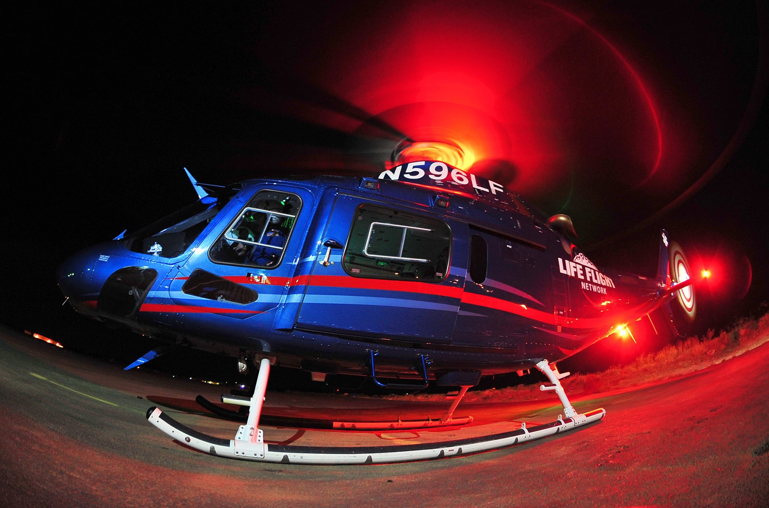

***Website:*** [www.emsassociates.com](http://www.emsassociates.com)

***Facebook:*** [www.facebook.com/emsassociates](http://www.facebook.com/emsassociates)

***Twitter:*** @emsassociates

**Instagram:** @emsassociates

***Mail In Form***

|  |  |  |  |  |  |  |  |
| --- | --- | --- | --- | --- | --- | --- | --- |
| **Last Name:** | | | | **First Name:** | | | |
| **Street Address (Include PO Box):** | | | | | | | |
| **City:** | | | | **State:** | | | **Zip:** |
| **Phone:** | | | | **Work Phone:** | | | |
| **E-Mail:** | | | | **EMS Department E-Mail:** | | | |
| **Affiliated Title and Agency (Department)** | | | | **Agency Address:** | | | |
|  | | | | | | | |
| **Payment Method**  *(Select Option)* | **Check Enclosed □**  ***Make checks payable to:* “EMS Associates”**  ***Mail to Framework (address below)*** | | | | **Purchase Order □**  **Credit Card □** | | | |
| **PURCHASE ORDER # *(terms = net 30 days)*** | | | | | | | | |
| **Company Name:** | | | | | | | | |
| **Billing Address:** | | | | | | | | |
| **E-Mail Address:** | | | | | | | | |
| **City:** | | **State:** | | **Zip:** | | | | |
|  | | | | | | | |
| **CREDIT CARD PAYMENT**[http://t1.gstatic.com/images?q=tbn:ANd9GcSsvVFB1ZZiJkyjG4sj9YtnMD6kYwUBPGHUO7CYW4rjygo1z-LO](http://www.google.com/imgres?imgurl=http://www.janablog.com/wp-content/uploads/4_visa_mastercard_american_express_logos.png&imgrefurl=http://www.janablog.com/visa-mastercard-american-express-discover-logo&h=585&w=2489&sz=133&tbnid=_VCpaJe3ZoSkCM:&tbnh=29&tbnw=122&prev=/search?q=mastercard+logo&tbm=isch&tbo=u&zoom=1&q=mastercard+logo&usg=__x_srl2mQx8rbl8Xd_1ld1TZw2bE=&docid=vPb3WObsNJmY2M&hl=en&sa=X&ei=W5AYUaz6GqKsjALy-ICwDw&ved=0CEQQ9QEwAg&dur=1442) | | | **Cardholder Name:** | | | | |
| Billing Address: | | |  | | | | |
| City: | | | State: | | | Zip: | |
| Card Number: | | | | Expiration Date and CVV code: | | | |
| Authorized Signature: | | | | | | | |
| Contact Person: | | | | Phone: | | | |
| E-Mail Address (required for credit card payment): | | | | | | | |

**MAIL COMPLETED FORM TO: Framework Meetings and Destinations**

**Attn: Registration, The *"SUMMIT"* CDA 2015**

**2192 E. Grandview Drive**

**Coeur d'Alene, ID 83815**



**The *“Summit”* in Coeur d’Alene**

(An EMS and Emergency Services Conference) ***May 7th- 9th, 2015***

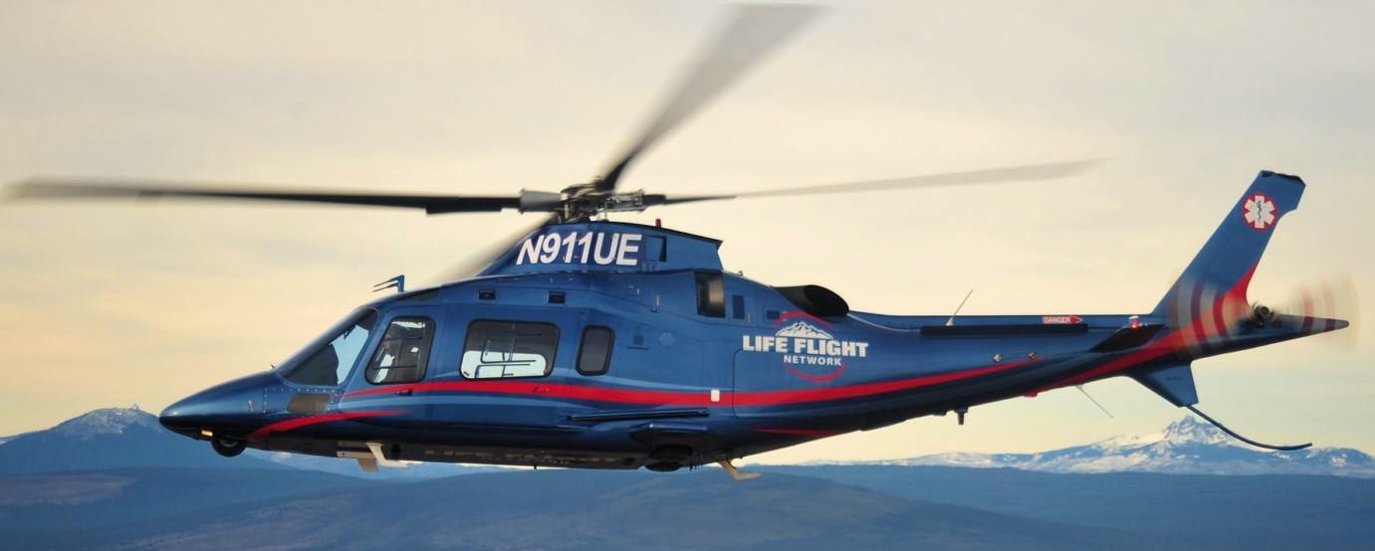

***Website:*** [www.emsassociates.com](http://www.emsassociates.com)

***Facebook:*** [www.facebook.com/emsassociates](http://www.facebook.com/emsassociates)

***Twitter:*** @emsassociates

**Instagram:** @emsassociates