SOMA Meeting Request Form (Non-Affiliate)

Name of Meeting: Click here to enter text.

Committee/Chapter/Group Responsible: Click here to enter text.

Contact Name: Phone Number: Click here to enter text.

Contact Email: Click here to enter text.

Requested Date: Click here to enter text. Requested Time: Click here to enter text.

Number of Attendees Expected: Click here to enter text.

Room Setup Requested (REQUIRED)

☐ Rounds ☐ U-Shape ☐ Hollow Square ☐ Classroom
☐ Theater ☐ E-Shape ☐ Banquet 6 Ft. tables ☐ Conference

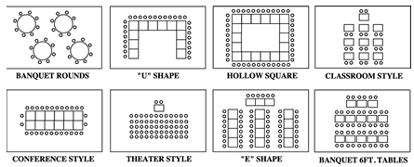
☐ Podium
☐ Head table
# 3 of presenters at Head Table
Audio/Visual Needs (REQUIRED)
Please note if your committee/chapter/group does not have a budget for AV through SOMA, you will not have AV or you will need to provide payment in advance for these items.

☐ No AV required

☐ LCD Projector
☐ Laptop
☐ I will be bringing my own laptop for projection
☐ Podium Microphone

☐ #____ Wireless Lavaliere Microphone(s)
☐ # Click here to enter text. Table Top Microphone(s)
☐ # Click here to enter text. Flipchart(s) and Markers
☐ Other: Click here to enter text.

Food & Beverage Needs
Please note if your committee/chapter/group does not have a budget for F&B through SOMA, you will not have F&B or you will need to provide payment in advance for these items.

Please list: Click here to enter text.

Person/Organization Responsible for Additional Payment (for additional AV/F&B only)

Name: Click here to enter text. Phone: Click here to enter text.

Email: Click here to enter text.
Address: Click here to enter text.

