Dr. Terri Cooper

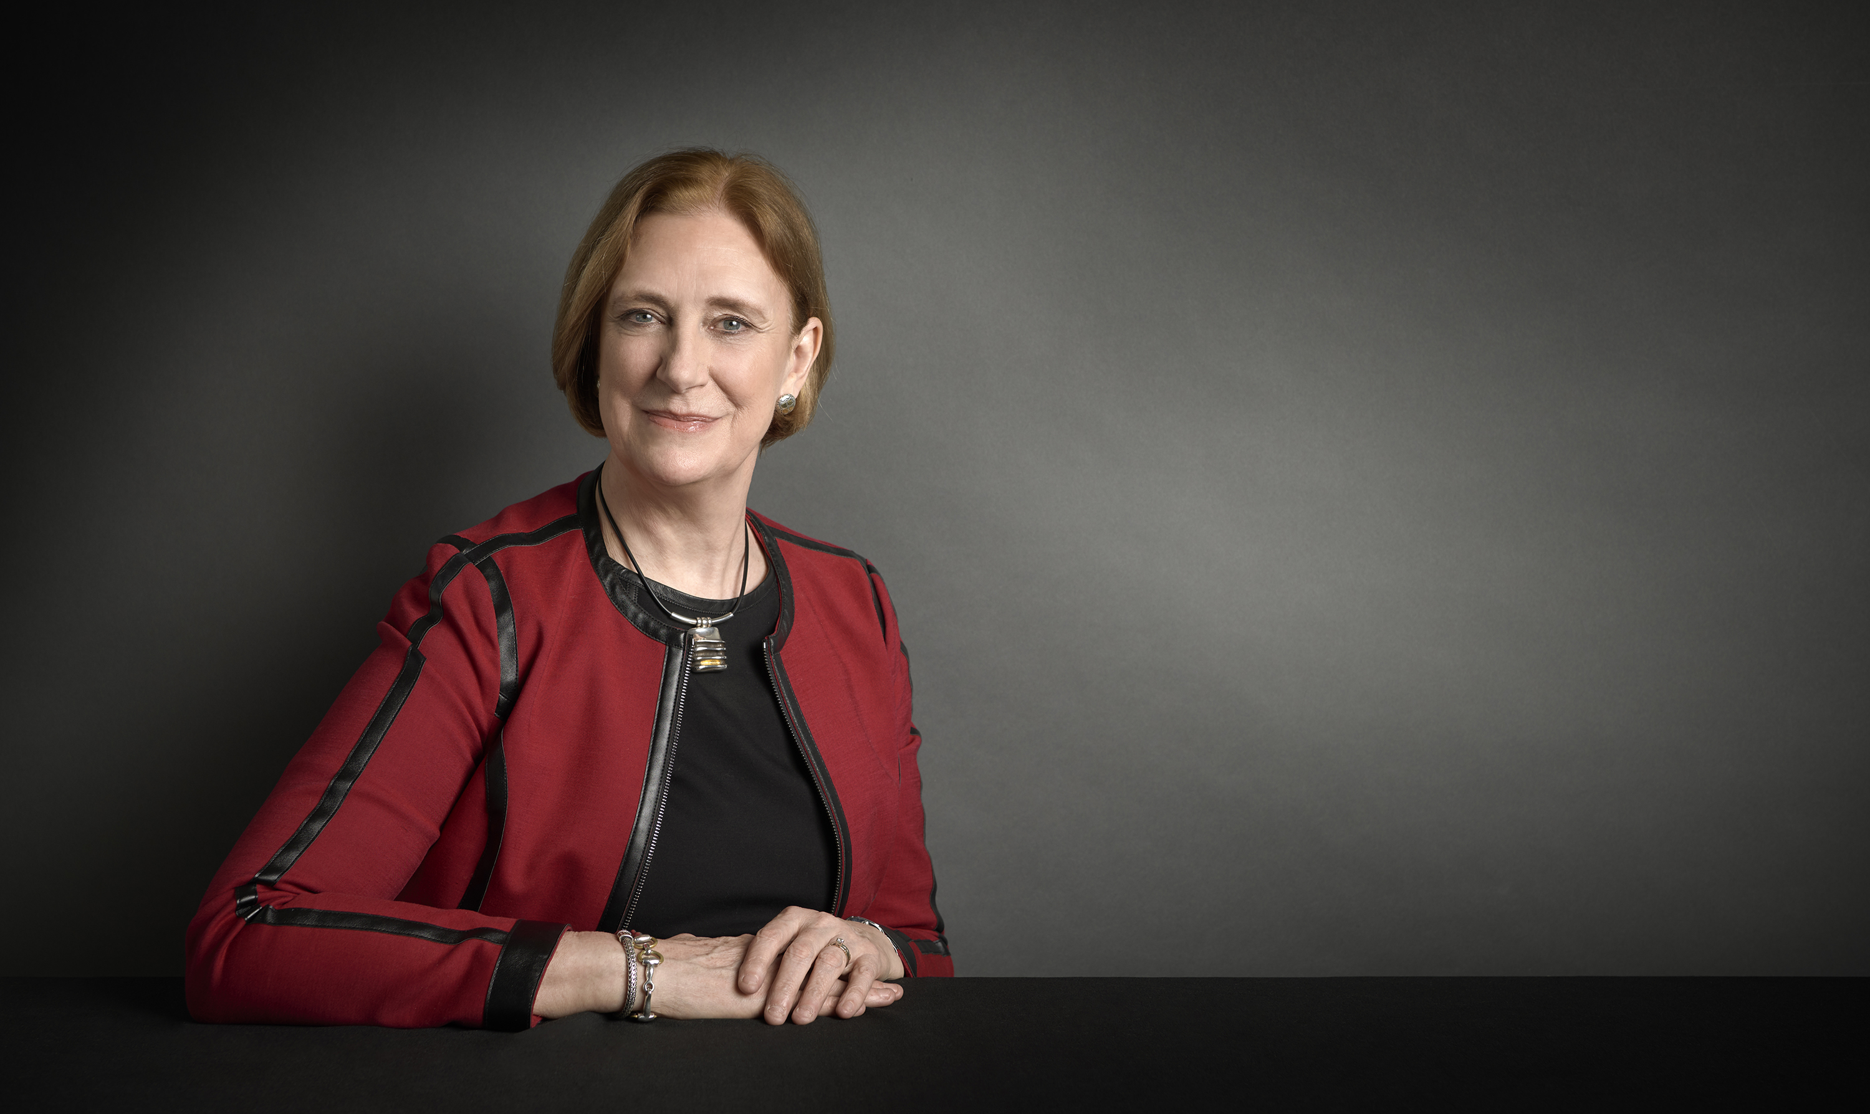
Chief Inclusion Officer, Deloitte US

Dr. Terri Cooper believes a strong culture of inclusion is key to serving clients with distinction, as complex global challenges increasingly require diversity of thought and experience.

As Chief Inclusion Officer for Deloitte US, Dr. Cooper is a member of Deloitte’s Executive Committee. In her role, Dr. Cooper spearheads Deloitte’s strategy to engage professionals throughout the talent lifecycle and foster a culture where everyone feels like they can connect, belong, and grow.

Dr. Cooper believes each and every individual has a role to play in creating an inclusive culture, and is passionate about instilling Deloitte’s Six Signature Traits of an Inclusive Leader - such as cultural intelligence and cognizance of bias - across the organization.

A Principal in Deloitte’s U.S. Consulting practice, Dr. Cooper has spent more than two decades in leadership and strategic advisory roles in the life sciences and health care industries. Most recently, she served as Deloitte’s Global Healthcare Sector leader in the US. Before becoming a consultant, she spent eight years in the pharmaceutical industry, in roles ranging from basic research to clinical development, regulatory affairs, sales, marketing, new product development, and licensing. She contributed to the launch of a major new pharmaceutical brand while also maintaining the growth of older existing products in competitive therapeutic markets.

Born and raised in a small town on the southeast coast of England, Dr. Cooper was the first in her family to attend college. She holds a Joint Honors Bachelor of Science Degree in Chemistry and Pharmacology and a PhD in Pharmacology from the University of London, U.K.

Dr. Cooper serves on the City Year New York City Women’s Board and Friends of Patients at the NIH. In her free time, she enjoys skiing, horseback riding, fly fishing, and bird watching.

Dr. Cooper frequently participates at industry conferences, speaking on topics relating Diversity and Inclusion as well as issues affecting the Life Sciences and Health Care industry.

Accomplishments:

- Fortune Most Powerful Women Summit 2018 panelist
- Fortune Magazine’s “100 Best Companies to Work For®” list
- Working Mother Magazine’s “100 Best Companies for Working Mothers”
- PEOPLE Magazine “Companies that Care”

Areas of expertise:
- Creating a culture of inclusion
- Inclusive leadership traits
- Mentoring and sponsorship

