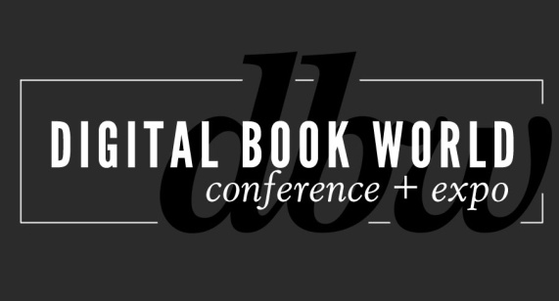
Digital Book World Readies for 5th Anniversary Event
Organizers tout top speakers, exclusive partnership programs, and specialized tracks
NEW YORK - September 20, 2013 - Digital Book World, the leading industry event in digital publishing strategy, has released select preview program details and opened registration for their January 13-15, 2014 event taking place in New York.
As the largest conference and expo dedicated solely to the business of digital publishing worldwide, Digital Book World, an F+W Media event, is produced in partnership with Publishers Launch Conferences and attracts an international audience of 1,500 industry professionals, 50 exhibitors and more than 100 speakers. http://conference.digitalbookworld.com
Key speakers include: Brad Stone, Bloomberg Businessweek writer and author of “The Everything Store: Jeff Bezos and the Age of Amazon” (October, Little Brown & Co). Stone, who has covered Amazon and Silicon Valley for more than 14 years, provides readers with the first ‘in-depth, fly-on-the-wall account of life at Amazon’ in his new book and will provide his perspective on Amazon and online retailing. Tim O’Reilly, Founder and CEO, O’Reilly Media, is also scheduled to speak. Since 1978, O'Reilly, “The Oracle of Silicon Valley” has been a catalyst of development, focused on technology trends that really matter in the industry.
“Change is always a good thing when you’re prepared to capitalize on it,” said David Nussbaum, Chairman & CEO of F+W Media. “That’s our mission for Digital Book World – to educate publishers to the trends and the opportunities in digital, and to exploit the many new ways we can reach and serve our readers and our customers more efficiently and effectively.”
"Our fifth year programming Digital Book World has us continuing to evolve along with the industry," said Mike Shatzkin, co-owner of Publishers Launch Conferences. "We have an exciting series of presentations about Amazon; we'll be featuring Tim O'Reilly in his first publishing conference appearance outside Tools of Change. Once again, we'll have unique data: about start-ups and about author preferences in a newly enabled self-publishing world."

Digital Book World consists of its customary 2-day multi-track, multi-faceted digital publishing program and exhibition hall. Other program details released for the January event:
- Specialized Tracks including: Academic/Scholarly; Change Management & Organizational Design; Children’s /K-12 Publishing; Marketing and the Future of Discovery; New Business Models; and Start-Ups & Technology.
- Launch Kids: Children’s Publishing Goes Digital, produced by Publishers Launch Conferences
- Creative Management of Authors and Literary Properties workshop presented by Jason Allen Ashlock of Movable Type Management
- Hands-on Technology: Practical Studies in ePub3 Coding, presented by Joshua Tallent, Chief EBook Architect, Firebrand Technologies; UX Design, presented by Anne Kostick, Partner, Foxpath IND
Digital Book World 2014 offers an exclusive opportunity to network with senior-level publishing professionals, from marketers and editors to publicists, to developers, librarians and booksellers. To learn more about the program and to register for the 5th Annual Digital Book World Conference+ Expo, visit http://conference.digitalbookworld.com. Early bird discount expires Monday, October 7th.

About F+W Media, Inc.
F+W Media, Inc. is a community-focused, content creator and marketer of products and services for enthusiasts offering a diversified portfolio of ecommerce, books, ebooks, magazines, events, competitions, education services, instructional video, and more. The Company is considered the authoritative, trusted voice guiding enthusiasts with relevant, helpful information and connecting them to the products and services they need to achieve success, profit from
their passion, or find inspiration. www.fwmedia.com.

Press Inquiries:
Stacie Berger, Vice President, Communications, F+W Media, Inc.
513.531.2690 x 11457
stacie.berger@fwmedia.com

Partnership and Exhibitor Opportunities:
Gary Lynch, Group Publisher, F+W Media Design Community, Digital Book World
212-447-1400 x12102
gary.lynch@fwmedia.com

