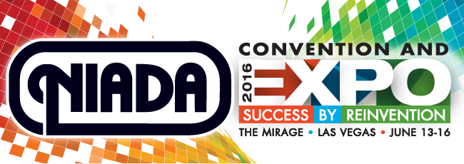

Topic: Session Title:

Category Track (circle one): RETAIL BHPH COMPLIANCE

Presenter(s)/Panelists (attach a brief bio, picture (jpeg), and contact info for each):

Objectives:

Description:

Date and time preference: June 14 June 15 June 16 AM PM

Will you be using a Power Point presentation? Yes No
NIADA requests that you use your own laptop and presentation clicker. We will provide an LCD projector and screen.

Preferred Stage Set Up Podium No Podium Chairs Behind Table Stool(s) Chair(s)

Session Video
To make the valuable information from your session available to individuals who cannot attend, NIADA may video this session and make it available for purchase via the NIADA website after the convention. This is an excellent opportunity for presenters as it expands their exposure to a larger audience.
*Submission of this proposal requires your acceptance of this requirement and conveys your permission to video your session.

Session Contact Information

Name:
Company:
Email:
Phone:

