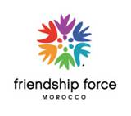
2016 FF Marrakech Conference, Morocco
Activities planned for Pre and Post-conference
Programs and what to know about Morocco:

This FF exchanges in Morocco is An exceptional and unique opportunity to get a first hand immersion in the Moroccan Moroccan culture and society. You will meet, debate and interact with Moroccans from all social levels through meetings and inter actions with officials and deputies, Activists and associations leader, women cooperatives members and, of course, you will enjoy the Moroccan hospitality, cooking and art workshops during your home stay days.
This exchange is, also, an amazing opportunity to visit and discover the hidden secrets of some of the most attractive cities in the world Fes, Marrakech and other fascinating imperial cities and Volubilis; the Roman city ruins in Morocco.

- What should ambassadors know about the weather and activity levels when preparing and packing for the exchange?

It's warm and sunny for most of the year in Morocco. During the peak summer months July and August it gets uncomfortably hot especially in Marrakech, Fes and southwest Morocco, towards the desert. Casablanca, Rabat and Essaouira are a bit more comfortable in the peak of summer because they benefit from a cooler ocean breeze.In the Mid Atlas, the region of Ifrane and Azrou mountains, the weather is often cool by the end of the afternoons and evenings in summer and cold and snowy in winters.
During the adviced months, above, light clothes are fine but a sweather and a light rain coat could be useful.

- What do international visitors often find surprising when they visit our city and country for the first time?

* The authenticity and modernism of Morocco: Very well preserved parts of
cities that are centuries old and others that are contemporary where people
live a modern/ traditional life style.
* Learning about how Morocco became a leading country of reforms and Human development in North Africa and the Midel East.

- What do international visitors love best about our city and country?
* The stunning cultural and geographical diversities in Morocco
* The sand dunes, camel treks and the nights under the nomad’s tents.
* The hospitality of the Moroccans

- What is one traditional dish our ambassadors will taste?
Tajines
Mishoui (Complete roasted lamp prepared in the local traditional way)
Pastilla

- What kind of activities do members of the host club enjoy?
1/ Cooking workshop
2/ Art workshop
3/ Picnic in the cedar trees forest and monkeys viewing
4/ Wedding party
5/ Inter action with children in desabilities associations and the women of the cooperatives
6/ Cross cultural discussions and fun with our International Ambassadors.

- What is our favorite part of the host itinerary?
All the parts of the host itinerary are great: Casablanca and Rabat are diffrent from Fes and Marrakech. Azroumountains are different from the Errfoud sand dunes and desert. In fact, each part has its particular attractive characteristics.

- What do we love best about life in our city? In our country?
Peaceful and exciting with a lots of warmth in people relations

- What will the Ambassadors be talking about long after the exchange is over?
Thy will feel like leaving home to go back home and they will be, always talking about their Moroccan friends.

- Are there any unique local places that tourists would not know about that ambassadors might get to experience?
The Moroccan house of parliament and other official institutions building that are also characterized by their amazing Moroccan architecture and handcraft arts. This kind of locations are only open for non profit organizations that are regognized by the Moroccan authorities as a public and international utility associations.

- Are there any fun facts about our area that ambassadors might be excited to learn about? (ie, movies filmed there, famous people who were born/live there, inventions that originated there, etc.)
1/ In the region of Azrou, The Ambassadors can visit the museum of the Moroccan resistance against the French colonialism and also, learn about some famous berber militants who were born there.
2/ In Ourzazatecity , also, called the Moroccan Hollywood, and others, the Ambassadors will enjoy visiting the cinema studios where a lots of American films were shot. Such as “Kingdom of Heaven, Gladiators, Diamond of the Nile and many many others.
3/ “The one thousand and one night” entertainment in Marrakech.
4/ The Argan oil worksops.
5/ The traditional Moroccan meals workshop.
And a lots more exceptional opportunities.

Pictures

Azrou forest:
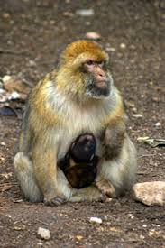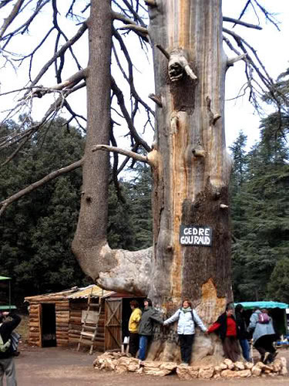

Meknes 16th century monuments:

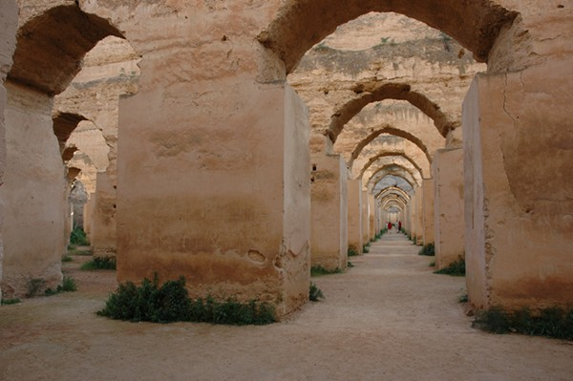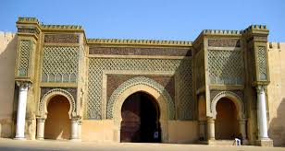

Volubilis (The ancient Roman city):
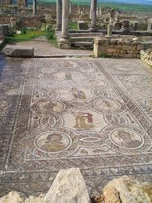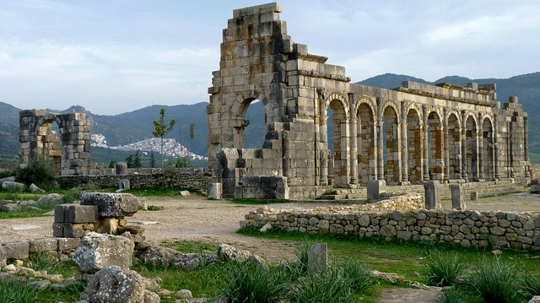

With the deaf children association

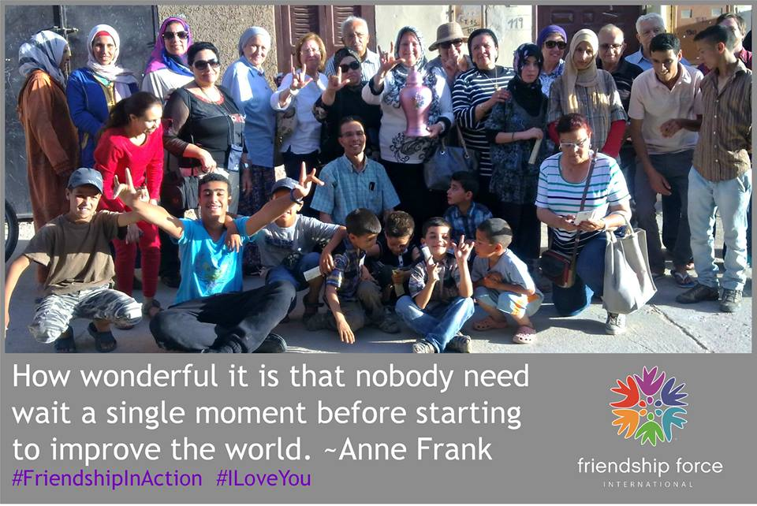

Camel trek in the sand dunes:
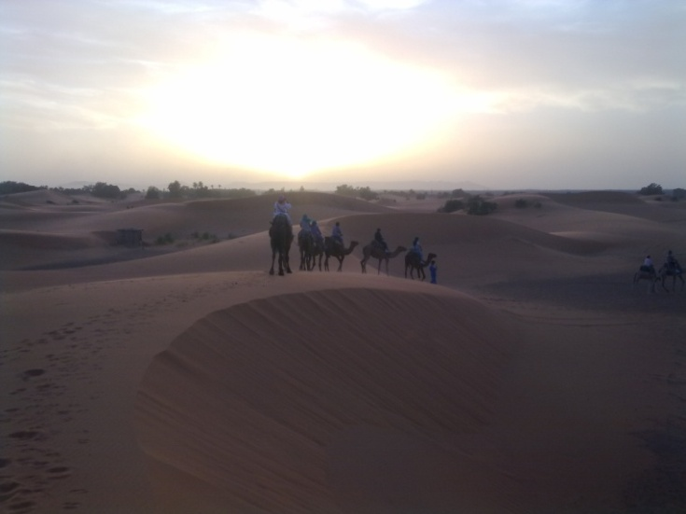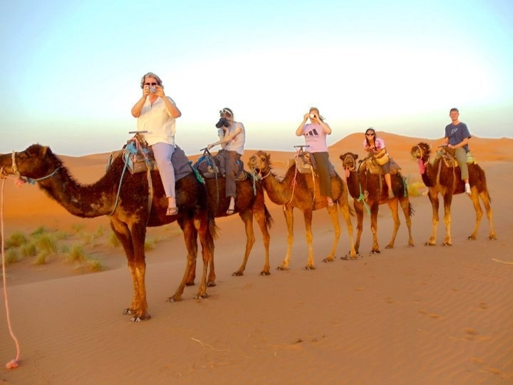

Cinema studios Ourzazate:
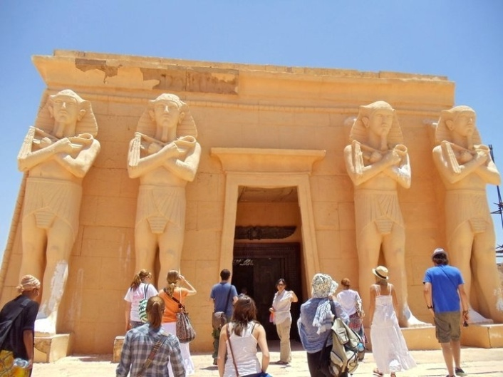

“Arabian One Thousand and One Nights” evening with all kinds of Moroccan Folkloric bands and music shows in Marrakech.
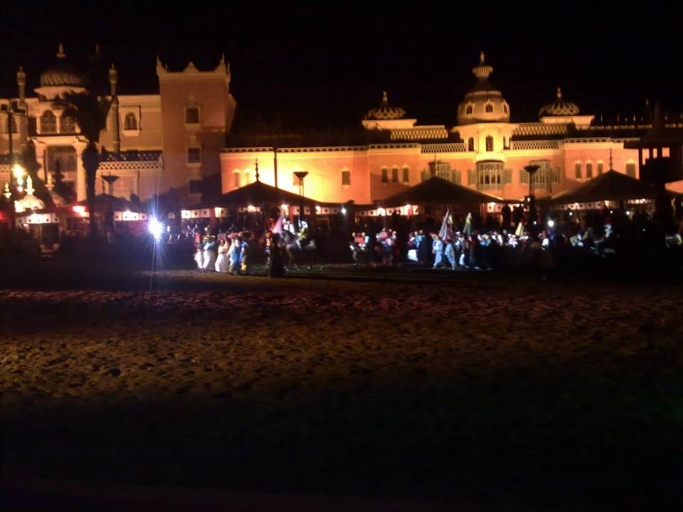

At the house of parliament with the president of the councilors chamber:
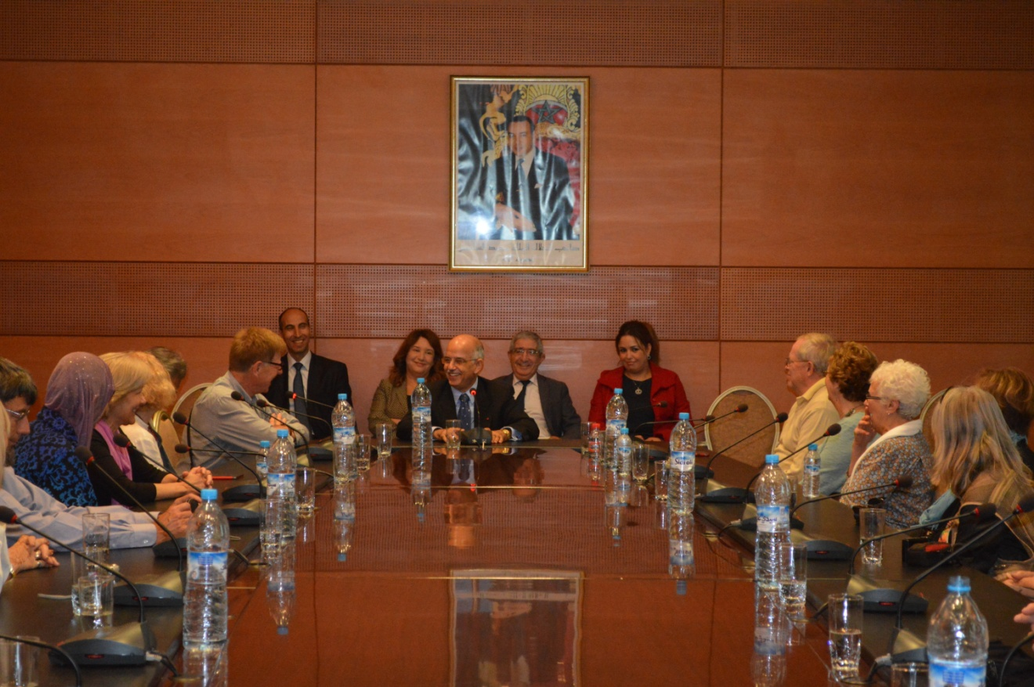

Argan oil workshop with the women coop.
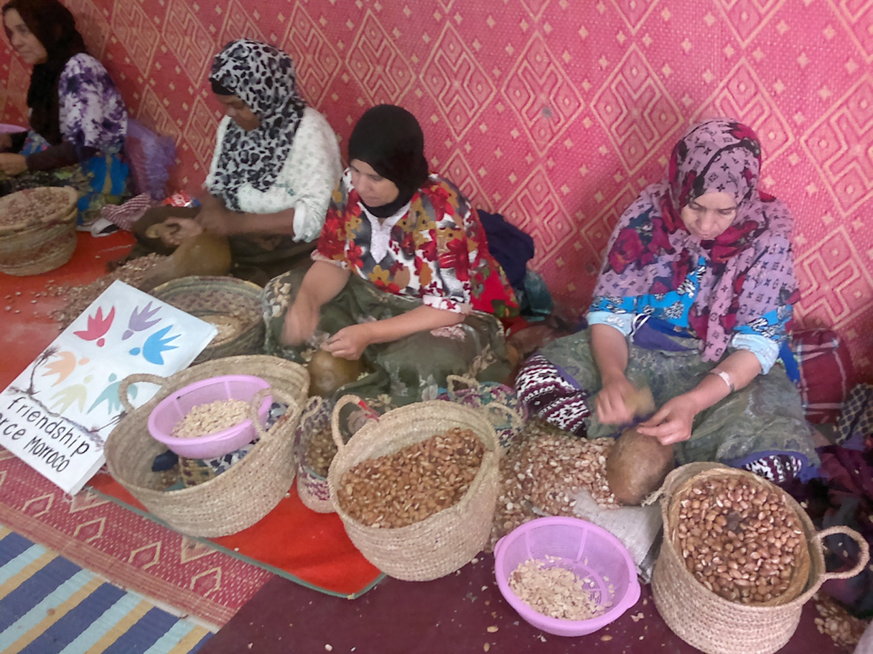

Mosque Hassan 2, Casablanca
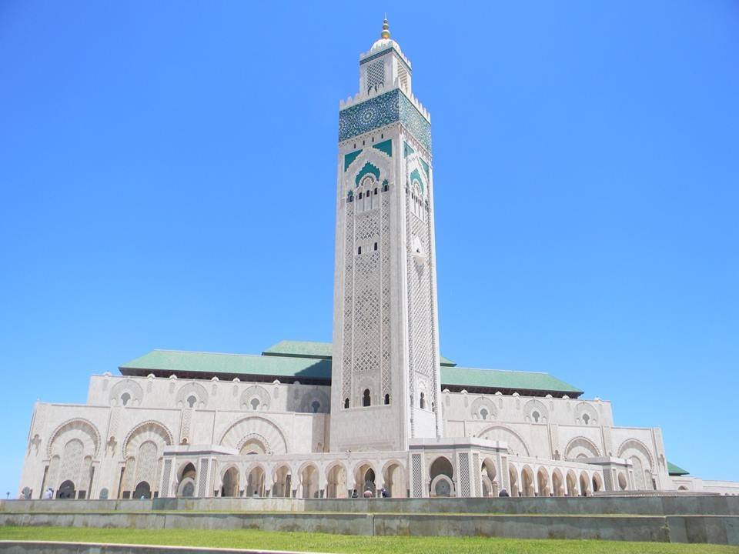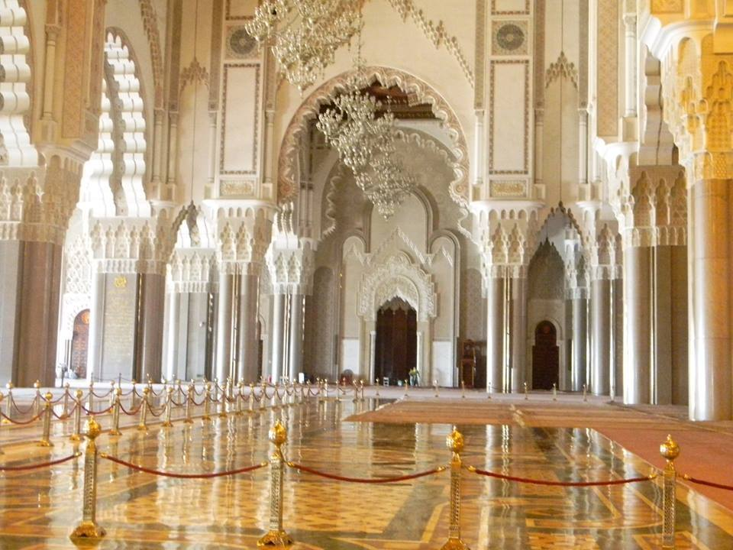

Cooking workshop:

