Monitoring and sensing solutions to manage your health
Technology can play a key role in empowering people to live a healthier life and to prevent diseases. It can bring medical quality data into the hands of the consumer – data that allow to make valid health predictions and to change our lifestyles.
An example is a wearable device that helps us to manage our fitness, by accurately monitoring our physical activity. Or a wristband that measures e.g. sweat, skin temperature and conductivity and heartbeat, and allows us to manage our stress.
Our health is also affected by our environment. Think about the quality of the air we breathe in. What we need are small wearable sensors, integrated in a watch or smartphone, that continuously measure our environment while we carry on our daily activities.
To be useful, all these sensors should have a comfortable and attractive form factor, must be powerful, extremely reliable and low-power. They should operate autonomously for long periods on a small battery, and communicate wirelessly. A key factor for their success therefore is their extreme low power consumption.
Imec and Holst Centre develop the technology and solutions for such body sensing applications. Applications that will allow people to manage their health and prevent diseases, in a comfortable and affordable way. We use our longstanding expertise in sensor, circuit, system and integration technology; in algorithms and data analysis.

Advancing cardiac monitoring solutions
At the 2013 ISSCC Conference, imec and Holst Centre have presented a low-power chip for the detection of ventricular fibrillation – a condition of the heart in which there is uncoordinated contraction of the cardiac muscle of the ventricles. The new chip features three power-efficient electrocardiogram (ECG) channels. An analog signal processor extracts the features of the ECG signals for the detection of ventricular fibrillation. When all channels are active, the chip consumes only 20µW. This achievement is an important step towards next-generation cardiac resynchronization therapy solutions.
To develop the next-generation of devices, Braemar Manufacturing (a BioTelemetry company), Delta and imec have entered into a multi-year collaboration to develop new products expected to greatly improve the patient’s experience during monitoring.
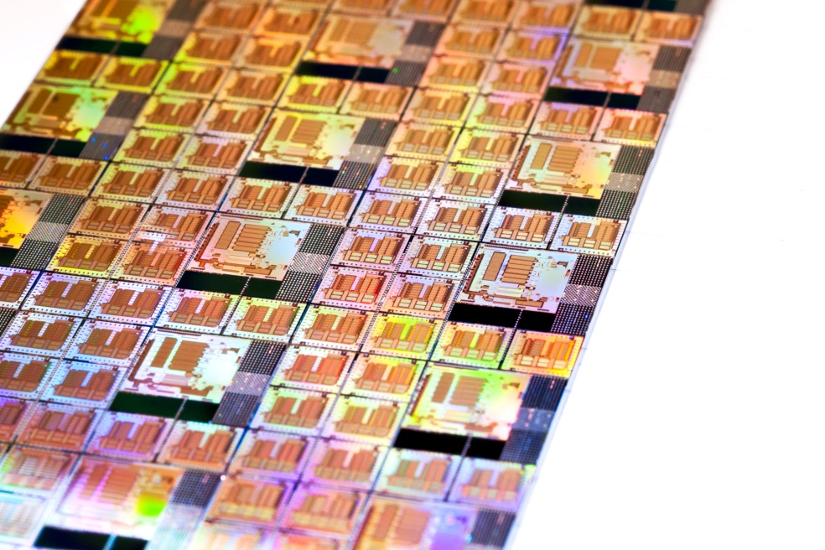

New ultralow-power circuits for wireless sensor applications
Imec and Holst Centre have demonstrated a 2.4GHz multi-standard radio that supports the most common standards for mobile sensor networks: Bluetooth Low Energy (BLE), ZigBee (IEEE802.15.4) and Medical Body Area Networks (MBAN, IEEE802.15.6). We also implemented a proprietary 2Mbps mode to support data-streaming applications like hearing aids. The radio is 2-5 times more power efficient than current state-of-the-art BLE solutions.
Next to ultralow-power wireless communication, energy-efficient data processing can help lowering the power consumption of body area networks. Imec and Holst Centre have developed an ultralow-power processor that operates reliably at near-threshold voltages as low as 0.4V. At these low operating voltages, the power consumption can be significantly reduced. In tests based on a Fast Fourier Transform, the processor consumed only 79µW. The new energy-efficient processor platform is customized for biomedical applications such as ECG and EEG monitoring.
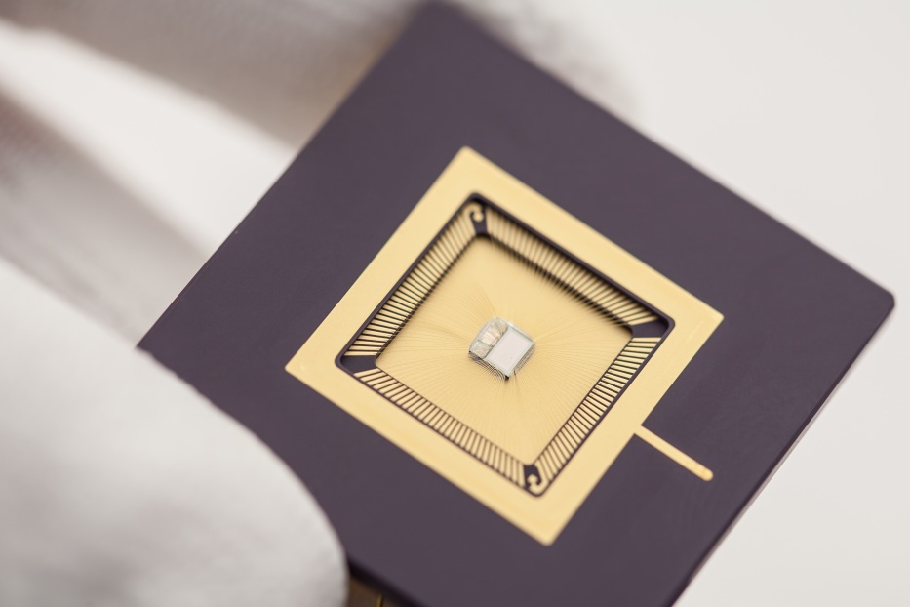

A tool to quantify a person’s habitual physical activity
Managing your fitness will help you to prevent diseases and to improve the quality of your life. But to do so, you need reliable tools that accurately measure and monitor your daily activities.
Imec and Holst Centre have now combined an accelerometer with a heart rate sensor, and included learning algorithms that continuously and automatically assess someone’s personal fitness level. This run-time fitness-level estimate is then used to increase the accuracy of the energy expenditure measurement.
The energy expenditure measurement tool is implemented in a comfortable health patch that is configured to acquire 128Hz ECG and 32Hz accelerometer signals. The patch sends its signals to an iPhone via Bluetooth Low Energy. A side-by-side comparison of our approach with existing solutions, using indirect calorimetry as a reference, demonstrated the accuracy of our tool for measuring energy expenditure.

