Index

BSR Events Team

Venue/Exhibition Schedule
- Address
- Build-up
- Exhibition opening times
- Core hours
- Breakdown

A-Z of Information
- Accommodation
- Audio Visual
- Badges and Passes
- Banking Facilities
- Build-up and Breakdown
- Business Centre
- Car Parking
- Carpet
- Catering
- Cleaning and Waste Collection
- Contractors
- Deliveries/Collections
- Dilapidations
- Disabled Visitors
- Distribution of Promotional Material
- Electrical Services
- Exhibitor Listing
- Fire Precautions
- First Aid
- Forklift Truck
- Furniture
- Gangways
- Height Limit
- Insurance
- Internet
- Late Working
- Loading/Unloading Times
- Marking out of Stands
- Meeting rooms
- Name Boards
- PA System
- Plumbing
- Registration
- Rigging
- Risk Assessments
- Scanners
- Security
- Stand Information
- Health and Safety Information and requirements
It is essential that all exhibitors and contractors read this section of the exhibition manual, sign and return the Health and Safety Declaration From to confirm that you agree to adhere to the regulations states. All personnel entering The ACC must comply with the current health and safety legislation.

BSR Events team

 | Irena Goldwag  Director of Events and Marketing  Direct Line: +44 (0)20 7842 0912  igoldwag@rheumatology.org.uk |  |  | Lindsay McClenaghan  Senior Events Manager  (Exhibition and sponsorship)  Direct Line: +44 (0)20 7842 0917  lmcclenaghan@rheumatology.org.uk
Gabrielle Saunders
Senior Education and Events Manager
(Programme)
gsaunders@rheumatology.org.uk

Other contacts:

Venue event manager: Alex Dugdale
Alex.dugdale@theicc.co.uk / 0121 644 5135

Exhibition contractor: Index, Nick Waring
n.waring@indexgroup.org / 0161-723-6105

Venue | Exhibitions schedule

Exhibition location
Broad St, Birmingham, West Midlands B1 2EA
To view a map to the convention centre, click here.

Access to the exhibition hall is via Bay B, from Cambridge Street. There is limited space in the Loading bay and a queuing system will be in operation.

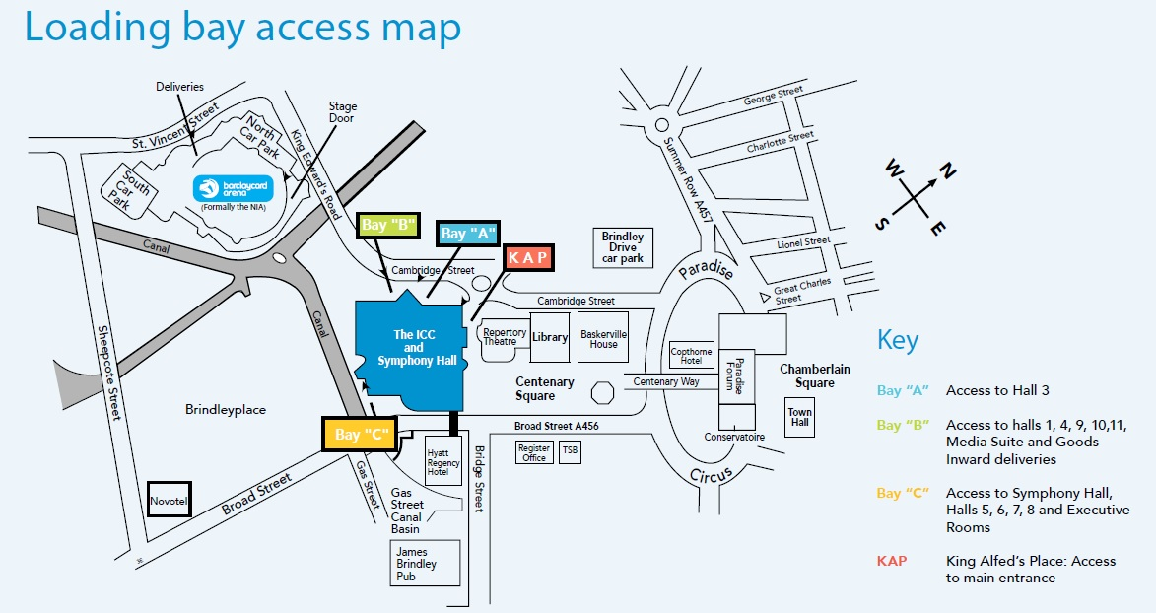

Build-up

Note: At this event, all stands are shell scheme. If you require the fascia board or lighting to be removed, please inform Lindsay McClenaghan as soon as possible.

Wednesday 14 October access will be given to the hall from 9pm – midnight
Thursday 15 October, access will be given from 6am
All stands must be completely set up by 08.15am on Thursday 15 October for opening

Additional hours can be worked beyond midnight if requested in advance and will come with a charge.

Badge pick up for exhibitors
Thursday 15th October, from 9am at the registration desk.

Exhibition open times
The exhibition will be open during the following times:

Thursday 15 October 09:00 – 15:40
Friday 16 October 08.30 – 15.20

If your stand is unmanned at any time, you must ensure that your stand is as safe as is reasonably practicable, preferably using rope and post to prevent delegates entering the area. Please note we will not be responsible for any valuables left on the stand when it is not staffed.

Breakdown
Friday 16 October breakdown of all stands from 15:30.

A-Z Information

A
ACCOMMODATION
BSR is using the services of Birmingham Convention Bureau to offer Autumn Conference 2015 delegates specially negotiated booking rates. For further information on booking and special rates please click here.

AUDIO VISUAL
If you require additional technical facilities for your stand please contact Alex.dugdale@theicc.co.uk

B
BADGES AND PASSES
Please note: No access into the exhibition area will be permitted at any time unless the relevant pass is displayed.

Contractor Passes - Anyone employed to build-up or breakdown your stand (including representatives from the exhibiting company) will require a Contractor wrist band for security purposes. This will allow them to access the exhibition hall during build-up and breakdown (but not during the exhibition open times). Bands will be supplied at the BSR desk at the loading bay.

Exhibitor Badges - Exhibitor badges are required for all personnel working on your stand during the open period. These badges will entitle you to entry to the exhibition area only. Should you wish to attend any of the scientific sessions you will need to register as a delegate.
Complimentary exhibition passes are allocated to stand holders via e-mail based on the size of your stand.
To register your exhibitor badges, please use the voucher code which you will be emailed separately. This voucher code will entitle you to the appropriate number of free passes for your stand size. If you require additional badges you can book these at the same time at a cost of £55 + VAT per day per person.
All badges will be available for collection by company representatives at registration desk.
The registration desk will be open from 08.30 each morning. Please note queues will be expected on Wednesday morning.

Each exhibitor will be entitled to the following:
- Access to the Exhibition Hall
- Refreshments
- Lunch

BANKING FACILITIES
A cash machine is available in the venue, please ask the concierge for directions.

BUILD-UP AND BREAKDOWN
Please refer to the Exhibition schedule on page 3.

BUSINESS CENTRE
A number of business facilities are available at the ICC, please refer to their amenities website for details.

C
CAR PARKING
There is large, multi-storey parking available located within the Barclaycard Arena, which is just a short walk away from the ICC. Both the ICC and Barclaycard Arena are signposted on motorways and major roads and are marked on most road maps.

CARPET
The exhibition hall is fully carpeted.

Exhibitors and contractors must use approved Stiktak B3/A5 exhibition tape and ensure that it is lifted at the end of the show, any tape left on the floor after the show will be subject to a charge of at least £7.50 per linear meter of tape. Damaged carpet will be subject to cleaning or replacement charges .

CATERING
The ICC are the sole caterers for any food and beverages consumed on the premises. For information on stand catering and hospitality please contact the Hilton event manager Alex Dugdale directly. If you intend to supply your own catering, please inform the venue, if you require plumbing or electrical supply for coffee machine etc, please contact Index.

CLEANING AND WASTE COLLECTION
Large bins will be provided throughout build-up and breakdown for exhibitor use.
General cleaning of stand will be carried out prior to the exhibition opening on each morning. This service is free of charge to all exhibitors and paper/packaging rubbish should be placed in the aisle at the end of the day (any bagged waste left on stands will not be removed). The cleaning of exhibits however remains the responsibility of the exhibitor. BSR will provide bins for the exhibition area which can be used throughout the event.
PLEASE NOTE THAT THERE ARE NO SKIP FACILITIES AT THE VENUE AND ANY LARGE SCALE WASTE MUST BE TAKEN AWAY BY EXHIBITORS OR EXHIBITORS MAY FACE PENALTY CHARGE

CONTRACTORS
If you are employing a contractor to build your stand, it is essential that your contractor is fully aware of the relevant forms, deadlines and their responsibilities under all health and safety legislation.
Please ensure that all of your contractors are fully competent to carry out the jobs allocated to them.
Forms to complete:
Health and Safety Declaration (all stands) (Appendix 1)
Shell scheme risk checklist (all stands) (Appendix 2)
Risk Assessment for complex stands (Appendix 3)

D
DELIVERIES/COLLECTIONS
Deliveries
BSR cannot accept deliveries on behalf of exhibitors. However arrangements can be made with Index Group Ltd who will arrange deliveries directly to your stand at the start of our tenancy. If you require this service please contact Sarah Jay.

For couriers, please use the delivery label (Appendix 4) and note the terms and conditions. Any packages delivered that are unclearly labeled will not be accepted, following standard security procedure.

Collections
Exhibitors should ensure that arrangements are made for the collection of all items from The ICC at the end of the exhibition before 8pm.
All delivery drivers, courier companies or personnel sent to the ICC to collect items after an event MUST be briefed with the following information:
Conference/event name
Client name
Client contact number
Exhibition stand number (if applicable)
Forwarding address
Number of items

Any items that are left onsite that are not sealed, boxed, packaged or clearly labelled will be treated as unwanted and disposed of. It is the Exhibitor’s responsibility to ensure packages for collection are clearly labelled and to advise of estimated collection date and time. You may be charged for disposal of any items you leave on site.

DILAPIDATIONS
You will be charged for making any damage to the hall or stand area, including the floor, caused by your staff or contractors. All tape used to secure carpets must be removed at the end of the exhibition. Under no circumstances can stand construction, graphics, displays etc. be attached to the fabric of the building.

DISABLED VISITORS
The Disability Discrimination Act 1995 (DDA) states that all disabled persons must be provided with the same service, on the same terms and to the same standard that is provided to others. Reasonable changes, adjustment and alterations must be made in order to facilitate this. In particular, we would ask that you ensure your stand and exhibits are easily accessible to disabled visitors with wheelchairs and consideration is given to the visually impaired. Your risk assessment must cover disabled visitors.

DISTRIBUTION OF PROMOTIONAL MATERIAL
All business including dispensing of literature and promotional material must be conducted from your stand. You are kindly asked not to hand out material etc in any part of the exhibition hall or at the entrance to the event, in the gangways, concourse or conference rooms.

E
ELECTRICAL SERVICES
All stands at this event are shell scheme stands inclusive of one power socket and two spotlights. To add additional electrical services please order via Index Group Ltd. (Appendix 5)

EXHIBITIOR LISTING
Each exhibitor is asked to submit a company description (65 words max) on booking to be listed in the final programme. BSR does not accept responsibility for mistakes within the submitted text.

F
FIRE PRECAUTIONS
All materials used for the interiors of stands must be thoroughly fireproofed or be non-combustible to the satisfaction of the local authority. Failure to do so may result in the removal of all offending fittings.

Any person whether Exhibitor or Contractor discovering a fire, should immediately notify a member of the ICC staff or operate a break glass unit. Fire extinguishers are located at convenient points around the Hall.

If the fire alarm sounds please evacuate the ICC by the nearest available fire exit and make their way to the front of the hotel until further instructions are given.

FIRST AID
In cases of medical emergency please contact a member of ICC staff.

FORKLIFT TRUCK
A forklift truck will not be made available without request. Please contact Index if you require equipment for moving goods to your stand.

FURNITURE
Please note: Shell scheme stands will be provided one basic table and two chairs. Additional furniture may be ordered online via Index Group Ltd or you can use the form in Appendix 6.

Alternatively you are able to bring your own.
Please inform lmcclenaghan@rheumatology.org.uk if you do not require furniture on your stand.

G
GANGWAYS
Gangways shall be kept unobstructed at all times and exhibits shall not project into gangways. This is for fire evacuation safety.

H
HEIGHT LIMIT
A height limit of 4 metres must not be exceeded at the ICC. This limit includes the overall height of the stand fitting, any branding and all raised platforms as measured from the hall floor. Stands wishing to exceed this height must supply the full drawings and structural calculations by a minimum of one month prior to the event, for approval. Contact Lindsay McClenaghan for details. Stands over 4m coming onto site without approval will not be permitted to be built.

I
INSURANCE
Neither BSR nor its contractors nor the ICC shall accept any liability for the loss, damage or destruction of any exhibits or contents therein. Exhibitors are reminded that in accordance with the Terms and Conditions of booking they should take out adequate insurance cover against any risk of loss, damage, injury or liability.

INTERNET AND TECHNICAL SERVICES
Wifi access for exhibitors and delegates is inclusive for this event. If you require dedicated service, please contact the ICC.

L
LATE WORKING
There may be a possibility for late working during build up and breakdown. This is at the discretion of BSR and all costs incurred for extra staffing will be payable by the exhibitor. To arrange this, please contact Lindsay McClenaghan. There is a charge of £500 + VAT per hour

M
MARKING OUT OF THE STANDS
This will be carried out prior to the exhibition build-up times.

MEETING ROOMS
If you require a meeting room at the conference you can book this via the ICC directly by contacting the Event Manager, Alex Dugdale.

N
NAME BOARDS
All shell scheme stands are provided with a fascia board bearing the exhibiting company’s name in standard script. The name of the company as it appears on your online booking form will be shown.

P
PLUMBING
To organise any plumbing for water or waste, please contact index. If you do not require plumbing but will require water, contact the ICC.

R
RESISTRATION
To register your exhibitor badges, please use the voucher code which you will be emailed separately. This voucher code will entitle you to the appropriate number of free passes for you stand size. If you require additional badges you can book these at the same time at a cost of £55 + VAT per day per person.
All badges will be available for collection by company representatives at the main registration desk.
The registration desk will be open from 08.30 Thursday 15 October. Please note queues will be expected on Thursday morning.

RIGGING
There is provision to rig within the exhibition hall at the Hilton and all rigging enquires need to go through Lindsay McClenaghan for prices and regulations.

RISK ASSESSMENTS
All stands must complete a risk assessment or the checklist below and send it, signed, to Lindsay McClenaghan by 01 October 2015

Forms to complete:
Health and Safety Declaration (all stands) (Appendix 1)
Shell scheme risk checklist (all stands) (Appendix 2)
Risk Assessment for complex stands (Appendix 3)

S
SCANNERS (Data Capture)

Scanning facilities are not offered at this event.

SECURITY
BSR will control general security arrangements for the exhibition and ensure the premises are adequately patrolled. Whilst BSR will make reasonable arrangement for security coverage, they and the venue are not responsible for any loss or damage which may occur and it will be the exhibitor’s responsibility for the security of their stand, its exhibits and contents including personal property.

To help ensure good security at the exhibition please take note of the following points:

- Do not leave cash, handbags, phones, valuables etc. in drawers, cupboards or on exhibits on your stands.
- Do not leave valuables in unattended clothing.
- Check all lockable desks and cupboards before leaving your stand.
- If you have small valuables that you wish to leave on your stand, you are advised to obtain lockable steel cabinets or other safe storage areas.
- Make sure you arrive prior to the official opening times and do not leave your stand at night before the hall is clear of delegates.

Please note that the build-up/breakdown days are high risk periods.

STAND INFORMATION
Shell scheme specification
Shell scheme stands are built to an overall height of 2.4m high, consisting of aluminum components, 6mm thick grey polyweave material that accepts Velcro fixings, 250mm deep fascias to all open sides and a name sign. The stand will be constructed by the official contractor Index Group Ltd.
Additional stand fittings can be ordered via Index Group

Shell scheme stands include:

- 3 walls with 1 open side or 2 walls with two open sides on a corner stand
- One power socket and two spot lights
- Fascia panel with Stand number and company name

Visual of typical stand
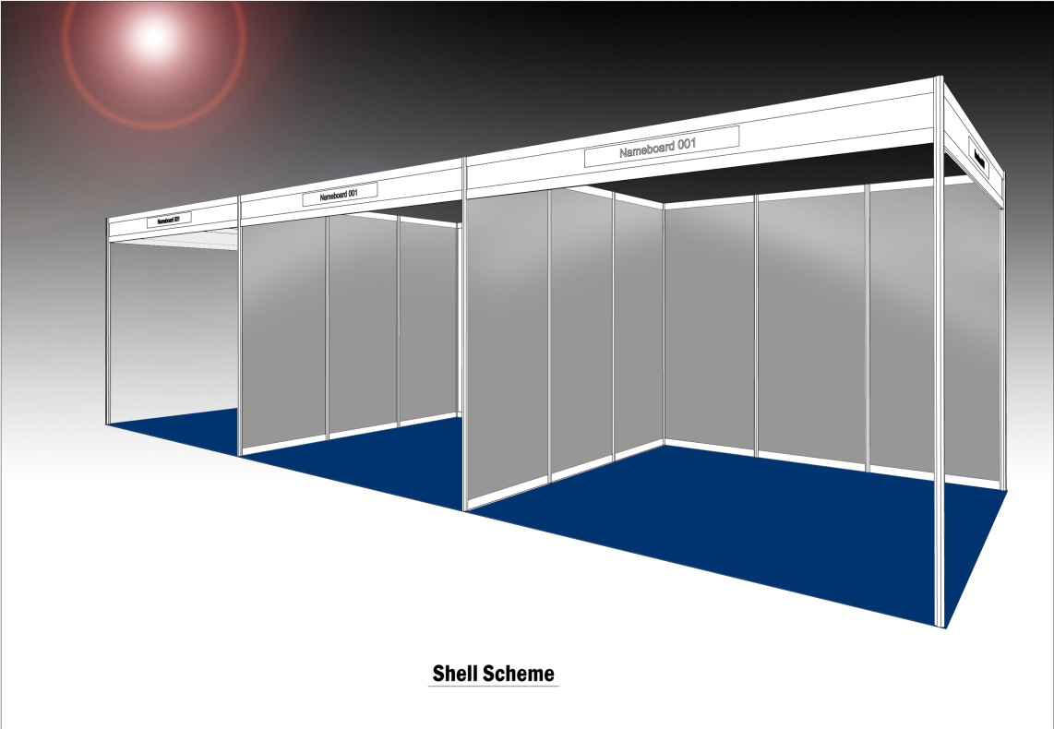

Space only specification
Space only stands are allocated by request, no stand services are provided, and exhibitors are responsible for building their own displays.
You are required to supply a plan, method statement and risk assessment for all free standing build stands for approval and these should be for the attention of:

Lindsay McClenaghan
Senior Events Officer
The British Society for Rheumatology
Bride House
18-20 Bride Lane
London EC4Y 8EE

The plan must show the name of the Company, Stand Number and Stand Measurements. No exhibit of part of any structure may extend beyond the boundaries of the area allocated. Risk assessments must cover build, breakdown and open period.

Health and Safety Information

It is essential that all exhibitors and contractors read this section of the exhibition manual, sign and return the Health and Safety Declaration From to confirm that you agree to adhere to the regulations states. All personnel entering The ICC must comply with the current health and safety legislation.

RESPONSIBILITIES AND POLICY STATEMENT
As the organiser, it is BSR’s policy to manage Autumn Conference 2014 in accordance with the Health and Safety at Work Act and make the event safe so far as is reasonably practicable.

EXHIBITOR’S RESPONSIBILITIES
All exhibiting companies/organisations are responsible for ensuring that their staff, contractors and sub-contractors comply with the Health and Safety at Work Act 1974. You should ensure that your exhibits and materials comply fully and that due thought and consideration is given to your own, and others’ health, safety and welfare throughout the event. Neither your actions, nor the actions of those working on your behalf should give rise to accidents, injuries or an unsafe working environment so far as is reasonably practicable.

If you have any concerns regarding health and safety now, or at any point during the event please contact Lindsay McClenaghan via the contact details above or the registration desk onsite.

ALCOHOL AND SUBSTANCE ABUSE
Workers must not present themselves for work under the influence of alcohol or other substances and consumption of alcohol on-site during the stand build or breakdown days is not permitted. If alcohol is consumed off-site during the working day this should be in strict moderation. Workers who are also seen to be breaching this policy must be brought to the attention of the organisers (Lindsay McClenaghan or Irena Goldwag at the BSR) whereupon steps may need to be taken to remove the person concerned from site. Drivers, users of machinery, electrical equipment, or those working at height are at particular risk where alcohol consumption is concerned, and the exhibiting company should ensure that all individuals or sub-contractors working on its behalf adhere to this policy.

CHILDREN ON-SITE
It is not permissible for children under the age of 16 to have access to any part of Autumn Conference 2015 including the exhibition build and breakdown periods. Please note that this policy will be strictly enforced on-site.

EXCESSIVE NOISE
Exhibitors should be aware of noise levels during the build-up, breakdown and open periods of their stand. Ear protection must be worn if noise levels are deemed excessive during build-up and breakdown. All noise during the open period (from plasma screens, coffee machines etc.) should be kept under levels deemed acceptable by Health and Safety legislation and BSR - please refer to NAWAR 2005.
If noise from your stand is considered to be excessive you will be asked to lower the volume or remove the cause of noise.

PLATFORM EDGES ON SPACE ONLY STANDS
At major exhibitions there have been numerous injuries caused by having a vertical step on the stand edge. It has been found that a non-slip gradient (of up to 20 degrees) to the platform edge significantly reduces the risk of slips, trips and falls, and eliminates serious injury, therefore BSR advises exhibitors with space only stands to bear this in mind when designing their stands. The ramp must be part of the marked stand area, not added to the edge of the space.

RISK ASSESSMENT
Each exhibitor must undertake a risk assessment prior to the exhibition, identifying the hazards present and ways in which these hazards will be controlled. Your risks, and the controls put in place to reduce them, must be fully considered and a signature from a responsible staff member is required. If you have no hazards or risks present please complete and sign the risk checklist as this is a legal requirement.

All stands must complete a risk assessment or the checklist below and send it, signed, to Lindsay McClenaghan by 01 October 2015

Forms to complete:
Health and Safety Declaration (all stands) (Appendix 1)
Shell scheme risk checklist (all stands) (Appendix 2)
Risk Assessment for complex stands (Appendix 3)

METHOD STATEMENT- SPACE ONLY STANDS
If you have a SPACE ONLY stand please ensure that you submit a full method statement to BSR at the same time as your risk assessment form. Your method statement should include the following:

Named responsible: Employee who will be the responsible person for overseeing all the main construction and breakdown of your stand.
Details of the stand: Loadings, dimensions, location/stand number, unusual features.
Erection: The sequence and schedule in which all
stand elements will be built, and any safety control measures.
Stability: Methods of ensuring adequate structural
support of any vertically aligned stand elements.
Scaffolding: Details of any construction work to be
carried out at height, and the methods employed to ensure a safe system of work.
COSHH: Any proposed use of hazardous and toxic
substances, including protection provided for employees and workers on adjacent stands.
Environment: Consider any abnormal noise created through constructing your stand, or work
that may create dust or fumes – what control measures will be provided?
Safety equipment: Identify the safety equipment and precautions that you will be providing
on-site.
Exhibits: Detail any exhibits that will be on the stand and may present a hazard to the delegates
and/or the operator.

HOT WORK PERMITS
A hot work permit should be raised when there is a requirement for any of the following work scenarios during exhibition build or breakdown:
1. Work involving flames or temperatures likely to cause ignition of flammable gas including the use of welding, burning or soldering equipment, blow of torches, some power-driven tools, sand blasting etc.
2. Work involving steelwork or pipe work being erected or dismantled which needs welding, cutting or grinding.
3. Any work requiring an open flame.

The venue will specify the safety precautions in the hot work permit, as an example for welding these may include:
- Operatives must wear suitable protective clothing.
- A fire extinguisher might need to be place locally.
- Combustible rubbish and waste material might need to be removed from the surrounding area.
- The area might need to be cordoned off and signage erected.
- A fire screen or guard may be required to stop stray sparks.

GENERAL GUIDELINES FOR STAND BUILD AND BREAKDOWN PERIODS
- Pedestrian operated vehicles (e.g. trolleys) should be used safely in pedestrian gangways avoiding damage to the building fabric at all times.
- All floor cabling must be made safe and kept neat and tidy at all times.
- Ensure rubbish from stands does not accumulate under or on any stand and is disposed of appropriately.
- All equipment must be in safe, clean condition and if appropriate, tested before use on The Hilton premises.
- Contractors’ equipment including cranes, hoists, trestles, step ladders, boards and other items shall be removed by them prior to the opening of the exhibition and shall not be left in any part of the exhibition hall.
- No lifts or escalators shall be operated by any person other than those appointed by The Hilton .
- The escalators must not be used by contractors or their workmen as a means of access from floor to floor.
- Flame proofed and fire proofed materials must be used for all stand construction including decorative draping and muslin ceilings. Tests may be carried out onsite.
- No smoking is allowed in the venue at any time.
- Trolleys and lifting equipment must not be overloaded as this may cause injury to persons and can damage exhibits and other equipment.

CARE OF BUILDING
- Please do not fix anything to the walls, e.g. with sellotape, Velcro, gaffer tape, blu-tac etc. No nails or similar fixings are permitted to be used on any property belonging to The Hilton .
- Exit, directional or other permanent signs or ventilation grilles shall not be interfered with or removed and alarm points may not be concealed or obstructed.
- Ample and clear access shall remain to all hydrants hose-rack, fire buckets and similar equipment.
- Carpet tiles and ceiling tiles may not be uplifted or removed.
- All furniture and fitting should be used for the correct purpose only, e.g. no standing on, or laying of equipment on chairs.
- Due care should be taken at all times when transporting equipment around the building to avoid any damage to doors and the fabric of building.
- No dangerous exhibit or dangerous explosive materials of any kind shall be allowed inside the building unless the Exhibition Hall Manager has given written permission.
- All damage, however small, must be reported prior to leaving the premises. All damage to the building fixtures and fittings (internal and external) will be assessed by the Exhibition Hall Manager and charges will be levied where necessary.

APPENDIX 1
APPENDIX 2

APPENDIX 4

INSTRUCTIONS FOR DELIVERIES TO THE ICC

NAME OF PERSON COLLECTING PARCEL ON SITE | COMPANY NAME/STAND NUMBER |  | CONTACT NO
NAME OF THE EVENT  BSR AUTUMN CONFERENCE 2015 |  | DATE OF THE EVENT  15/16 OCTOBER 2015
EVENT MANAGER NAME  Lindsay McClenaghan |  | HALL NUMBERS  11
DELIVERY ADDRESS

THE ICC
GOODS INWARDS/ BAY B
CAMBRIDGE STREET

BIRMINGHAM
B1 2NP
Deliveries to Site -
Deliveries to site are only accepted during tenancy times, and preferably when the client is available to sign for packages.
Delivery label should be fully completed, and couriers should be advised to report to Bay B of the ICC (off Cambridge Street) for further delivery instructions. The ICC Goods Inwards will sign for goods (on acceptance of arrival basis only). The ICC will not accept any liability for items after delivery.
Please be advised that there is no on-site storage available, and all tenancy areas must be clear at the end of the event.
Any parcels or stands left at the venue must be clearly marked ready for collection and left in Bay B/Goods Inwards. Collection must be made within 3 working days of tenancy ending; anything left behind beyond this time will be disposed of by the venue.
Please note that it is the responsibility of the individual organiser/standholder to arrange their own courier.

INSTRUCTIONS FOR COLLECTIONS FROM THE ICC

NAME/ COMPANY/ ADDRESS OF WHERE PARCEL IS GOING

CONTACT TELEPHONE NUMBER | EVENT & DATE ATTENDED AT ICC
DATE & TIME OF COLLECTION | COURIER DETAILS
Any parcels or stands left at the venue must be clearly marked ready for collection and left in Bay B/Goods Inwards. Collection must be made within 3 working days of tenancy ending; anything left behind beyond this time will be disposed of by the venue.
Please note that it is the responsibility of the individual organiser/standholder to arrange their own courier.

APPENDIX 5
APPENDIX 6

