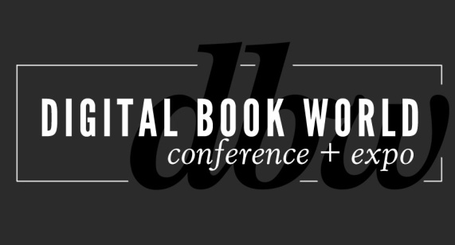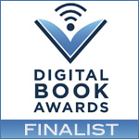
Random House, Harper Collins, Yale University Press
Among 2014 Digital Book Award Finalists

NEW YORK – December 18, 2013-- Finalists for the 2014 Digital Book Awards were announced today, recognizing excellence in digital publishing over the past year.

Winners will be announced at a dinner gala hosted by LeVar Burton, actor and co-founder of Reading Rainbow, at the 2014 Digital Book World Conference & Expo, January 14, 2014 at the Sheraton Hotel & Towers, New York.

“This year’s finalists represent the most creative work taking place in digital publishing today,” said David Blansfield, co-president of parent company F+W Media, Inc. “It’s our pleasure to honor these companies and individuals and doubly exciting having the opportunity to do so at Digital Book World next month.”
Finalists by category are:

App, Adult Fiction
George R.R. Martin’s A World of Ice and Fire, Random House
Steampunk Holmes: Legacy of the Nautilus, Noble Beast
The Metamorphosis for iPad, Rocket Chair Media

App, Adult Non-Fiction
The Pocket Scavenger, Penguin
Psychometry, Carol Golemboski Ltd.
Ready, Set, Baby! The Watch and Learn Guide to Baby’s First Year, Open Air Publishing

App, Children
The Adventures of Captain Underpants, Scholastic
Axel’s Chain Reaction, Allison Pomenta
COWZAT!, Colour Me Play
Goodnight Moon Storybook App, Loud Crow Interactive
Little Red Riding Hood, Nosy Crow

App, Illustrated/Comics Graphic Novels
Go Big or Go Home: Taking Risks in Life, Love and Tattooing, Kat Von D, Harper Collins, Harper Design
The Journey, Alta Editions

App, Reference/Academic
The Animator’s Survival Kit, Faber and Faber
Disney Animated, Touch Press/Disney
Interaction of Color by Josef Albers, Yale University Press
On the High Line, Arjun Gupta

Ebook Fixed Format/Enhanced – Adult Fiction
Collected, Donna M. Thompson
Mistress of France, Emma Boling, Sherisse Hawkins, Alex Milewski
Rain Shadow, Rebecca H. Carrer

Ebook Fixed Format/Enhanced – Adult Non-Fiction
Henri, le Chat Noir: The Existential Musings of an Angst-Filled Cat, Ten Speed Press
Isa Does It, Little Brown
Pizza Pilgrims, Harper Collins, Harper Non-Fiction

Ebook Fixed Format/Enhanced – Illustrated/Comics/Graphic Novels
A Long Way Away/Along A Long Road, Little Brown for Young Reader (from Hachette Book Group)
The World Atlas of Wine iPad Edition, Octopus Publishing Group

Ebook Fixed Format/Enhanced – Children
Alicewinks: Alice’s Adventures in Wonderland, Walrus & Carpenter Productions LLC
First Time on a Plane, Parragon
The Man with the Violin, Annick Press Ltd.
Seahorses & Pipefish, Dive in Your Imagination

Ebook Fixed Format/Enhanced – Reference/Academic
American Sign Language (Enhanced), Thunder Bay Press
Cracking the GRE: Interactive Prep & Review for the GRE Exam, Random House Information Group
Introduction to Food Engineering, Elsevier/Academic Press
Julius Caesar: The Shakesperience, Sourcebooks
Language of Medicine 10th Edition, VitalSource ® Edition, Elsevier/Saunders
The Making of Star Wars, Ballantine Group

Ebook Flowable – Adult Fiction
Cerberus: Book 1 of Parish, BookRix GmbH & Co. KG
Eversea: A Love Story, Natasha Boyd

Ebook Flowable – Adult Non-Fiction
Cooking Light: Lighten Up, America!, Oxmoor House
The Israeli-Palestinian Conflict, InterVarsity Press
Life After Life: The Story of Wayne Ford, John D. Cruickshank
That Polio Season, John D. Cruickshank, Toronto Star Newspapers

Ebook Flowable – Children
Can You Survive the Titanic?: An Interactive Survival Adventure, Capstone Press
Cinderella Spinderella, Light Publications

Ebook Flowable – Reference/Academic
CAE Strategic Relationships: Building Rapport with the Executive Suite, The Institute of Internal Auditors Research Foundation
Scotland’s Marine Atlas, APS Group Scotland

Digital Cover Design
Breaking Bad: Alchemy, Sony Pictures Television
A Long Way Away/Along a Long Road, Little Brown
The Persian Square, Davar Ardalan
A Shiver of Sharks, Little Bahalia Publishing
Steam Train, Dream Train, Chronicle Books

Transmedia (Any Format)
The 39 Clues, Scholastic
The Descent, Kobo
The Niantic Project: Ingress, Niantic Labs at Google
The Ruptured Sky, TEACH Magazine
Spirit Animals, Scholastic

The Digital Book Award for Inkling Habitat
The Louvre: All the Paintings, Black Dog & Leventhal Publishers and Inkling Publishing
Modernist Cuisine at Home, The Cooking Lab
Moore’s Clinically Oriented Anatomy, Lippincott Williams & Wilkins
The New Sunset Western Garden Book, Oxmoor House
The Way of Taiko, Stone Bridge Press

Learn more about the Digital Book Awards and reserve your ticket for the awards dinner by visiting conference.digitalbookworld.com.
# # #
About Digital Book World
The Digital Book World Conference + Expo is the largest event dedicated solely to the business of digital publishing worldwide. It consists of a 2-day multi-track, multi-faceted digital publishing program, pre-conference events, Digital Book Awards gala and exhibition hall. Digital Book World, an F+W Media event, attracts an international audience of 1,500 industry professionals, 50 exhibitors and more than 100 speakers. http://conference.digitalbookworld.com
Contact: Stacie Berger
F+W Media, Inc.
513.531.2690 x 11457
stacie.berger@fwmedia.com

