CONTACT
Naomi Iheme
Events and Sponsorships
Goodwill Industries International
Direct: (240) 333-5345
Fax: (301) 258-0578
naomi.iheme@goodwill.org
sponsorshipandshows@goodwill.org

2018 Member marketplace LIVE exhibitor prospectus

ABOUT GOODWILL®

Goodwill works to enhance the dignity and quality of life of individuals and families by strengthening communities, eliminating barriers to opportunity and helping people in need reach their full potential through learning and the power of work.
Goodwill has:
- 161 member organizations
- 3,250 Goodwill stores
(North America)
- 129,795 employees
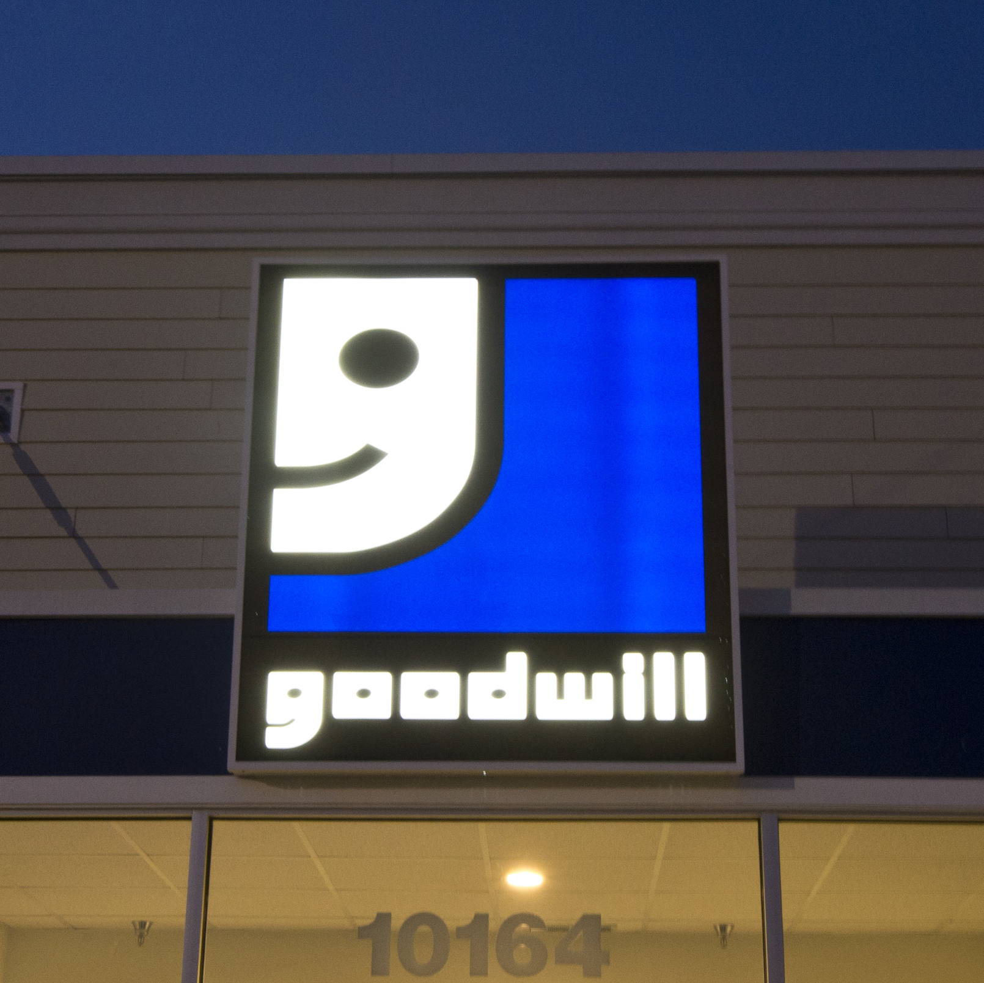

Goodwill is:
- Recognized by GuideStar with its Platinum Seal of Approval.
- The number-one brand doing the most good in the world for two consecutive years (Enso).
- The second-largest nonprofit organization in the United States.
- Number 23 of America’s top 25 inspiring companies for three consecutive years (Forbes).
- One of the nation’s top-five most valuable and recognized nonprofit brands (Cone LLC).

Most Recent Statistics (2016)
- Persons served with face-to-face services: 2,101,438
- Persons served via virtual means: 34,484,313
- Total people served: 36,585,751
- Total services provided: 68.8 million
- People placed in employment: 313,188
- Estimated total annualized earnings of people placed in employment: $5.7 billion
- Percent revenue spent directly on programs: 87 percent
- Total employees at year-end: 129,795 (0.7% increase)
- Total number of material donations:
101.6 million (4% increase)
- Total number of retail and outlet stores at year-end: 3,250 (2.7% increase)

Member marketplace live
Goodwill Industries International (GII) holds two exhibits annually, bringing together hundreds of Goodwill professionals from across the United States and Canada who seek to improve their operations, save costs and increase revenue to support and advance the Goodwill mission. Seize the opportunity to showcase your organization exclusively to Goodwill staff during these two events.

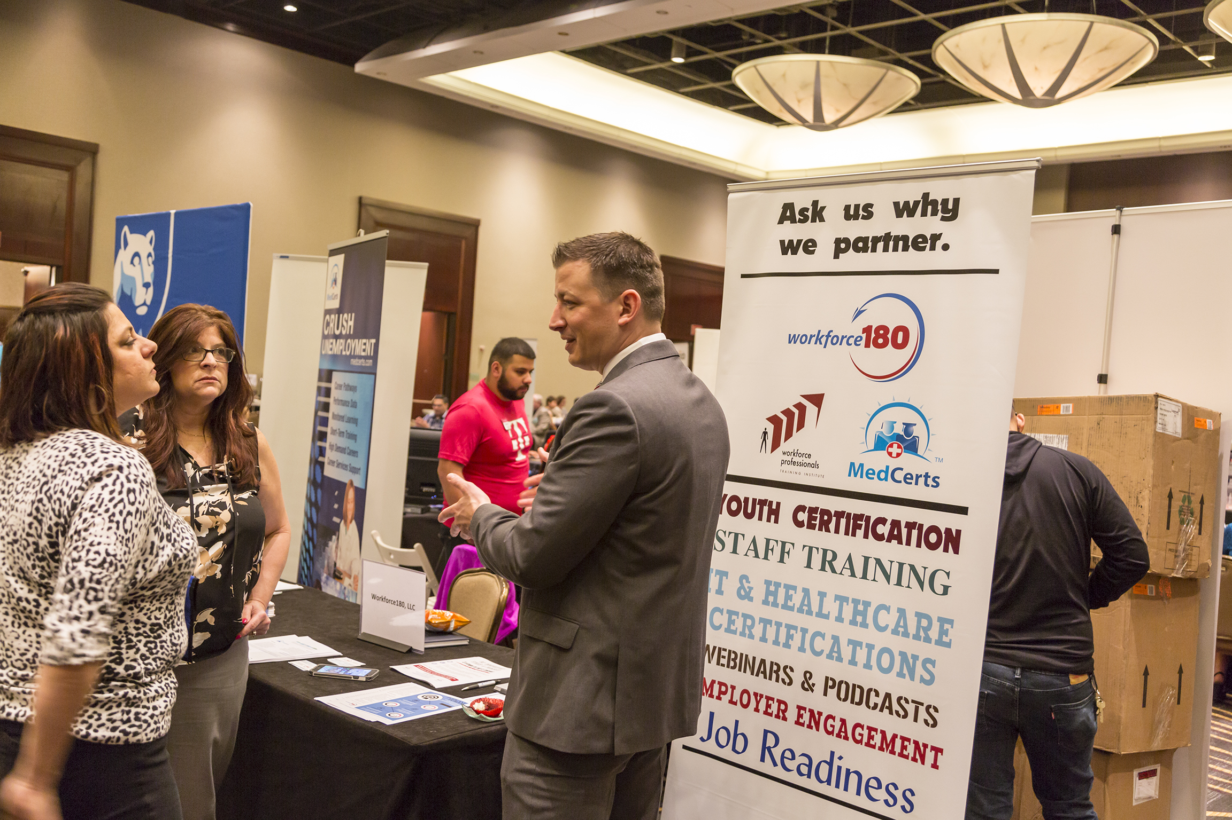
Spring conference
member marketplace live

The Spring Conference takes place May 6 – 9, 2018, in Sarasota, FL. This conference is the opportunity for Goodwill mission services, human resources and resource development professionals to engage in networking and learning opportunities. Participants can earn continuing education credits by attending certain sessions. The conference also recognizes performance achievement in mission services and programs. The Member Marketplace LIVE is a two-day event during the conference and affords attendees with the opportunity to learn industry best practices from vendors like you.

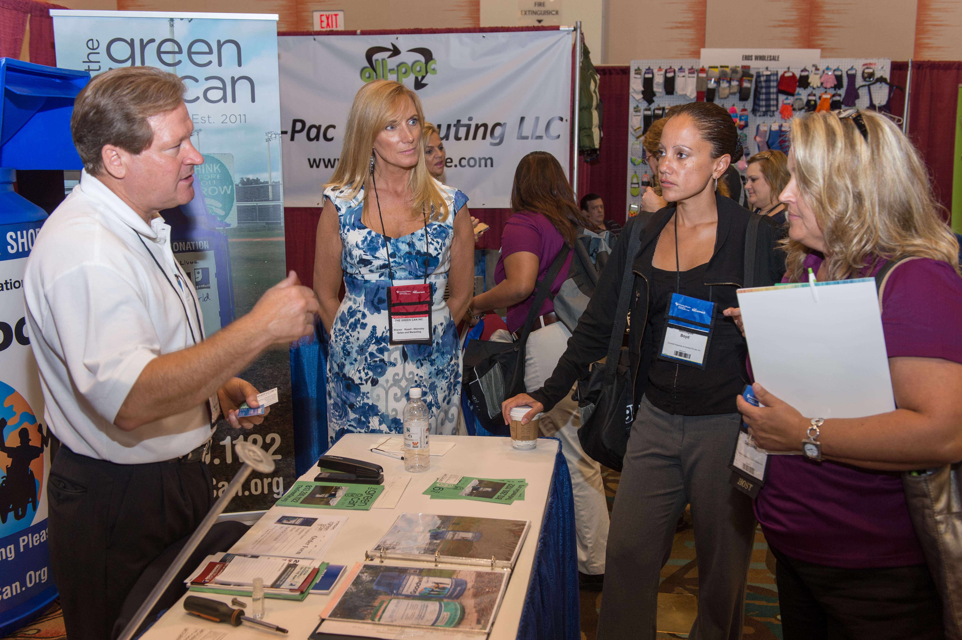
Summer Conference
Member Marketplace LIVE

The Summer Conference takes place July 29 – August 1, 2018, in Austin, TX. This conference provides the opportunity for Goodwill retail, marketing, information technology, finance, loss prevention, safety, business services and resource development professionals to engage in networking and learning opportunities. Participants can earn continuing education credits in accounting and finance by attending specific courses. The conference also recognizes performance achievement in the above-mentioned business areas. The Member Marketplace LIVE is a two-day event during this conference and affords attendees with the opportunity to learn industry best practices from organizations exhibiting at the conference.

Why Exhibit?

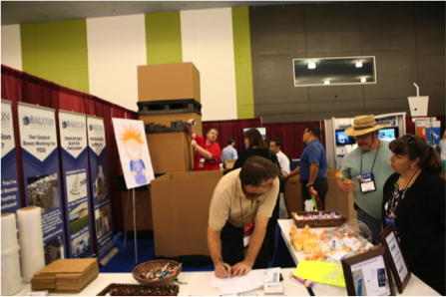
BUILD RELATIONSHIPS AND MARKET YOUR ORGANIZATION
Participate in valuable networking opportunities that allow you to personally introduce yourself to potential customers, build upon your standing relationships, demonstrate industry innovations and distribute samples of your products.
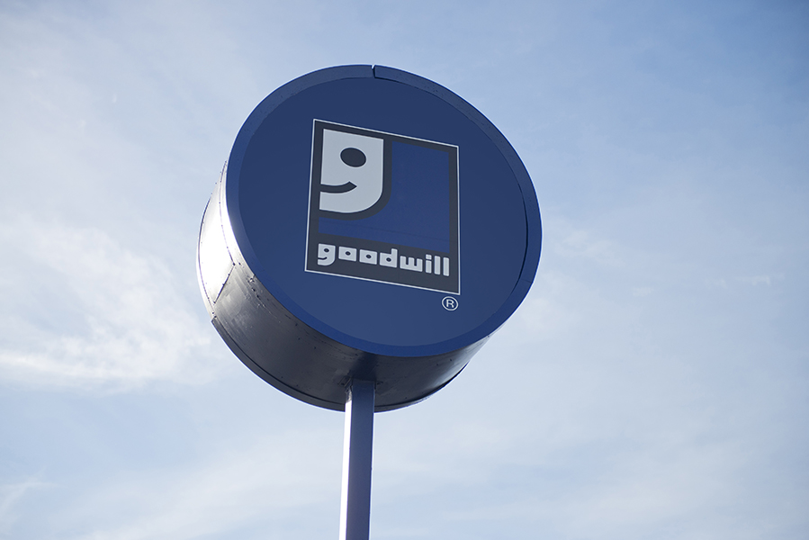

Align with the Goodwill Brand
Form a bond with the second-largest nonprofit organization in the United States (Forbes) and one
of the nation’s top-five most valuable and recognized nonprofit brands (Cone LLC). Goodwill was also ranked by Enso as the number-one brand doing the most good in the world, and is the only nonprofit brand in Forbes’ 20 most inspiring companies for three consecutive years. Aligning with such a powerful brand and household name allows your organization to expand its sales revenue and reach audiences it may otherwise leave untapped.

Change Lives
Partner with Goodwill and improve the lives of people in the communities where you live and work. Goodwill generates opportunities for people to achieve economic stability and build strong families and vibrant communities through job training and placement services and other community-based programs. By working with Goodwill, you create jobs.

EXHIBITing Details – Spring

Exhibit Dates:
May 7 – 9, 2018

Exhibit Location:
Hyatt Regency Sarasota
Sarasota, FL

Estimated Goodwill Attendees:
350

Exhibit Type:
6’ x 2’ tabletop

Exhibit Format:
Hosted buyer (during session breaks)

Exhibit Fee:
$3,000

Booth Package Includes:

One (1) skirted 6' x 2' table

Two (2) side chairs

Two (2) "Exhibit Hall Only" passes

One (1) wastebasket

Additional Exhibitor Expenses Include:

Additional exhibitor passes
($500 per/person)

Audio visual equipment and accessories

Certificate of insurance

Electricity

Shipping and handling

Exhibitor Kit: See registration site

EXHIBIT APPLICATION PROCEDURES
- Booth reservation must be completed online.
- Exhibitor must agree to GII Exhibit
Terms and Conditions.
- All registering organizations will be subject to a review process by GII.

Review criteria include:
- Organization must be incorporated in the United States or Canada.
- Organization’s records must be
verifiable with public tools such as Dun and Bradstreet, LexisNexis or otherwise.

During registration, all exhibitors must upload the following:
- A valid certificate of insurance. See registration site to view certificate of insurance requirements.
- Current company logo in .jpeg and .eps formats.

EXHIBITing Details – summer

Exhibit Dates:

EXHIBIT APPLICATION PROCEDURES
- Booth reservation must be completed online.
- Exhibitor must agree to GII Exhibit
Terms and Conditions.
- All registering organizations will be subject to a review process by GII.

Review criteria include:
- Organization must be incorporated in the United States or Canada.
- Organization’s records must be
verifiable with public tools such as Dun and Bradstreet, LexisNexis or otherwise.

During registration, all exhibitors must upload the following:
- A valid certificate of insurance. See registration site to view certificate of insurance requirements.
- Current company logo in .jpeg and .eps formats.

July 30 – August 1, 2018

Exhibit Location:
Hilton Austin
Austin, TX

Estimated Goodwill Attendees:
350

Exhibit Type:
8’ x 10’ Booth (16’ x 20’ Double)

Exhibit Format:
Tradeshow (dedicated hours)

Exhibit Fee:
$3,000 – $6,000

Booth Package Includes:

One (1) skirted 6' x 2' table

Two (2) side chairs

Two (2) "Exhibit Hall Only" passes

One (1) wastebasket

Additional Exhibitor Expenses Include:

Additional exhibitor passes
($500 per/person)

Audio visual equipment and accessories

Certificate of insurance

Electricity

Shipping and Handling

General Service Contractor:
Fern Expositions: Click to Contact FERN
Exhibitor Kit: See registration site

À la carte SPONSORships

Enhance your ROI potential with targeted à la carte sponsorships.

Spring and Summer Conference Opportunities
- Attendee Email Marketing Message: $750
- Dine-Around Sponsorship: $2,500

- Hotel Room Key Card: $2,500
- Hotel Room Drop: $2,500

À La Carte Sponsorship Guidelines:
- Co-sponsorships are not permitted.
- Payment is due at purchase.

Purchase Deadlines:
- Spring Conference – April 15, 2018
- Summer Conference – June 15, 2018

- Hosted Buyer: $3,000
- Lead Retrieval: $300
- Member Marketplace LIVE Moments: $2,500
- Member Marketplace Subscription: $600
- Mobile App Banners: $1,000
- Networking Break Sponsorship: $2,500
- Vendor-Facilitated Meeting Room: $2,500
- Vendor-Hosted Reception: $2,500
- Webinar Express Series: $1,000

Á la carte DESCRIPTIONS

- Attendee Email Marketing: Grow awareness and subsequently your return on investment by sending an e-blast message to up to five segments of conference attendees.
- Dine-Around Sponsorship: Connect over dinner with your core audience. Benefits also include mention in the event mobile app and ability to leave dinner participants with a promotional item/gift.
- Hotel Key Card: Advertise to attendees through your company logo and message on room keys.
- Hotel Room Drop: Impress attendees at the conference by having a thoughtful gift and/or marketing material delivered to their rooms. Limited to a selected day.
- Hosted Buyer Matchmaking: Save time and money by opting into meet with attendees at specific times during the conference.
- Lead Retrieval: Increase your ROI immediately by capturing your leads and following up with them in real time.
- Member Marketplace LIVE Moments – Seize the stage to briefly demo your company product and services to attendees at the conference.
- Member Marketplace ONLINE Subscription: Enjoy post-conference benefits of being listed on Goodwill’s virtual vendor database for a full year. This discounted offer is only for exhibitors. The regular price is $1,200. Membership includes an online listing and weekly promotion exposure.
- Mobile App Banners: Increase your brand awareness through ad banners on the mobile app.
- Networking Break Sponsorship: Increase your exposure by sponsoring the networking breaks. This is a daily sponsorship opportunity and its benefits include your logo on the conference website, print program, mobile app and networking break table tents.
- Vendor-Facilitated Meeting Room: Conduct a business meeting with 15 or less of your existing or new clients. This is a daily sponsorship opportunity and its benefits include up to two hours of access to a meeting room at the conference facility. The meeting room will be set up in your desired format. You will be responsible for marketing the meeting to potential participants. Audio-visuals, food and beverage are not included in the sponsorship fee.
- Vendor-Hosted Reception: Network informally with attendees by hosting a reception. Food and beverage are additional costs at sponsor expense.
- Webinar Express Series Sponsorship: Introduce your company to attending and non-attending Goodwill staff and encourage them to visit your table or contact you through a Webinar Express.

eXHIBIT facts and Statistics

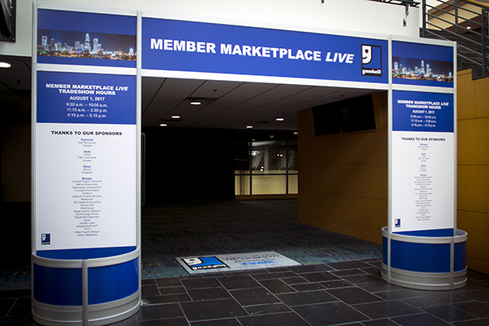
Frequent ExhibitING organizatiOns

The following organizations have exhibited at the
Member Marketplace LIVE multiple times since 2010.

Acme Display Fixture
Anchor Packaging
Baby King/Pet King
Balcon Enterprises
Berengaria Development
The Boon Group
Brainshark
CashMateUSA
Chem-tainer Industries
Cintas Corporation
College Hunks Hauling Junk
ComSurv
Dell Reconnect
FCE Benefit Administrators
Global Cash Card
Grand+Benedicts
Haddad International
Hangers Unlimited
Insurance Auto Auctions
LP Software
LRI International
Midwest Label & Tag
Mood Media
National Charity Services
Neatoscan, Inc.
ORBIS Corporation
Orkin
Palay Display Industries
PassPort Marketing
PCI Waste and Recycling
Penske Truck Leasing
Profit Solutions Group
QuestMark Flooring
Retail Control Systems
RightPath Resources
Royal Basket Trucks
Ryder
shopgoodwill.com®
Sprint
Stores Supply Warehouse
Sullivan Commercial Supply
TechSoup Global
TheThriftShopper.Com
Thrift Books, LLC
TSYS Merchant Solutions
United Container Co.
UPS
UsedCardboardBoxes

terms and conditions

Upon acceptance by GII, all Exhibitors are required to agree and comply with the following Terms and Conditions:

1. INDEMNIFICATION
- The Exhibitor agrees to indemnify, hold harmless and defend GII and the hotel or facility and their respective members, officers, directors, agents and employees from and against any and all liabilities, damages, actions, losses, claims and expenses (inclusive of attorney’s fees) on account of personal injury, death, or damage to or loss of property or profits arising out of or contributed to by any act, omission, negligence, fault, or violation of a law or ordinance by the Exhibitor or its employees, agents, contractors, patrons and invitees.
- GII will cooperate fully, but cannot assume responsibility for damage to Exhibitor’s property, lost shipments either arriving or departing the premises, or moving costs. Any damage due to inadequately packed property is the Exhibitor’s own responsibility. If the exhibit fails to arrive, the Exhibitor will nevertheless be responsible for booth rental fee, and no refund will be made. Exhibitor should carry insurance against such risks.

2. LIABILITY/INSURANCE
- The Exhibitor shall, at its own cost and expense, carry and maintain Comprehensive General Liability Insurance, through companies satisfactory to Goodwill Industries International, in a minimum amount of $2,000,000 combined single limit.
- All such policies (except Workers’ Compensation) shall specifically state: “Named as additional insurer under above policies.” The additional names are: Goodwill Industries International, Inc.
- Each policy shall provide that it may not be canceled or changed without at least ten (10) days’ prior written notice to GII.
- GII shall furnish to exhibit space facility with a copy of the Exhibitor’s certificate of insurance evidencing such coverage prior to the commencement of services hereunder and shall continue to provide exhibit space facility subsequent certificates of insurance evidencing uninterrupted compliance with this insurance requirement until the termination of this agreement.
- GII will provide a security guard solely for the tradeshow location from tradeshow move in on through exhibit end/tear down hours; however, the furnishing of such security services shall not be construed as an assumption, obligation or duty of GII with respect to the protection of property of the Exhibitor.
- The Exhibitor is solely responsible for the protection of its property. Due to the tremendous value of exhibits, it is impractical and impossible for GII to insure the Exhibitor’s equipment against loss, theft, damage or breakage.
- Neither GII nor the hotel, nor any facility, nor any of its employees or representative(s), nor any representative of GII, nor any subcontractor will be responsible for any injury, loss or damage to the Exhibitor or the Exhibitor’s employees or property, however caused.

3. REJECTED DISPLAYS
- GII determines the eligibility of any company or product for exhibit. GII may forbid installation or require removal or discontinuance of any exhibit or promotion, wholly or in part, that in its sole opinion is not in keeping with the spirit and mission of Goodwill.
- Unethical conduct, breach of this contract, or infractions of rules on the part of the Exhibitor or its representative(s), or both, will subject the Exhibitor or representative(s) to dismissal from exhibit areas.
- In the event of such dismissal, no refund shall be made, and the Exhibitor or its representative(s) may make no demand for redress.
- Exhibitors and representative(s) who fail to observe these conditions of contract or who, in the opinion of GII, conduct themselves unethically may be dismissed without refund or appeal for redress.

4. SPACE ASSIGNMENTS
- Space assigned to Exhibitor may be reassigned by GII to affect balance against congestion, to avoid confusion in company names, to solve competitive conditions, or for similar reasons.
- No such reassignment will be made without notification to the Exhibitor. An Exhibitor may not share with or sublet space to another party. If the Exhibitor has requested more than one booth space, GII will assign contiguous space if such space is available.
- The Exhibitor must conduct all its activities within its assigned booth space. The Exhibitor may not use the aisles or other areas of the exhibit hall for its promotional activities.

5. HEIGHT AND SPACE RESTRICTIONS
- All in-line exhibits, back walls and decorations will be limited to eight (8) feet in height, not extending more than three (3) feet from the back wall, except actual equipment that in normal operation exceeds this height. Permission to exhibit equipment with abnormal heights must be obtained from GII.
- Exhibits should not project beyond the space allotted and should not obstruct the view or interfere with traffic to other exhibits. The wings of an exhibit should not project more than three (3) feet from the back wall.
- Exhibitors who assemble a display that does not meet these height and space restrictions or that obstruct sight to other Exhibitor booths will have their booths moved, rearranged or dismantled at the Exhibitor’s expense.

6. SOLICITATION
- GII may, at its sole discretion, withhold or withdraw permission to distribute souvenirs, advertising or other material it considers objectionable. Novelty gifts or souvenirs must be submitted to GII for review prior to distribution.
- Direct selling of products or services is prohibited. The Exhibitor agrees that selling goods or services in the exhibition hall will result in the closing of the exhibit by GII. It is agreed that no refund of exhibit fees and no demand for redress will be made by the Exhibitor or its representative(s) in this event. No soliciting for business shall be permitted in aisles or in other Exhibitors’ booths.
- Exhibitor may distribute samples, catalogues, pamphlets, publications and promotional materials only within their own booth.
- No Exhibitor will be permitted to give away any premium items, or to conduct any prize drawings for awards for signing of names and addressees, or other extreme promotions, without first obtaining written permission from GII.
- Advertising, canvassing, solicitation of business, and other activities are not permitted in the exhibit hall except by companies that have obtained space to exhibit from GII, and then only in the space assigned.
- Exhibitor’s use of GII’s name and its Smiling G logo or any other GII-owned trademarks is strictly prohibited in any advertising or marketing material on the web or in print or as part of the exhibit. The only logo permitted for use in tradeshow marketing material is the Goodwill Member Marketplace LIVE logo, which will be available to exhibitors for download during registration.

7. BOOTH MATERIALS/FIRE REGULATIONS
- All Exhibit and booth materials must comply with federal and city fire laws, insurance underwriter, and hotel/facility safety regulations, and must be flameproof. All packing containers, excelsior and similar materials are to be removed from the exhibition area upon completion of booth set-up.
- The Exhibitor is restricted to materials that will pass inspection. Decorations of paper, pine boughs, leafy decorations, tree decorations or tree branches are prohibited. Any substance prohibited by the city fire and safety departments or authorities will not be permitted in the exhibition area. In addition, all electrical work and electrical wiring must be approved and installed in accordance with local regulations.
- Exhibits must not block aisles or fire exits. Any questionable materials to include helium, gas, etc., must be approved by GII.
- The Exhibitor will not be permitted to store packing crates, containers and boxes in its booth during the tradeshow period. The Exhibitor may make arrangements with the GII contracted exhibitor decorator or the facility for storage of packing crates, containers and boxes that are properly identified with the Exhibitor’s name. GII is not responsible for the damage, destruction or theft of any packing crates, containers or boxes.

8. AUDIO AND VIDEO
- Motion picture projectors and apparatuses must conform to the fire regulations of the facility. Projection of motion pictures must be supervised by a licensed operator where required.
- An exhibitor with audible electric sound, motion pictures or other microphones or devices that GII, in its sole discretion, deems objectionable to other Exhibitors will be required to discontinue this method of promotion. GII reserves the right to impose sound limitations on Exhibitors when their promotional activities are interfering with the activities of other Exhibitors or participation and enjoyment of the exhibit hall by Goodwill members.

9. BOOTH STAFFING
- In its best interest, and for security, the Exhibitor shall keep staff in the booth(s) during all exhibit hours. Each exhibiting company is entitled to up to two (2) exhibit staff badges per booth. An exhibit staff badge is for personnel responsible for working in the booth during show hours, and it will not provide access to any other event. Badges must be worn at all times for admission to the exhibit hall. Additional personnel and additional badges per booth can be obtained for $500 per person. This does not apply to sponsors.
- GII is not responsible for any loss or damage to Exhibitor’s display, materials, or other personal property left in the booth, whether the booth is attended or unattended.
10. INSTALLING/DISMANTLING/REMOVING BOOTHS
- The exhibit hall will be available to Exhibitors during the designated move-in hours for the installation of displays. All exhibits must be operational by the time the tradeshow opens. No installation will be permitted during the tradeshow hours without special written permission from GII. Space not occupied by tradeshow open may be reassigned for other purposes by GII. Any Exhibitor failing to occupy contracted space is not relieved of the obligation to pay for such space at the full rental price, and GII shall have the right to use such space as it deems appropriate to eliminate blank space in the exhibit hall.
- The exhibit hall will be available to Exhibitors during published tear down hours for the dismantling and removal of displays. No exhibit may be dismantled before the specified time, nor may any part of the exhibit or equipment be removed once it has been set up, without permission from GII.
- Before any exhibit may be removed from the building, the Exhibitor must make arrangements satisfactory to GII and the facility for payment of any charges incurred by the Exhibitor in connection with the exposition therein.
- The Exhibitor must surrender the booth space in the same condition it was in when the Exhibitor arrived. The Exhibitor and its employees and agents shall not damage or deface any part of the building where the tradeshow is held, the booths, or the equipment or furniture of the booth, or property of other Exhibitors.
- The Exhibitor may not tape, nail or otherwise affix the exhibit or signs to the walls, doors or other components of the booth space of facility in a way that might cause damage. The Exhibitor is liable to the owner of the property for any damage caused by the Exhibitor, its employees or agents. GII or the facility may remove any display, materials or other personal property left in the booth space after the end of tear down hours and neither GII nor the facility shall have any liability to the Exhibitor for the return of any property so removed or compensation for its value. The Exhibitor will be solely responsible for any charges incurred by GII or the facility in removing the Exhibitor’s personal property from the booth space.
- The Exhibitor will comply with all rules and regulations imposed by the facility on the use of hand trucks, carts or other vehicles for transporting displays and materials into and removing them from the exhibit hall.

11. THIRD-PARTY CONTRACTORS
- All Exhibitors are strongly encouraged to use the contracted exhibitor decorator for booth exhibits.
- GII has selected and contracted an official exhibitor decorator for the tradeshow, with labor and equipment to be provided at prevailing rates. Contact information for the exhibitor decorator will be provided.
- Due to limited storage, large shipments of drayage, packages or exhibits for an exhibit and/or production company or client will not be accepted by the facility. A large shipment is roughly defined as any shipment with more than five boxes, or weighing in excess of 100 pounds. Should an Exhibitor send unqualified package(s), they will not be accepted by the Receiving Department. Please make arrangements for pre- and post-shipping, drayage handling and storage with the contracted exhibitor decorator.
- No deliveries can be made through the public areas of the hotel. Please deliver all materials through the shipping and receiving department.
- Small outgoing shipments can be handled by the facility.
- The Exhibitor assumes full responsibility for any third-party contractor hired by the Exhibitor.

12. PAYMENT, CONFIRMATION AND CANCELLATION POLICY
- Exhibiting space will not be assigned without full payment.
- Goodwill Industries International, Inc. may not be able to accommodate all applicants. Companies that have applied to exhibit will be accommodated at the sole discretion of Goodwill Industries International, Inc. and will be notified as such.
- Any Exhibitor may cancel or withdraw from exhibiting at the tradeshow subject to the following conditions:
- The Exhibitor shall give GII written notice of cancellation. Such notice will be considered official on the date of receipt by GII.
- Written cancellations received prior to [ENTER DATE] will be honored with a full refund, less a $150 processing fee.
- After [ENTER DATE], no refund shall be given for cancellations or no-shows. The Exhibitor assumes the risk of transportation, delivery, contractor and other delays that may prevent the Exhibitor or its display from arriving on time at the tradeshow.
- In the event the premises of the facility are destroyed or damaged, or if the tradeshow fails to take place as scheduled or is interrupted or discontinued, or access to the premises is prevented or interfered with by reason of any strike, lockout, injunction, act of war or terrorism, act of God, emergency declared by any government agency, or for any other reason, GII may terminate the tradeshow. In the event of such termination, the Exhibitor waives any and all damages and claims for damages and agrees that the sole liability of GII is to return to the Exhibitor its space fee payment after payment of all tradeshow expenses.

13. AMERICANS WITH DISABILITIES ACT
- All Exhibitors shall be responsible for complying with the accommodations or requirements of the Americans with Disabilities Act (“ADA”), including:
- The readily achievable removal of physical barriers to access to the assigned exhibit and common areas.
- The provision of auxiliary aids and services where necessary to ensure that the Exhibitor treats individuals with disabilities no differently than other individuals.
- The modification of the Exhibitor’s policies, practices and procedures applicable to all guests and/or groups as necessary to provide goods and services to individuals with disabilities.
- The Exhibitor shall indemnify and hold harmless GII against all losses, liabilities, claims, suits, expenses and damages, including attorney’s fees, on account of or relating to any actual failure of the Exhibitor to comply with local, state and/or federal laws regarding ADA accommodations.

14. AMENDMENT TO RULES
- Any and all matters or questions not specifically covered by these Terms and Conditions shall be subject solely to the discretion of GII.
- GII may, in its sole discretion, make reasonable changes, amendments or additions to these terms and conditions. Any such changes shall be binding on Exhibitor equally with the other terms and conditions contained herein.

