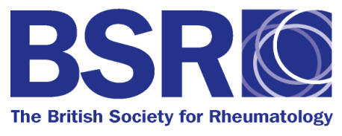
Application for BSR ultrasound course bursary

Please complete in BLOCK CAPITAL LETTERS

To apply for the bursary you will need to:

- Be a current BSR/BHPR member
- Have access to an ultrasound machine, and for the developing skills course have attended the BSR basic ultrasound course or equivalent
- Return this completed form, countersigned by your local ultrasound trainer, or BSR regional chair
- Attend and complete the course

Full name:

Job title/Grade:

Correspondence address (bursary cheque will be posted to this address):

BSR or BHPR membership number:

Please tick the BSR ultrasound course you wish to receive a bursary for:

BSR Basic ultrasound course, York, 26-27 September 2014

BSR Developing skills in ultrasound course, Nottingham, 8-9 November 2014

If you are planning to attend the Developing skills in ultrasound course, please document here which basic course you have attended: (course/ year)

For non BSR courses please attach a copy of the course CPD attendance certificate, or a supporting note from the local trainer describing the course.

I certify the information above is correct.

Signature of applicant:……………………………………………….. Date:…………………………………………….

I certify the above named person has regular access to an ultrasound machine for training under my supervision.

Name of regional trainer/ BSR regional chair:

Signature:……………………………………………………………..Date:……………………………………………..

On completion of the course, a cheque for £500 will be posted to the correspondence address you have given.

Any queries please contact Lucy Witcomb on lwitcomb@rheumatology.org.uk.

Please return completed forms to:

Lucy Witcomb
The British Society for Rheumatology, Bride House, 18 – 20 Bride Lane, London, EC4Y 8EE

Or emailed a scanned copy to: lwitcomb@rheumatology.org.uk

