Welcome County Engineers to the 2019 Professional Development Conference!

WSACE holds the Professional Development Conference annually to encourage non-technical learning/professional growth and to promote networking. The varied topics draw varied participation - in addition to technical/engineering staff, we often see environmental, contract admin, office, field staff and others at this conference.

This year we welcome Kevin Eikenberry of the Eikenberry Group. Kevin brings with him nearly three decades of leadership development, coaching and training.

This year we meet again at the beautiful Suncadia Resort outside of Cle Elum, WA. Join us for opportunities to network with your peers, share ideas, and learn how to be a more effective, strategic and thoughtful leader.
Kevin Eikenberry is a world-renowned leadership expert, a two-time bestselling author, speaker, consultant, trainer, coach, leader, learner, husband and father (not necessarily in that order).

Kevin is the Chief Potential Officer of The Kevin Eikenberry Group, a leadership and learning consulting company that has been helping organizations, teams and individuals reach their potential since 1993. Kevin’s specialties include leadership, teams and teamwork, organizational culture, facilitating change, organizational learning and more.

Kevin’s philosophy in business and in life is that every person and every organization have extraordinary potential. Investments of time, energy, focus and money are required for that potential to be realized. He believes learning is an active, ongoing process, not a passive, one-time event. Learning, work and life should be fun; and, if we are doing it right, work (and learning) is play.

He has worked with Fortune 500 companies, small firms, universities, government agencies, hospitals, and more. His client list includes the American Red Cross, A & W Canada, Chevron Phillips Chemical Company, John Deere, Purdue University, Sears Canada, Shell, Southwest Airlines, the U.S. Marine Corps, U.S. Mint, and Verizon.

Guest Speaker: Kevin Eikenberry
LINK to Kevin’s Bio

Wednesday Afternoon, 2/6/2019:
What Leadership Looks Like
- Expectations and their importance
- Skills of Remarkable Leaders
- Mistakes new leaders make
- Leading former peers
- Two leadership mindsets
Thursday Morning, 2/7/2019:
The Leader as a Learner
- Why learning matters to leaders
- Habits of continual learners
Leadership Communication
- Barriers to leadership communication
- How to communicate important messages
- The listening leader
Thursday Afternoon 2/7/2019:
The Leader as a Coach
- Giving effective feedback
- Using a coaching model to improve performance
- Effective delegation
- Understanding and creating accountability
Friday Morning, 2/8/2019:
Influencing Skills
- Importance of personal values as a leader
- Keys to greater influence
Decision making skills
- Approaches to decision making
- Managing high risk decisions
Wrap-up and Action Planning

A SPECIAL THANK YOU TO OUR CONFERENCE SPONSOR:

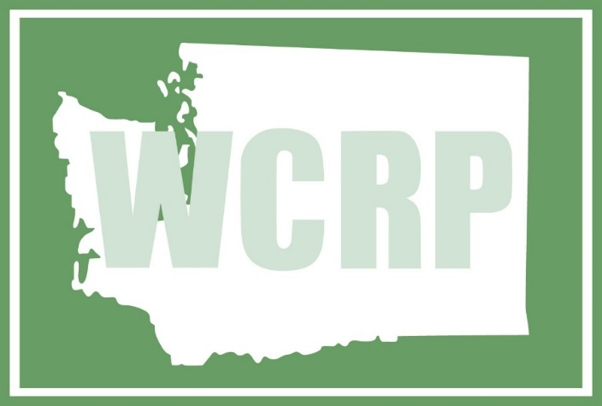
Washington Counties Risk Pool

2018 – 2019 WSACE Executive Officers

President: Paul Randall-Grutter, P.E., Skagit County

President-Elect: Eric Pierson, P.E., Chelan County

Secretary/Treasurer: Scott Lindblom, P.E., Thurston County

Past President: Melissa McFadden, P.E., Pierce County

Western District Rep: Tim Elsea, P.E., Skamania County

Eastern District Rep: Scott Yaeger, P.E., Adams County

NACE Director-at-large: Andrew (Drew) Woods, P.E., CRAB

NACE President: Rich Sanders, P.E., Polk County, MN
WSACE Managing Director Jane Wall

*Save the Date: 2019 WSACE Annual Conference – June 19-21, 2019
Semiahmoo Resort (Blaine, WA)

