|  |  |  |  |  |  |  |  |  |  |  |  |  |
| --- | --- | --- | --- | --- | --- | --- | --- | --- | --- | --- | --- | --- |
|  | | **SCHOLARSHIP FORM**  **October 1 – 3, 2012**  **Yakima, WA**  **Yakima Convention Center** | | | | |  | |  | | --- | |  | | DATE | | REGISTERED | | STAFF INITIALS | |
|  |  | | | | | | |  |
| **ATTENDEE INFORMATION** | | | | | | | | |
|  | |  | |  | | | | |
| FIRST & LAST NAME: | |  | | | | | | |
| JOB TITLE: | |  | | | | | | |
| COMPANY/ORGANIZATION: | |  | | | | | | |
| ADDRESS: | | | | | | | | |
| CITY: STATE: ZIP: | | | | | | | | |
| CITYS POPULATION #: | | | COUNTY: | | |  | | |
| PHONE NUMBER: | |  | | | | | | |
| E-MAIL: | | | | | | | | |
| **CONTACT INFORMATION (IF DIFFERENT FROM ATTENDEE)** | | | | | | | | |
| FIRST & LAST NAME: | | |  | | | | | |
| JOB TITLE: | | |  | | | | | |
| EMAIL: | | |  | | | |  | |
| PHONE: | | |  | | | |  | |
| **TRAVEL ASSISTANCE** | | | | | | | | |
| TIB and the Road & Street Conference are happy to provide travel assistance to the 2012 conference. Travel assistance will be **provided to one attendee per city/town**. Any city that wishes to have additional staff attend will be considered before the Board for approval.  *Please pick one of the following if you wish to receive travel assistance.*  (2) Nights Hotel OR  Mileage Reimbursement | | | | | | | | |
|  | | | | | | | | |
|  |  | | | |  | |  | |

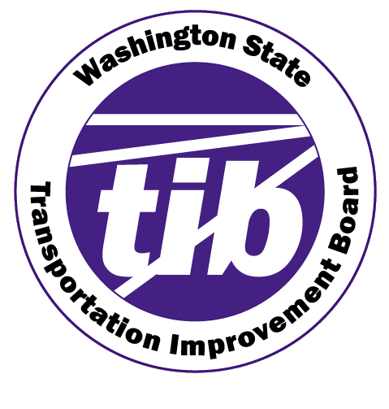

**Please email form to Emily Houg, at** [**ehoug@wsu.edu**](mailto:ehoug@wsu.edu)

**No Later than Friday, September 14th**

S*cholarship will provide conference registration and travel assistance of choice to one attendee per city/town. Additional attendees from the same city/town will be considered before the Board for approval.*

Street Operations and Maintenance personnel from incorporated cities under 5,000 population will be

eligible to be considered for this scholarship.