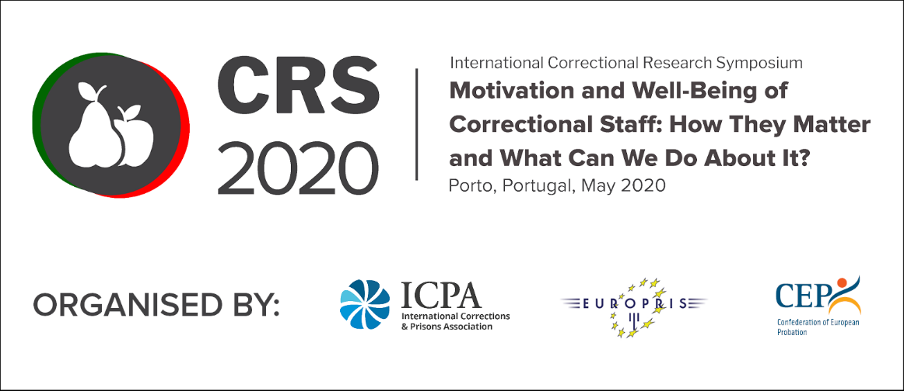

3rd International Correctional Research Symposium, May 2020
Call for Papers – Submission Form

Under the title “MOTIVATION AND WELL-BEING OF CORRECTIONAL STAFF: HOW THEY MATTER AND WHAT CAN WE DO ABOUT IT?” the Symposium aims to elaborate on questions, such as:
- When (and how) do correctional staff in Prison and Community Services over the world work at their best?
- What are the challenges and difficulties of correctional work – in prisons and in the community? What are the outcomes for staff?
- Can we give examples of outstanding correctional staff? What difference can they make in offender rehabilitation? What is the evidence base?
- Are there environments or types of leadership that can support staff well-being and increase motivation?
- How do staff working in corrections innovate, or work creatively, to achieve good outcomes?
- What supports correctional staff in their work? What supports them best in managing increasing complexity? Is more training the answer?
- How can corrections staff successfully navigate job related stress?
- Can we give examples of excellent workforce development?
- What strategies are used to recruit, retain and reward staff?
- Where are the gaps in research?
Name of Speaker
Names(s) of any co-speakers
Organisation/Agency
Country
Email Address
Telephone Number (inc. Country Code)

Brief Description: This should be a summary explanation of what the presentation is about. Maximum 100 words.
Abstract: The Programme Committee review this and their decision is based on this text. We ask that abstracts are no more than 500 words.

Keywords: Please provide some keywords that describe the theme of your presentation.

Biography: Enter a brief biography here (100 words). Include a biography for any co-speakers (If applicable). Do not send or include a CV.

This form should be returned no later than 15th January 2020 to kirstenhawlitschek@europris.org.
There is no need to send any additional materials.
The Programme Committee will notify you by the end of January on the outcome of their review.
In the meantime, please do mark the dates in your calendar .
Thank you for your interest and cooperation.

Regards,
CRS2020 Team

