How to Enter the Game
A $10 glow bracelet purchase grants you game entry.
How the Game Works
1. When the emcee announces it's game time, all those with bracelets stand up.
2. The emcee asks, "Heads or tails?"
3. Indicate your choice by placing your hands on your head... or tail.
4. A coin is flipped.
5. Remain standing if the placement of your hands matches the coin. Sit down if it doesn't match.
6. Repeat steps 2 - 5 until one person remains. She or he wins the prize.
Prizes
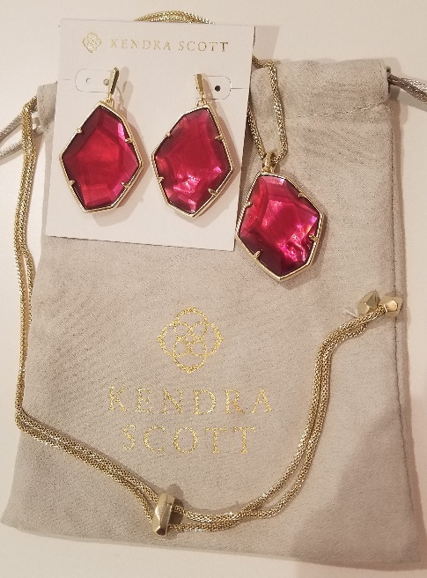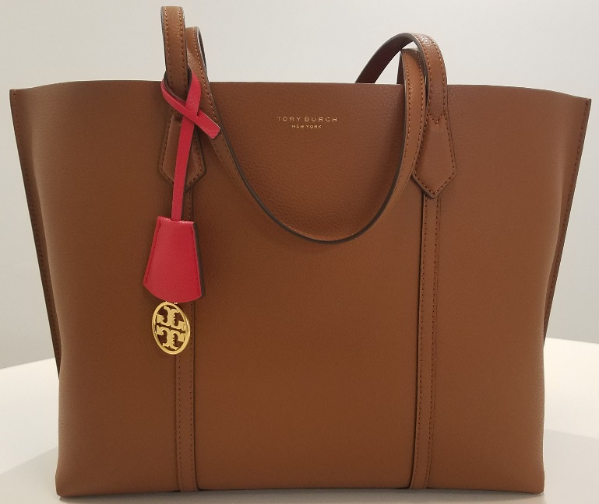
Kendra Scott Jewelry Set Tory Burch Perry Tote
Value: $170 Value: $348

