**Paraskevi Belogia**

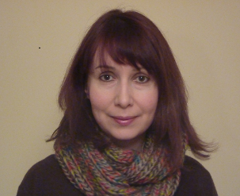Effective evaluation and documentation of a project – 29/10/2016, 10:00-11.30

Paraskevi Belogia has studied English Language and Literature and she holds a Master’s degree (Msc) in Sciences and Technologies of Language and Communication. She has wide experience as an EFL teacher (both in primary and secondary education since 2004) and teaching material developer. She joined eTwinning in 2006. As a teacher she has worked on many eTwinning projects and she has been awarded National and European Prizes. She was also an eTwinning Ambassador in 2013-14, spreading her eTwinning passion to other teachers. She has been a member of the Greek National Support Service of eTwinning since 2014, currently seconded to the Greek Ministry of Education, evaluating eTwinning projects, organizing and participating in several seminars and conferences and running face-to-face and online training and professional development workshops and courses at a national and a European level to support teachers who work on eTwinning projects and introduce them with innovative pedagogical practices and ICT tools.

**Vincenzo Bianca**

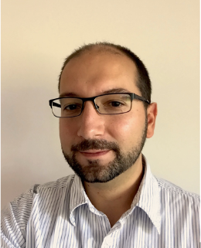Creativity in context of digital citizenship – 28/10/2016, 11:00-12.15

Vincenzo is an educational psychologist in creativity. He worked at the University of Liège before creating his own training and consultancy structure in soft skills, the CTISS. He also worked as an expert in creativity management for various structures throughout Europe and developed in 2014 a new creative project management model. Today he is in charge of various programs around creativity, including the Creative Lab School program that implements creative labs in the High Schools in Belgium.

**Petra Boháčková**

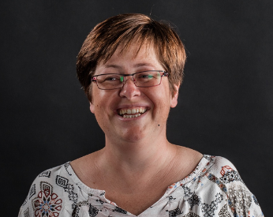BYOD: using them in ETW projects – 28/10/2016, 11:00-12.15

My name is Petra Boháčková. I am a deputy headmaster at ZS Dr. E. Benese school in Prague. I teach Physics and English. I am an eTwinning ambassador and I specialize in using mobile devices in project and also in my lessons. I am also a Future Classroom Lab Lead ambassador for the Czech Republic, Apple Distinguished Educator and Professional Trainer and I also work in a Google Education group called Teach with us. In my free time I do Geocaching and I love reading.

**Ignacio Casado Alda**

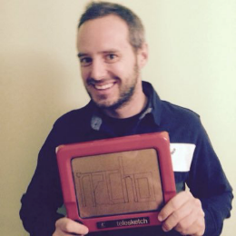Who are you online? – 29/10/2016, 10:00-11.30

Physical Education, English Teacher and NSS Member.

**Tommaso Dalla Vecchia**

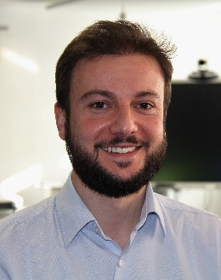Introduction to digital creation and coding for all – 28/10/2016, 11:00-12.15

Tommaso Dalla Vecchia has been working since 2012 on awareness raising, education and training projects, especially in the area of digital skills and coding. He is responsible for the [European Coding Initiative](http://www.allyouneediscode.eu/), a public-private partnership, aiming at better understanding and encouraging the introduction of coding and programming teaching and learning in primary and secondary schools. Tommaso is currently supporting the implementation of the awareness raising campaign, [e-Skills for Jobs 2016](http://eskills4jobs.ec.europa.eu/), and has coordinated European Schoolnet work in the framework of the European Commission’s Grand Coalition for Digital Jobs.

**Maité Debry**

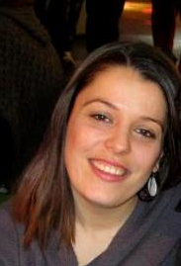Discover new collaboration opportunities with eTwinning Plus! – 28/10/2016, 11:00-12.15

Tools for Responsible Research and Innovation in Science – 29/10/2016, 10:00-11.15

Maité has nine years of experience in European education projects management (STEM, innovation in education, awareness raising) with a background in development cooperation and international relations. She  currently coordinates the eTwinning Plus project (<https://plus.etwinning.net/>), that provides a platform for schools in Europe’s immediate neighbourhood, to link with schools participating in eTwinning. She also manages the STEM Alliance ([www.stemalliance.eu](http://www.stemalliance.eu)), on school-industry collaboration and the activities linked to education in the RRI Tools project (<http://rri-tools.eu/>), an EC initiative on Responsible Research and Innovation. Originally from Belgium, Maite has a Degree in Political Sciences and a Master Degree in Development Projects and Programmes.

**Katja Engelhardt**

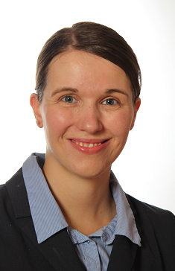Accessibility in Education – 28/10/2016, 11:00-12:15 and 15:00-16.30

Katja Engelhardt has joined the Knowledge Building Team of European Schoolnet in September 2012. She supports several projects (MENTEP, TASK) and regularly prepares reports and studies, e.g. currently the study “[An analysis of educational approaches to developing Computational Thinking (CompuThink](https://ec.europa.eu/jrc/en/computational-thinking)). Previously, she was involved in the ‘ICT4IAL’ project, the ‘Creative Classrooms Lab’ and the ‘SENnet’ project. Working on these projects, she developed expertise in the areas of mobile learning, special needs education and accessibility of information, coding as a 21st century skill, self-assessment, and online teacher training. Previously, Katja completed traineeships at the unit “Education, Youth, Culture, Audiovisual and Sport” of the Council of the European Union and the Pestalozzi Programme of the Council of Europe. She has teaching experience in France (Reunion Island). Katja holds a LLM degree in International Laws and a BA degree in Social and Cultural Studies.

**Lourdes Gozalo Arranz**

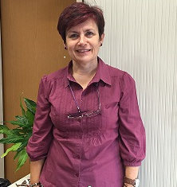Who are you online? – 29/10/2016, 10:00-11.30

Math Secondary Teacher and NSS Member

**Lysiane Gransé**

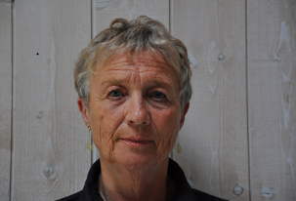Teacher resources on migration – 28/10/2016, 10:00-11.30 and 29/10/2016, 10:00-11:30

Retired teacher in a French vocational school,I taught English and French for more than thirty years. I have been a volunteer for more than twenty years in a NGO called Terre des Hommes (TDH). I am currently president of TDHFrance and president of the International Federation of Terre des Hommes.

With another volunteer, we produced three leaflets on child's rights in the context of migration. Children are very sensitive to rights and to justice. We believe in the education to rights for school children at a young age. This education will make them better citizens.

**Tatjana Gulič**

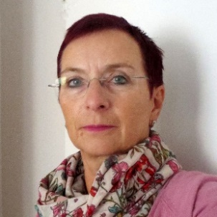Project planning step by step – 28/10/2016, 10:00-11/30 and 29/10/2016, 10:00-11.30

I have been an eTwinning Ambassador since 2010. I teach maths, physics and ICT.

**Marion Haga**

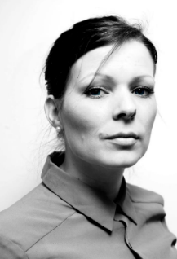Teaching in the 21th century – 29/10/2016, 15:00-16.30

Risør barneskole, Norway. Worked 8 years as a teacher. Master’s degree in ICT in Learning.

**Eleanor Hayes**

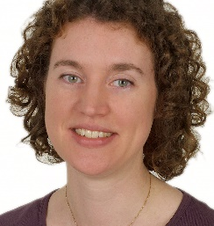Science in schools – 28/10/2016, 15:00-16.30

Eleanor Hayes is the editor-in-chief of Science in School, the European journal for science teachers. She studied zoology at the University of Oxford, UK, and completed a PhD in insect ecology. She then spent some time working in university administration before moving to Germany and into science publishing in 2001. In 2005, she moved to the European Molecular Biology Laboratory to launch Science in School.

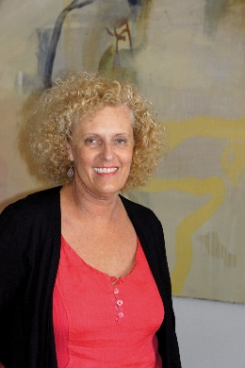**Erika Hummer**

The integration of newly arrived migrants in daily school life – 28/10/2016, 15:00-16.30

After completing my degree in Philosophy at the University of Vienna, I started to teach Italian, History and Computer Science at a Secondary School l (Grammar School). Since 200 I have been coordinating several projects focused on eLearning and multilingua didactics as well as intercultural didactics for the Austrian Ministry of Education:

[http://voxmi.at](http://voxmi.at/)

[http://eeducation.at](http://eeducation.at/)

[http://www.eschoolsvienna.at](http://www.eschoolsvienna.at/)

[http://elsa.schule.at](http://elsa.schule.at/)

I also act as an instructor (teacher trainer) at the University of Teacher Education Vienna and the Austrian Virtual Teacher Academy.

**Michalis Ierides**

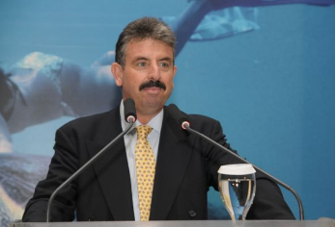Dr. Ierides was born in April 1957 in Nicosia. He graduated from the Faculty of Science of Paul Sabatier University, Toulouse, successfully completed a Master’s Degree at Pierre & Marie Curie University, Paris and obtained his Doctorate in Human Biology in Toulouse. He was a teacher at the Falcon School, as a tutor of the Empire State College of the State University of New York, Lecturer at Frederick University and as an Agent of the Leeds Metropolitan University. Since 1992 he is the Secretary General of CYMEPA (Cyprus Marine Environment Protection Association). He is the Eco-Schools National Operator and the Treasurer of the Foundation for Environmental Education.

**Teresia Jildenhed**

Communication is not an issue! – 28/10/2016, 15:00-16.30

Teresia Jildenhed is a primay teacher in Sweden. She teaches students, 7-10 years old, with special needs and speak and language disabilites.. She has run two eTwinning-project with a school in Germany and won the national eTwinning Prize 2016 with the project “Together though the year”. In the session you will hear more about that project.

**Elina Jokisalo**

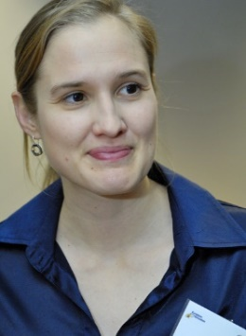Introducing the School Education Gateway/Teacher Academy – 28/10/2016, 10:00-11:30 and 29/10/2016, 10:00-11.30

Elina Jokisalo has been working at the European Schoolnet since 2010. Currently she coordinates the School Education Gateway, European Commission’s platform for school community in 23 languages. She is also in charge of the Future Classroom Lab, a unique and inspiring learning space created by European Schoolnet – in particular its teacher training programme and visits to the lab.

**Oskars Kaulens**

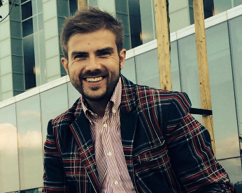Use of social media in learning – 28/10/2016, 15:00-16.30

I have masters degree in political science, I have worked as a history, political science and cultural studies teacher for 5 years and now I am a deputy director of Ventspils State Gymnasium No. 1 (my responsibility is methodical work with teachers from my school and schools of other regional districts).

**Kornelia Lohynova**

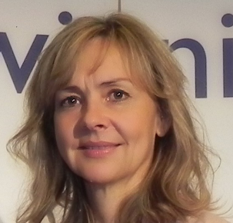Building resilience at school – 28/10/2016, 15:00-16.30

**Kornelia Lohynova** is a teacher of Hotel Management and Tourism Business in Hotel Academy in Bratislava, Slovakia. Additionally, she is a teacher and a teacher trainer of Junior Achievement Entrepreneurial Programs. She has been an eTwinning ambassador for 7 years.

Kornelia speaks at conferences and leads workshops. She moderates two eTwinning featured groups, “Entrepreneurship in Education” and “Teacher Academy Alumni-PBL course”.

She was selected as one of the twenty women global leaders 2013 for the International Visitor Leadership Program Women and Entrepreneurship granted by the US Department of State.

She worked as a tourist guide some years ago and her passion for travel is still very strong.

**Emma Mulquenny**

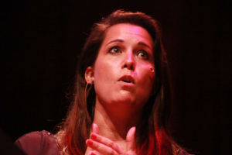Emma is the founder of Rewired State and Young Rewired State, a Commissioner for the Speaker’s Commission on Digital Democracy and a Google Fellow. She has been recognised with an OBE in the Queen’s 90th birthday honours list, is included in the annual edition of Who’s Who and voted:

* onto the Wired 100 list,
* Tech City 100,
* BIMA Hot 100,
* one of the UK’s top 100 most compassionate business leaders (Salt Magazine),
* one of the top ten women in technology by The Guardian,
* top five influential women in IT by Information Week,
* into the top ten Tech Heroes for Good by NESTA,
* as one of the 25 most influential women in IT by Computer Weekly and
* one of 2014’s 50 most incredible women in STEM.

Emma writes regularly for the British Press and on her own blog, speaks on radio and on television, is best known for her campaign: ‘Year 8 is too Late’ (encouraging girls into technology subjects) and insights into the social digital generation: the 97ers.

**Sofia Papadimitriou**

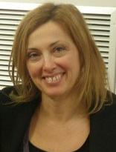Using media to flip your classroom – 28/10/2016, 11:00-12.15

Sofia Papadimitriouhasstudied Mathematics and Computer Science (M.Sc) in the [Athens National University](http://www.uoa.gr). Her PhD entitled “*The role of tutor-counsellor and the development of his supporting mechanism in a collaborative learning environment in distance education*” regards in the field of Open and Distance Learning in Higher Education and has been developed at the [Hellenic Open University](http://www.eap.gr). She has been an ICT Secondary teacher since 1990 and also an educator in ICT training courses for primary and secondary teachers. She has been working in the [Educational Radio-Television](http://www.edutv.gr), since 2007 coordinating its Digital Media and she has been the Head of the unit since 2015. Furthermore, she has coordinated on behalf of her unit the European projects: [EduTubePlus](http://www.edutubeplus.info)*,* [MEDEAnet](http://www.medeanet.eu/), [March (MAke science Real in sCHools](http://sciencemarch.eu/index.php/en/)) and has also participated in the [Energy-bits](http://www.energybits.eu/) project and the development of the [Digital School](http://dschool.edu.gr/) reform.

**Ana Pasarić**

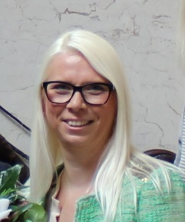eTwinning in classroom: pupil perspective – 28/10/2016, 10:00-11.30

I have been working for over sixteen years in Secondary school Hrvatski kralj Zvonimir, Krk, Croatia. I always try to introduce innovative and creative teaching methods to enhance students' motivation. I have introduced eTwinning projects, Erasmus + and been the project coordinator for a number of school projects.

**Irene Pateraki**

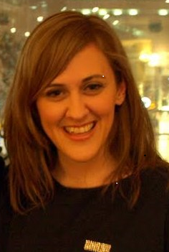Effective evaluation and documentation of a project – 29/10/2016, 10:00-11.30

Irene Pateraki has been working for the Greek National Support Service of eTwinning since 2010 organizing events, running courses, evaluating projects and offering support to the teachers. She is the moderator of the eTwinning Ambassadors Group since 2012 and the Creative Classroom Group since 2008 and has run several Learning Events and online courses for the Central Support Service of eTwinning and courses/webinars for the Greek National Support Service. She holds an MA in Education and has worked as a pre-primary teacher for nine years. At the moment, she is interested in adult education organizing seminars and workshops for teachers in Greece and Europe.

**Christine Redecker**

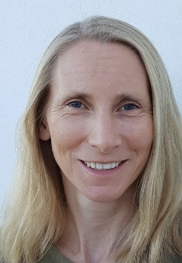Teachers’Digital Competence as a lever for students’Digital Citizenship – 28/10/2016, 10:00-11.30 and 15:00-16.30; 29/10/2016, 10:00-11.30

Christine Redecker works as Scientific Officer at the European Commission's Joint Research Centre (JRC), in Seville, where she is currently in charge of drafting a European Digital Competence Framework for Educators. She first started working at the JRC in 2008, on a project on "Learning 2.0". Subsequently she has been involved in research on the Future of Learning, the use of ICT for the Assessment of Key Competences and Open Education 2030. She holds a PhD in Philosophy and a degree in teaching. Before joining the European Commission, she worked as a high school teacher and university lecturer.

**Dr. Elena Shulman**

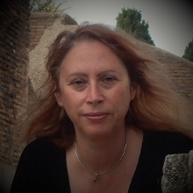

Essentials for creating your own Open Educational Resources – 28/10/2016, 10:00-11.30 and 15:00-16.30

Dr. Elena Shulman is an expert in digital resource management, eLearning content quality and Open Educational Resources discovery and exchange. She has contributed to the design and administration of eLearning portals in Europe and the United States (e.g. OER Commons, European Schoolnet’s Learning Resource Exchange, and the International Baccalaureate Schools Portal). She has been a university lecturer and is also an author of journal articles and award winning scholarly works. Dr. Shulman has managed and contributed to a number of European Commission funded projects on OERs and the technology enhanced learning domain such as LangOER which provides the basis for today’s demonstration and discussion.

**Ellen Stassart**

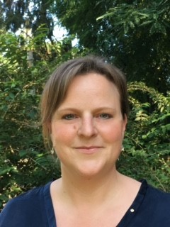Enable against bullying – 28/10/2016, 11:00-12.15 and 29/10/2016, 10:00-11.30

Ellen Stassart is a Master in Law and in Criminology and is working as an independant consultant-expert and trainer. Currently Ellen is working as in-house consultant at European Schoolnet (project ENABLE) She is passionate about Children’s Rights, Education and Empowerment of children dealing with emerging technologies. She worked as a University researcher and lecturer, Deputy Director at the Flemish Government and as Chief Officer at Child Focus. She is the author and editor in chief of a series of expertise articles and researches. She was the Coordinator of the Belgian Safer Internet Center. She lead various (Research) projects, co-funded by the European Commission. As a mother, she is President of the School Board and Representative in a school community of 10 schools. She is also more than 8 years active in parent’s associations and is often subject matter expert speaker.

**Karoline Tømte**

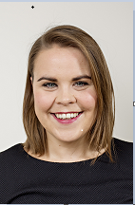Internet awareness in eTwinning – 28/10/2016, 10:00-11.30

Senior Adviser at The Norwegian Centre for ICT in Education and project manager for Dubestemmer.no/ YouDecide.

**Svetlana Varbanova**

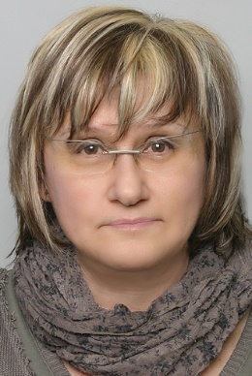The successful eTwinning Project – 29/10/2016, 10:00-11.30

Geb. 1959 in Dobritsch, Bulgarien

1974 – 1978 Deutschsprachiges Gymnasium in Dobritsch, Bulgarien

1978 –1982 Stidium der Germanistik an der Universität Veliko Tarnovo, Bulgarien und an der Universität Rostock, Deutschland

1982 – 2014 Lehrerin für Deutsch –als Fremdsprache und Wirtschaftsdeutsch in Dobritsch, Bulgarien, Gera und Lörrach, Deutschland

2005 – 2008 mehrmonatige Studienaufenthalte in der Schweiz

seit 2009 eTwinning ambassador /eTwinning –Moderatorin

seit 2015 Leben in der Schweiz

Teilnahme an mehreren Comenius- und Erasmus+-Projekten

**Matea Velnić**

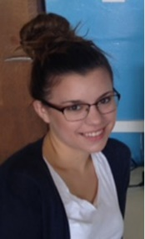eTwinning in classroom: pupil perspective (mentor) – 28/10/2016, 10:00-11.30

I am a senior VET student (hotel and tourism industry). My experience and participation in eTwinning projects motivated me to apply for an eTwinning ambassador. I am enthusiastic and willing to share my skills with other students.

**Bart Verswijvel**

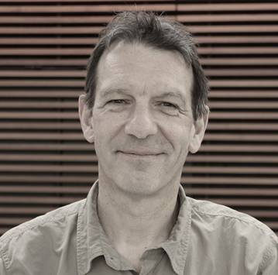Teachmeet 1 – 28/10/2016, 10:00-11.30

Enable against bullying – 28/10/2016, 11:00-12.15

Teachmeet 2 – 28/10/2016, 15:00-16.30

Enable against bullying – 29/10/2016, 10:00-11.30

Bart Verswijvel is a Belgian educator and expert trainer who works with Ministries of Education and schools as a Pedagogical Adviser for European Schoolnet in Brussels. Bart’s special interest is in whole-school approaches to the use of information and communication technology and the ways in which sustainable, growing networks of teachers are developed to enhance technology integration in teaching and learning. Bart promotes and investigates innovative teaching practices and new ways of continuous professional development for teachers. Bart is an international keynote speaker and a leader of workshops, Teachmeets and Twitterchats. He is the pedagogical lead of the Future Classroom Lab, the concept of a flexible learning space. Before joining European Schoolnet, Bart worked as a teacher of Dutch in a secondary school and as a coordinator at the Flemish National Support Service of eTwinning.

**Irena Rimc Voglar**

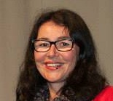Project planning step by step – 28/10/2016, 10:00-11.30 and 29/10/2016, 10:00-11.30

One of the most enjoyable things for me are learning and teaching languages and doing e-Twinning projects. I teach English and German at a small village school in Slovenia, near the Croatian border. Our school is small, but has everything big schools have, in the first place enthusiastic and nice pupils who love eTwinning and are eager to meet peers from other European countries. My pupils are aged between 12 and 15 and have been eTwinners since 2007.

**Sabrina Vorbau**

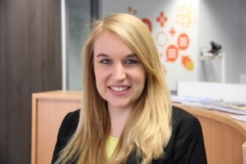Better Internet for kids: enable your students to grow-up online! – 28/10/2016, 11:00-12.15

Sabrina Vorbau is Project Officer at European Schoolnet and part of its Digital Citizenship Team. She works for a variety of online safety projects such as [Better Internet for Kids](https://www.betterinternetforkids.eu/web/portal/home), [Web We Want](http://www.webwewant.eu) and the [eSafety Label](http://www.esafetylabel.eu). She is in charge of the day-to-day project coordination of the Web We Want and eSafety Label. Within Better Internet for Kids, she is acting as Assessment Officer, taking care of project evaluation, quality assurance and joint research approaches. Moreover, Sabrina is also part of the eTwinning eSafety taskforce group and hosted together with her colleagues two eTwinning learning events on eSafety and digital skills.

**Riina Vuorikari**

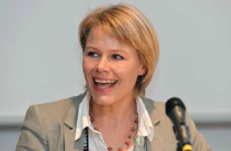Riina Vuorikari is member of eTwinnig Pedagogical Advisory Team and has a long-term research interest in eTwinning and teacher networking. She currently works as Scientific Officer at the European Commission's Joint Research Centre (JRC), where she started in 2013. Her work focuses on Digital Competence for citizens and Innovation in education. Before joining the JRC in Sevilla, she worked as a Project Manager and Research Analyst in various EU-funded projects for educational organisations such as European Schoolnet. She has degrees in education, hypermedia and Information and Knowledge Systems.