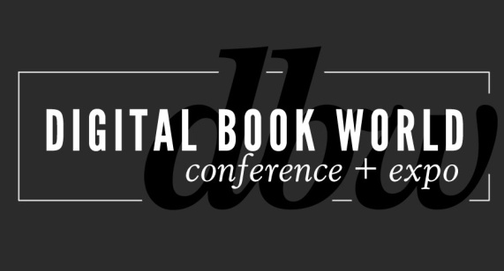
Contact: Stacie Berger F+W Media, Inc.
513.531.2690 x 11457
stacie.berger@fwmedia.com
Digital Book World 2014: 5 Years Later what has the iPad Wrought?
NEW YORK – December 2, 2013 – Digital publishing is at a watershed moment in history. With the initial surge of the first e-readers and tablets settling into a more mature marketplace, digital publishing is coming of age. The first Digital Book World Conference+ Expo coincided with the launch of the iPad. What will the fifth annual DBW usher in? Discover what’s next at the Digital Book World Conference+ Expo, January 13-15, 2014 at the Sheraton Hotel and Towers in New York City. Find complete details and register for the event at http://conference.digitalbookworld.com.
The most prominent market influencers, senior executives and industry analysts will reveal how digital publishing will be fundamentally different from this point forward at Digital Book World Conference & Expo 2014.

- Tim O’Reilly, founder & CEO, O’Reilly Media, Inc. will present his case that the ebook revolution is just beginning.
- Brad Stone, author and Businessweek contributor, will expand on his new best-selling book about Jeff Bezos and Amazon.com.
- Jim Cramer, author and host of CNBC’s Mad Money, will talk about the future of the business of (and investing in) publishing and media.
- Emanuel Rosen, author and social media strategist, will share insights on how to influence customers who point and click to purchase.
- Carolyn Reidy, President and CEO of Simon and Schuster joins the discussion on Big Publishing’s perspective on what’s next on a CEO panel joined by Michael Cader, creator of Publisher’s Lunch, David Nussbaum, Chairman and Chief Executive Officer of F+W Media and Tim O’Reilly.

- LeVar Burton, actor and producer of Reading Rainbow, will host the Digital Book Awards, where the year’s best products in digital publishing will be recognized.

Plus, case studies, and insights from publishing professionals, with the latest research and analysis in academic publishing, kids publishing, change management, technology implementation, sales, marketing and production.
The inaugural Digital Book World Conference + Expo coincided with the launch of the iPad and just like the hardware, has evolved to respond to the needs of the book publishing industry. The largest event of its kind in the world, it offers an exclusive opportunity to network with 1500 senior-level publishing professionals, from marketers and editors to publicists, to developers, librarians and booksellers. To learn more about the program and to register for the 5th Annual Digital Book World Conference+Expo, visit http://conference.digitalbookworld.com. Discount pricing expires December 13.
# # #
About Digital Book World
The Digital Book World Conference + Expo is the largest event dedicated solely to the business of digital publishing worldwide. It consists of a 2-day multi-track, multi-faceted digital publishing program, pre-conference events, Digital Book Awards gala and exhibition hall. Digital Book World, an F+W Media event, attracts an international audience of 1,500 industry professionals, 50 exhibitors and more than 100 speakers. http://conference.digitalbookworld.com

