How It Works
When you purchase a $50 bling box, you are guaranteed one of three prizes valued at $125, plus a chance at a grand prize valued at $5,200! The prizes are placed in decorated boxes and remain closed until we announce it's time for the reveal. The person who wins the grand prize has a special note in their box to come to the stage to redeem.
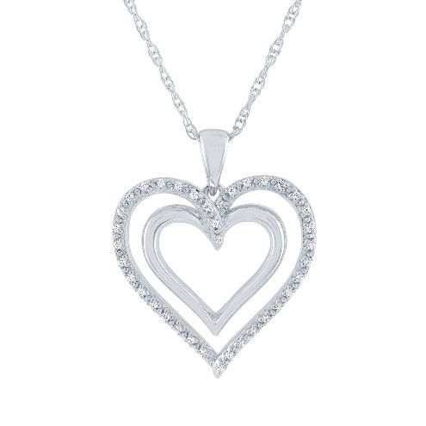
Guaranteed Prize Selections
1/10 CT. T.W. Genuine Diamond Pendant Heart Necklace
in Sterling Silver

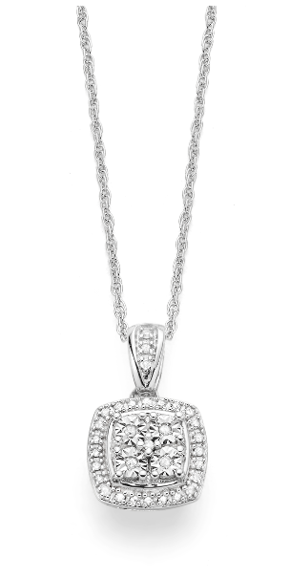
1/10 CT. T.W. Genuine Diamond Pendant Necklace
in Sterling Silver

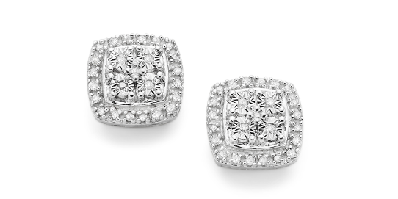
1/10 CT. T.W. Genuine Diamond Stud Earrings
in Sterling Silver

Grand Prize
2 CT. T.W. Diamond Ring in 10K White Gold
