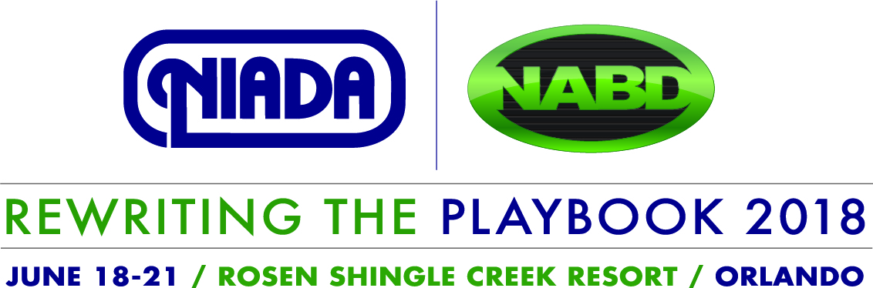

EDUCATION SESSION POLICIES
Commercial-free Education
The education sessions are considered a learning experience rather than a marketing opportunity. Presenters/panelists are referred to as industry experts with knowledge gained from working in the automotive industry. However, all speakers/panelists must ensure presentations are commercial-free and vendor neutral.

Session Delivery Limits
Unless otherwise preapproved by NIADA, sessions are limited to two presenters and panels are limited to a moderator and three panelists.

Session Follow-up and Planning Conference Calls
NIADA staff will facilitate these calls per the submission calendar and assist session planners as needed.

Honoraria, Travel Expenses and Complimentary Registration
Presenting at the NIADA/NABD Convention and Expo is done on a voluntary, unpaid basis. Speakers/panelists will be required to pay for their own travel, lodging and meals. NIADA will provide a complimentary registration to the Convention and Expo to all presenters. A special registration code will be provided to each speaker/panelist for registration purposes.

Use of Approved PowerPoint Template
PowerPoint presentations are encouraged, but not required. If a PowerPoint presentation will be used, presenters must use the approved NIADA/NABD Convention and Expo PowerPoint slide template. The template will be provided at the time the session is approved.

Handouts
Handouts are not required for session presentation. Any handout intended to be used in a session presentation must be submitted to NIADA staff for approval by the deadline indicated on the Submission Calendar. Handouts will be made available electronically for downloading by the attendees. Handouts will not be distributed onsite.

