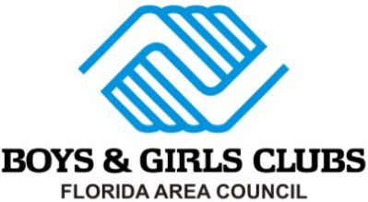

2019 Florida Area Council

Program Impact Excellence Awards

Email nomination forms to:
Jennifer Allen
Business Support & Events Specialist
Boys & Girls Clubs of America
jallen@bgca.org

The goals of the Florida Area Council Awards Program are as follows:
- To capture written descriptions of the best programs in the state which will serve as a resource for all Club organizations by posting all entries on our statewide website for the FL Area Council and Alliance.
- To encourage Clubs organizations to participate in this program sharing and awards program by making it easier to complete the forms and allowing more time to work on the entries.
- To maintain a digital process that saves money (paper, copying, postage, staff time, etc.), makes it easier for organizations to submit entries (via email), and easier to distribute entries to the judges (via email). Please enter one program in each core service area that has been implemented since September 2018. This can be a unique local program or unique approach to a national BGCA program. Focus on the idea of sharing your best program ideas and efforts with your peers in the state.

Program Categories

Character & Leadership Development
Education & Career Development
Health & Life Skills
The Arts
Sports, Fitness & Recreation
Overall Program

DEADLINE – Wednesday, 7/31/2019
2019 Florida Area Council
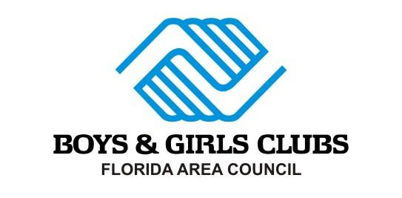
Awards for Program Impact Excellence
Core Service Program - Entry Form

Please type in the yellow areas provided. Double click the appropriate yellow boxes (menu will appear to check the box).
Program Name:
Unit Name:
Organizational Name:
Person Submitting Entry: Title:
Email Address: Phone:
Chief Professional Officer (CPO) Name:
CPO Email Address:
Reviewed by the CPO: YES NO

Award Program Category (Check One)
Character and Leadership Development The Arts
Education and Career Development Sports, Fitness and Recreation
Health and Life Skills Overall Program (5 core program areas)

Program Information

Number of participants:

Age range program served: Program start date:

Total program hours: Program end date:

Judging Criteria
25% Needs Assessment documented data that clearly aligns to the program solution.
25% Program Description program creativity, direct solution to the need, and ability to replicate.
40% Program Impact clear, measurable, and documented outcomes.
10% Presentation correct spelling, correct grammar, and appearance of entry.

How To Enter

Email award nominations to Jennifer Allen at jallen@bgca.org
Deadline for submission: Wednesday, 7/31/2019

Award Entry Support Documents

You may include any support documents in this document within the limits described below. This not a requirement for submission, however include these documents if it will help explain your program.
ATTACHMENTS MUST BE INCLUDED WITHIN THIS DOCUMENT!
- Scan or save all attachments as JPEG or GIF files and paste on to the last pages of this document.
- The final MS Word or PDF award entry file cannot exceed 9MB.The BGCA email system can only accept 9MB of total attachments per email, so you may need to send your entries attached to several emails.

2019 Florida Area Council
Awards for Program Impact Excellence
Core Service Program - Entry Form

Please type in the yellow areas provided. Double click the appropriate yellow boxes (menu will appear to check the box).
For each question, please begin typing or paste your copy in the yellow spaces provided. This document will add and number pages as needed.
NOTE: These answers will apply to questions in the application for the National Honor Awards for Program Excellence.
- Program Needs Assessment: Please describe the specific local needs that the program addresses. Please be specific.

- Program Description: Please describe the purpose, objectives and day-to-day activities of the program. Please attach appropriate support documents such as news articles, photos, program flyers, etc.

- Program Impact: Please describe how you determine the effectiveness of the program. Who was involved in this process? What specific tools did you use to assess effectiveness? What were the results? Please be specific as possible.

How To Enter

Email award nominations to Jennifer Allen at jallen@bgca.org
Deadline for submission: Wednesday, 7/31/2019

Award Entry Support Documents

You may include any support documents in this document within the limits described below. This not a requirement for submission, however include these documents if it will help explain your program.
ATTACHMENTS MUST BE INCLUDED WITHIN THIS DOCUMENT!
- Scan or save all attachments as JPEG or GIF files and paste on to the last pages of this document.
- The final MS Word or PDF award entry file cannot exceed 9MB.The BGCA email system can only accept 9MB of total attachments per email, so you may need to send your entries attached to several emails.

