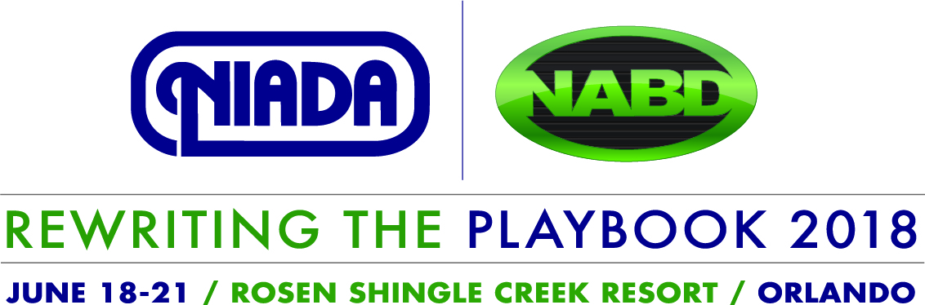

CALL FOR PRESENTATIONS

Submit Your Education Session Proposal
Deadline: February 2, 2018
The Convention Planning Committee invites you to submit a proposal for an education breakout session for the National Independent Automobile Dealers Association/National Alliance of Buy Here, Pay Here Dealers Convention and Expo, scheduled for June 18-21, 2018, at the Rosen Shingle Creek Resort in Orlando, Florida.
NIADA has recently acquired the assets and operations of NABD and for the first time will merge its two shows for what is expected to be the largest used motor vehicle industry conference. Our mission to represent and assist the independent dealer for 72 years has been ever-changing. Therefore, we are looking for topics that will give attendees the skills, knowledge and motivation to “Rewrite the Playbook” to grow their businesses and increase their profits. Session presentations can be tailored to help either the retail dealer, buy here pay here dealer, or both. Session topics should be classified as focused toward one of the following: Retail, Buy Here Pay Here, Compliance, Certified Pre-owned, or General Education.
- Topics should address the issues that dealers find most challenging in their day-to-day operations.
- The committee is open to single speakers and panels. No more than two speakers or three panelists and a moderator per session.
- Sessions must be commercial-free and vendor neutral.
- Sessions should be approximately 50 minutes in length.
- Presentations should engage the attendees, not just speak to the audience.

Submission Calendar
January 2, 2018 Call for Presentations posted and disseminated
February 2, 2018 Submission deadline
March 2, 2018 Notification of selection
March 16, 2018 Bios, Headshots, Session Titles, Session Descriptions due
March 16-30, 2018 Follow-up calls to presenters/panelists to ensure presentations meet
session expectations, if needed
April 27, 2018 Final Presentation Due (PowerPoint, Handouts, etc.)

Session proposal to be sent to: Shaun Petersen via email shaun@niada.com or fax 682-558-8281

CALL FOR EDUCATION SESSION PRESENTATIONS
SUBMISSION FORM

Topic:
Session Title:
Category Track (circle one): RETAIL BHPH COMPLIANCE CPO GENERAL

Presenter(s)/Panelists (attach a brief bio, picture (jpeg), and contact info for each):

Session Objectives:

Description:

Date and time preference: June 19 June 20 June 21 AM PM

Will you be using a Power Point presentation? Yes No
You will need to use your own laptop and presentation clicker. NIADA will provide an LCD projector and screen.

Preferred Stage Set Up: Podium No Podium Chairs Behind Table Stool(s) Chair(s)

Session Video
NIADA will video this session and make it available for purchase via the NIADA website after the convention. This is an excellent opportunity for presenters as it expands their exposure to a larger audience. Submission of this proposal requires your acceptance of this requirement and conveys your permission to video your session if it is selected.

Session Contact Information
Name:
Company:
Email:
Phone:

Submit proposal by February 2, 2018 to Shaun Petersen
(email: shaun@niada.com or fax: 682-558-8281)

