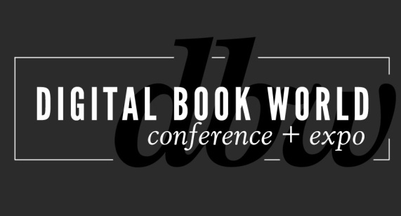
Contact: Stacie Berger F+W Media, Inc.
513.531.2690 x 11457
stacie.berger@fwmedia.com

NEW at Digital Book World 2014: Digital Design & Production Conference:
The Mechanics of Ebook Implementation
NEW YORK – November 7, 2013 – Adobe and other ebook production and technology experts will take part in a one-day conference focused on production, workflow, design, EPUB3, typography and the future of ebook production at Digital Book World, January 13-15, 2014 in New York City. The Digital Design & Production Conference: the Mechanics of EBook Implementation offers two tracks addressing ebook production and ebook design. Find complete session details and register at http://conference.digitalbookworld.com.
"With our Mechanics of Ebook Implementation Conference, we are picking up where other conferences have left off to provide the latest and best information on the tools and technologies that are used in today's fast-paced and high-tech ebook production workflow. Anyone involved in ebook production or design shouldn’t miss this," says Jeremy Greenfield, Digital Book World Editorial Director.

Ebook production track:

A Practical Introduction to ePub3 with Joshua Tallent, Chief eBook Architect, Firebrand Technologies.
Participants will walk away with a clear picture of the true differences and advancements in ePub3 over ePub2 and a solid understanding of how ePub3 files work in the real world.

Introduction to EPUB creation with Adobe InDesign CC 4 with Chris Kitchener, InDesign Product Manager. An introduction to the most important design concepts and InDesign features to ensure your EPUB provides readers with the most interactive, intuitive reading experience on any device.

Advanced EPUB creation for iPad with Adobe InDesign CC with Douglas Waterfall, InDesign Engineering Architect. A deep dive into more technical aspects of EPUB creation from InDesign. This workshop is for those familiar with the EPUB creation process who want to take their design to the next level.

Ebook design track:
Ebook Design: Beyond Straight Text with Colleen Cunningham, eBook Developer, F+W Media, Inc. Cunningham will address the challenges of formatting a flowable ebook to render well on a variety of ereaders. Creating format extracts, lists, sidebars, and tables that are flexible enough to render consistently across multiple ebook platforms: iBooks, Nook, Kobo, and Kindle.

First, Do No Harm: Best Practices for Typography in eBooks with Charles Nix, Co-Founder, Scott & Nix, Inc. Nix will present fundamentals and techniques for superior ebook typography: choosing type for ebooks; typographic dos and don'ts; and a step-by-step guide to grooming text for an optimal reading experience.

UX Design for Digital Books: Learn and apply UXD for better ebook experience with Anne Kostick, Principal, Foxpath IND and Pamela Hilborn, VP, Product & Design, Kobo. Learn the most up-to-date trends in eBook user-experience design in this two-part session.
The Digital Design & Production Conference will take place Monday, January 13th at the Sheraton New York Hotel and Towers. In addition to the educational programming, there will be tabletop exhibits featuring products and services for ebook creators. For more information on participating in the exhibit area, contact Ray Kyle at ray.kyle@fwmedia.com.
Digital Book World participants may register only for the Monday-only Digital Design & Production Conference or select the Total Access registration package, and save by combining the Monday event with the full Digital Book World Conference + Expo. To learn more about Digital Book World program and to register for the 5th Annual Digital Book World Conference+ Expo, visit http://conference.digitalbookworld.com.
# # #

About Digital Book World
The Digital Book World Conference + Expo is the largest event dedicated solely to the business of digital publishing worldwide. It consists of a 2-day multi-track, multi-faceted digital publishing program, pre-conference events, Digital Book Awards gala and exhibition hall. Digital Book World, an F+W Media event, attracts an international audience of 1,500 industry professionals, 50 exhibitors and more than 100 speakers. http://conference.digitalbookworld.com
Press Inquiries:
Stacie Berger, Vice President, Communications, F+W Media, Inc.
stacie.berger@fwmedia.com

