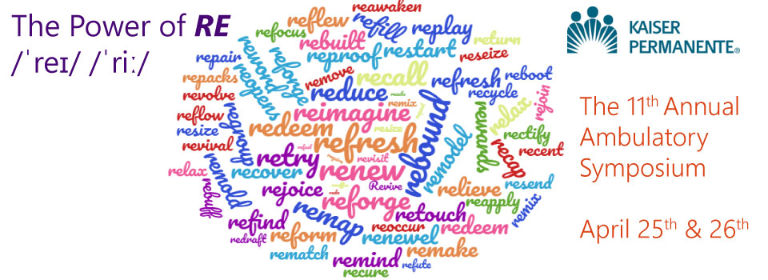
AGENDA
7:30 – 8:30am RE-gistration, Poster Presentation Viewing, Networking and Breakfast
8:30am | Welcome and Announcements | Hazel Torres, MN, RN  Director, Regional Professional Development and Research Ambulatory Services, Walnut Center
8:45 – 9:15am | RE-flections  At the end of the session, the participant will be able to:  - Cite examples of how concepts of “re” are utilized in the leader’s journey.  - Explain how the rest of the conference topics relate to their personal and professional roles. | Sylvia Everroad, MSN, RN  Regional Chief Administrative Officer, Walnut Center  Aileen Oh, RN, MSN  Director, Ambulatory Clinical Services, Walnut Center  Chris Recinos, RN, MSN, FNP-BC  Regional Director of Advanced Practice and Target Clinics,  Walnut Center
9:15 – 10:30am | RE-treat, RE-late, RE-new  At the end of the session, the participant will be able to:  - Participants will become more mindful of their own health, so that they may serve others and value self-care.  - Participants will gain a greater understanding of mental health issues and their associated stigma.  - Participants will bring forward increased wisdom and compassion for Kaiser Permanente members struggling with mental health. | Alice Ducey  Executive Consultant, National Health Plan & Hospitals Quality, Oakland
10:30 – 10:50am AM Break and Poster Presentation Viewing
11:00– 11:30am | RE-liance: The Team You Can Depend On  At the conclusion of this presentation attendees will be able to:  - Verbalize the Phone number to access the Behavioral Healthcare Helpline (BHCHL).  - State at least 2 services provided by the BHCHL.  - Discuss how the BHCHL aligns its services with the KP Promise.  - Identify at least one measure of success for the BHCHL Program.  - Describe one limitation of the BHCHL Program. | Christopher Brown, RN  Quality Coordinator RN, Case Coordination Center  Lolita Manigbas, RN Quality Director, Case Coordination Center

11:30 – 12:00pm | RE-imagining Life Care Planning  At the conclusion of this presentation attendees will be able to:  - Address and demystify common misunderstandings about Life Care Planning and its role in the long view of care.  - Be familiar with strategies on how to approach this topic with patients and their families.  - Identify 1-2 action items to encourage or promote Life Care Planning for your patients, loved ones, or for yourself. | Lori Viveros, MPH  Regional Director, Life Care Planning, Regional Offices  Susan Wang, MD  Regional Physician Lead, Life Care Planning,  West Los Angeles
12:00 – 12:55pm LUNCH
1:00 – 1:45pm | RE-new the Spirit of Compassion and Happiness at the Bedside  At the conclusion of this presentation attendees will be able to:  - Recognize 3 unique symptoms of Compassion Fatigue.  - Differentiate between Compassion Fatigue and Burnout.  - Discuss 3 strategies that contribute to Compassion Satisfaction. | Lina Najib Kawar, PhD, RN, CNS  Nurse Scientist  Translational Research; Regional Nursing Research Program, Walnut Center
1:45 – 2:30pm | RE-silience Building with HeartMath  At the conclusion of this presentation attendees will be able to:  - Strengthen resilience through research-based tools that help increase energy levels and connect to core values.  - Leverage ability to think clearly under pressure and discern appropriate solutions to problems.  - Diminish symptoms of personal and professional stress such as confusion, fatigue and sleep disturbance. | Nikki West, MPH Director HealthCare Education Management, KP Northern California Regional Offices  Robert Browning, PhD (h.c.)  Director & Senior Master Trainer, HeartMath Healthcare
2:30 – 2:50pm PM Break and Poster Presentation Viewing
3:00 – 4:00pm | RE-capturing Your Passion for Nursing:  “Conquering Raiders of the Lost Spark”  At the conclusion of this presentation attendees will be able to:  - Discover the secrets of resetting your priorities.  - Evaluate and manage balance in the major areas of your life.  - Employ ways to live with more purpose and meaning.  - Understand the correlation between good self-care and creating an excellence-based culture. | Connie Merritt, RN, BSN, PHN
4:00 – 4:15pm | RE-invigoration | Theresa Monakil, MSN, RN  Professional Development and Education Consultant,  Walnut Center
4:15 – 4:30pm | RE-cap and Closing RE-marks
4:30 – 4:45pm | Certificate Distribution
Agenda subject to change

