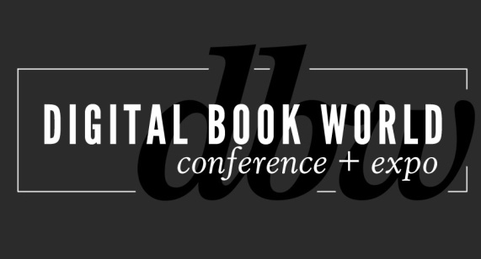
Digital Book World: Solutions for Publishers in a Data-Centric Environment
NEW YORK – October 14, 2013 – Publishing is increasingly becoming a data-centric endeavor versus a “gut-feel” business. As a result, data-based decision-making is more critical than ever to a book’s success. Publishing experts will paint the broad picture of opportunity for data management and offer actionable solutions in plenary sessions at Digital Book World, January 13-15, 2014 in New York City. Find complete details and register now at conference.digitalbookworld.com.
Digital Book World sessions will address collection and usage of data and how that benefits all of the links in the supply chain. In Data-Driven Decision-Making: Publishing Smarter, a panel session moderated by Ken Brooks, Senior VP, Global Supply Management, McGraw-Hill, speakers will outline how to focus on the data and the methods you need today to provide real benefit, tomorrow. Discussion topics include:
- What in-house, industry, or supply-chain data can be captured - and how should it be used?
- What data is a waste of time?
- How can you avoid the pitfalls of bad data or worse – misinterpreting data you collect?
- How can data improve efficiency and help you understand and reach consumers?
Later, Digital Strategist Peter McCarthy, Founder, McCarthy Digital will address how data should influence your marketing efforts. In What Consumers Want: Utilizing Data for Acquisitions and Marketing, publishers will learn how to tap into data streams to inform them of potential audience groups, the best search optimization options, and social media outreach. He’ll explain how those same data streams can be used before a book is acquired to help the publish-or-not-publish decision.
Len Vlahos, Executive Director of the Book Industry Study Group will moderate Optimizing Metadata for Global Impact. This panel session will offer an update on global standardization (or lack thereof), and how publishers can optimize their metadata for global impact – including the knotty mechanics of pricing for different markets, dealing with multiple languages, and understanding how different retailers and search engines employ metadata around the world.
Digital Book World 2014 offers an exclusive opportunity to network with 1300 senior-level publishing professionals, from marketers and editors to publicists, to developers, librarians and booksellers. In addition to the programming on the topic of data management, the exhibit hall will feature service suppliers who specialize in supporting publishers in the data management and measurement process. To learn more about Digital Book World program and to register for the 5th Annual Digital Book World Conference+ Expo, visit http://conference.digitalbookworld.com.
# # #

About Digital Book World
The Digital Book World Conference + Expo is the largest event dedicated solely to the business of digital publishing worldwide. It consists of a 2-day multi-track, multi-faceted digital publishing program, pre-conference events, Digital Book Awards gala and exhibition hall. Digital Book World, an F+W Media event, attracts an international audience of 1,500 industry professionals, 50 exhibitors and more than 100 speakers. http://conference.digitalbookworld.com
Press Inquiries:
Stacie Berger, Vice President, Communications, F+W Media, Inc.
513.531.2690 x 11457
stacie.berger@fwmedia.com

