Research Symposium 2013
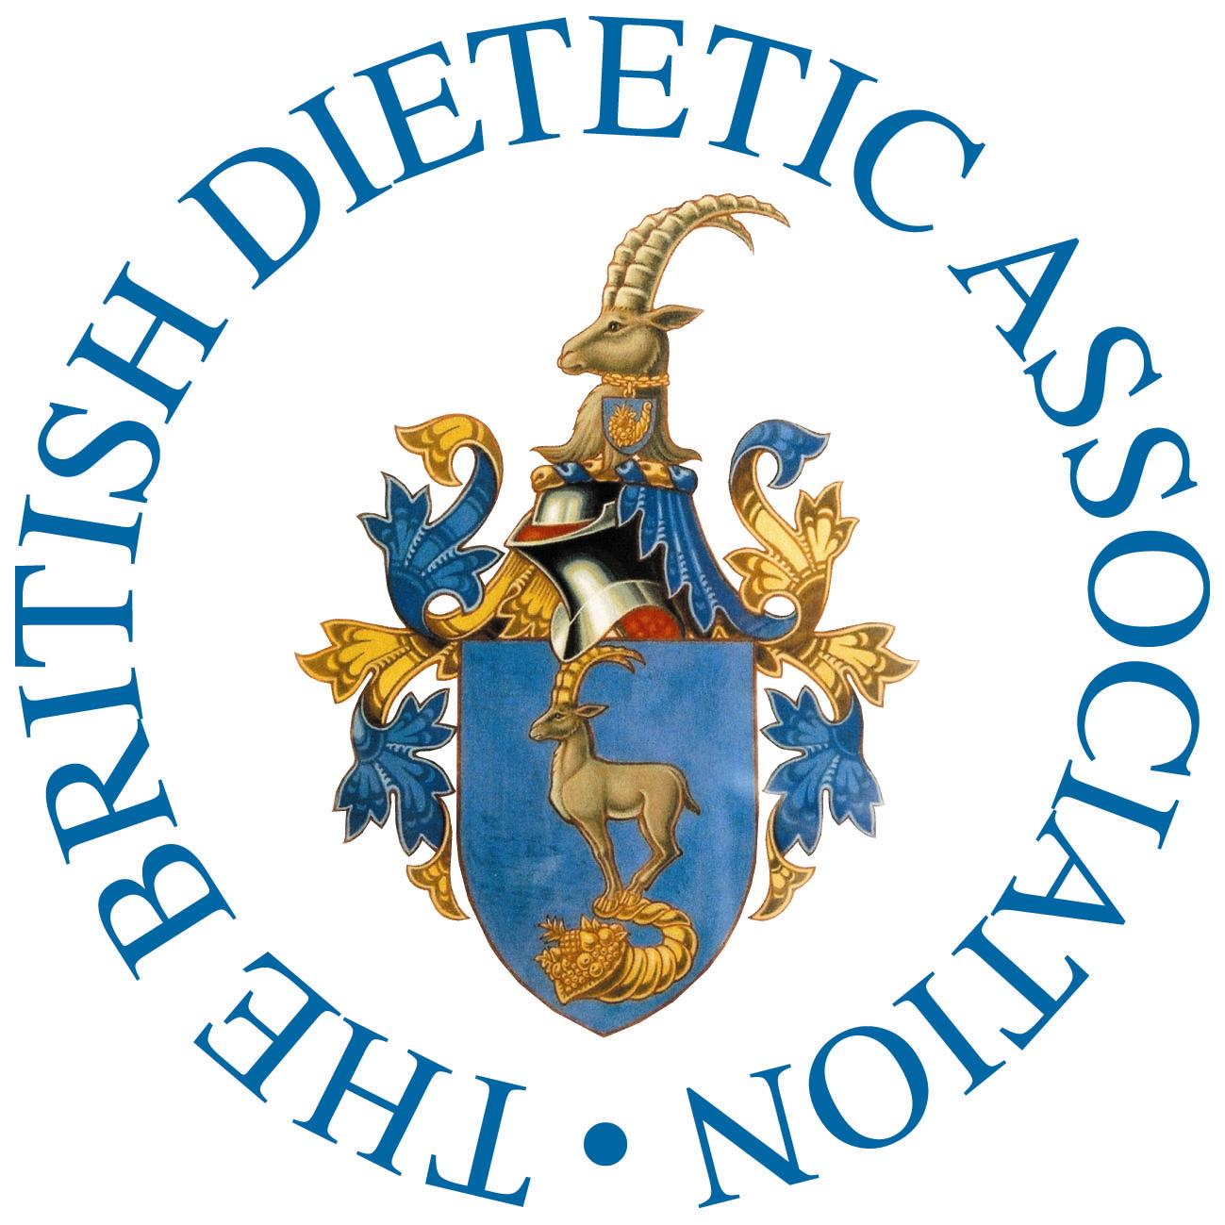
Programme
4th December 2013, Birmingham
Novotel
70 Broad St
Birmingham
B1 2HT
8.15 | Registration opens
8.30 9.30 | Breakfast Briefing Dr Liz Greenstreet, Head of Medical and Scientific Affairs, Nestlé Nutrition  “The implications of clinical trials for industry”  Join us for a complimentary breakfast and hear about the latest research.  This session will look at two trials and show the results and how the business has interpreted them – including an industry sponsored trial and one independent using their product.
9.35 | Introductions & Welcome – Dr Judy Lawrence – Research Officer - BDA
9.40 – 10.10 | “Dietitians must be involved in research: why, who and how”.  Prof Kevin Whelan, Professor of Dietetics – Kings College, London
10.15 – 11.26 | Presentations
 | New to Research  Room: The Burne Jones Suite  Chair- Dr Judy Lawrence  Research Officer BDA |  | New to Research  Room: Lunar Suite  Chair – Prof Kevin Whelan, Professor of Dietetics – Kings College, London
10.15 – 10.22 | Rosalyn Mallinder |  | Rosemary Allen
10.23 – 10.30 | Julia McDonald |  | Marion Ankcord
10.31 – 10.38 | Kirsten Whitehead |  | Presenter Cancelled
10.39 – 10.46 | Gemma Phillips |  | Heidi lewis
10.47 – 10.54 | Emma Pryke |  | Aoife Burke
10.55 – 11.02 | David Simms |  | Emily Capener
11.03 – 11.10 | Gemma Phillips |  | Rekesh Corepal
11.11 – 11.18 | Rachel Kennedy |  | Susan Dawe
11.19 – 11.26 | Sian Magee |  | Charlotte Whitmore
11. 26 – 11.40 | Refreshment Break – Lobby Area
11.40 – 12.10 | Breakout sessions
Opportunities for Clinical academic Training
Room: Lunar Suite
Dr Judy Lawrence
Research Officer BDA

12.10 – 13.27 | Presentations
 | Malnutrition  Room The Burne Jones Suite  Chair – Dr Emma Parsons  Southampton University |  | New to Research  Room: Lunar Suite  Chair – Donna Duncan Deputy Head of Nutrition and Dietetics Bridgend and Neath Port Talbot
12.10 – 12.17 | Hannah Diskin |  | Rachel Davies
12.18– 12.25 | Kathryn Kerr |  | Erini Koutroulis
12.26– 12.33 | Kathryn Kimber |  | Michelle Dewar
12.34– 12.41 | Bernice Tighe |  | Margaret Farragher
12.42– 12.49 | New to Research |  | Charlotte Gee
12.50– 12.57 | Nicola Weaver |  | Ann How
13.05– 13.12 | Jennifer Dray |  | Lucy Pearson
13.13 – 13.19 | Annie Skillings |  | Nicola Griffiths
13.20 – 13.27 | Kate Powell |  | Yvette Solomon
13.28 – 13.35 | Sam Meredith |  | Jo Ascione
13.35– 14.05 | Buffet Lunch – Lobby Area
14.05 – 14.40
Writing a paper Workshop  Room: The Burne Jones Suite  Chair – Dr Mary Hickson  Imperial College London  - Learning Objectives:  - Understand the process of getting research accepted for publication in a peer reviewed journal  - Recognise how to deal with lack of time to write  - Summarise what you want to write for your next  paper |  | Getting a practice based research project started.  Room: Lunar Suite  Chair – Dr Avril Collinson  Plymouth University
14.40 – 15.29 | Presentations
 | Practice Evaluation  Room: The Burne Jones Suite  Chair – Donna Duncan Deputy Head of Nutrition and Dietetics .Bridgend and Neath Port Talbot. |  | New to Research  Room: Lunar Suite  Chair – Dr Judy Lawrence/Kath Hart  Research Officer BDA
14.40 – 14.47 | Ruth Boocock |  | Jade Hanson
14.55 – 15.02 | Perryn Carroll |  | Laura Helm
15.03 – 15.10 | Perryn Carroll |  | Jennifer Hoare
15.11 – 15.18 | Perryn Carroll |  | Emma Howard
15.19 – 15.26 | Melissa Little |  | Louise Humphreys
15.27 – 15.34 | Susan Meredith |  | Orla Kearney
15.35 – 15.45 | Refreshment Break – Lobby Area
15.45– 16.24 | Presentations
 | Practice Evaluation  Room: The Burne Jones Suite  Chair – Steven Grayston  Chair Professional Practice Board |  | Public Health  Room: The Burne Jones Suite  Chair – Dr Judy Lawrence  Research Officer BDA  Room: The Burne-Jones Suite
15.45– 15.52 | Emma Oates |  | Sarah Bath
15.53 – 16.00 | Alison Scott |  | Ann Ashworth
16.01– 16.08 | Sally Search |  | Patricia Thomas
16.09 – 16.16 | Joanne Thomson |  | Laura Birch
16.17 – 16.24 | Jenni Woods |  | Kath Hart
16.20 – 16.50 Prize Presentations & Structured Networking with tea.
16.50 Close
We would like to thank our supporters - Nestle and Yakult

