How to Write a Fraud Risk Statement

It sounds simple, right? In one sense it is simple, if you use a methodology. This article will introduce a methodology for writing a fraud risk statement and the use of fraud risk nomenclature.
The most important aspect to remember is that the elements of the fraud risk statement drives the fraud risk assessment, the fraud data analytics and the audit program as illustrated by the following diagram:
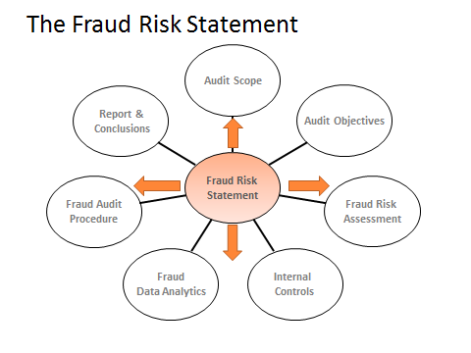
So, let’s start with an illustration of a fraud risk statement using the methodology and then we will discuss the importance of a methodology and the elements of the fraud risk statement:
Budget owner acting alone / cause’s a shell company to be set up on the vendor master file / causes the issuance of a purchase order and approves a fake invoice for goods or services not received / causing the diversion of company funds.

Or from a FCPA perspective:

Senior manager acting alone / cause’s a shell company to be set up on the vendor master file / causes the issuance of a purchase order and approves a fake invoice for goods or services not received / depositing the funds in an off-book bank account for the purposes of paying a bribe.

As illustrated, the fraud risk statement has five elements and should be written in the following order:

- Person committing
- The type of entity
- Fraud action statement
- Fraud impact statement
- Fraud conversion statement

The Science of Writing a Fraud Risk Statement

The purpose of the methodology is to create a logic based approach to fraud risk identification versus an experience based approach to fraud risk identification. The methodology relies on the auditor identifying the permutations for each element in the fraud risk statement. In using the permutation methodology the following statement is conceptually true:

The number of fraud risk statements for a business system can be mathematically calculated.

The proceeding statement is not intended to create a debate on the math but rather the logic formula of writing a fraud risk statement. There are up to five variables to the fraud risk statement, as you change each variable the auditor creates a new fraud risk statement.

I have also introduced the idea of a standard nomenclature to writing a fraud risk statement. For an international traveller, the ability to speak the local language is critical in order to communicate in that country. Therefore, it is important that the entire audit team speaks the same language. The key words and definitions relate to the five elements of a fraud risk statement. Also, having a common fraud name is important. Right now our industry uses many fraud words interchangeably: fraud risk; fraud scenario; inherent fraud risk; identified fraud risk; fraud risk statement; etc.

Furthermore, a fraud risk statement is not how the fraud is concealed or how a perpetrator benefits from a committing a fraud risk statement. The fraud risk statement is intended to provide fraud auditor with the necessary elements to build their fraud audit program. Within the context of this article, the following statements are not fraud risks (how some people refer to a fraud risk statement):
- Bribery fraud risk. A bribe is how the person benefits from committing a fraud risk statement, the fraud conversion statement.
- False document scheme. A false document is how a perpetrator creates the illusion that the transaction is real, the fraud concealment statement.
- Fraud concealment correlates to the fraud red flag analysis versus the fraud risk statement. On occasion, describing some aspect of the concealment helps in understanding the fraud risk statement. This is an element of style versus methodology.
It is not my intent to take exception to someone else’s nomenclature but rather, to create a common language throughout this article so the reader and I speak the same language. While the statement bribery fraud risk statement may help with fraud awareness; the statement does not provide the auditor with the necessary description to design a fraud audit program.
Remember, the intent of the fraud risk statement is to provide the auditor with the necessary specifications to design the fraud audit plan. Now that we understand what a fraud risk statement is and what is fraud risk statement is not, let’ discuss the five components of a fraud risk statement.

Five components of a Fraud Risk Statement

Person committing: The process of identification starts with a generic description such as Accounts Payable Function or Budget Owner. The generic description changes to the specific control owner as the internal auditor gains an understanding of the business process. As a rule, we do not list specific names but rather company titles. In a more complex discussion, the “person committing” element needs to consider direct access, indirect access and the impact of the internal control inhibitors on the person committing analysis.

Type of entity: The description starts with the business system. In the above illustration, the type of entity is a vendor. We start with two types of vendors: a false vendor or a real vendor. In a more complex discussion the real and false has over twenty five different permutations.

Fraud action statement: is the act committed by the person committing the scheme. Focusing on disbursement fraud schemes, the primary category of acts are: false billing; pass thru schemes, over billing and disguised expenditure schemes. Each primary category has multiple sub categories. I.e. the pass thru scheme has ten different permutations. Also, the statement needs to be adapted to the industry. I.e. in a construction audit, the pass thru maybe a sub-contractor that is legally owned by the general contractor with the intent to inflate contract costs.

Impact statement: describes either the monetary or the non-monetary impact on the organization. As a matter of style, I defer to the reader to create their own writing style for the impact statement.

Conversion statement: I call this the believability statement. Over the years, I have come to understand that if the reader of the fraud risk statement does not understand how the perpetrator benefits from the scheme, the reader may dismiss the scheme as theoretical versus reality. While the conversion statement is not necessary to create the audit program, it will tell the reader whether the financial conversion occurred on the company books or off the company books.

This article summarizes the concept of writing a fraud risk statement which is offered in the MIS course Fraud Audit College. Future postings will discuss how to link the fraud risk statement to your fraud data analytics plan and your fraud audit program.

