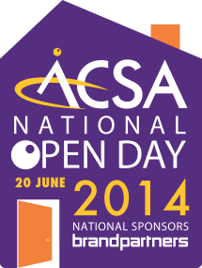

2 June 2014

Inaugural Open Day to celebrate Aged Care Services takes shape

On 20-21 June 2014 Aged & Community Services Australia (ACSA) will hold the first Open Day, an aged care event designed to bring people closer to the aged care services in their communities. It will be a day of celebration of older people and the services provided to assist them.

Aged & Community Services Association of NSW & ACT Incorporated now has over 140 organisations registered for its first Open Day and more than 300 ACSA members have registered nationally.

Over 100 organisations in NSW and the ACT will be involved. There is a smorgasbord of events planned, all over NSW and the ACT. We have Tai Chi, High Tea, stalls and fetes, BBQs and sausage sizzles, a multicultural day of feast and fashion, cultural concerts, a masked ball, a special mayoral morning tea for residents over 100 years old, and an Elvis Presley impersonator! One new aged care facility will open for the first time on 20 June, with a fete and live broadcast.

Last year the inaugural Open Day took place in the United Kingdom. This year Australia, South Africa, Malta and some other European sites are joining in. Each year this event will grow in number and colour.

In 2012, 14% of the Australian population was over 65 and 1.8% over 85 years. By 2032 it is predicted that around 24% will be over 65 and 7-8% will be over 85 years. (ABS, Population projections in Australia, 2012). As our population ages it is important that we learn more about the options available for retirement living, support to stay in your family home, or should it be needed, services available in an aged care facility.

Visit www.nationalopenday.com.au to see who is participating and what they have planned. The events are free, fun and open to everyone.

Open Day is a national event organised by Aged and Community Services Australia (ACSA) to support local aged care service providers to engage with their local communities. ACSA represents the not-for-profit providers of aged care services, including residential and community care and independent living and retirement villages.

Media contact: Illana Halliday, CEO ACS NSW and ACT M: 0448 498 016
E: illanah@acs.asn.au

