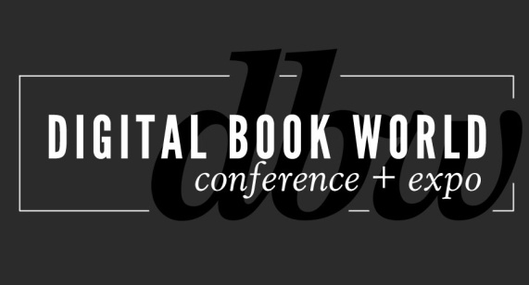
Digital Book World Survey: Start-Ups in Publishing
New Survey Collects Information that will facilitate Start-Up/Publisher Understanding
NEW YORK – November 1, 2013 – Digital Book World today announced that a brand new survey – “Start-Ups in Publishing” – is open for responses. The survey is aimed at publishers to find out what they want fledgling businesses to focus on, as well as at the start-ups themselves, to understand how they view the potential for working with publishers. The survey results will be revealed on the main stage at the Digital Book World Conference + Expo, January 13-15, in New York City. Survey closes: November 18th http://svy.mk/1aKavJZ

“This is a subject that generated a lot of discussion among our Conference Council,” said Mike Shatzkin, organizer of the Digital Book World program. “And there’s a lot of frustration all around. Many start-ups find publishers to be hide-bound and unwilling to experiment. But publishers see many start-ups as funded tech companies in search of a problem and with too little understanding of the business they want to help, or disrupt.” In addition to the survey results, Digital Book World panels will feature real talk from publishers, industry start-ups, and the investors who back them.

Shatzkin says that the survey will also help the Digital Book World conference team frame the questions the two panels will discuss. And the start-ups’ questionnaire, particularly, will uncover new perspectives and panelists to staff that conversation. “We know the business development people at the publishers; we’re thinking we’ll find some new and interesting start-ups from the responses,” he added.
# # #
About Digital Book World
The Digital Book World Conference + Expo is the largest event dedicated solely to the business of digital publishing worldwide. It consists of a 2-day multi-track, multi-faceted digital publishing program, pre-conference events, Digital Book Awards gala and exhibition hall. Digital Book World, an F+W Media event, attracts an international audience of 1,500 industry professionals, 50 exhibitors and more than 100 speakers. http://conference.digitalbookworld.com
Press Inquiries:
Stacie Berger, Communications VP, F+W Media, Inc.
513.531.2690 x 11457
stacie.berger@fwmedia.com
DBW Program Inquiries:
Jess Johns, Director of Operations, Publishers Launch Conferences
212.758.5670
jess@idealog.com

