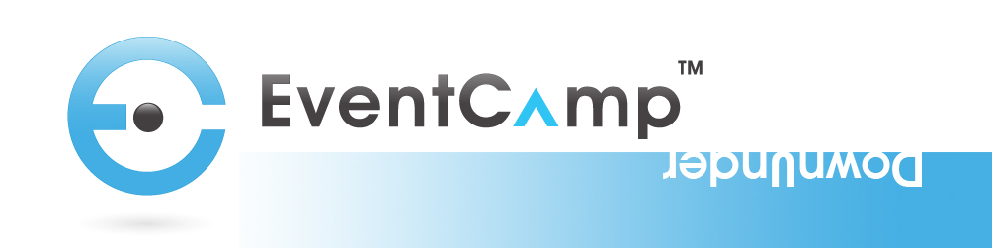

Event Camp DownUnder 2012 Report

Event Camp DownUnder brought together Event Professionals and speakers on location in Sydney, a Pod in Auckland and over 350 remote attendees.

Remote Attendance: across the 2 days of ECDU12 over 350 remote participants joined us from more than 10 countries with the majority in the US, Australia, New Zealand, Canada and the UK. Streaming Stats: Full Report

ShowGizmo - Event App Stats:
95% logged in with iPhone.
45% of delegates downloaded.
Job title - 20% MD, Director or CEO.
Most favourited person: Ryan Morris.
Top search term: Alice Springs.
Top rated speakers: Craig, Liz, William, Jo-Anne, Marc and Danny tied for first place.

Social Media
Twitter hashtag #ECDU12: used by over 38 twitter accounts used the hashtag between 20th December and 2nd March.
Facebook Event: had over 26 people attending
LinkedIn Group: had over 18 people attending

Photos online: all photos from both days can be found here: http://www.flickr.com/photos/75498294@N05/

Slides online: all speaker slides are up on site (http://www.eventcampdownunder.com) or refer ECDU’s slideshare account: http://www.slideshare.net/ShowGizmo

Videos are being edited and will be available online shortly…
- Event Highlights Video
- Personalised speaker videos

Sustainability – ECDU12 aspired to being a sustainable event. We will be finalising our Sustainability report with the use of the SEMS system and this will be onsite soon.

Much thanks must again go to the committee and our amazing sponsors for making this event happen. Stay in touch across #ecdu12 and we look forward to hosting you again soon.
