DELIVERY ADDRESS: 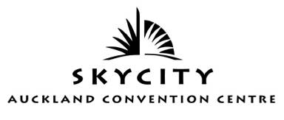
C/- Senior Duty Manager
SKYCITY AUCKLAND CONVENTION CENTRE
LOADING DOCK
88 Federal Street
Auckland
New Zealand
EVENT NAME | Annual ALGIM Conference 2015
STAND/BOOTH NAME & NUMBER
(if applicable)
EVENT DATE | 24th – 27th November 2015
EVENT ROOM NAME | NZ Room
SKYCITY CONTACT | Michael Boys 09 363 7121 or 021 226 4185
Loading Dock | 09 363 7166 or 021 496 189

SENDER DETAILS
SENDER NAME |  |  | COMPANY
ADDRESS |  |  | PHONE #
INSERT DESCRIPTION
INSERT DESCRIPTION:
NUMBER OF BOXES:

