Communication between PCM600 and the IED
The communication between the IED and PCM600 is independent of the used communication protocol within the substation or to the NCC.

The communication media is always Ethernet and the used protocol is IEC 61850.

Table 1 shows the Ports that must be open in the firewall for the different protocols.

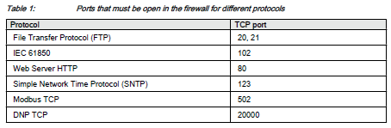

For successful use of PCM600 with REF615, we need the students to check the Laptop firewall TCP and UDP port configurations, especially for IEC 61850 and FTP. Other protocols are not used for engineering and/or they are optional.

Other issue is that due to internal IT policies the firewall settings could be blocking PCM600 itself.

Below there is a screenshot of the Windows firewall settings.

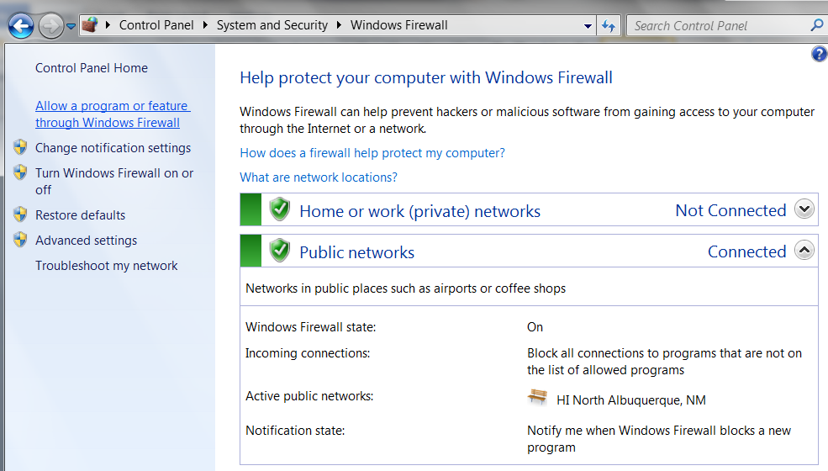

We need the students to install PCM600 and verify that the program is the list of allowed programs as shown below:

