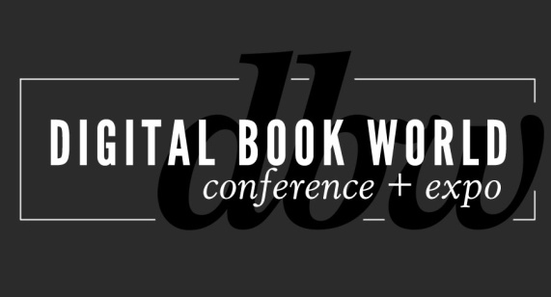
Contact: Stacie Berger F+W Media, Inc.
stacie.berger@fwmedia.com

NEW at Digital Book World 2014: Digital Design & Production Conference:
The Mechanics of Ebook Implementation
NEW YORK – November 7, 2013 – Adobe and other ebook production and technology experts will take part in a one-day conference focused on production, workflow, design, EPUB3, typography and the future of ebook production at Digital Book World, January 13-15, 2014 in New York City. The Digital Design & Production Conference: the Mechanics of Ebook Implementation offers two tracks addressing ebook production and ebook design. Find complete session details and register at conference.digitalbookworld.com.
"With our Mechanics of Ebook Implementation Conference, we are picking up where other conferences have left off to provide the latest and best information on the tools and technologies that are used in today's fast-paced and high-tech ebook production workflow. Anyone involved in the ebook production or design process should not miss this," says Jeremy Greenfield, Digital Book World Editorial Director.

The ebook production track focuses on managing the technical aspect of EPUB Creation:

A Practical Introduction to ePub3 with Joshua Tallent, Chief eBook Architect, Firebrand Technologies.
In this session, Joshua will review some of the foundational coding changes that come with ePub3. Participants will walk away with a clear picture of the true differences and advancements in ePub3 over ePub2 and a solid understanding of how ePub3 files work in the real world.

Introduction to EPUB creation with Adobe InDesign CC 4 with Chris Kitchener, InDesign Product Manager. Chris will introduce you to important concepts for the design and creation of EPUB files from InDesign CC. This is an introduction to a the most important design concepts and InDesign features to ensure your EPUB provides readers with the most interactive, intuitive reading experience on any device.

Advanced EPUB creation for iPad with Adobe InDesign CC with Chris Kitchener and Douglas Waterfall, InDesign Engineering Architect. This session will provide a deep dive into more technical aspects of EPUB creation from InDesign. This workshop is for designers familiar with EPUB creation who want to take their design to the next level.
Jeremy Greenfield, will wrap up the day by moderating a discussion on the future of eBook production and workflow from a panel of experts.
The ebook design track focuses on design to enhance the user experience:
Ebook Design: Beyond Straight Text with Colleen Cunningham, eBook Developer, F+W Media, Inc. Colleen will address the challenges of formatting a flowable ebook to render well on a variety of ereaders. She will share the secrets to robust CSS specifically built for e-reader quirks. Format extracts, lists, sidebars, and tables that are flexible enough to render consistently across multiple ebook platforms: iBooks, Nook, Kobo, and Kindle.

First, Do No Harm: Best Practices for Typography in eBooks with Charles Nix, Co-Founder, Scott & Nix, Inc. Charles Nix will present fundamentals and techniques for superior ebook typography: choosing type for ebooks; typographic dos and don'ts; and a step-by-step guide to grooming text for an optimal reading experience.
UX Design for Digital Books: Learn and apply UXD for better ebook experience with Anne Kostick, Principal, Foxpath IND and Pamela Hilborn, VP, Product & Design, Kobo showcases up-to-date trends in a two-part session focused on ebook user-experience design.
The Digital Design & Production Conference will take place Monday, January 13th at the Sheraton New York Hotel and Towers. In addition to the educational programming, there will be tabletop exhibits featuring products and services for ebook creators. For more information on participating in the exhibit area, contact Ray Kyle at ray.kyle@fwmedia.com.
The Total Access registration package offers the best value for registrants, combining the Monday Digital Design and Production Conference with the full Digital Book World Conference + Expo. Designers. Design and production staff may choose a Monday-only option. Visit http://conference.digitalbookworld.com to learn more and register.
# # #
About Digital Book World
The Digital Book World Conference + Expo is the largest event dedicated solely to the business of digital publishing worldwide. It consists of a 2-day multi-track, multi-faceted digital publishing program, pre-conference events, Digital Book Awards gala and exhibition hall. Digital Book World, an F+W Media event, attracts an international audience of 1,500 industry professionals, 50 exhibitors and more than 100 speakers. http://conference.digitalbookworld.com

.

