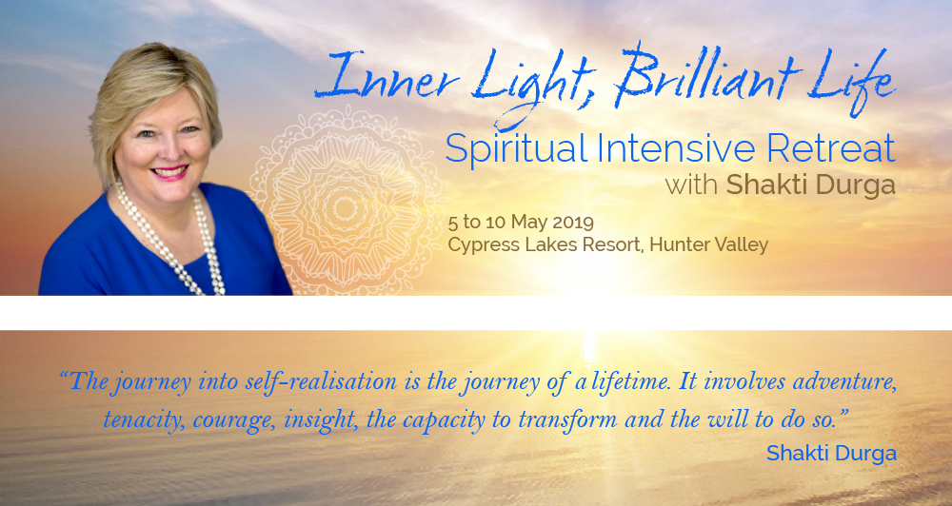

ITINERARY

The Venue

Cypress Lakes Resort
15 Thompsons Road
Pokolbin NSW 2320
Hunter Valley
Reception: +61 2 4993 1555

5 – 10 May 2019

Sunday 5 May: 2.00pm: Retreat check in at Reception. Please be at reception promptly at 2pm where you will be greeted by a member of the retreat team and guided through the retreat check in process.

4.00pm: The first session for the retreat will commence. Please arrive by 3.45pm so you are settled and ready for 4.00pm start.

Monday 6 May to Friday 10 May: Morning sessions will commence at 7.00am. These will include teachings, meditation, music and chanting. During the day there will be other activities and sessions and you will be given that information as the retreat progresses.

Vegetarian full buffet breakfast will be served at 9.00am, vegetarian hot buffet lunch will be served at 1.00pm.

Friday 10 May: Morning session 7.00am. Breakfast 9.00am. The retreat concludes 10.00am.

Check-out time 10.00am

