Provided by

How it Works
When you purchase a bling box for $50, you receive a pair of 1/10 CT. T.W. diamond hoop earrings in sterling silver valued at $125, PLUS a chance at one of five grand prizes.

Guaranteed Prize

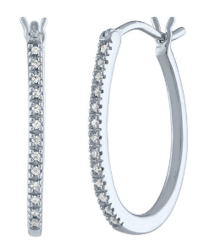
1/10 CT. T.W. Diamond Hoop Earrings
in Sterling Silver
(retail $124.98)

Grand Prize Selections

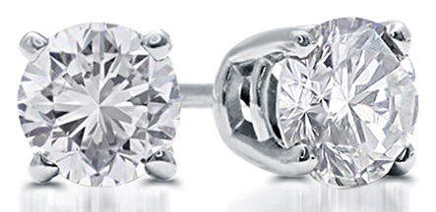
1 CT. T.W. Round Diamond Stud Earrings in 10K White Gold
(retail $1,999.98)

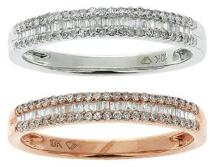

1/4 CT. T.W. Diamond Band in 10K White Gold and 1/4 CT. T.W. Diamond Band in 10K Rose Gold
(retail $1,249.96)

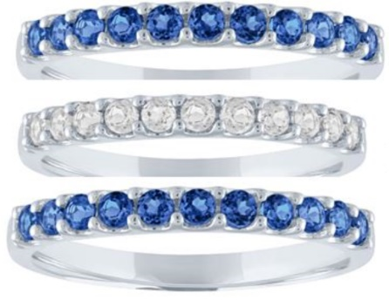
Lab Created Blue and White Sapphire Band in 10k White Gold
(retail $499.98)

Grand Prize Selections Continued

Two tickets and parking pass to a Dallas Mavericks game
Game is Wednesday, March 4 at 7:30pm vs New Orleans Pelicans; Section 117, Row K, Seats 9 and 10
Donated by
Texas Standard Commercial Construction

Two tickets to a Dallas Stars game
Game is Saturday, March 7 at 1:00pm vs Nashville Predators, Section 112, Row P, Seats 15 and 16
Donated by
Dallas Stars

