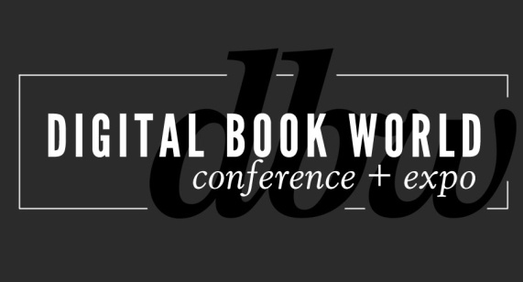
BISG to Co-Locate the Making Information Pay for Higher Education Conference with Digital Book World 2014

NEW YORK - September 27, 2013 – Digital Book World and the Book Industry Study Group (BISG) have announced a partnership to co-locate BISG’s Making Information Pay for Higher Education event with Digital Book World Conference & EXPO 2014. The event will take place on Monday, January 13 at the Sheraton Hotel and Towers in New York City and is now accepting registration at http://conference.digitalbookworld.com.

Now in its 5th year, Digital Book World, an F+W Media event, is the largest conference and expo dedicated solely to the business of digital publishing worldwide. Produced in partnership with Publishers Launch Conferences, Digital Book World attracts an international audience of 1,500+ industry professionals. BISG is the book industry’s leading trade association for policy, standards, and research. Membership consists of publishers, manufacturers, suppliers, wholesalers, retailers, librarians, and others engaged in the business of print and electronic media.
Since 2010, BISG’s Making Information Pay for Higher Education program has explored the migration from print to digital in higher education publishing. Recent programs have featured new results from BISG's ongoing Student Attitudes Toward Content in Higher Education survey and other data-rich presentations offering new insights into the unfolding digital transformation and online learning including MOOCs.

With this new partnership, BISG will be responsible for the Conference content, including session topics and speakers, while Digital Book World will coordinate conference logistics and will work with BISG to market the event and to develop and execute a sponsor/exhibitor sales plan.
“We’re excited about working together with BISG on their event because it fits so well with our mission to facilitate change in the business of publishing” says David Blansfield, President, F+W Media. “Digital strategies and solutions are transforming education, and academic and scholarly publishing is poised to benefit. Helping publishers capitalize on digital change is what Digital Book World is all about.”
Len Vlahos, BISG Executive Director agrees, “We are very pleased to be working with Digital Book World on this conference. BISG is known for its rich history of programs on data, best practices, and transformation. Digital Book World has unparalleled expertise in the emerging content delivery space and will help bring our programs to a larger audience.”

# # #
About F+W Media, Inc.
F+W Media, Inc. is a community-focused, content creator and marketer of products and services for enthusiasts offering a diversified portfolio of ecommerce, books, ebooks, magazines, events, competitions, education services, instructional video, and more. The Company is considered the authoritative, trusted voice guiding enthusiasts with relevant, helpful information and connecting them to the products and services they need to achieve success, profit from
their passion, or find inspiration. www.fwmedia.com.

About the Book Industry Study Group, Inc.
The Book Industry Study Group, Inc. (BISG) is the book industry’s leading trade association for policy, standards, and research. The mission of BISG is to create a more informed, empowered, and efficient book industry. Membership consists of publishers, manufacturers, suppliers, wholesalers, retailers, librarians, and others engaged in the business of print and electronic media. For over 35 years, BISG has provided a forum for all industry professionals to come together and efficiently address issues and concerns to advance the book community. Learn more about BISG at www.bisg.org.

Press Inquiries:
Stacie Berger, Vice President, Communications, F+W Media, Inc.
513.531.2690 x 11457
stacie.berger@fwmedia.com
Book Industry Study Group
Jeanette Zwart
646-336-7141
jeanette@bisg.org

Partnership and Exhibitor Opportunities:
Gary Lynch, Group Publisher, F+W Media Design Community, Digital Book World
212-447-1400 x12102
gary.lynch@fwmedia.com

