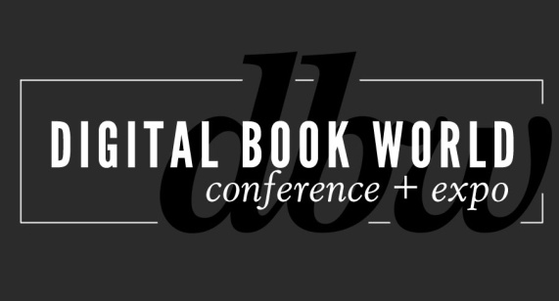
Contact: Stacie Berger F+W Media, Inc.
513.531.2690 x 11457
stacie.berger@fwmedia.com

Digital Book World 2014: Analyzing Amazon: A New View

NEW YORK – October 29, 2013 – Whether Amazon is your customer, competitor, or collaborator, you’ll get a new perspective on Amazon’s culture, its place in the academic market, and what its network of start-ups means to you and your business at the upcoming Digital Book World Conference + Expo. The largest digital publishing event in the world takes place January 13-15, 2014 in New York City. Find complete details and register at http://conference.digitalbookworld.com.

“If your business is moving further online, chances are it’s moving further to Amazon. Keeping current with the industry’s largest most innovative player is critical,” says Mike Shatzkin Digital Book World Conference Council Chair and Founder of The Idea Logical.

Wednesday morning, January 15th will be dedicated to an examination of the industry’s most important, and disruptive, customer. Sessions include:

Amazon’s “Everything” Strategy - Businessweek contributor and Amazon insider Brad Stone walks you through the halls and behind the thinking of Amazon – and its creator Jeff Bezos. Stone will share his unique understanding of Amazon beyond the pages of his popular – and controversial – book , “The Everything Store”.

Deconstructing Amazon -Listen to analyst Benedict Evans and you’ll come away with unique insight on the biggest player in our industry. Knowing its many its complex parts is as important as knowing the .com customer we all work with. Evans will deconstruct its many acquisitions, partnerships, and subsidiaries to help you get to know the real Amazon.

Amazon’s Growing Share of the Institutional Market - Former publishing executive and consultant Joseph Esposito uncovers yet another facet of Amazon. The Company is quickly making strides into the Academic and K-12 market and aims to own it. Acquisitions of education software companies, libraries using the site as their principal sourcing method, plus the Company’s rich customer-base: Amazon is well on its way.

The Future of Amazon and the Publishing Business - In a panel discussion moderated by Mike Shatzkin, Stone, Evans, and Esposito return to the stage for a conversation – and questions from the audience – about what the future holds for Amazon and the publishing business.

- Read an exclusive Q&A with Shatzkin about Amazon at www.digitalbookworld.com
Digital Book World 2014, an F+W Media Event, offers an exclusive opportunity to network with 1,500 senior-level publishing professionals, from marketers and editors to publicists, to developers, librarians and booksellers. In addition to rich conference programming addressing the pain points as well as the opportunities for publishers, the event features an Expo hall showcasing a wide range of service suppliers and business resources. Sign up by November 8 to secure the lowest rate available. To learn more about Digital Book World program and to register for the 5th Annual Digital Book World Conference+ Expo, visit http://conference.digitalbookworld.com.

