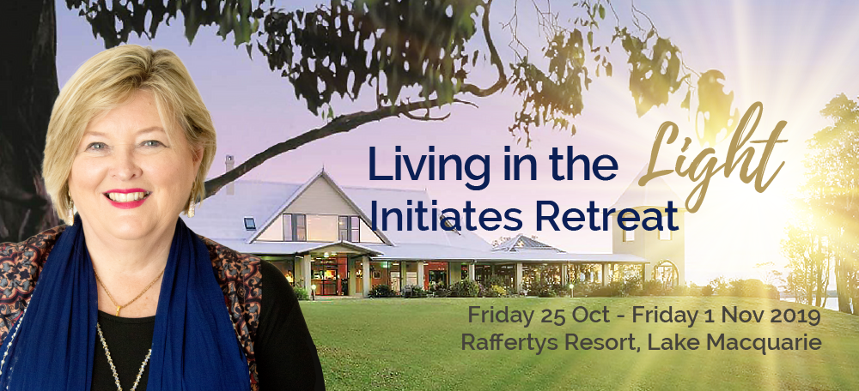

TIMETABLE
(Please note timetable is subject to change according to Divine Program – any changes will be communicated to all participants in a timely manner)
Friday, 25 October | 2:00pm | Check in for those who have booked retreat with accommodation.
 | 5:00pm – 6:00pm | Registration for Retreat outside Dr Cam’s conference room
 | 6:25pm | Outdoor Welcome Ceremony and Blessing
Saturday, 26 October | 7:00am – 8:30am | Morning Session Pranayama, music and meditation
 | 8:30am | Morning tea provided with snack, you may also want breakfast which can be purchased at the resort or self-cater
 | 9:30am | Exercise
 | 11:15am – 1:30pm | Initiations/discourse/new directions/contemplation time
 | 1:30pm | Lunch
 | 2:15pm – 5:30pm | Siesta/socialising/spa time/exercise
 | 5:30pm | Afternoon tea
 | 6:00pm – 7:30pm | Kirtan/groups/sweeping clinic
 | 7:30pm | Dinner – Self-cater or eat out
Sunday, 27 October | 8.00am | Full Buffet Breakfast – For people who have booked the retreat with accommodation
 | 8:30am | Travel to Cooranbong for Mission Day satsang and celebrations
 | 9.30am | Satsang at the Abode of Peace, 45 Kings Road, Cooranbong
 | 11.00am | Morning Tea to be purchased at the Tuck Shop or bring your own
 | 11.45am | Disciple Vow Renewal
 | 1.30pm | Lunch to be purchased at the Tuck Shop or bring your own
 | 2.30pm | Hand of Narayani
 | 5.00pm | Return to Rafferty’s at your leisure after Mission Day Celebrations
 | 7.30pm | Dinner self -catered or eat out
Monday, 28 October | 7:00am – 8:30am | Morning Session Pranayama, music and meditation
 | 8:30am | Morning tea provided with snack, you may also want breakfast which can be purchased at the resort or self-cater
 | 9:30am | Exercise
 | 11:15am – 1:30pm | initiations/discourse/new directions/contemplation time
 | 1:30pm | Lunch
 | 2:15pm – 5:30pm | Siesta/excursion/socialising/spa time/exercise
 | 5.30pm | Afternoon tea
 | 6:00pm – 7:30pm | Kirtan/groups/sweeping clinic
 | 7:30pm | Dinner – Self-cater or eat out
Tuesday, 29 October | 7:00am – 8:30am | Morning Session Pranayama, music and meditation
 | 8:30am | Morning tea provided with snack, you may also want breakfast which can be purchased at the resort or self-cater
 | 9:30am | Exercise
 | 11:15am – 1:30pm | Initiations/discourse/new directions/contemplation time
 | 1:30pm | Lunch
 | 2:15pm – 5:30pm | Siesta/excursion/socialising/spa time/exercise
 | 5:30pm | Afternoon Tea
 | 6:00pm – 7:30pm | Kirtan/groups/sweeping clinic
 | 7:30pm | Dinner – Self-cater or eat out
Wednesday, 30 October | 7:00am – 8:30am | Morning Session Pranayama, music and meditation
 | 8:30am | Morning tea provided with snack, you may also want breakfast which can be purchased at the resort or self-cater
 | 9:30am | Exercise
 | 11:15am – 1:30pm | Initiations/discourse/new directions/contemplation time
 | 1:30pm | Lunch
 | 2:15pm – 5:30pm | Siesta/excursion/socialising/spa time/exercise
 | 5:30pm | Afternoon Tea
 | 6:00pm – 7:30pm | Kirtan/groups/sweeping clinic
 | 7:30pm | Dinner – Self-cater or eat out
Thursday, 31 October | 7:00am – 8:30am | Morning Session Pranayama, music and meditation
 | 8:30am | Morning tea provided with snack, you may also want breakfast which can be purchased at the resort or self-cater
 | 9:30am | Exercise
 | 11:15am – 1:30pm | Initiations/discourse/new directions/contemplation time
 | 1:30pm | Lunch
 | 2:15pm – 5:30pm | Siesta/excursion/socialising/spa time/exercise
 | 5:30pm | Afternoon Tea
 | 6:00pm – 7:30pm | Kirtan/groups/sweeping clinic
 | 7:30pm | Dinner – Self-cater or eat out
Friday, 1 November | 7:00am – 8:30am | Morning Session Pranayama, music and meditation
 | 8:30am | Morning tea provided with snack, you may also want breakfast which can be purchased at the resort or self-cater
 | 9:30am | Exercise or pack
 | 10:00am | Check out of accommodation
 | 11:15am – 1:30pm | Initiations/discourse/new directions/contemplation time
 | 1:30pm | Lunch
 | 2:30pm – 4:00pm | Last Session
 | 4:00pm | Afternoon Tea and retreat close

